FESHM 4100: INDUSTRIAL HYGIENE PROGRAM

Revision History

Author | Description of Change | Revision Date
Rob Bushek / Kathy Vuletich | - Section 4.2.3 removed links to internal databases and moved them to Technical Appendix A. | November 2021
Rob Bushek | - Added IH Process Flowchart  - Added definition of qualitative and quantitative assessment  - Changed AREC process to Baseline Exposure Assessment Process  - Removed IH Employee of the Year | February 2020
Dave Baird | - Updated AREC Table and FESHM Chapter links.  - Added List of IH training courses.  - Added sections on IH Employee of the Year Award and IH Consensus Standards.  - Minor edits. | April 2016
Jonny Staffa | - Added FESHM Chapter formatting template and more complete guidance on Chapter content. | August 2015

TABLE OF CONTENTS

1.0 INTRODUCTION 2
2.0 DEFINITIONS 2
3.0 RESPONSIBILITIES 2
3.1 Laboratory Director 2
3.2 Chief Safety Officer 2
3.3 Industrial Hygiene Group 2
4.0 Program Description 3
4.1 Industrial Hygiene Consensus Standards 3
4.2 Baseline Exposure Assessment Process 3
4.2.1 Plans 5
4.2.2 Assessments 5
4.2.3 Databases 6
4.2.4 Reports 6
4.3 Education, Training and Reference Materials 6
4.4 Lessons Learned 7
4.5 Industrial Hygiene Group Efforts 7

INTRODUCTION

Fermilab’s Industrial Hygiene (IH) program has been developed to protect the health and well-being of working people and the public from chemical, microbiological and physical health hazards present at, or emanating from, the workplace.

This chapter describes the process, assessments, databases, reports, reference materials, lessons learned, and IH Group efforts that are used to assure that the Industrial Hygiene systems established at Fermilab and Fermilab leased spaces are operating effectively and efficiently.

This chapter is intended to be a summary chapter. Where applicable, more detailed information may be found described in other Fermilab Industrial Hygiene related FESHM Chapters and websites. These chapters and websites will be referenced in the body of this chapter. Please note that many of the IH websites are password protected.

DEFINITIONS

None

RESPONSIBILITIES

Laboratory Director
The Laboratory Director is responsible for assuring that the Industrial Hygiene program is in place and effectively monitoring Industrial Hygiene systems.

Chief Safety Officer
The Chief Safety Officer is responsible for fully participating in all of the elements that make up the Industrial Hygiene program. Assuring the personnel assigned to the Industrial Hygiene activities possess the experience, knowledge, skills, and abilities to perform effectively.

Industrial Hygiene Group
The Industrial Hygiene Group is responsible for using the anticipation, recognition, evaluation, and control (AREC) process described below to identify potential Industrial Hygiene issues for either new or existing activities/processes. Creating a dynamic IH Plan using the Industrial Hygiene Plans Database for either new or existing activities or processes. Documenting IH assessments using the Industrial Hygiene Assessment Database. Documenting IH sampling surveys using the Industrial Hygiene Sampling Database. Tracking and trending the IH Assessment and Sampling efforts.

4.0 Program Description

4.1 Industrial Hygiene Consensus Standards
In a letter to the DOE Fermilab Site Office (FSO), as of April 30, 2015 Fermilab formally adopted the lower exposure limits published in either the Occupational Safety and Health Administration (OSHA) 1910.1000 Subpart Z – Toxic and Hazardous Substances standard or the American Conference of Governmental Industrial Hygienist (ACGIHs) Threshold Limit Values (TLVs) for Chemical Substances and Physical Agents and Biological Exposure Indices (TLV booklet). It is important to note that the adoption of the TLVs will not be aligned specifically with the 2016 TLV booklet as identified in 10 Code of Federal Regulations (CFR) 851, Worker Safety and Health Program (WSHP) but more appropriately to the most recent TLV booklet.

4.2 Baseline Exposure Assessment Process
Industrial Hygiene is primarily concerned with the control of occupational health hazards that arise as a result of or during work. Industrial Hygiene has been defined as “that science and art devoted to the anticipation, recognition, evaluation, and control of those environmental factors or stresses arising in or from the workplace, which may cause sickness, impaired health and well-being, or significant discomfort among workers or among citizens of the community.” At Fermilab members of the Industrial Hygiene Group will utilize the AREC process to ensure that employees are not overexposed to physical, chemical or biological agents during the course of their work. The table below lists those items which Fermilab’s Industrial Hygienists use in meeting the objectives of the AREC process.

Anticipation | Recognition | Evaluation | Control
Job, Daily and/or Operational Meetings | Injury/Illness Investigations | Health and Safety Walkthroughs | Engineering
Purchase Requisition Reviews | IH Assessment Dbase  (refer to section 4.2.2) | IH Sampling Dbase  (refer to section 4.2.3) | Administrative
Project Reviews | Job Planning & Hazard Analyses | Negative Exposure Assessments | Personal Protective Equipment
Hazardous Materials Management Program | Product Labels and (M)SDSs | Professional Judgment | Product Substitution
Education, Training & Reference Materials (refer to section 4.3) | Written Procedures | Exhaust System Survey Database (refer to section 4.2.3) | Respiratory Protection Report (refer to section 4..2.4)
IH Group Meetings | Medical Surveillance | Environmental Potential to Emit Spreadsheet | Hearing Conservation Report (refer to section 4.2.4)
IH WAAF Exposure Assessment Tool  (refer to section 4.2.3) | Fire Department Run Reports | Laser Dbase  (refer to section 4..2.3) | Laser Registration Process Report  (refer to section 4.2.4)
Anticipation | Recognition | Evaluation | Control
Design Reviews &  Experiment Reviews | Audiometric Dbase  (refer to section 4.2.3) | IH Equipment Dbase  (refer to section 4.2.3) | Oxygen Sensor Inventory Report (refer to section 4.2.4)
Tool Box Meetings | Employee Concerns |  | IH Score Card
Chemical Hygiene Plans
Lessons Learned
(refer to section 4.4)
Confined Space Dbase
(refer to section 4.2.3)
IH Plan Database
(refer to section 4.2.1)
TSW/ORC Database
IMPACT Tool
Those items in the table above that are high-lighted in yellow are explained in greater detail in the paragraphs below. Where appropriate, additional items are also linked.
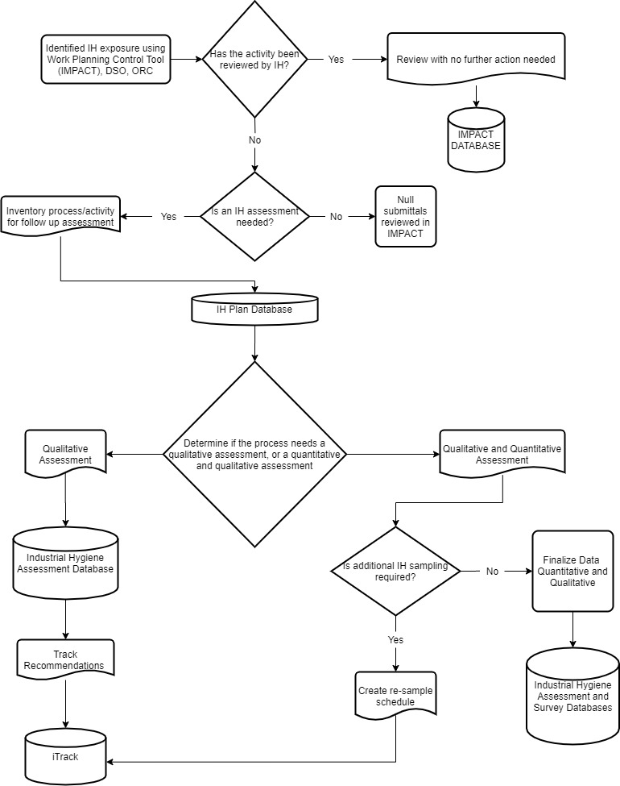
Figure 1: Industrial Hygiene Baseline Exposure Assessment Flow Chart

4.2.1 Plans
The IH Plans Database shall be reviewed and updated no later than October 31st of each year. This database indicates the Divisions/Sections/Projects assessment/sampling expectations for both past and current years.

The exposure type associated with the plan is provided by ESH at the conclusion of the IH Assessment or IH Sampling campaign to prioritize control efforts or to identify the need to collect more information based on level of exposure, severity of health effects, and the uncertainty associated with the exposure profile documented. Exposures may be grouped into one of three areas: unacceptable, uncertain, or acceptable.

- “UAE” – Unacceptable exposures, as defined in Fermilab’s institutional IH goals and program expectations are subject to control with monitoring/testing as appropriate.

- “UCE” – Uncertain exposures are those that aren’t well understood, or those where professional judgment cannot rule out the potential for unacceptable exposure. These exposures require further characterization, typically involving exposure monitoring or modeling.

- “ACE” – Acceptable exposures may not need further action, although confirmatory exposure monitoring is sometimes warranted to validate the acceptability of the assessment and to ensure the operation is under control.

In the event of an Unacceptable exposure “UAE”, or possibly an Uncertain exposure “UCE”, enter into iTrack and provide the iTrack Finding ID# as means to follow-up with additional sampling, investigations or corrective actions.

This is a dynamic plan that may be modified or updated at any point during the calendar year based on the introduction of new activities/processes or as a result of an IH Assessment or IH Sampling campaign.

4.2.2 Assessments
Industrial Hygiene assessments and other structured operational awareness activities are all part of Fermilab’s Industrial Hygiene Program. The Industrial Hygiene assessment database is described by the Industrial Hygiene Assessment Form. Results of the assessments are located in the Industrial Hygiene Assessment Database.

- Qualitative Assessment – is collecting objective data to make a determination if a process or activity is safe. Data such as; safety data sheets, toxicological information, quantities, occupational exposure limits, existing data, sources of exposure and controls.
- Quantitative Assessment – is used when the initial qualitative assessment determines that the exposures are uncertain or unacceptable. This will utilize measurable data to make a determination of acceptable controls for an exposure.

4.2.3 Databases
There are a number of databases with corresponding data entry forms that assist the lab in maintaining a well-organized Industrial Hygiene program. Links to the data entry forms and databases are available in the Technical Appendix A.

4.2.4 Reports
Other IH computer databases are utilized to track progress in the areas of Respiratory Protection, Hearing Conservation, Laser Registration Process and Oxygen Sensor Inventory.

4.3 Education, Training and Reference Materials
In addition to the following IH training courses in TRAIN;

- Asbestos Awareness [FN000251/CR/01]
- Back Works-Functional Activities [FN000335/CR/01]
- Back Works Refresher [FN000364/CR/01]
- Beryllium Associated Worker [ES000249/CR/01]
- Beryllium Handling [FN000196/CR/00]
- Beryllium Worker [FN000320/CR/01]
- Blood Borne Pathogens [FN000208/CR/00]
- Computer Workstation Ergonomics [FN000324/CR/02]
- Confined Spaces [FN000003/CR/00]
- GHS Hazard Communication Update [FN000496/CR/01]
- Hazard Communication [FN000156/CR/00]
- Hearing Conservation [FN000154/CR/00]
- Hydrofluoric Acid Handling [FN000406/CR/01]
- Hydrofluoric Acid Worker [FN000404/CR/01]
- Industrial Ergonomics [FN000297/CR/02]
- Laser Safety [FN000126/CR/00]
- Lead Handling [FN000123/CR/01]
- Lead Worker [FN000292/CR/01]
- MSA Altair Multi-Gas Detector [FN000452/CR/01]
- O.D.H Training [FN000029/CR/02]
- Nanomaterial Handling Training [FN000577/CR/01]
- Respiratory Protection [FN000024/CR/00]
- Respiratory Protection for Supervisors [FN000558/CR/01]
- Scott Air Pack - Fire Dept. [ES000031/CR/01]
- Silica Hazard Awareness Training [FN000547/CB?01

There are a number of FESHM Chapters which describe in greater detail the specific IH related programs at Fermilab. These chapters provide the foundation for the IH program at Fermilab. These chapters include:

- FESHM 4180, “Asbestos Management Program,”
- FESHM 4190, “Special Toxic Hazards-Beryllium & Beryllium Alloys,”
- FESHM 4195, “Special Toxic Hazards-Respirable Crystalline Silica,”
- FESHM 4220, “Bloodborne Pathogens,”
- FESHM 4230, “Confined Spaces,”
- FESHM 4160, “Emergency Eyewash and Shower Stations,”
- FESHM 4210, “Environmental Biological Hazards”
- FESHM 4120, “Ergonomics Program,”
- FESHM 4110, “Hazard Communication,”
- FESHM 4170, “Hazard Control Ventilation,”
- FESHM 4140, “Hearing Conservation,”
- FESHM 4260, “Lasers,”
- FESHM 4200, “Special Toxic Hazards-Lead Containing Materials,”
- FESHM 4240, “Oxygen Deficiency Hazards (ODH),”
- FESHM 4130, “Personal Protective Equipment (PPE),”
- FESHM 4290, “Preventative and Occupational Medicine”
- FESHM 4150, “Respiratory Protection,”
- FESHM 4270, “Static Magnetic Fields,”
- FESHM 4250, “Temperature Extremes – Heat Stress and Cold Stress,”
- FESHM 4280, “Ultraviolet Radiation Exposure,”
- FESHM 4310, “Nanomaterials.”

Imbedded in many of these chapters are procedures and in some instances IH FESHM Forms which help to control and manage the appropriate flow of information needed for proper program implementation and development. Other forms, called IH Field Forms also assist in this endeavor.

4.4 Lessons Learned
Fermilab’s Lessons Learned program is described in FESHM 3020, “Incident Investigation.” Other references are found in FESHM 3010, “Significant and Reportable Occurrences.”

4.5 Industrial Hygiene Group Efforts
The Industrial Hygiene Group is responsible for assisting line management in the implementation of Fermilab’s Industrial Hygiene policies, the Industrial Hygiene portions of the Fermilab ES&H Manual, and the Work Smart standards relevant to Industrial Hygiene. It is charged with meeting on a regular basis to discuss Industrial Hygiene issues, lessons learned and to develop and recommend solutions that will not only ensure compliance but also establish sound and standardized Industrial Hygiene practices throughout the Lab to support continuous improvement efforts.

Fundamentals of Industrial Hygiene, Third Edition, National Safety Council, 1988.
A Strategy for Assessing and Managing Occupational Exposures, Third Edition, AIHA, 2006.

