FESHM 6020.5: FLAMMABLE & COMBUSTIBLE LIQUIDS

Revision History

Author | Description of Change | Revision Date
Jim Niehoff | Updated with Chart of Single Container Amount; Clarified NFPA 30 Classification and GHS-SDS; Added additional information on explosion hazard. | October 2019
Jim Niehoff | Initial release | May 2018

TABLE OF CONTENTS

1.0 INTRODUCTION 3
2.0 DEFINITIONS 5
3.0 RESPONSIBILITIES 6
3.1 Cryogenics Safety Subcommittee 7
3.2 Fire Hazard Safety Subcommittee 7
3.3 Division Safety Officer 7
3.4 ES&H Industrial Hygiene Group 7
3.5 Mechanical Safety Subcommittee 7
4.0 EVALUATION OF HAZARD 7
4.1 Fire Hazard 7
4.2 Explosion Hazard 8
4.2.1. Potential Building/Room Explosion 9
4.2.2. Potential Equipment Explosion 9
5.0 STORAGE & HANDLING/PROCESSES 9
5.1 Storage and Handling 9
5.1.1. Safety Containers 9
5.1.2. Containment, Drainage, and Spill Control 9
5.2 Processes 9
5.2.1. Pumping and Piping 10
5.2.2. Emergency Shutoff 10
6.0 REFERENCES 10
7.0 TECHNICAL APPENDICES 11
7.1 NFPA: National Fire Protection Association website: 15
7.2 GHS 1st Edition (2003) website: 15

INTRODUCTION

This chapter provides guidance for the prevention of, and protection against, fires and explosions in industrial occupancies handling, processing, or transferring flammable and/or combustible liquids. This chapter is applicable to the main site at Batavia, Illinois and to all Fermilab leased spaces. Additional recommendations may be needed on a case by case basis to provide adequate prevention and protection subject to hazardous chemical reactions. The Globally Harmonized System-Safety Data Sheets (GHS-SDS) shall be followed in handling and storage of flammable and combustible liquids. This chapter excludes motor fueling dispensing facilities, repair garages, on-demand mobile fueling, and isolated construction sites.

The following table shows the allowable amounts for each class of liquid in a single container.

Container^{1,2} | Class IA⁴  (Category 1) | Class IB^{3,4}  (Category 2) | Class IC  (Category 3) | Class II  (Category 3) | Class IIIA  (Category 4)
Glass/approved plastic | 1 pt. (0.5L) | 1 qt. (1L) | 1.3 gal. (5L) | 1.3 gal. (5L) | 5.3 gal. (20L)
Metal (other than DOT drums) | 1.3 gal. (5L) | 5.3 gal. (20L) | 5.4 gal. (20L) | 5.3 gal. (20L) | 5.3 gal.  (20L)
Safety cans | 2.6 gal. (10L) | 5.3 gal. (20L) | 5.3 gal.  (20L) | 5.3 gal.  (20L) | 5.3 gal.  (20L)
Metal drums (DOT spec.) | 119 gal. (450L) | 119 gal. (450L) | 119 gal. (450L) | 119 gal. (450L) | 119 gal.  (450L)
Approved Portable Tanks | 660 gal  (2,498L) | 660 gal  (2,498L) | 660 gal  (2,498L) | 660 gal  (2,498L) | 660 gal  (2,498L)

- Taken from NFPA 30 Flammable and Combustible Liquids Code. Definitions are: Class 1A liquids have a flash point (FP) below 73°F, and boiling point (BP) below 100°F; Class 1B – FP below 73°F, and BP at or above 100°F; Class 1C – FP at or above 73°F, but less than 100°F (BP not addressed); Class II – FP at or above 100°F, but below 140°F; Class III – FP at or above 140°F.
- Container exemptions: Medicines, beverages, foodstuffs, cosmetics, and other common consumer items, provided as such by the manufacturer’s approved container.
- Items have been packaged according to commonly accepted practices for retail sales. Class IA and Class IB liquids may be stored in approved package containers (capacity ≤1 gal) if the required liquid purity (such as ACS analytical reagent grade or higher) would be affected by storage in metal containers, or if the liquid can cause excessive corrosion of the metal container.
- Chemical Laboratory units, such as those at Lab 5 & 6, follow the scope of NFPA 45, Standard on Fire Protection for Laboratories Using Chemicals - contact FP-AHJ for additional guidance.

The following table shows the allowable amounts for each class of liquids that can reside outside a flammable storage cabinet based on maximum quantity per 100 ft² (9.29 m²).

NFPA 30 Class | GHS-SDS | Without Flammable Storage Cabinet
Class IA | Category 1 | 2.6 gal. (10L)
Class IB | Category 2 | 5.3 gal. (20L)
Class IC | Category 3 | 5.3 gal. (20L)
Class II
Class IIIA | Category 4 | 5.3 gal. (20L)

Fermilab does not require a flammable storage cabinet if the quantities are less than 10 gallons (38 L) of flammable liquids in approved containers and GHS-SDS are followed have been reviewed by the DSO. In addition, employees and users are encouraged to use flammable liquids storage cabinets, when practical, to store unused flammable/combustible liquids regardless of quantities. All use of flammables should be reviewed and follow FESHM Chapter 2060.

The following table can be used for guidance in conjunction with consultation of the DSO and FHS. Of particular concern is the location of storage and use with the proximity of combustibles and ignition sources. This table is based on a single-story grade level facility use only and assumes liquids are stored in a listed flammable liquids cabinet. For underground or subsurface storage and use, consult with the Fire Hazard Safety subcommittee (FHS). The maximum quantity of liquid that may be stored in each building utilizing a flammable storage cabinet cannot exceed the following without additional reviews of FHS and DSO:

With Flammable Storage Cabinet (Note 1)
Liquid | NFPA 30 Class | Category (GHS-SDS) | NFPA 704 Identification | Gallons  (Note 2)
Flammable Liquids | IA | 1 | 4 (Danger) | 25 (95L)
 | IB | 2 | 3 (Warning) | 120 (460L)
 | IC | 3 | 3 (Warning) | 120 (460L)
Combustible Liquid | II |  | 2 (Caution) | 120 (460L)
 | IIIA | 4 | 2 (Caution) | 330 (1,265L)
 | IIIB | -- | 1 | See Note 3
      - Flammable liquids shall not be stored or used so as to limit use of exits, stairways, or area normally used for the safe egress.
      - Storage in operating areas in identified controlled storage area, such as listed flammable cabinets. as specified in OSHA and NFPA 30. The limit for a single flammable/combustible storage cabinet is 60 gallons (230 L) of Class IA, IB, IC, and II (Category 1, 2 or 3) flammable liquids, or 120 (460 L) gallons of Class IIIA (Category 4) flammable liquids. And, up to three safety cabinets are allowed in a storage area. Class IB, IC, II or IIIA shall not exceed 660 gallons (2,498 L) in a single portable tank.
      - Consult with FHS and DSO for storage of Class IIIB liquids.

DEFINITIONS

- Appropriate Governing Code – A national, state, or local code or standard that specifies design, fabrication, and operation requirements and practices that must be followed.
- Boiling Point – The temperature at which a liquid’s vapor pressure is equal to the atmospheric pressure on the liquid. The boiling point is measured at an atmospheric pressure of 14.7 psi absolute (approximately 1 bar absolute). The boiling point of a flammable or combustible liquid permits the comparison of liquid volatility without knowing the vapor pressures. Liquids with low boiling points are very volatile and extremely flammable.
- Container - Any vessel of 119 gallons (450L) or less capacity used for transporting or storing liquids. This includes cans, barrels, drums.
  - Closed Container - A container so sealed by means of a lid or other device that neither liquid nor vapor will escape from it at ordinary temperatures.
  - Portable container (Metal Drum) - A closed container having a liquid capacity over 60 gallons (227 liters) and not intended for fixed installation
  - Safety container (can) – An approved container, of not more than 5.3 gallons (20 liters) capacity, having a screen or strainer, pour opening having a spring-closing lid and spout cover and so designed that it will safely relieve internal pressure when subject to fire exposure.
- Control Area – A facility or portion of a facility within which flammable or combustible liquids are allowed to be stored, dispensed, and used.
- Cryogenic Fluids – A fluid with a boiling point lower than -130F (-90C) at an absolute pressure of 14.7 psi (101.325 kPa).
- Flash Point – The minimum temperature to which a liquid must be heated, in a standardized apparatus, so that a transient flame moves over the liquid when a small pilot flame is applied
- Flammable Storage Cabinet – Storage Cabinet that meets the requirements of NFPA 30, 2018, Edition, Section 9.5.3.
- Fire Point – The lowest temperature at which a liquid must be heated in a standardized apparatus, so that sustained combustion results when a small pilot flame is applied, as long as the liquid is at normal atmospheric pressure.
- Fire Area – An area of a facility separated from the remainder by construction having a fire resistance of at least 1 hour or higher.
- Flammable and Combustible Liquid – Any liquid or liquid mixture that will burn. A liquid will burn if it has a measurable flash point and/or boiling point. Liquids include flammable liquids and combustible liquids. For the purpose of defining flammable or combustible liquid, NFPA 30 shall be used as the classification and is defined into two categories, flammable and combustible.
Note: OSHA CFR 29 1910.106 classifies flammable liquids as “any liquid having a flashpoint at or below 199.4°F” Furthermore they are divided into four categories according to their flashpoint temperature. NFPA 30, classifies flammable liquids into six classes – Class I-A, I-B, I-C, II, III-A to III-B. Dividing them into flammable and combustible based on their flashpoint temperatures. International Building and Fire Code recognizes NFPA 30 classifications.

Flammable Liquid
NFPA 30 Class | Category (GHS-SDS) | Flash Point | Boiling Point | NFPA 704 Identification | Common Examples
IA | 1 | <73F (<22.8C) | <100F (<37.8C) | 4 (Danger) | Diethyl either, ethylene oxide, some light crude oils
IB | 2 | <73F (<22.8C) | ≥100F (≥37.8C) | 3 (Warning) | Isopropyl or ethyl alcohol, gasoline, toluene, lacquers, lacquer thinner
IC | 3 | ≥73F (<22.8C) to <100F (<37.8C) | Not Applicable | 3 (Warning) | Xylene, some paints, some solvent based cements

Combustible Liquid
NFPA 30 Class | Category (GHS-SDS) | Flash Point | Boiling Point | NFPA 704 Identification | Common Examples
II | 3 | ≥100F (≥37.8C) to ≤140F (≤60C) | Not Applicable | 2 (Caution) | Diesel fuel, paint thinner
IIIA | 4 | ˃140F (˃60C) to <200F (<93C) | Not Applicable | 2 (Caution) | Home heating oil
IIIB | Not Applicable | ≥200F (≥93C) | Not Applicable | 1 | Cooking oils, lubricating oils, motor oil

Reference the Technical Appendix for a comparison of Classification of Liquids between various agencies.
- Heat Release Rate – The rate at which thermal energy is released by a fire, often expressed as kilowatts per unit of burning area. It consists of a combination of convective, radiative, and conductive heat. It can be calculated from the mass burning rate if the heat of combustion and combustion efficiency are known.

RESPONSIBILITIES

The responsibilities are supplement to the FESHM Chapter 6010, Section 4.0.

Cryogenics Safety Subcommittee
The Cryogenic Safety Subcommittee is responsible for providing guidance and review to the laboratory concerning all engineering systems operating with flammable and non-flammable cryogenic fluids.

Fire Hazard Safety Subcommittee
The Fire Hazard Safety Subcommittee is responsible for providing guidance and review of flammable liquids storage and use.

Division Safety Officer
The Division Safety Officer is responsible for assisting in the review process and providing guidance in the storage and use of flammable or combustible liquids.

ES&H Industrial Hygiene Group
The Industrial Hygiene is responsible for providing guidance and review of the use of flammable, combustible and carcinogens type chemicals/liquids.

Mechanical Safety Subcommittee
The Mechanical Safety Subcommittee is responsible for providing guidance and review to the piping processes and vessels.

EVALUATION OF HAZARD

Flammable or combustible liquid fires increase in severity with increased pool size. Fire severity will be minimized if the flammable or combustible liquid can be contained within the equipment or contained to small footprint on the floor. If the flammable or combustible liquid is released from the equipment and forms a large pool, there is the potential for a large fire. Recommendations for passive and active fire protection features will vary depending on the severity of the potential fire hazard. The intent is to limit the amount of flammable or combustible liquids that can become involved in a fire. To evaluate the process or storage, the actual exposure created by flammable or combustible liquids must be analyzed by conducting a hazard analysis. This can be documented in an HA and/or SOP, or method, in accordance with FESHM Chapter 2060. Evaluate each step separately prior to handling/processing/use to determine the actual exposure created by the Flammable or combustible liquid. For additional information, reference NFPA 30 Chapter 6 and FM Data Sheet 7-32.

Fire Hazard
The overall severity of the fire hazard depends on the amount of liquid and the surrounding occupancy. A highly sensitive occupancy, e.g., clean room, may not be able to tolerate even a few gallons (liters) of burning liquid. The factors that need consideration prior for fire hazard evaluation include:
- The quantity of flammable or combustible liquid involved;
- Ignition sources (e.g., open flames, lightning, cutting and welding, electrical sparks, static electricity, frictional heat or sparks)
- Use conditions (e.g., temperature, pressure, flow rate);
- Equipment/piping arrangements (e.g., open, closed, interconnected, welded, flanged);
- Equipment/pipe location (e.g., indoors, outdoors, at grade, in a cutoff room, in an assembly/detector hall);
- Building factors such as containment and or vent line or ventilation; Was the building suppression and protection of the steel designed for a pool or process fire. Re-purposing buildings and areas of building for processes or storage may overwhelm design.
- Emergency planning (e.g., shutting down or isolating equipment, egress for safe evacuation).

Explosion Hazard
When vapors of a flammable liquid are mixed with air in the proper proportions in the presence of a source of ignition, rapid combustion or an explosion can occur. The proper proportion is called the flammable range and is also often referred to as the explosive range. The flammable range includes all concentrations of flammable vapor or gas in air, in which a flash will occur, or a flame will travel if the mixture is ignited. There is a minimum concentration of vapor or gas in air below which propagation of flame does not occur on contact with a source of ignition. There is also a maximum proportion of vapor in air above which propagation of flame does not occur. These boundary‐line mixtures of vapor with air are known as the lower and upper flammable limits (LFL or UFL) respectively, and they are usually expressed in terms of percentage by volume of vapor in air. See figure below.

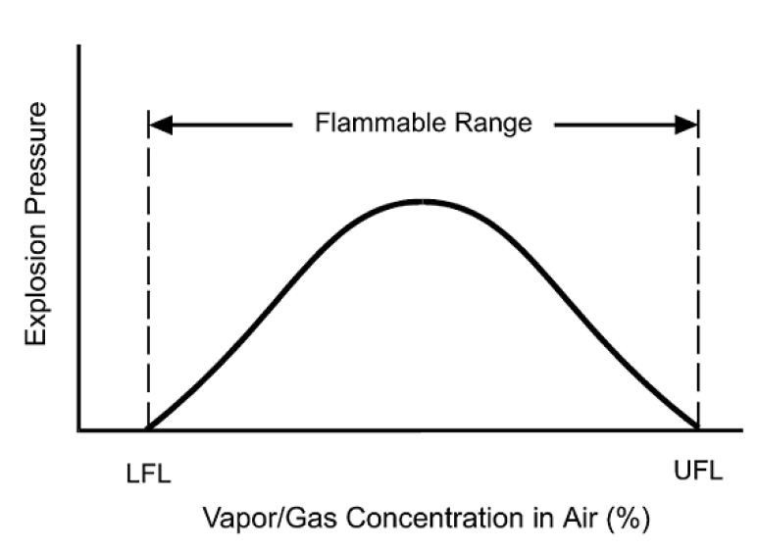

The LFL is also known as the lower explosive limit (LEL). The UFL is also referred to as the upper explosive limit (UEL). No attempt is made to differentiate between the terms flammable and explosive as applied to the lower and upper limits of flammability.

An explosion hazard exists in a building, room, or piece of equipment when all of the following elements exist:
- Fuel
- Oxidizer
- Confinement
- Ignition Source
- Fuel Dispersion

Potential Building/Room Explosion
The potential for a building/room explosion hazard exists when any of the following are true:
- A flammable or combustible liquid is handled/processed/used at or above its atmospheric boiling point and has a flash point at or below 425F (218C).
- Process uses flammable or combustible liquids with a boiling point at or below 100F (38C).
- A piece of equipment with a defined equipment explosion hazard occupies more than 10% of the building/room’s volume and is not protected in accordance with building code.

Potential Equipment Explosion
The potential for equipment explosion hazard exists when any of the following are true:
- A flammable or combustible liquid is handled/processed/used at or above its flash point and there is a vapor space within the equipment.
- A flammable or combustible liquid exists as a mist within the equipment due to a mechanical process (e.g. spraying, mixing).

STORAGE & HANDLING/PROCESSES

Areas where flammable liquids are stored, handled, dispensed (process) or mixed shall be designed in accordance with NFPA 30, Table 7.3.3 titled Electrical Area Classifications. The extent of the classified area is allowed to be reduced, or eliminated, where sufficient technical justification is provided through the Operational Readiness Review process and reviews by appropriate laboratory safety subcommittees.

Other general considerations should be given, such as sources of ignition, e.g., static electricity, friction heat, or sparks from mechanical equipment, reference NFPA 30 and FM Data Sheet 7-32.

Storage and Handling

Safety Containers
Drums, portable tanks, and intermediate bulk containers shall comply with NFPA 30.

Containment, Drainage, and Spill Control
Storage areas shall be designed and operated to prevent the discharge of liquids to waterways, sewers, etc. Containment system shall be in accordance with other applicable FESHM chapters.

Processes

Pumping and Piping
Where flammable liquids are being utilized in a process where pumps and / or piping is used, shall be designed in accordance with the applicable codes and standards. In addition, the process design shall be reviewed by the appropriate laboratory safety subcommittee(s).

Emergency Shutoff
It is recommended that such processes be provided with an emergency shutoff valve or electronic button to ensure prompt shutdown of all liquid flow in the event of a fire, spill, leak, or explosion.

REFERENCES

- 29 CFR 1910.106, (OSHA) Flammable Liquids
- American National Standards Institute (ANSI) Z400.1/Z129.1, Hazardous Workplace Chemicals – Hazard Evaluation and Safety Data Sheet and Precautionary Labeling Preparation
- United Nations – Globally Harmonized System (UN-GHS)
- United States – Department of Transportation (DOT)
- International Fire Code (IFC) Chapter 50 and 57, 2018 Edition
- National Fire Protection Association
  - NFPA 1, Fire Code, Chapter 66, 2018 Edition
  - NFPA 30, Flammable and Combustible Liquids Code, 2018 Edition
  - NFPA 704, Standard System for the Identification of the Hazards of Materials for Emergency Response, 2017 Edition
- Factory Mutual Insurance, Property Loss Prevention Data Sheet 7-32, 2018 Edition
- Principles of Fire Protection Chemistry and Physics, 3rd Edition, 1998
- Fermilab Environmental, Safety, & Health (ES&H) Manual:
  - Chapter 2060, Work Planning and Controls
  - Chapter 5031.1, Piping Systems
  - Chapter 6010, Fire Protection Program
  - Chapter 9100, Electrical Safety Program

TECHNICAL APPENDICES

The below table is derived from NFPA 30, 2018, Appendix A.4.3.

Agency | Agency Classification | F | C | NFPA 30 Definition | NFPA 30 Classification | NFPA Flash Point  F C
ANSI*  Z129.1 | Flammable | <141 | <60.5 | Flammable Combustible | Class I  Class II  Class IIIA | <100  ≥100 to <140  ≥140 to <200 | <60.5  ≥37.8 to <60  ≥60 to <93
 | Combustible | ≥141 to <200 | ≥60.5 to <93 | Combustible | Class IIIA | ≥140 to <200 | ≥60 to <93
DOT | Flammable | <141 | <60.5 | Flammable Combustible | Class I  Class II  Class IIIA | <100  ≥100 to <140  ≥140 to <200 | <37.8  ≥37.8 to <60  ≥60 to <93
 | Combustible | ≥141 to <200 | ≥60.5 to <93 | Combustible | Class IIIA | ≥140 to <200 | ≥60 to <93
DOT  HM-181 Domestic Exemption | Flammable | <100 | <37.8 | Flammable | Class I | <100 | <37.8
 | Combustible | ≥100 to <200 | ≥37.8 to <93 | Combustible | Class II  Class IIIA | ≥100 to <140  ≥140 to <200 | ≥37.8 to <60  ≥60 to <93
UN | Flammable | <141 | <60.5 | Flammable Combustible | Class I  Class II  Class IIIA | <100  ≥100 to <140  ≥140 to <200 | <37.8  ≥37.8 to <60  ≥60 to <93
 | Combustible | ≥141 to <200 | ≥60.5 to <93 | Combustible | Class IIIA | ≥140 to <200 | ≥60 to <93
29 CFR 1910.106  OSHA** | Flammable | <100 |  | Flammable | Class I | <100 | <37.8
 | Combustible | ≥100 |  | Combustible | Class II  Class IIIA  Class IIIB** | ≥100 to <140  ≥140 to <200  ≥200 | ≥37.8 to <60  ≥60 to <93  ≥93
*ANSI Considers Class IA Liquid extremely flammable
**2012, OSHA adopted UN-GHS and renamed to categories – See 29 CFR 1910.106 for Class IIIB exemptions

Table below provides a summary of Global Harmonized System and NFPA 30 Classification

Criteria | UN GHS Category | NFPA 30 Classification
Flash Point <73F (23C) and initial boiling point ≤95F (35C) | Flammable 1 | Class IA
Flash Point <73F (23C) and initial boiling point ˃95F (35C) | Flammable 2 | Class IB
Flash Point ≥73F (23C) to ≤140F (60.5C) | Flammable 3 | Class IC to Class II
Flash Point ˃140F (60.5C) to ≤199.4F (93C) | Flammable 4 | Class IIIA
Flash point above >200F (93C) | Not Addressed | Class IIIB

Diagram of NFPA 30 and comparison of OSHA’s UN- categories

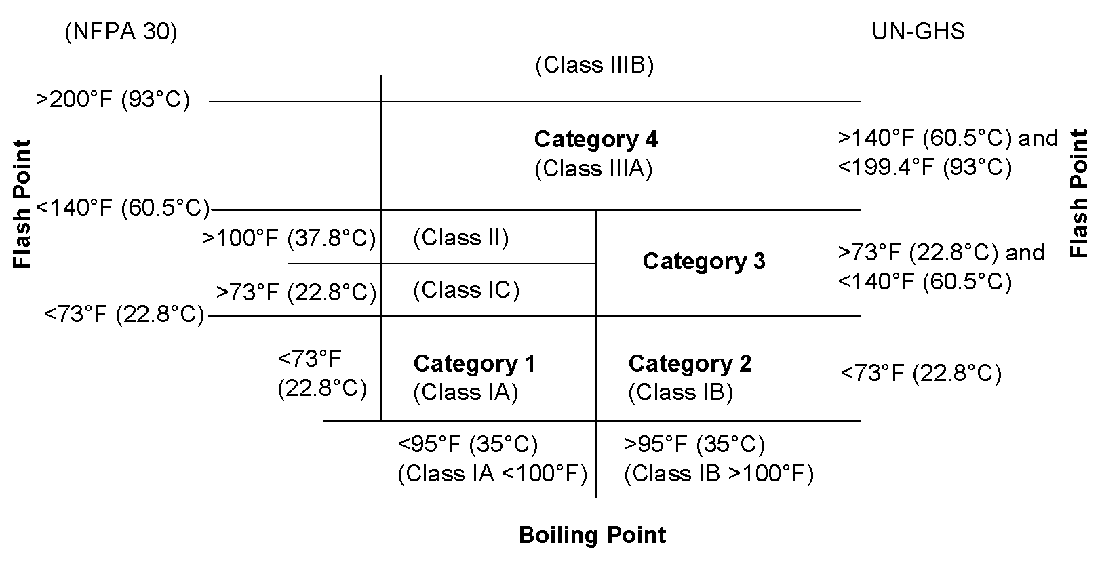

Note: Category and Flammable are interchangeable.

NFPA FIRE DIAMONDS & GHS SYMBOLS SAFETY DATA SHEETS (SDS)

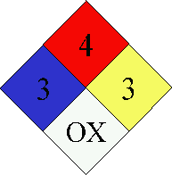
The NFPA (National Fire Protection Association) 704 or NFPA Diamond is the standard for the identification of hazardous materials and emergency response. These signs can be found on reagent bottles, gas tanks, vehicles that transport chemicals, and doors to rooms containing certain chemicals. Their main purpose is to quickly indicate to first responders the dangers presented by the substances present. However, the fire diamond is useful for anyone, especially a student, who is handling chemicals.
Flammability
Health
Reactivity

Special Notices

This diamond shaped sign is divided into 4 sections: health (blue, left), flammability (red, top), reactivity (yellow, right), and specific warnings (white, bottom). For the first three categories, the severity of the danger is indicated by a scale of 0 (minimal hazard) to 4 (extreme hazard).
 | Reactivity | Conditions
4 | explosion | normal pressure & temperature
3 | explosion | strong initiating source
2 | chemical  change | elevated pressure &  temperature
1 | unstable | elevated temperature
0 | stable

Flammability  Materials with |  |  |  |  | Reactivity  Material Behavior:
 |  | Flashpoint | Boiling Point
 | 4 | < 23C (73F) | > 38C (100F)
 | 3 | < 23C  > 23C | > 38C  < 38C
 | 2 | 38 to 93C
 | 1 | > 93C (200F)
 | 0 | Material normally doesn’t burn
Health  Materials with an oral LD50 |  |  |  |  | Special  W Water Reactive  OX Oxidizer  COR Corrosive  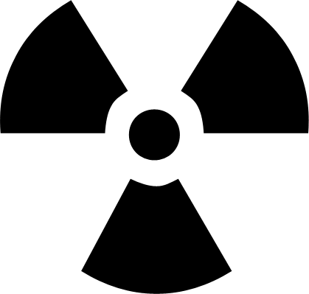 Radioactive
 | 4 | < 5 mg / kg
 | 3 | 5 – 50 mg / kg
 | 2 | 50 – 500 mg / kg
 | 1 | 500 – 2000 mg / kg
 | 0 | > 2000 mg / kg

Definitions of terms used in the table above:
Flash point: the lowest temperature at which a substance will vaporize and catch fire.
LD50 (median lethal dose): the amount of a substance needed to kill 50% of the population. Oxidizer (oxidizing agent): a chemical that will take electrons away from another chemical (thereby oxidizing that other chemical). Examples: KMnO₄, H₂O₂, NaOCl (bleach), K₂Cr₂O₇. Corrosive (caustic): a chemical that will damage or destroy another substance. Examples: strong acids (HCl, H₂SO₄) & bases (NaOH), strong oxidizers (concentrated H₂O₂).

The Global Harmonized System (GHS) was created by the United Nations in the 1990s. The goal was to create a set of symbols that would be universally understood. Nine pictograms are used to depict the classes of hazards associated with chemicals.
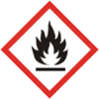  Flammables, Self-Reactive, & Pyrophoric | 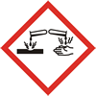  Skin, Eye, & Metal Corrosives | 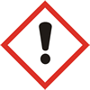  Irritants & Sensitizers
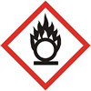  Oxidizers | 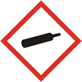  Gases under Pressure | 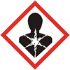  Carcinogen, Mutagen, Teratogen
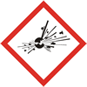  Explosives & Peroxides | 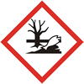  Environmental Effects | 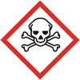  Acute Toxicity  / Fatal

The best information source for the NFPA values (numerical values, the colored diamond is not displayed) and the GHS symbols is a chemical’s Safety Data Sheet (SDS). An SDS provides more detailed information on a chemical’s reactivity - containing guidelines for the chemical’s handling, storage, and disposal. Furthermore, the health effects of and the emergency procedures for exposure to a chemical are an integral part of an SDS. Always look up the SDSs for the chemicals you will use in lab. Note: Only neutral compounds have SDS, ions do not. To start, look up chemicals you are familiar with - like table salt (NaCl), sucrose (C₁₂H₂₂O₁₁), ethanol (C₂H₅O, drinking alcohol), and sodium cyanide (NaCN). This activity will help give you the perspective needed when evaluating an SDS.

The two links below provide online access to these documents:

UC Irvine’s Environmental Health & Safety SDS website: http://www.ehs.uci.edu/msds.html
(If off-campus, go through the Library’s website and use the “Connect from off-campus” link.)

Chemical Manufacturer with User-Friendly website:
Sigma-Aldrich: http://www.sigmaaldrich.com/united-states.html
(Type chemical name into the search field in the upper right corner. When the chemical comes up, click on MSDS on the right side just before the price.)

Other websites:

NFPA: National Fire Protection Association website:
http://www.nfpa.org

Quick card here: https://www.nfpa.org/Assets/files/AboutTheCodes/704/NFPA704_HC2012_QCard.pdf

FAQ here (number 11 specifically): https://www.nfpa.org/Assets/files/AboutTheCodes/704/704_FAQs.pdf

GHS 1st Edition (2003) website:
http://www.unece.org/trans/danger/publi/ghs/ghs_rev00/00files_e.html

