FESHM 4170: HAZARD CONTROL VENTILATION

Revision History

Author | Description of Change | Revision Date
Jonathan Staffa | - Updated current labels to 5.1-Labeling | January 2022
Jonathan Staffa | - Added Reference Section  - Added Technical Appendix | September 2016
Jonathan Staffa | - Added FESHM Chapter formatting template and more complete guidance on Chapter content | August 2015

TABLE OF CONTENTS

1.0 INTRODUCTION 3
2.0 RESPONSIBILITIES 3
3.0 PROCEDURES 3
4.0 REFERENCES 4
5.0 Technical Appendix 4
5.1 Labeling 6
5.2 System Specific Requirements 7

INTRODUCTION

Hazard control ventilation is used to limit personnel exposures to atmospheric contamination, oxygen deficiency and extremes of temperature. Both local exhaust and dilution ventilation are employed to control air contaminants. With the former, contamination is contained and/or collected at the source of generation, thus preventing the contaminant from mixing within the room. Typical local exhaust systems used at Fermilab include abrasive blast cabinets, lab hoods, and welding duct exhausts. In dilution ventilation, fresh air is introduced into the work area at a rate sufficient to dilute contamination to acceptable levels. This chapter describes procedures to assure that local exhaust systems under FRA leased spaces control the atmospheric contaminants for which they are intended.

RESPONSIBILITIES

The ES&H Section’s Industrial Hygiene Group shall conduct annual surveys of the use and performance of hazard control ventilation. Reports of inadequacies and recommendations for improvement shall be sent to appropriate management personnel, the "owner" of the ventilation system and the Division Safety Officer (DSO).

Those supervising areas containing hazard control ventilation shall, when available, post the ventilation manufacturer's operating instructions on or near the unit. For Laboratory-designed/built units, or where manufacturer's instructions cannot be obtained, a standard operating procedure written by the user shall be posted in a similar place. Special effort must be made to put the operating instructions in an area that is visible and where they will not be destroyed, obstructed or painted over.

PROCEDURES

1. Local exhaust ventilation shall adequately control the hazard for which it is being used. Control shall be deemed acceptable only if one or both of the following conditions are met:

a. The air flow performance of the system meets the requirements set forth in the technical appendix to this policy (preferred).

b. The level of atmospheric contamination is known to fall within DOE prescribed limits 10 Code of Federal Regulations Part 851 “Worker Safety and Health Program.

2. Ventilation systems meeting only condition (b) shall only be used for operations for which it has been demonstrated that personnel are not exposed to air contaminants in excess of prescribed levels. Each operation shall be assessed to assure compliance. In addition, such systems shall be posted with the following label found in section 5.1 of the technical appendix (marked and attached by the ES&H Section). The names of acceptable operations shall be written on the blank lines.

REFERENCES

ACGIH® “Industrial Ventilation: A Manual of Recommended Practice for Design,” 29th Edition, 2016.

Technical Appendix

Air contamination is often controlled with ventilation. Both local exhaust and dilution ventilation are used.

With local exhaust, air is collected in a hood which is situated near or around the source of contamination. The velocity of air at the source is sufficient to capture the contaminant before it mixes with the room air. From there the contaminant is transported through ductwork to the outside of the building. Some local exhaust, such as fume extractors may contain filtering systems that actually collect airborne contaminants (dust and fume).

CAUTION: Do not mix combustible materials, such as, buffing lint, paper, wood, dust aluminum and magnesium, with dust generated from grinding ferrous metals due to the potential fire hazard caused by sparks in the dust collecting systems. This would apply to items such as fume extractors, toxic material vacuuming system, etc.

Special labels that state "Caution: Not for use with Aluminum/Magnesium Dust or Fume" and "Caution: For use with Aluminum/Magnesium Dust or Fume Only" are available through the ES&H Section.

In dilution ventilation, fresh air is introduced into work areas at a rate sufficient to dilute contamination to acceptable levels. The quantity of dilution ventilation is often expressed as air changes per unit time. The Lab minimum for continuously occupied areas is one air change per hour; most offices on site have six volume changes per hour.

Local exhaust is usually preferable to dilution ventilation since the contamination is completely controlled and flow rates are relatively less. Unfortunately, local exhaust systems are more expensive, more complex, require more maintenance, and must generally be moved if the operation moves.

In power-ventilated buildings air enters via air inlets; may mix with room air; is collected into an exhaust hood (local exhaust); then passes through exhaust ductwork, an exhaust fan, and an exhaust stack.

Air inlets should be located near the roof and far from sources of contamination. Make-up air should be power-supplied rather than dependent on infiltration. This allows the subsequent exhaust flow to be maintained at specified values and permits proper direction and tempering. For typical applications, the make-up rate should be slightly greater than the exhaust rate to minimize infiltration and drafts. For highly toxic contaminants, it is desirable to have a make­ up rate which is slightly less than the exhaust rate to limit exfiltration of contaminants to the environment. Within the workroom, air should generally flow from cleaner to dirtier areas. It should be introduced in the "living zone," about 8-10 ft. from the floor.

Exhaust hoods should be designed to enclose the source of contamination as much as possible. If the air contaminant leaves the point of operation with an initial velocity, the exhaust system should take advantage of this motion. If the source cannot be closed, the hood and the source should be brought as close together as possible.

Exhaust ductwork should be kept as short, smooth, and straight as possible. Larger duct diameters are preferred and any necessary changes in diameter or direction occur gradually. These measures will minimize the power needed to drive the exhaust fan.

Exhaust fans should be situated outside of the building. This will cause the entire system within the building to be at negative pressure. Therefore, if there are any leaks, they will be into the system. The fans should be properly specified by flow and pressure requirements.

Exhaust stacks should be kept as far as possible from air inlets. They should not have a rain cap. Rain caps significantly add to the pressure against which the fan must work and they cause contaminants to be dispersed horizontally rather than vertically. Alternative stack designs are available which allow vertical contaminant dispersion, rain diversion, and low pressure gains. The stack height should be 30-100% of the building height to prevent trapping of the contaminants within the air currents surrounding the building.

5.1 Labeling
The following stickers shall be applied to local exhaust ventilation based on system specific characteristics.
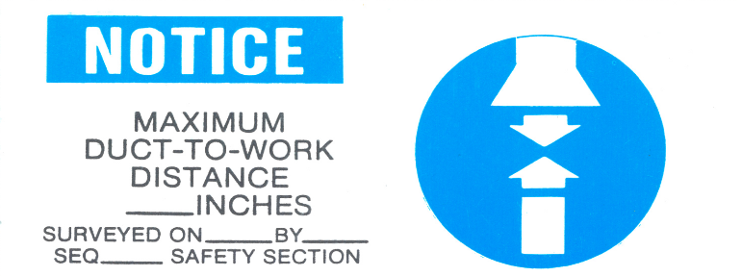
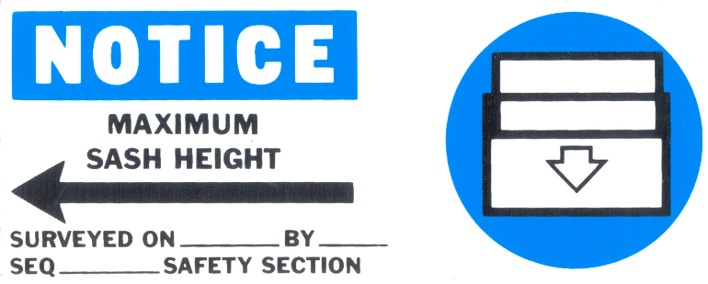
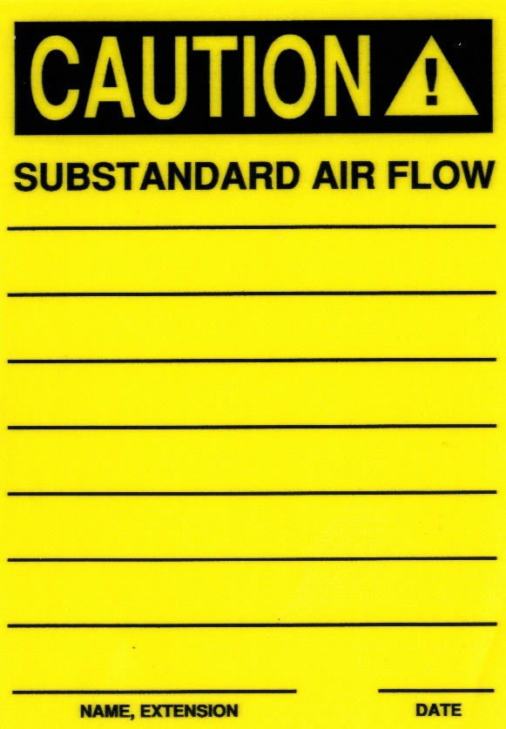
Applied to lab hoods
Applied to moveable hoods
Applied after survey
Temporarily applied to systems due to substandard flow rates

5.2 System Specific Requirements

ABRASIVE BLAST BOOTH

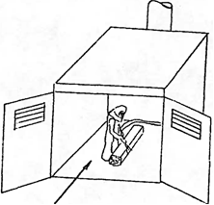

In abrasive blasting, surfaces are cleaned by impacting small abrasive particles via a stream of high pressure air. An abrasive blast booth is an enclosure occupied by an operator who directs the blast at the surface being cleaned. The primary hazard is dust which contains abrasive as well as material from the surface being cleaned. Sand should not be used as an abrasive since breathing even modest concentrations of crystalline silica dust can cause a serious lung disease (silicosis). Serious dust hazards can also result from blasting highly toxic materials such as lead, beryllium, or radioactive substances. The purpose of ventilation in abrasive blasting is to provide adequate visibility during blasting ·and rapid removal of dust after blasting, as well as to control dust exposure outside the blasting enclosure.

Flow Requirements

Minimum average flow across work = 80 cfm/ft²
Minimum velocity at inlets = 250 fpm

ABRASIVE BLAST CABINET

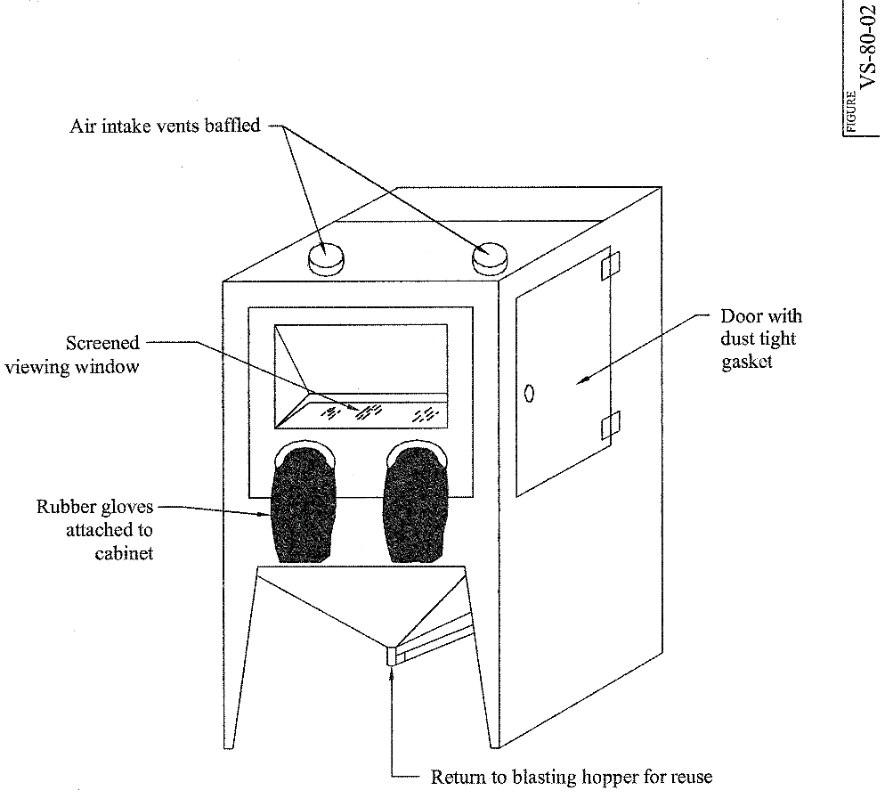

An abrasive blast cabinet is an enclosure in which the blast is directed by an operator located outside of the cabinet. Air contamination is controlled primarily by enclosure although more abrasive blast cabinets have powered exhaust systems. See also "Abrasive Blast Booth" above.

Flow Requirements

Minimum static pressure during blasting = 0.043" H₂O
(This static pressure ensures a minimum inward leakage of 500 fpm)

DOWNDRAFT TABLE

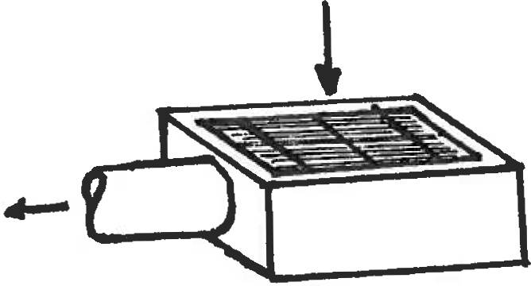

A downdraft table is used to control air contaminants generated in welding and cutting operations.

Flow Requirements

Minimum average velocity at the work piece= 100 fpm

PAINT BOOTH

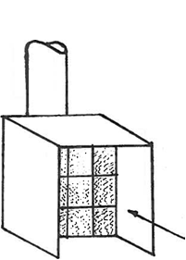

A paint booth is a power-ventilated, usually box-shaped enclosure which is open on one side. It is used to control atmospheric contaminants generated in spray coating operations. Spraying should be confined to the inside of the booth.

Flow Requirements

Minimum average velocity in plane of opening = 125 fpm for face area greater than 4 ft²
Minimum velocity in plane of opening = 100 fpm for face area less than or equal to 4 ft²

LAB HOOD

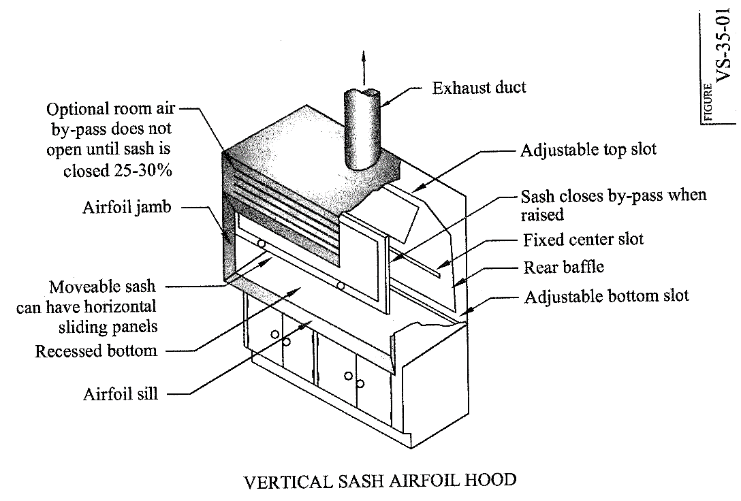

Laboratory hoods are power-ventilated enclosures with transparent sliding doors. They are typically employed in laboratory environments in which atmospheric hazards are variable and generally unquantified.

During use, the door sash height should be adjusted no higher than that indicated by the sticker attached by the ES&H Section during a survey (refer to page 7).This is the maximum height for which the air flow will be adequate.

Flow Requirements

Minimum average velocity in plane of sash = 80-100 fpm

SLOT EXHAUST

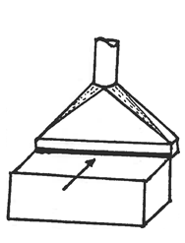

Slot exhaust systems are used to control vapors or gases from extended sources of contamination such as long tanks or tables. They are typically used for dip tanks, degreasing, or soldering operations. Air enters the system via a horizontal slot(s) situated along one, or both, long edges of the source. The performance of slot exhaust systems is maximized by minimizing the slot-to-work distance and enclosing the system as much as possible.

Flow Requirements*

Minimum flow = 50-100 cfm/ft² of work surface
Minimum velocity at work = 50-100 fpm
Maximum slot-to-work distance = 2 ft.

The lower end of the range applies to low toxicity contaminants with a low generation rate. The upper end of the range applies to higher toxicity contaminants with a higher generation rate.

*For Fumes and Fine Dusts

Q=350 cfm/ft. of hood width
Maximum slot-to-work distance = 2 ft.

WELDING DUCT EXHAUST

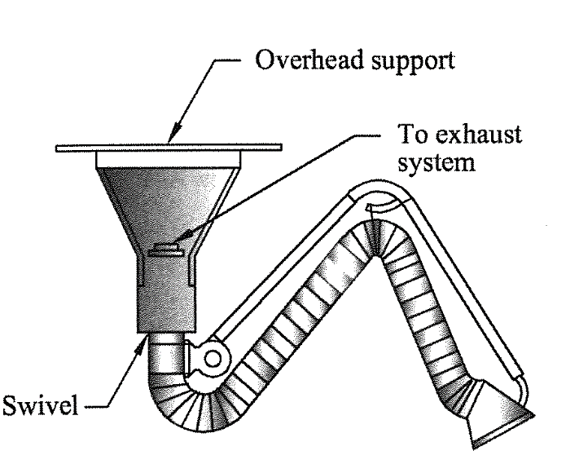

Welding duct exhaust systems are power­ ventilated ducts, the ends of which are brought close to welding operations to control air contaminants. It is desirable to get the end of the duct as close to the operation as possible but not interfere with the inert gas. The maximum effective distance is specified on a sticker (attached by the ES&H Section during survey, example shown on page 7). This sticker is the same as the one used for power tool exhaust. Typical flow rates through welding duct exhaust systems are 300-1000 cfm.

Flow Requirements

Minimum velocity at work = 100 fpm

VEHICLE EXHAUST

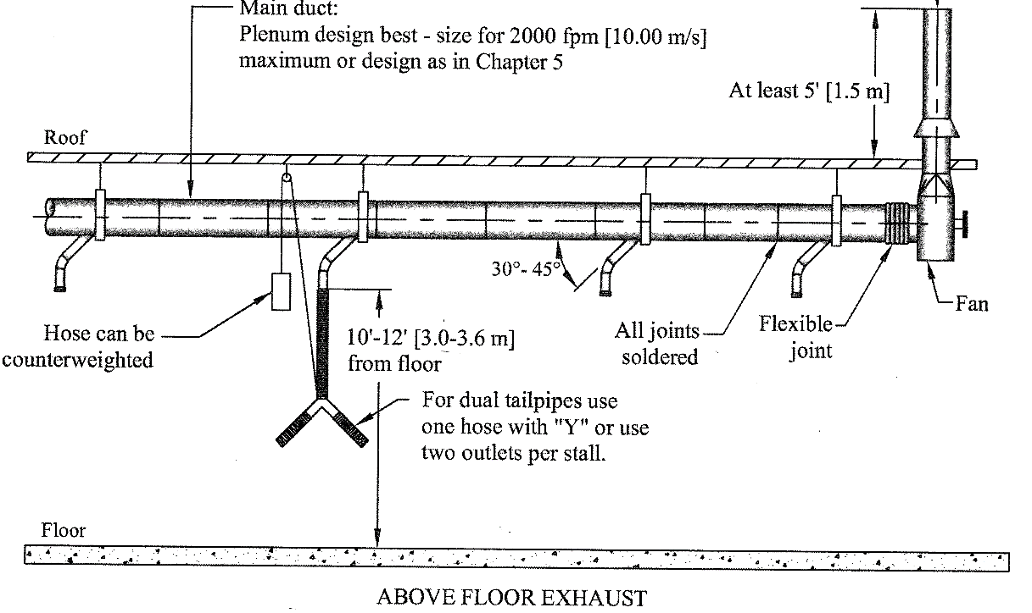

Vehicle exhaust systems are used to control air contaminants from vehicle engines.

Flow Requirements

Minimum flow per vehicle =400 cfm

