FESHM 5031.1: PIPING SYSTEMS

**Revision History**

|  |  |  |
| --- | --- | --- |
| **Author** | **Description of Change** | **Revision Date** |
| Michael White | Clarified rules for performing proof tests in Section 5.5(e) for cases where Charpy impact testing exemptions are applied | August 2019 |
| Michael Geynisman, Michael White | Added requirements for purchased unlisted components and piping systems – Section 5. | September 2018 |
| Michael White | * Removed requirement for less than 20% of combined stress in order to qualify as low stress piping. Replaced with a rule for less than 20% of basic allowable stress * Clarified rules for leak testing low stress piping in Section 6.0. Minimum leak test pressure set at 80% of relief device set pressure. Clarified that all requirements of FESHM 5034, including workflow processes, are to be applied to the leak test. Added requirement for required leak test sensitivity to be evaluated in engineering note. References to “pressure test” were replaced by “leak test” to maintain consistency with ASME B31.3 terminology | October 2017 |
| Michael Geynisman | * Added “international” to the list of appropriate governing codes. * Updated Section 5, para.2 to distinguish between requirements for the piping systems per B31 codes and EN13480 standard. * Updated Table 1 to indicate EN13480 as an applicable standard. * Updated Section 6 to include requirements for proof testing. * Updated Section 7 to distinguish between requirements for the Engineering Note for the piping systems per B31 codes and EN13480 standard. * Added Technical Appendix 2 - EN13480-5 Table 9.4-1 | August 2016 |
| Michael White | * Added low stress piping category | March 2016 |
| Terry Tope | * Clarified 150,000 ft-lb threshold for piping engineering note generation. * Added an exclusion for piping attached to a single gas bottle. * Added guidance with respect to independent review. * Added WPS and inspection guidance in 7.0 items 6 and 7. * In-process examination form added as a technical appendix. | June 2015 |
| Terry Tope | Updated Teamcenter posting procedure. | April 2015 |
| Terry Tope | Required posting of engineering note to Teamcenter. Explicitly noted that amendments require Division/Section/Center approval. Provided additional guidance with respect to used piping systems. | October 2014 |
| Thomas Page | Revised wording in Section 5.0, Item 8 to clarify the review of Amendments. Added wording in Section 7.0, Items 7, 8 and 9. | September 2012 |
| Thomas Page | Applied new FESHM template. Revised wording in Section 7, Item 2. Added Non-flammable Scintillator to Table 1. | July 2012 |

**TABLE OF CONTENTS**

1.0 INTRODUCTION AND SCOPE 3

2.0 DEFINITIONS 3

3.0 RESPONSIBILITIES 4

4.0 PROGRAM DESCRIPTION 4

4.1 Policy 4

4.2 Documentation 4

4.3 Review of piping systems 6

4.4 Modifications to a compliant piping system 6

4.5 Director's Exception 6

5.0 PROCEDURES - DESIGN, FABRICATION, INSPECTION AND TEST 6

5.1 Purchased Piping Systems & Components 6

5.2 In-House Built Piping Systems 7

5.3 Existing Piping Systems In Service 7

5.4 4. Reclaimed Piping Systems 7

5.5 Leak Test 7

5.6 Component Identification 9

5.7 Table 1: Applicable code guidance for common systems at Fermilab. 10

6.0 ENGINEERING NOTE 11

7.0 PIPING SYSTEM ENGINEERING NOTE FORM 13

8.0 TECHNICAL APPENDICES 14

# INTRODUCTION AND SCOPE

This chapter defines procedures for designing, fabricating and testing piping systems. This chapter applies to all piping systems fabricated and/or operated at Fermilab or in any leased spaces with the exception of piping falling under the scope of FESHM 5035: Mechanical Refrigeration Systems.

# DEFINITIONS

Construction: all-inclusive term comprising materials, design, fabrication, examination, inspection, testing, certification, and pressure relief

Engineering Note: A written analysis demonstrating that a given piping system satisfies the requirements of this chapter.

Qualified Person: A qualified person is a person who, by possession of a recognized degree or certificate of professional standing, or who, by extensive knowledge, training and experience, has successfully demonstrated the ability to solve or resolve problems relating to the subject matter and work.

Radioactive Water (RAW) System: Water systems containing radioactive water as defined in FRCM (Fermilab Radiological Control Manual) Article 346, *Control of Radioactivated Cooling Water.*

Appropriate Governing Code: An international, national, state or local piping code or standard that specifies design, fabrication, and operation requirements and practices that must be followed for piping systems within their respective scopes (see Table 1 for guidance).

Exceptional Piping System: A piping system which cannot meet the requirements of this chapter and therefore requires a Director’s exception.

Listed: A definition that for the purposes of the ASME B31.3 Code, describes a material or component that conforms to a specification in Appendix A, Appendix B, or Appendix K or to a standard in Table 326.1, A326.1, or K326.1. For the purposes of the EN13480 Code, listed components are those which conform to one of the harmonized EN standards listed in the harmonized standards database of European Pressure Equipment Directive 2014/68/EU. All materials or components which are not “listed” are categorized as “unlisted”.

Low Stress Piping: A piping system in normal fluid service which adheres to the following criteria:

* The design gage pressure is less than 150 psig (1.035 MPa)
* The calculated stress due to pressure per American Society of Mechanical Engineers (ASME) B31.3 paragraph 304 is less than 20% of the basic allowable stress listed in ASME B31.3 Table A-1
* All fittings are pressurized to less than 20% of their rated pressure
* The maximum design temperature is less than 366 °F (186 °C)
* All materials are ASME code listed for the range of design temperatures
* The fluid handled is nonflammable, nontoxic, and, except for effects of temperature, not damaging to human tissue

# RESPONSIBILITIES

The Division/Section Head or Project Manager (D/S/P) who controls the area of operation of the piping system is responsible for carrying out the requirements of this chapter. The D/S/P or designee shall arrange for the review of required Engineering Notes by a qualified person and shall certify piping systems compliance with this chapter by signing the Engineering Notes. The Engineering Notes shall be placed into Teamcenter.

The Environment, Safety, Health, and Quality (ESH&Q) Section shall audit the Divisions/Sections/Projects on their compliance to this chapter.

The Mechanical Safety Subcommittee (MSS) shall serve the D/S/P’s and ESH&Q Section in a consulting capacity on all piping system matters. This includes providing recommendations regarding the applicability of a standard to a given piping system. The Mechanical Safety Subcommittee may propose appropriate modifications to this chapter as necessary. Changes in policy and responsibility shall be recommended by the Fermilab Environmental, Health, and Safety Committee (FESHcom) after consulting with the D/S/P.

# PROGRAM DESCRIPTION

## Policy

All piping systems built and/or operated at Fermilab shall be in accordance with this chapter and the appropriate governing code. See Table 1 for guidance in the selection of the appropriate governing code for common piping systems operated at Fermilab. Note that the recommendations given in Table 1 are general. Evaluation of each specific piping system (operating parameters, fluid type, environment, etc.) is necessary to determine the appropriate governing code and category.

1. When an appropriate governing code cannot be identified for a particular piping system or a when a piping system falls outside the scope of the appropriate governing code, accepted engineering practice (commensurate with the piping system parameters and risk factors) shall be employed. The piping system in question is still subject to the remaining requirements of this chapter.
2. Where multiple codes apply, accepted engineering judgment shall determine the most appropriate code considering the hazards and risks of the individual piping system. At a minimum, ASME B31 Pressure Piping code series will govern for those piping systems within their respective scopes.

## Documentation

An Engineering Note shall be prepared by a qualified person for all piping systems identified below (5.2.a), whether purchased or in-house built. The format of the Engineering Note is shown section 7.0. Its purpose is to allow a reviewer to check the design and installation and to inform a future user of the piping system’s parameters.

For the piping systems built per B31 governing codes listed in Table 1, the Engineering Note shall include design calculations and manufacturer's compliance to the appropriate governing code. All code-required documentation shall be appended to the document including welding/brazing qualification records and inspection/examination records.

For the piping systems built per EN 13480 standard, the manufacturer's final documentation package required per EN13480-5, Table 9.4-1, including all required items marked “x” or xa”, is mandatory for design verification. If CE mark must not be affixed (for SEP category) or CE mark does not bear identification by the appropriate EU/PED notified body (category I), the reviewer shall apply additional scrutiny as typically applied for the B31 series piping.

All Engineering Notes shall include calculations verifying that the piping system is protected from being operated outside the range of design pressure and temperature.

The document shall also include precautions, diagrams, documents and operation procedures necessary for the safe use of the piping system.

a. An Engineering Note must be prepared, reviewed, and approved when:

1. The piping system contains over 150,000-foot pounds (ft-lbs) of stored energy or the operating pressure is above 150 pounds per square inch (psi) for gas, or 500 psi for liquid, or the design operating temperature is above 366º F. The stored energy calculation should include all pressurized volumes connected to the piping such as pressure vessels. Excluding those piping systems temporarily erected for pressure testing purposes. These systems are subject to the Fermilab Environment, Safety, and Health Manual (FESHM) Chapter 5034, *Pressure Testing*. Also excluding piping systems of ½ inch Nominal Pipe Size (NPS) diameter or smaller, which are erected on the downstream side of the pressure regulator connected to a single gas cylinder and adequately protected with relief(s) below 150 psi.
2. The piping system falls within the scope of ASME B31.3 Process Piping Code – Normal Fluid Service (excluding those piping systems containing only water).
3. The piping system is a hydraulic (oil) piping system (primarily hydrostatic; not used for transport of the fluid) with a design operating pressure above 10,000 psi.
4. The piping system falls within the scope of ASME B31.3 Process Piping Code – Category M.
5. The piping system has the potential for an environmental release exceeding the occurrence reporting criteria of FESHM 3010, *Significant and Reportable Occurrences*. This includes RAW cooling systems.
6. The piping system is an Exceptional Piping System.
7. The piping system is designed and manufactured per EN 13480 standard.

b. Piping systems that do not require Engineering Notes are still required to satisfy the appropriate governing code. In these cases, all code-required documentation shall be kept on file by the responsible engineer or Department Head (or their designee).

## Review of piping systems

All required Engineering Notes (see 5.2.a above) shall be reviewed by an independent, qualified reviewer, other than the person who prepared it, for concurrence to this chapter. The review of the Engineering Note shall include review of code-required installation documentation to ensure conformance of the installation to the appropriate governing code. The engineering note reviewer should not report directly to the preparer of the note nor should he or she be able to be perceived as having a conflict of interest in reviewing the note. As a general guideline, a conflict of interest could result from the reviewer having direct involvement in the project for which the note was written.

7. *Piping* *Systems with Additional FESHM Chapter Requirements*: Some piping systems must comply with more stringent safety analyses. Additional Fermilab ESH&Q chapters have been written for these specific systems. The documentation and review requirements for these systems are included in the following chapters:

a. Any flammable gas system covered and reviewed under Fermilab ESH&Q Manual Chapter 6020.3, *Storage and Use of Flammable Gases.*

b. Any cryogenic system covered and reviewed under FESHM Chapter 5032, *Cryogenic System Review*.

## Modifications to a compliant piping system

Any subsequent changes in usage or operation of a piping system (already in compliance with this chapter) shall meet the requirements of this chapter. Significant modifications impacting piping system safety, for example addition of piping components by welding or brazing, shall be pressure tested and documented in an Amendment to the original Engineering Note (for those systems requiring Engineering Notes). This Amendment shall be reviewed in the same manner as the original note and requires D/S/P approval. A new piping engineering note form shall be created for each revision.

## Director's Exception

Exception to the provisions of this chapter shall be allowed only with the approval of the Laboratory Director or his designee and documented in the Engineering Note. The need for such exceptions is to be minimized by adherence to the provisions of this chapter. Exceptions are to be identified and submitted to the Director for review as early in the design process as possible. These exceptions shall only be allowed after the Director is assured that sound engineering practice will be followed during design, fabrication and testing of the piping system. Amendments to exceptional piping engineering notes require the Director’s approval if the changes documented by the amendment are in exception to the provisions of this chapter. Amendments to exceptional piping engineering notes which document changes in compliance with this chapter requires D/S/P approval.

# PROCEDURES - DESIGN, FABRICATION, INSPECTION AND TEST

## Purchased Piping Systems & Components

All piping systems and components purchased by Fermilab or its experimenters shall be constructed in accordance with this chapter. The purchaser shall provide a summary of the listed components and their certifications to applicable construction standards in the engineering note. The purchaser is also responsible for specifying the technical requirements and collecting the associated technical documentation necessary to be able demonstrate that the construction of unlisted components conforms to the piping Code and this chapter. In some cases, the construction steps will be performed, and documentation will be generated by a combination of both the manufacturer and the purchaser. Examples of typical design and quality assurance specifications and requirements for purchased systems and components may include, but are not limited to, the following:

* Applicable piping Code and Fluid Service Category
* Required pressure-temperature ratings
* Material specifications and certifications
* Design drawings
* Design calculations
* Welder and weld procedure specifications and qualifications
* Weld inspection, examination, and testing results
* Pressure & leak testing results
* Pressure relieving requirements
* Interlock specification and validation

Upon receiving, the unlisted piping components and purchased piping systems shall be visually inspected by an Owner Inspector to verify conformance to the requirements of the purchasing technical specifications.

## In-House Built Piping Systems

All pressure piping systems built at Fermilab or experimenter's shops shall be designed and fabricated in accordance with this chapter. Welding/brazing executed at Fermilab shall be done in accordance with the appropriate governing code requirements including applicable welding qualification and inspection/examination requirements. When an appropriate governing code cannot be identified for a particular piping system or when a piping system falls outside the scope of the appropriate governing code, accepted welding/brazing fabrication procedures (commensurate with the piping system parameters and risk factors) shall be employed.

## Existing Piping Systems in Service

All such piping systems must be in accordance with this chapter. Piping systems with unknown histories shall be reviewed and documented in accordance with this chapter except that they may be retested per the *Leak Test* section of this chapter (see 5 below) in lieu of detailed welding qualification records and non-visual examination/inspection records. Acceptance of this substitution is subject to the reviewer’s discretion.

## 4. Reclaimed Piping Systems

Used piping systems shall be classified as an existing piping system and will have their previous service taken into account during the review process. Used piping systems or components that have been reclaimed, moved to a new location, or put into new service require either the creation of a new piping engineering note or an amendment to an existing piping engineering note.

## Leak Test

All piping systems shall be leak tested, either at Fermilab or at the vendor’s, site as required by the appropriate governing code. When an appropriate governing code cannot be identified for a particular piping system or when a piping system falls outside the scope of the appropriate governing code, accepted engineering practice (commensurate with the piping system parameters and risk factors) shall determine leak test requirements. Used piping systems or components that have been reclaimed, moved to a new location, or put into new service shall meet the same leak test requirements as new construction. Unmodified piping between a pressure vessel and the first flange or isolation valve need not be leak tested provided the service is unchanged.

a. The initial service test is considered the leak test for ASME B31.3 Category D piping systems. No safety officer oversight per FESHM 5034 is required for pressure testing piping systems in this category.

b. The leak test for Low Stress Piping shall be performed with room temperature fluid using a final test pressure no less than 80% of the relief device set pressure. All requirements of FESHM 5034, including the workflow defined in Section 6.0, shall apply to the leak test. At a minimum, a gross leak test shall be performed while adhering to the following procedure:

* The pressure shall be gradually increased until the pressure reaches the lesser of one half the final test pressure or 25 psig is attained, at which point a preliminary leak check of all joints and connections shall be made.
* Thereafter, the pressure shall be gradually increased in steps until the final test pressure is reached, holding the pressure at each step long enough to equalize piping strains.
* The final leak test pressure shall be maintained for at least 10 min and then all joints and connections shall be examined for leaks.

The required leak test sensitivity to ensure that the piping system can be safely operated at the full design pressure shall be assessed in the engineering note. Supplemental sensitive leak test techniques as described in ASME B31.3 345.8 may be used to achieve the leak test sensitivity required by the engineering design.

c. Internally pressurized tests as described in ASME B31 Codes for externally pressurized pipe are not required for ASME B31.3 Category D and B31.9 vacuum jackets and vacuum piping. Standard sensitive leak tests using tracer gases satisfy the leak test requirements of this chapter. No safety officer oversight per FESHM 5034 is required for these tests.

d. All other piping systems requiring leak tests shall be leak tested as described per FESHM 5034. In case of conflicts between the appropriate governing code and FESHM 5034, the more restrictive or conservative procedure will be followed.

e. If a proof test is required for a non-listed component, which does not have a documented pressure rating by the manufacturer:

i. Prior to proof testing, a basis for the pressure rating shall be determined using an appropriate governing code or analysis.

ii. The proof test shall be conducted in accordance with all requirements and guidelines of FESHM Chapter 5034. Proof tests shall be performed hydrostatically to minimize the stored energy.

iii. When a component is proof tested to establish the MAWP of duplicate or geometrically-similar components, the MAWP is established following the rules of the ASME BPVC UG-101(m), ASME B16.9, or other appropriate code. These methods account for component-to-component variations in tensile strength and fabrication.

iv. When the component being proof tested will be put into service, there are no component-to-component variations in tensile strength or fabrication to consider.

* + - 1. If the allowable stresses at the proof test temperature and at the service temperature are equal, the MAWP = proof test pressure / 4.
      2. If the allowable stresses at the proof test temperature and at the service temperature are not equal, the MAWP = (proof test pressure / 4) x (SServiceTemp / STestTemp) where SServiceTemp is the allowable stress at the service temperature and STestTemp is the allowable stress at the proof test temperature.
      3. If the service temperature is below the minimum material temperature, exemption from impact test requirements may require further de-rating (as per ASME BPVC UHA-51(g), for example) of the component. If UHA-51(g) is applied, then one of the following methods shall be used:
         1. Qualification of unlisted components for which the MAWP cannot be calculated:

MAWP = (proof test pressure / 4) x (0.35*SServiceTemp / STestTemp)

* + - * 1. Qualification of unlisted components for which the MAWP can be calculated, but fabrication and inspection requirements cannot be verified:

MAWP = (proof test pressure /4) x (SServiceTemp / STestTemp)

Calculations shall be provided demonstrating all primary membrane tensile stresses are less than 35% of the allowable stress at minimum service temperature and maximum design pressure. The Experiment Vessel MAWP shall be less than 35% of the piping component MAWPs specified by the piping component manufacturers.

All accessible welds shall be visually examined internally and externally by an Inspector qualified per ASME B31.3 340.4. Defective welds shall be repaired per ASME B31.3 341.3.3 prior to the proof test

A sensitive leak test per ASME B31.3 345.8 shall be performed before and after the proof test to demonstrate leak tightness

## Component Identification

Components on piping systems shall be labeled as required by the appropriate governing code. It is also recommended that components on all piping systems that require Engineering Notes be labeled to correspond to an up-to-date piping and instrument diagram (P&ID). Labels should be permanent, securely attached and easy to read. Each component label should list a unique component number for that system. Guidance may be obtained from American National Standards Institute (ANSI) A13.1 "Scheme for Identification of Piping Systems".

## Table 1: Applicable code guidance for common systems at Fermilab.

|  |  |  |  |  |  |  |  |  |  |  |  |  |
| --- | --- | --- | --- | --- | --- | --- | --- | --- | --- | --- | --- | --- |
| **Piping Service or Application** | **Applicable Code or National Standard** | | | | | | | | | | | |
| ASME B31.1 | ASME B31.3 Normal Fluid Service or EN13480 | ASME B31.3 Cat. D Fluid Service  or EN13480 | ASME B31.3 High Purity Fluid Service or EN13480 | ASME B31.5 | ASME B31.8 | ASME B31.9 | NFPA 13 | NFPA 24 | ASME A17.1 | ANSI Z223.1 | Illinois Plumbing Code, Title 77 Part 890 |
|
|
|
| Building Sump Pump Discharge |  |  |  |  |  |  | **X** |  |  |  |  |  |
| Non-Cryogenic System: Compressed air/inert gas (non-cryogenic) |  |  |  |  |  |  | **X** |  |  |  |  |  |
| Cryogenic System: Liquid or Gas |  | **X** | **X** |  |  |  |  |  |  |  |  |  |
| Domestic Potable Water |  |  |  |  |  |  |  |  |  |  |  | **X** |
| Elevator and Lift Hydraulic Systems |  |  |  |  |  |  |  |  |  | **X** |  |  |
| Fire Protection |  |  |  |  |  |  |  | **X** |  |  |  |  |
| Flammable Gas |  | **X** |  |  |  |  |  |  |  |  |  |  |
| Fuel Gas Piping from point of delivery to burner |  |  |  |  |  |  |  |  |  |  | **X** |  |
| Fuel Gas Transmission Piping |  |  |  |  |  | **X** |  |  |  |  |  |  |
| House Vacuum |  |  |  |  |  |  | **X** |  |  |  |  |  |
| Industrial Cooling Water external to buildings |  |  |  |  |  |  |  |  | **X** |  |  |  |
| Industrial Cooling Water internal to buildings |  |  |  |  |  |  | **X** |  |  |  |  |  |
| Inner Pipe of Vacuum Insulated Cryogenic Piping |  | **X** |  |  |  |  |  |  |  |  |  |  |
| Low Conductivity Water |  | **X** | **X** |  |  |  |  |  |  |  |  |  |
| Non-flammable Scintillator |  |  |  | **X** |  |  |  |  |  |  |  |  |
| Pond Water Cooling Systems |  |  |  |  |  |  | **X** |  |  |  |  |  |
| Radioactive Water |  | **X** |  |  |  |  |  |  |  |  |  |  |
| Refrigerant for HVAC |  |  |  |  | **X** |  |  |  |  |  |  |  |
| Refrigerant for Process Systems |  | **X** |  |  |  |  |  |  |  |  |  |  |
| Sewer Piping |  |  |  |  |  |  |  |  |  |  |  | **X** |
| Steam for Heating Applications |  |  |  |  |  |  | **X** |  |  |  |  |  |
| Steam for Power Generation | **X** |  |  |  |  |  |  |  |  |  |  |  |
| Vacuum Jacket of vacuum insulated piping |  |  | **X** |  |  |  |  |  |  |  |  |  |

# ENGINEERING NOTE

1. Engineering Note: An Engineering Note shall be prepared by the designer addressing the topics below for the piping system. Its purpose is to allow the reviewer to check the design and installation and to inform the future user / re-tester of the system parameters. The note shall be deposited in Teamcenter as noted in Chapter 5031.1 under “Special Responsibilities” using the procedure outlined below.
   1. A New Item shall be created in Teamcenter with the type chosen as Engineering Note
      1. The New Item Name shall use the Piping System prefix followed by a meaningful Name which briefly describes the contents of the note
      2. A full Description shall be entered for the New Item
   2. If applicable the Division Legacy Number shall be entered
   3. The appropriate Engineering Note category of Piping System shall be chosen
   4. The Revision Author, Revision Comments, Lab Location Code, Exceptional Status, and Division\Section shall be entered
   5. The Engineering Note and supporting files shall be added as Data Sets. All documentation required for independent review of the Engineering Note must be included.
   6. Approval
      1. The Teamcenter Workflow may be used to electronically obtain the required approvals and release the Engineering Note.
      2. Approvals may also be obtained by physical signature, scanned, and included with the Engineering Note. A Teamcenter Workflow must still be completed so that the Engineering Note is released. This workflow need not involve the required approvers in the case of physical signature.
   7. Amendments to existing Engineering Notes shall be entered as a Revision to the original Item in Teamcenter.
2. Description and Identification: Describe the system, its purpose, fluid contents, piping materials, site location, and how the design pressure and temperature were established. All documents deemed pertinent to the safety shall be listed and included.

Note: For the piping systems built per EN 13480 standard, the manufacturer's final documentation package required per EN13480-5, Table 9.4-1, including all required items marked “x” or xa”, is mandatory for design verification. If CE mark must not be affixed (for SEP category) or CE mark does not bear identification by the appropriate EU/PED notified body (category I), the reviewer shall apply additional scrutiny as typically applied for the B31 series piping.

1. Design Verification: Identify the applicable Code and provide design calculations.

Design of the purchased or modified piping system shall be verified for all external pressure and mechanical loads from all interfaces to the other piping systems, vessels, structures, or environments.

1. Pressure Containment / Relief System: If required, describe any system features which prevent design pressure from being exceeded beyond Code-specified pressure accumulation limits
2. Welding / Brazing Information: Welding / brazing executed at Fermilab shall be done in a manner according to the applicable Code. In-house procedures shall be appended to the Note for welded and brazed systems built at Fermilab. Purchased systems shall be welded according to the applicable Code. (Weld procedures for purchased piping systems need not be included in the Engineering Note but should be provided by the contractor to the Inspector if requested.)
3. Welder’s Qualification:
   1. Attach welder’s qualification records if welded / brazed in-house.
   2. Qualification of a new in-house WPS should include any examinations required by the inspection plan.
4. Inspection Plan:
   1. Attach a copy of the system’s inspection plan. This should specify how the system was inspected: radiography, in-process, etc.
   2. The inspection plan should be shared with the welders and/or brazers prior to the start of fabrication.
   3. The technical appendix contains the in-process examination form for typical stainless-steel piping butt welds performed in-house.
5. Examiner’s Report: Attach a copy of Examiner’s report. This should include the examination reports: radiography reports, in-process examination forms, etc.
6. Inspector’s Certification: Attach a copy of Inspector’s certification of this system. This applies to purchased systems and will be a report or statement on vendor’s certification that the piping system conforms to the appropriate Code.
7. Component Identification: Attach the Process and Instrumentation Diagram (P&ID) and the associated component and instrumentation list.
8. Leak Test: Attach a copy of the leak test plan, including test pressure, and results, if available, at the time of review. The test permit and test results should be appended to the approved Note as soon as they become available.

Note: Any modifications or additional fabrications made in field for the piping system (purchased or in-house built) shall be per appropriate Code and be fully described in the Engineering Note.

1. Extended Engineering Note for Exceptional Piping Systems: In addition to the items listed above, the Note shall include the following information:
   1. *Reason for Exception:* D/S/P or designee shall provide a statement showing the necessity for a Director’s exception.
   2. *Exception Protocol:* The D/S/P or designee shall provide a written record of the decisions, judgment, tests, administrative controls, and hazard analysis that were necessary to approve this type of system.
   3. *Proof Test:* Proof tests of unlisted components in the system shall be performed in accordance with ASME Boiler Pressure Vessel Code Section VIII, Division 1, UG-101 or ASME B16.9.
   4. *Fabrication:* The system designer shall provide a fabrication procedure, a list of planned and completed inspections and any other quality control procedures taken.
   5. *What-if Analysis:* The system designer shall provide a description of personnel hazards associated with system operation and the methods used for protection. The What-if Analysis shall address application, operating limits and controls, possible effects in the event of failure and inherent safeguards provided.

# PIPING SYSTEM ENGINEERING NOTE FORM

[The Piping System Engineering Note Form,](https://esh-docdb.fnal.gov:440/cgi-bin/ShowDocument?docid=1229) Form 5031.1, can be found on the ESH&Q website or the ESH&Q document management database (DocDB).

# TECHNICAL APPENDICES

1. In-process examination form



1. EN13480-5, Table 9.4-1

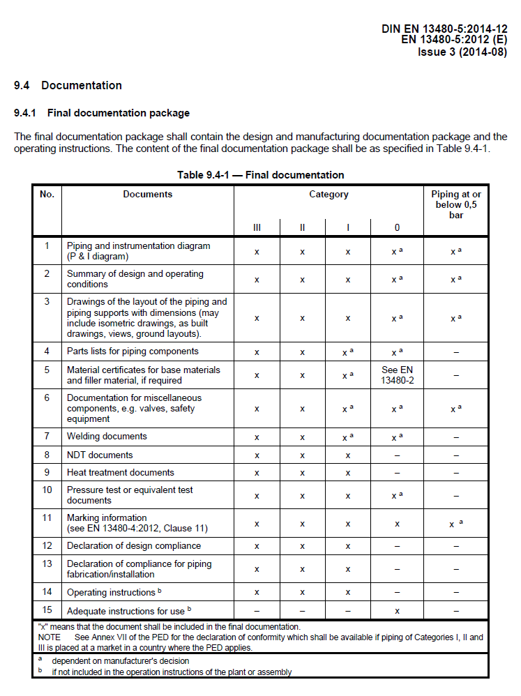

1. EN13480-7, Conformity Assessment Tables

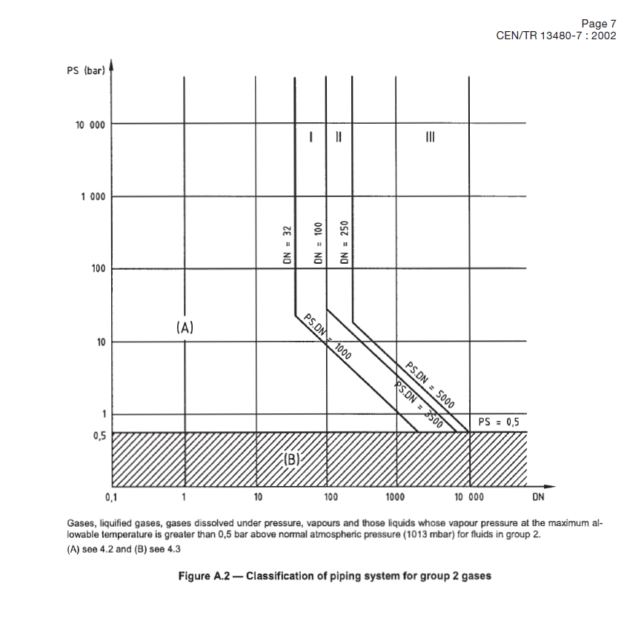

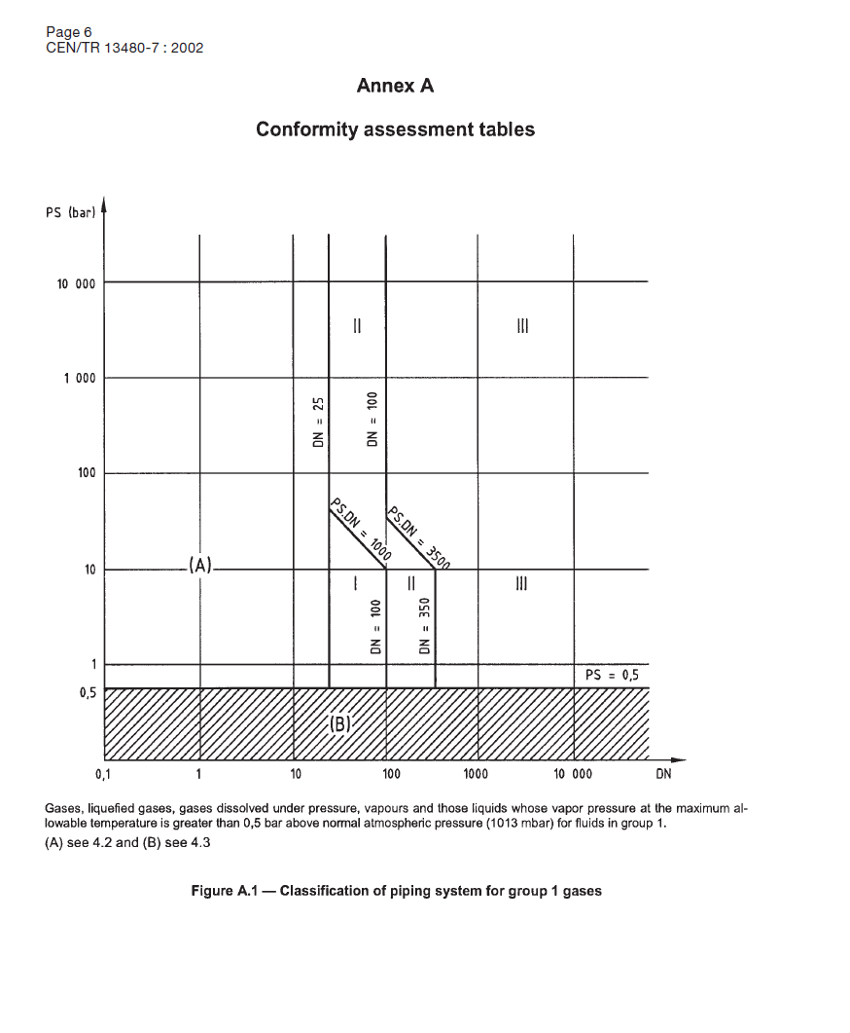

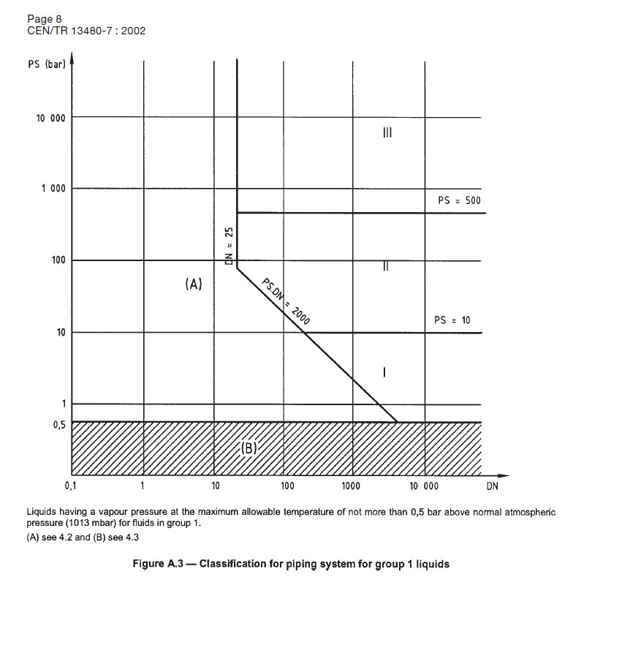

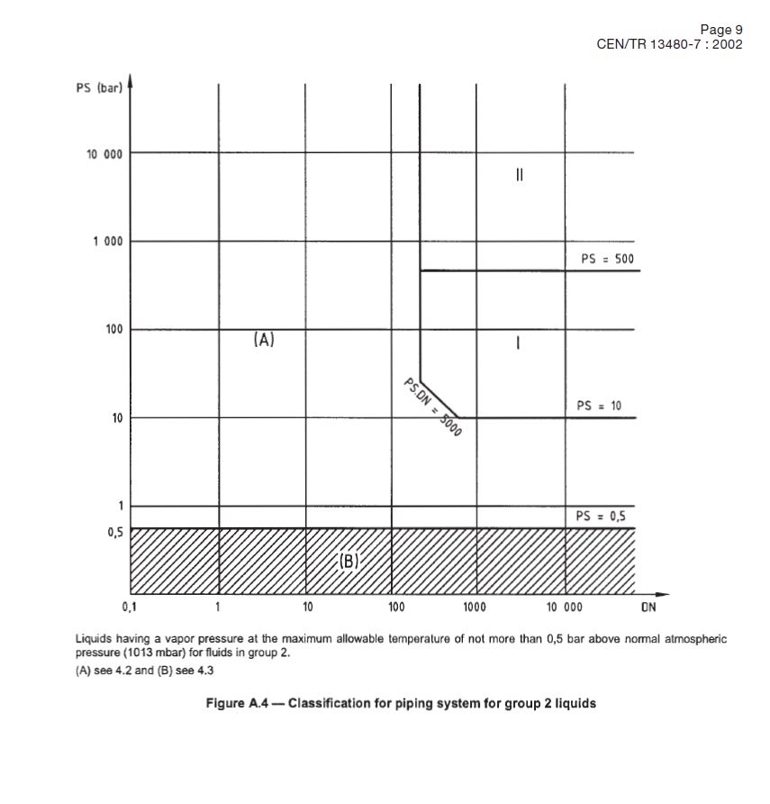

1. Typical EN13480-7, Conformity Assessment Procedures

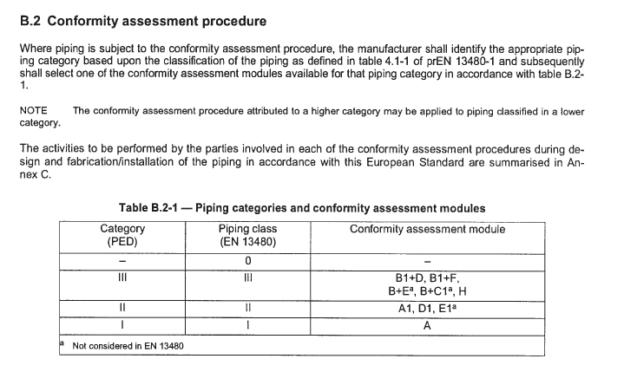

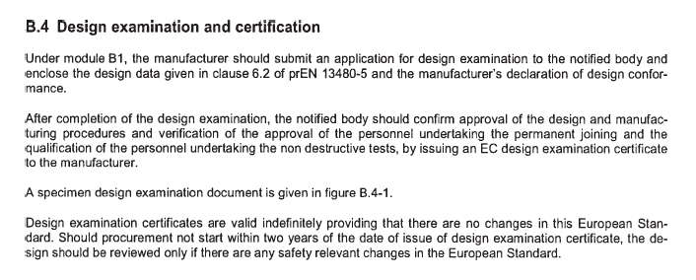

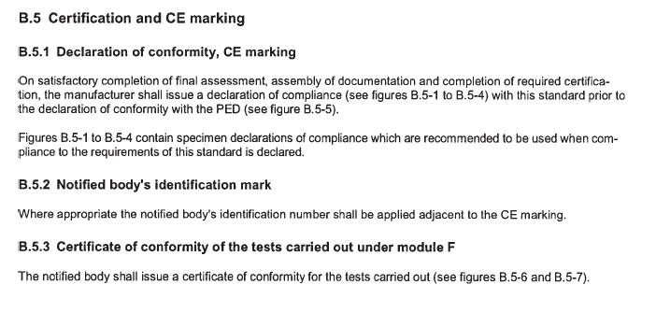

See example on the next page.

