FESHM 4270: STATIC MAGNETIC FIELDS

**Revision History**

|  |  |  |
| --- | --- | --- |
| **Author** | **Description of Change** | **Revision Date** |
| Matthew Spaw | * Magnetic Region Boundary terminology developed. * Low and High projectile boundaries defined, and associated signage described * MR Hazard Management controls defined * MR Status Management requirements defined | July 2020 |
| Matt Quinn & David Baird | Fermilab Environment Safety Health Manual (FESHM) 4270, *Static Magnetic Fields* replaces FESHM 5062.2, *Static Magnetic Fields*. The chapter was revised during its five-year review. In March, 2015, Fermilab decided to adopt the current (2015) version of the American Council of Governmental Industrial Hygienists (ACGIH) Threshold Limit Values (TLVs). These values are in line with increased values adopted by ACGIH in 2010, and reflect updated knowledge of the biological effects of static magnetic fields. Changes to the chapter include:   * The text was rewritten to reflect improved knowledge of the biological effects from magnetic fields and to align the format with that of other industrial hygiene chapters. * The exposure limits are unchanged and are set equal to the 2015 ACGIH TLVs. The whole body values for general workers and medical device wearers are unchanged. The TLV for limbs is increased in Section 4.0, Procedures. * The TLVs now omit the 8-hour Time Weighted Average, and include a separate limit (also in Section 4.0) for workers with special training and controlled workplace environments. * Chapter updated to new FESHM Format along with references to Environment, Safety and Health (ESH) Section changed to Environment, Safety, Health, and Quality (ESH&Q) Section. | July 2015 |

**TABLE OF CONTENTS**

1.0 INTRODUCTION 3

2.0 RESPONSIBLILITIES 3

2.1 Division/Section Heads or Project Managers 4

2.2 Supervisor 4

2.3 ES&H Section 4

2.4 Fermilab Occupational Medical Office 4

2.5 Employee/User 4

3.0 PROCEDURES 4

3.1 MR Boundaries Definitions and Hazards 4

3.2 MR Environment Boundary 4

3.3 MR Projectile Boundaries 5

3.4 MR Ceiling Boundary 5

3.5 MR Hazard Management 5

3.6 MR Status Management 6

4.0 Controlling Exposures to SMF 7

4.1 Occupational Exposure Limits 7

4.2 Monitoring 7

4.3 Posting 8

4.4 Medical Surveillance 10

5.0 REFERENCES 10

# INTRODUCTION

Particle accelerators and associated detectors often rely on intense static magnetic fields (SMF) in order to operate. The fields associated with most of Fermilab’s magnets (i.e., accelerator magnets) are constrained to their interiors and present little hazard. On the other hand, there are specific cases where magnets associated with experiments can present exposures that are comparable to those encountered in medical magnetic resonance imaging (MRI) scanners. (For example, the Muon g-2 main magnet, the Mu2e, detector, transport, and production solenoids, and fixed target analyzing magnets.) Other sources of SMFs are more typical of a general work environment such as permanent magnets, electromagnets used for lifting, and steel products with residual magnetization.

This chapter describes Fermilab’s program and procedures for addressing exposure to SMFs, and describes hazards as Magnetic Region (MR) Boundaries.

**DEFINITIONS**

Ferromagnetic – Materials that exhibit a strong attraction to magnetic fields and can retain magnetic properties after the external field has been removed. Iron, nickel, and cobalt are examples of ferromagnetic materials.

Gauss – a non-SI unit of magnetic flux density. 10,000 Gauss equals 1 Tesla. The symbols for tesla and gauss are T and G, respectively.

Magnetohydrodynamic – Refers to the interaction of magnetic fields and electrically conducting fluids such as blood.

MR Environment - The three-dimensional volume of space surrounding the magnetic field that contains the 0.5 mT field contour (5 G line). This volume is the region in which a person may be subject to a hazard due to the magnetic field.

Phosphenes - Brief spots of light brought on by eye movement that last for less than a few seconds.

Static magnetic field (SMF) – constant fields which do not change in intensity or direction over time, in contrast to a low and high frequency alternating field. Hence, they have a frequency of 0 Hz.

Tesla – SI unit of magnetic flux density (B). 1 tesla = 10,000 gauss. The symbols for tesla and gauss are T and G, respectively.

Vestibular - Having to do with the body's system for maintaining equilibrium.

# RESPONSIBLILITIES

## Division/Section Heads or Project Managers

Ensure the requirements of this chapter are fulfilled regarding SMF hazards including MR Status Management and MR Hazard Management implementations as necessary. Where appropriate, ensure SMF boundaries are determined by calculation ahead of commissioning, and by field measurement during commissioning.

## Supervisor

Assist in identifying potential exposures and in implementing any necessary controls. Supervisors have a key role in assuring that their personnel adhere to requisite behaviors.

## ES&H Section

Work with division/sections/projects, the Medical Office, and potentially exposed personnel in assessing exposures, designing controls, training, and providing signs and labels. Assist affected divisions/sections in providing technical advice in this chapter, assessing exposures, designing controls, training, and providing signs and labels.

## Fermilab Occupational Medical Office

Provide guidance to workers on potential hazards of SMF and interference with electronic medical devices, if requested. In the event of a known or suspected SMF overexposure, conduct and exam and arrange for further exams as necessary.

## Employee/User

Assist in identifying potential exposures and in implementing any necessary controls. Adhere to requisite safety behaviors.

# PROCEDURES

## MR Boundaries Definitions and Hazards

|  |  |  |
| --- | --- | --- |
| **MR Boundaries** | **Definition** | **Hazard** |
| MR Environment Boundary | 5 G (0.5 mT) | Implanted metallic or electronic medical device interference |
| MR Projectile Boundary- Low | ≥ 30 G (3 mT) | Projectile object hazard |
| MR Projectile Boundary- High | ≥ 300 G (30 mT) | Projectile object hazard |
| MR Ceiling Boundary | ≥ 20,000 G (2 T) | Health hazard posed to the general working population |

## MR Environment Boundary

Inside the MR Environment Boundary, conditions may be unsafe for individuals with certain biomedical implants or devices. Electronically activated medical devices can be subject to excessive heating and the induction of electrical currents (pacemakers, implantable cardioverter defibrillators, neurostimulators, etc.) Ferromagnetic implants can also be affected due to movement or dislodgment.

The MR Environment boundary aligns with the ACGIH Occupational Exposure Limit for medical device wearers presented in Section 4.1. MR Environment Boundaries shall be clearly posted with signage. Examples of signage are presented in Section 4.3.

## MR Projectile Boundaries

Projectile incidents may occur when a ferrous object is subject to a SMF. Ferrous objects in a magnetic field may experience a rapidly increasing velocity due to magnetic forces acting on the object. For that reason, an impact could cause injury to people or body parts in the path of the object, even for small objects.

There is currently no consensus standard for ferrous projectile hazards. The thresholds used for the MR Projectile Boundaries in this chapter are based on guidance developed for use with magnetic resonance (MRI) scanners and studies performed at Fermilab.

Above 30 G (3 mT), there can be a kinetic hazard from ferrous objects due to the force experienced in the magnetic field. Typically, frictional forces and conventional support structures are adequate to balance this force in the range of 30 G (3 mT) to 300 G (30 mT); however, the use of ferrous materials in that field strength range needs to be evaluated to understand the hazard and ensure the necessary controls are in place to control the hazard. Beyond 300 G (30 mT), the risk increases for both small and large objects, and additional controls on materials and personnel access into areas where the field is greater than 300 G (30 mT) are required.

## MR Ceiling Boundary

The MR Ceiling Boundary aligns with the ACGIH Occupational Exposure Limit (OEL) Ceiling for whole body exposure to SMFs presented in Section 4.1. Areas within the Boundary are those that meet or exceed the OEL. MR Ceiling Boundary procedures will be location dependent. Contact your DSO for assistance in developing a MR Ceiling Boundary procedure.

## MR Hazard Management

SMF hazards change depending on the field strength. As field strength increases additional hazards are introduced, and controls are scaled up to mitigate those hazards. The MR Hazard Management table below lists the required controls for each Magnetic Region.

|  |  |  |
| --- | --- | --- |
| **MR Hazard Management** | | |
| **Magnetic Region** | **Static Magnetic Field** | **Required Controls** |
| MR Environment Boundary | 5 G  (0.5 mT) | * Medical device DANGER sign posted at boundary |
| MR Projectile Boundary: Low | 30 G  (3 mT) | * Ferrous Material CAUTION sign posted at boundary * A documented safety analysis of the workspace   + Completed prior to operation   + Provided to the DSO for review   + Include consideration for materials in the area   + Include an assessment of consequence |
| MR Projectile Boundary: High | 300 G  (30 mT) | * Ferrous Material DANGER sign posted at boundary * A documented safety analysis of the workspace   + Completed prior to operation   + Provided to the DSO for review   + Include consideration for materials in the area   + Include an assessment of consequence * Material control procedure * Access controls |
| MR Ceiling Boundary | 20,000 G  (2 T) | * MR Exposure DANGER sign posted at boundary * Access prohibited to all workers unless given written approval by Division/Section/Project Head with DSO concurrence. |

Note: Depending upon the characteristics of the magnetic field and the existing features of the building in which the magnetic field is present, not all boundaries need to be demarcated, as long as boundary postings and controls are more conservative (more protective) than required by the table above. For instance, if there is a natural control point (such as a door or gate) that encompasses all areas where the field is >5 G (0.5 mT)), then that control point may be used as the MR Environment Boundary even though the field strength at that point is <5 G (0.5 mT).

## MR Status Management

Electromagnets are capable of both powered-on and powered-off states. An electromagnet that is powered-off does not typically pose a magnetic field hazard to workers. MR Boundaries are typically unnecessary for an electromagnet in the powered-off state.

When an electromagnet is powered-off and all necessary configuration controls are in place to ensure the magnetic field hazard is removed, MR-Open status allows access restrictions to be relaxed or lifted to carry out maintenance or other activities. (In some cases, it’s possible that residual fields could pose a hazard and will have to be addressed during the MR-Open state.) MR-Closed status establishes that the electromagnet can be powered-on, once the appropriate access restrictions are in place.

MR-Open/Closed status require the implementation of a written MR status management procedure to track the steps necessary to ensure safe access to a workspace containing one or more operational electromagnets.

A summary of MR-Open and MR-Closed states are as follows:

|  |  |  |
| --- | --- | --- |
| **MR Status** | **Electromagnet Power State** | **Requirements** |
| MR- Open | Powered-off | * Magnetic field configuration controls engaged * Area of signage in accordance with MR status management procedures |
| MR- Closed | Powered-on | * Magnetic field hazard access and material control restrictions engaged * Area of signage in accordance with MR status management procedures |

# Controlling Exposures to SMF

## Occupational Exposure Limits

The values given below refer to SMFs to which it is believed that nearly all workers may be repeatedly exposed without experiencing adverse health effects (2020 American Council of Governmental Industrial Hygienists Threshold Limit Value for SMFs).

|  |  |
| --- | --- |
| **Target area** | **Ceiling** |
| Whole body (general workplace) | 2 T / 20,000 G |
| Whole body (special worker training and controlled workplace environment) | 8 T / 80,000 G |
| Limbs | 20 T / 200,000 G |
| Medical electronic device wearers | 0.5 mT / 5 G |

## Monitoring

Divisions/Sections/Projects managing activities involving SMF sources are responsible for arranging industrial hygiene monitoring whenever exposures are reasonably expected to meet or exceed limits. If results do not exceed exposure limits, further monitoring is not required unless the activity is modified in a way that is expected to increase exposures.

SMF exposure limits were established assuming a homogeneous field. For inhomogeneous fields, the magnetic flux density should be averaged over 100 centimeter (cm) squared. This approach should be especially useful when dealing with dimensionally small sources.

## Posting

There are three types of SMF signs:

1. MR Environment sign designating the 5 G (0.5 mT) boundary for medical device wearers:
   * DANGER: MAGNETIC FIELD HAZARD: No Persons with cardiac pacemakers or electronic medical devices
2. MR Projectile Boundary: Low sign designating the 30-300 G (3-30 mT) boundary for ferrous object consideration
   * CAUTION: MAGNETIC FIELD HAZARD: 30-300 G (3-30 mT), Loose ferrous objects may become projectiles
3. MR Projectile Boundary: High sign designating the 300 G (30 mT) or greater boundary for ferrous object consideration
   * DANGER: HIGH MAGNETIC FIELD HAZARD: No ferrous materials when magnet is energized

Appropriate signs should be posted in a way that best serves to warn potentially exposed personnel. The layout and wording may be customized as best suits the nature of the SMF source(s) and potentially exposed individuals. Suggested sign layouts are shown below.

Current 5 G (0.05 mT) Danger Sign:

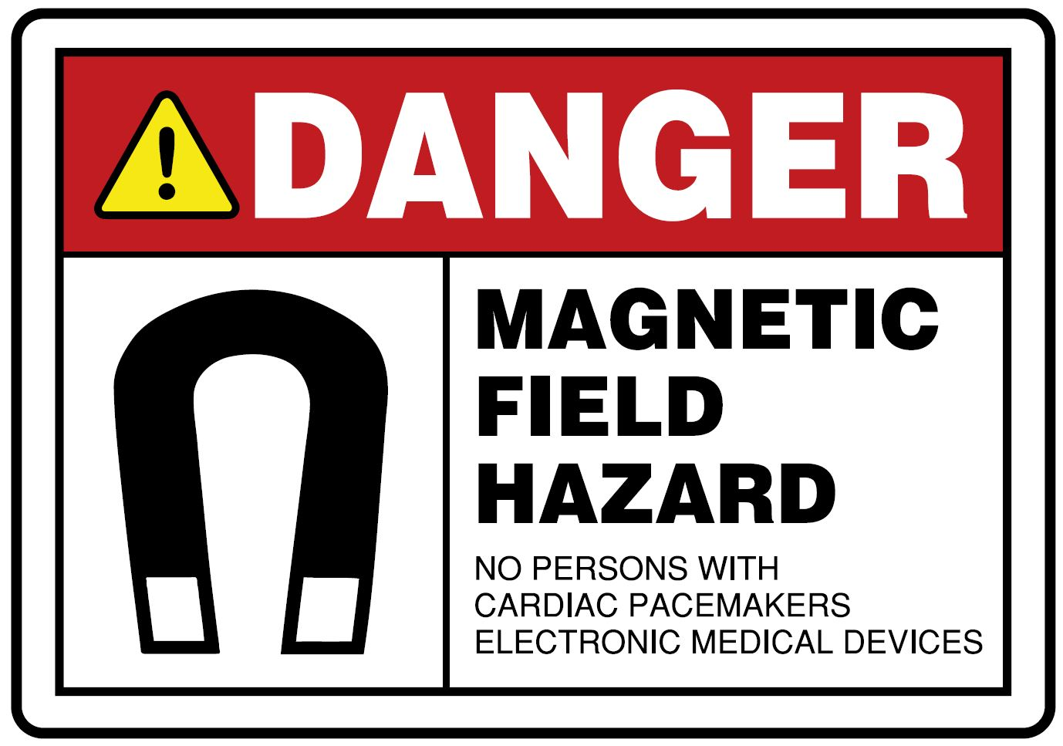

MR Projectile Boundary: Low Caution Sign (2020):

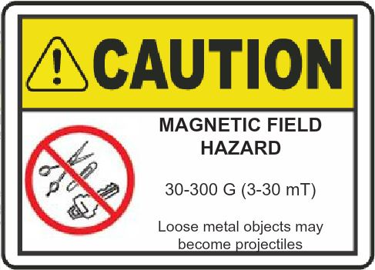

5 G (0.05 mT) Danger Sign through 2018:



Ferromagnetic Items Danger Sign through 2020:



MR Projectile Boundary: High Danger Sign (2020):

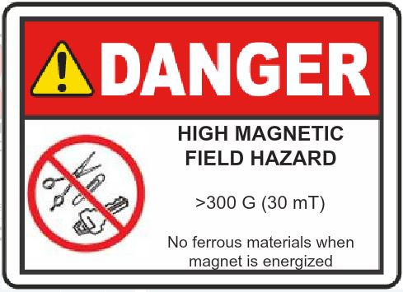

## Medical Surveillance

Potential exposures to high magnetic fields should be identified for personnel by supervisors or points of contact via the Work Activities Analysis Form (WAAF - <http://www-esh.fnal.gov/pls/default/WAAF.html>).

Persons with metallic implants (excluding dental fillings), metallic prosthesis, metallic fragments (especially in eyes), medical electronic devices, or active sickle cell anemia should be prohibited from the MR Environment unless permitted by the Fermilab Occupational Medical Office.

Medical electronic devices include cardiac pacemakers, cardiac defibrillators, hormone infusion pumps (e.g., for insulin), neuromuscular stimulation devices (e.g., for the sphincter muscle of the bladder), and electronically operated prosthetic devices (e.g., for the limbs and inner ear).

# REFERENCES

1. **ACGIH.** Static Magnetic Fields: TLV(R) Physical Agents 7th Edition Documentation. [Online] ACGIH. https://www.acgih.org/forms/store/ProductFormPublic/static-magnetic-fields-tlv-r-physical-agents-7th-edition-documentation.

2. **INTERNATIONAL COMMISSION ON NON‐IONIZING RADIATION PROTECTION.** *ICNIRP GUIDELINES ON LIMITS OF EXPOSURE TO STATIC MAGNETIC FIELDS.* Oberschleissheim : ICNIRP, 2009. HEALTH PHYSICS 96(4):504‐514; 2009.

3. *Experimental evaluation of ballistic hazards in imaging diagnostic center.* **Karpowicz, Jolanta and Gryz, Krzysztof.** 31–37, Warsaw : Laboratory of Electromagnetic Hazards, Central Institute for Labour Protection – National Research Institute, 2013, Vol. 78(2).

4. **The Society and College of Radiographers.** Static magnetic field. *THE SOCIETY OF RADIOGRAPHERS.* [Online] 2020. [Cited: June 01, 2020.] https://www.sor.org/learning/document-library/safety-magnetic-resonance-imaging/5-static-magnetic-field.

5. **Miller, T and Kenny, J.** ESH DocDB Document 5714-v1 Historical Technical Appendix to FESHM 4270. *ES&H DOCUMENT DATABASE.* [Online] https://esh-docdb.fnal.gov/cgi-bin/sso/ShowDocument?docid=5714.