FESHM 5031.7
Requirements for the Design, Fabrication, Erection, Quality Control, Testing, Maintenance, Repair, and Operation of Metallic Membrane Cryostats

Revision History

Author | Description of Change | Revision Date
Michael Geynisman  Mark Adamowski  John Anderson Jr.  David Montanari  Michael White | - Updated requirements for quality control, including pressure test. Removed references to 10CFR851.  - Removed requirement for PE being employed by a company nonaffiliated with Fermilab or CERN.  - Modified language to match requirements of 10CFR851  - References to equivalency between EU and US structural standards  - Clarification for gas pressurization of the insulation space  - Clarification for the extent of required documentation  - Replace “Guidelines” with “Requirements”  - Removed reference to MOU between CERN and Fermilab | January 2020
Michael Geynisman | - Modifications for the pressure test requirements to allow both, pneumatic and hydrostatic testing  - Modifications per Lab-wide review comments, including:  - Grammatical improvements  - Addressing potential spill due to piping penetrations below the liquid level  - Listing all loads to the support structure  - Clarifying attachment of the top plate to structural support | November 2015
David Montanari,  Barry Norris,  Michael Geynisman, Elaine McCluskey | - Initial release | April 2015

TABLE OF CONTENTS

1.0 INTRODUCTION 2
2.0 DESCRIPTION 2
3.0 CODES, STANDARDS AND RECOMMENDED PRACTICES 4
4.0 GENERAL REQUIREMENTS FOR DESIGN 6
5.0 SPECIAL REQUIREMENTS FOR STAINLESS STEEL MEMBRANE 6
6.0 SPECIAL REQUIREMENTS FOR INSULATION 6
7.0 SPECIAL REQUIREMENTS FOR SUPPORT STRUCTURE 8
8.0 QUALITY ASSURANCE 10
9.0 REQUIRED DOCUMENTATION 12

INTRODUCTION

“Requirements for the Design, Fabrication, Erection, Quality Control, Testing, Maintenance, Repair, and Operation of Metallic Membrane Cryostats” (this “Requirements”) has been developed by the Cryogenic Safety Subcommittee and references the current understanding of the best international practice in the design, fabrication, erection, quality control, testing, maintenance, repair, and operation of metallic membrane cryostats.

This “Requirements” discusses the applicability and use of the specific codes, standards, and recommended practices used by the membrane cryostat industry. It also provides guidance where sound engineering practice shall be used.

DESCRIPTION

A membrane cryostat is an integrated assembly, wherein a foam-insulated austenitic stainless steel membrane formed of prefabricated panels containing the cryogen is integrated within a structural support. The load exerted by the liquid head and the gas pressure is transferred from the metallic membrane to the structural support through the load-bearing insulation. The insulation space is purged with gaseous argon or nitrogen at pressure protected from exceeding the differential pressure limits specified by the membrane designer/manufacturer. The metallic membrane cryostat constitutes a complete low pressure vessel, which provides for leak tightness and pressure containment.

Figure 2.1 shows a basic construction of the metallic membrane cryostat. It shows how the foam-insulated stainless steel membrane formed of prefabricated panels is integrated within a structural support. The cryogenic feed-throughs and piping are shown here to penetrate though the top plate or fixed portion of the cryostat roof. Cryostat may also have side or bottom piping penetrations for liquid withdrawal (special case, not shown here). Figure 2.2 shows a section of a metallic membrane cryostat with the different layers:

- Metallic membrane
- Fireproof board
- Insulation (two layers with secondary barrier in-between)
- Vapor barrier
- Support structure (concrete in this figure, but could be also a steel support structure)

The welded pre-fabricated panels of the stainless steel metallic membrane constitute the primary containment of the metallic membrane cryostat. The top plate or the roof completes the metallic membrane cryostat and typically accommodates the penetrations through the vessel.

The fireproof board protects the insulation from heat generated during welding of the membrane panels and is part of the insulation. Refer to Fermilab Environment, Safety, and Health Manual (FESHM) 6010 for general details about the Fermilab Fire Protection Program requirements and FESHM 6020.2 for specific requirements regarding welding, burning, brazing, and spark producing operations.

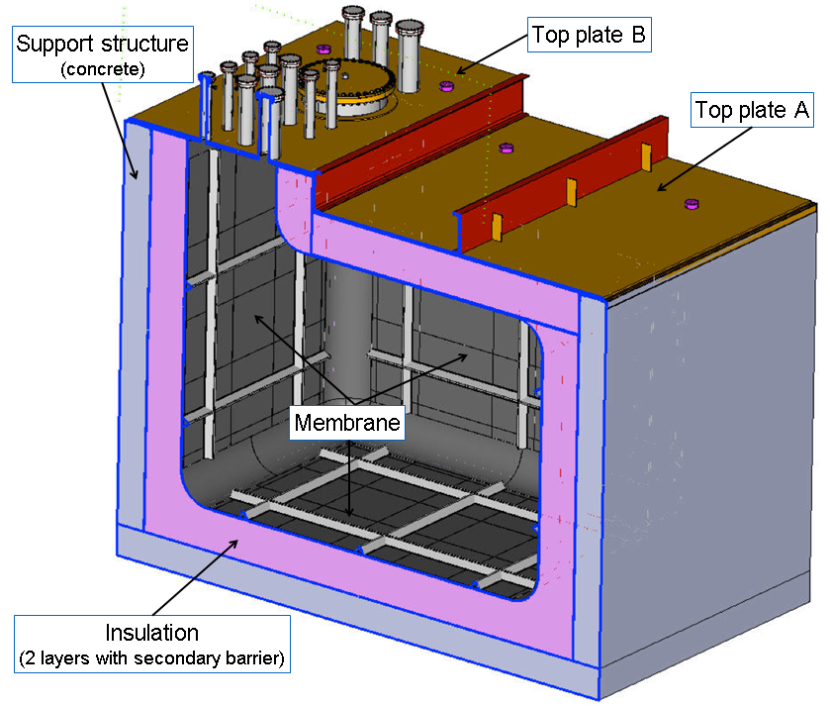
Figure 2.1 – basic construction of a metallic membrane cryostat

Two layers of the foam insulation provide a thermal barrier between the membrane at the liquid cryogen temperature and the support structure at ambient temperature.

The secondary barrier is a physical protection that contains the liquid cryogen in case of a failure of the membrane. This secondary containment can be part of the insulation, or the support structure. Figure 2.2 shows alternative options when the secondary barrier is part of the insulation or part of the support structure.

The vapor barrier is attached to the support structure and keeps external moisture out of the insulation (particularly in the case of a concrete support structure).

The support structure made of steel or concrete, or combination of both, provides support for all internal and external loads exerted on the membrane cryostat, including pressure, hydrostatic, thermal, weight, and seismic loads.

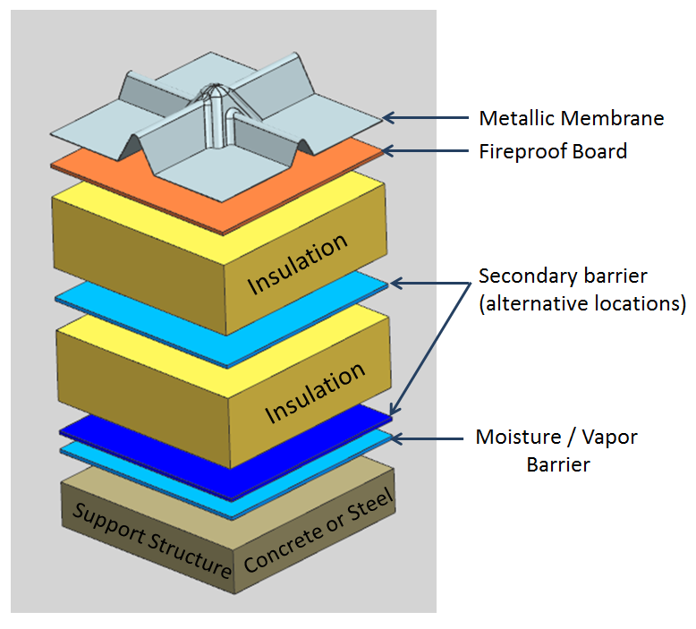
Figure 2.2 – Typical metallic membrane cryostat technology

CODES, STANDARDS AND RECOMMENDED PRACTICES

There are two known suppliers of metallic membrane cryostat technology: Ishikawajima-Harima Heavy Industries Co., Ltd. (IHI) out of Japan, and GazTransport & Technigaz (GTT) out of France. Therefore, the following standards and recommended practices are used in the design, fabrication, erection, quality control, testing, maintenance, repair, and operation of metallic membrane cryostats:

- Japanese Gas Association Recommended Practice 107-02 (JGA RP-107-02) “Recommended Practice for LNG Inground Storage”
- British Standard BS EN 14620 “Design and manufacture of site built, vertical, cylindrical, flat-bottomed steel tanks for the storage of refrigerated, liquefied gases with operating temperatures between 0°C and -165°C”

IHI primarily uses the JGA RP-107-02 recommended practice but may also use the BS EN 14620 standard if required by the Authority Having Jurisdiction. GTT only uses the BS EN 14620.

JGA RP-107-02 and BS EN 14620, were developed for containing Liquified Natural Gas (LNG). Both contain practices that are applicable to other liquefied gases such argon and nitrogen.

The main differences between nitrogen/argon and LNG are analyzed in this section and show the applicability of the JGA RP-107-02 and EN 14620 to argon and nitrogen tanks as well. Table 3.1 presents the main differences between nitrogen/argon and LNG.

 | LNG | Nitrogen | Argon
Boiling temperature (at atmospheric pressure) | 108K | 77K | 87K
Liquid Density at 0.101 MPa | 410-500 kg/m³ | 806 kg/m³ | 1,395 kg/m³
Ratio of Liquid to Vapor Density at 0.101MPa | 233 | 242 | 175
Specific Heat Ratio | 1.31 | 1.40 | 1.67
Latent Heat of Vaporization | 5.1x10⁵ J/kg | 1.991x10⁵ J/kg | 1.63x10⁵ J/kg
Compatibility with materials | Limited | Very high | Very high
Table 3.1 – Differences between LNG, Nitrogen, Argon.

EN14620-2 Table 1 and 4.3.1.2.2(e) allows membrane materials per EN 10028-7 to be used down to a minimum metal temperature of -165 C. The lower minimum metal temperatures for EN10028-7 materials also listed in EN13445-2 Table B.2-11 may be substituted provided that all requirements of EN13445-2 B.2.2.5 are satisfied. The austenitic stainless steel materials listed in American Society of Mechanical Engineers (ASME) Boiler and Pressure Vessel Code or American Petroleum Institute API 620 Annex Q may also be used as membrane materials provided that all of the associated base material, heat affected zone, and weld material inspection and testing requirements for that code for use at the membrane minimum metal temperature are also satisfied.

Nitrogen and argon are heavier than natural gas. Provisions shall be made to ensure that the design is suitable for a denser medium. For example, the insulation at the bottom of a vessel designed for nitrogen/argon shall be adequate to withstand the higher hydrostatic load when compared to a vessel designed for LNG. JGA RP-107-02 and EN 14620 may be used for the design, fabrication, erection, installation and testing of vessels containing liquid nitrogen and liquid argon with additional provisions to compensate for the higher density of argon.

If a solid metal plate construction is used for the top plate, then ASME BPVC, Section VIII (or alternative standard with FESHM 2110 equivalency) applies to the design, fabrication, erection, quality control, testing, maintenance, repair, and operation of the top plate(s).

ASME Code for Process Piping B31.3 (or alternative standard with FESHM 2110 equivalency) applies to the design, fabrication, erection, quality control, testing, maintenance, repair, and operation of external or internal process piping welded to the penetrations on the cryostat.

If the structural support, which bears the pressure loads of the cryostat, is made of reinforced concrete, then American Concrete Institute Standard ACI 318 (latest edition) “Building Code Requirements for Structural Concrete” applies to the design and construction of the concrete support structure.

If the structural support, which bears the pressure loads of the cryostat, is made of structural steel, then American Institute of Steel Construction Standard ANSI/AISC 360 (latest edition) “Specification for Structural Steel Buildings” or equivalent Eurocode EN 1990-1999 series of standards applies to the design and construction of the steel support structure, as detailed below in section 7 of this Requirements.

GENERAL REQUIREMENTS FOR DESIGN

The design, fabrication, erection, quality control, testing, maintenance, repair, and operation of the metallic membrane cryostat shall be performed per accepted engineering practice, according to the relevant codes, standards and recommended practices listed in section 3.0. Subsequently, the selection of the design parameters, materials, practices and calculation methods for each part of the cryostat shall be subject to the codes, standards and recommended practices listed in section 3.0, as well the codes cross-referenced in them.

Design data required to be included into Engineering Note is specified in section 6.0 of FESHM 5031.7 and further detailed in section 9.0 below.

SPECIAL REQUIREMENTS FOR STAINLESS STEEL MEMBRANE

The metallic membrane is not a structural component of the system and has a containment function only. It is a double network of orthogonal corrugations allowing its free contraction and expansion, in two directions, under thermal variations. Design of the metallic membrane shall be done per referenced standards, e.g. EN 14620, and recommended practices based on the design pressures and temperatures. The metallic membrane can be designed according to the plastic deformation method (e.g. EN14620-2 5.2.2). Additionally, design shall address cyclic deformations based on the number of specified thermal cycles.

The metallic membrane panels are purchased components and are to be assembled on site. As they are integral components of the metallic membrane cryostat, the assembly shall strictly follow the installation procedures designed by the manufacturer, including special procedures for welding and post-assembly testing.

SPECIAL REQUIREMENTS FOR INSULATION

The hydrostatic load and the gas pressure from the metallic membrane, as well as pressure from gaseous purge, are transferred to the support structure through layers of load-bearing foam that insulate the vessel to reduce the conductive heat to the required value. The insulation shall be designed according to the maximum load transferred to the support structure. The thickness of the passive insulation is determined by the required heat leak.

If a secondary barrier is embedded inside the layers of insulation, it shall be designed to contain the liquid cryogen in case of a failure of the membrane.

A fireproof board, i.e. made of fire-retardant plywood or calcium silicate, is attached to the inner most layer of insulation and protects it from the heat generated during the welding of the membrane panels.

The insulation transmits the load to the support structure. The main functions of the insulation are:

- To maintain the boil off below the specific limits.
- To protect the non-low temperature materials/parts of the support structure by maintaining them at the required temperature.
- To limit the cooling of the foundation/soil underneath the membrane to prevent damage from frost heave.
- To prevent/minimize condensation and icing on the outer surfaces of the support structure.

The design of the insulation shall conform to BS EN 14620 Part 4 and/or JGA RP-107-02 Section 9. Properties of different insulating materials are listed in BS EN 14620 Table A.3 and JGA RP-107-02 Section 9.2.

The outermost containment layer of the insulation space, e.g. steel liner used as vapor barrier, shall be leak checked and verified bubble leak tight. The insulation purge system is typically installed to facilitate ammonia or helium leak checking during installation and to remove impurities during operations.

The design of the metallic membrane cryostat shall specify insulation flow path volumes, purge flow rates, purity of the purge argon gas, recommended delivery pressure, and requirements for external overpressure protection for the metallic membrane. As per BS EN 14620, Part 1 Sections 7.2.1.8, the insulation space shall be monitored for controlling the differential pressure between insulation vapor space and primary containment space so that no damage can occur to the membrane. If the insulation space overpressure protection relies on active pressure relief valves (versus orifices), such pressure relief valves should be described in the Engineering Note per FESHM 5031.7.

SPECIAL REQUIREMENTS FOR SUPPORT STRUCTURE

This section includes specific requirements for the design, fabrication, erection, quality control, testing, maintenance, and repair of membrane cryostat support structures in addition to the general requirements in FESHM 5100 Structural Safety.

Support Structure Description

Figure 7.1 shows an example of two types of support structures: steel (left) and concrete (right). Both are valid design choices.

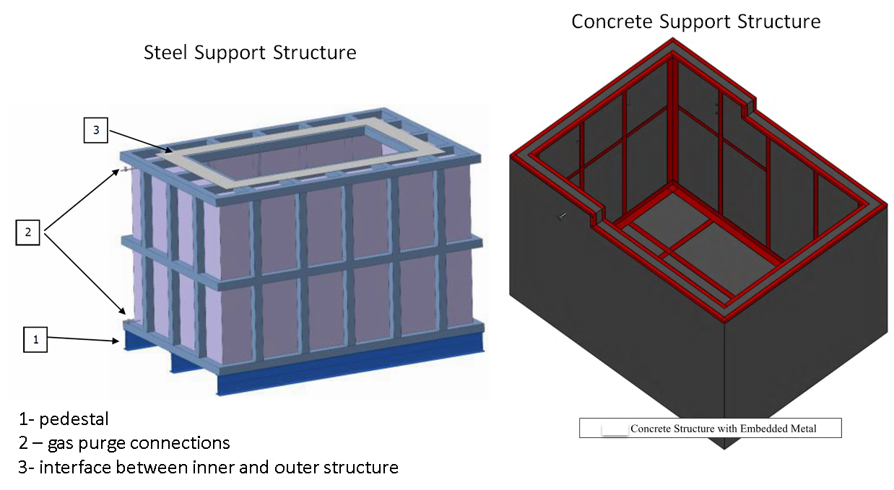
Figure 7.1 – Examples of steel support structure (left) and concrete support structure (right).

The support structure (steel plates and beams, concrete, or any other type) shall withstand the load of the liquid head and gas pressure and any other load applied to it. For example: the weight of the top plate, the equipment mounted inside the cryostat or on the top plate, the purge gas pressure, the seismic load, and any wind load.

If the secondary barrier is part of the support structure, the secondary containment and the support structure shall be designed to contain the liquid cryogen in case of a failure of the membrane. The design shall address the issues of the high boil-off rates due to non-insulated secondary containment and low temperature of the support structure.

The design, fabrication, erection, quality control, testing, maintenance, and repair of any structural support, which contains the pressure and hydrostatic loads, shall be based on codes and standards listed in section 3.0 of these “Requirements”.

Between the support structure and the outer insulation layer, a vapor barrier shall be placed that guarantees a maximum permeability of water vapor towards the insulation of 0.5 g/m2 per 24 hr. as per BS EN 14620 Part 4 Section 5.3.

The documentation for the support structure shall be reviewed. Specifically:
- All drawings, specifications and calculations showing conformance to the selected structural design standards shall be reviewed and approved by an independent qualified person.
- The fabrication, erection, quality control, testing, maintenance, and repair of the cryostat must be inspected for conformance to the selected structural fabrication and erection standards and approved by an independent qualified person.
- Cryogenic Safety Panel shall review results of such independent verifications and consult, if necessary, with the Fermilab Structural Authority Having Jurisdiction (AHJ).

Reinforced Concrete Support Structure

If the structural support, which bears the pressure loads of the cryostat, is made of reinforced concrete, then the American Concrete Institute Standard ACI 318 (latest edition) “Building Code Requirements for Structural Concrete” shall apply to the design, fabrication, erection quality control, testing, maintenance, and repair of the support structure.

In case of in-ground storage tanks with concrete support structure, an alternative approach is to intentionally freeze the soil (in a controlled way) to improve the performances of the vessel. Detailed calculations of the temperature profile of the soil shall be provided following JGA RP-107-02 Section 3.2, 4, and 5. Finite Element Analysis may also be used to calculate the temperature profile within the concrete.

Where an in-ground cryostat is supported directly by a concrete liner and the ground behind it is sufficient for additional stable support (such as hard rock), the concrete liner shall be designed to transmit the outward forces from the cryostat to the rock without damaging any intermediate layers such drainage systems that may be required for geotechnical reasons.

Structural Steel Support Structure

If the structural support, which bears the pressure loads of the cryostat, is made of structural steel, then the American Society of Civil Engineers Standard ASCE 7 “Minimum Design Loads for Buildings and other Structures” and American Institute of Steel Construction Standard ANSI/AISC 360 (latest edition) “Specification for Structural Steel Buildings” or the equivalent set of Eurocode (EN1990, EN1991, and EN1993) standards shall apply to the design, fabrication, erection, quality control, testing, maintenance, and repair of the support structure. The design shall be documented through numerical calculations, i.e. Finite Element Analysis (FEA), per applicable design standard, e.g. Eurocodes and EN 14620, illustrating that the stresses at every point of the structure are below allowable limits calculated with the partial material safety coefficient for the selected materials under all loading conditions calculated with partial load safety coefficients as prescribed in the design standard.

Where applicable, steel frames and a steel-reinforced concrete support structures for metallic membrane cryostats may be designed, constructed, quality controlled, tested, maintained, and repaired following guidance of BS EN 14620 and/or JGA RP-107-02 based on material maximum allowable limits given above.

Provisions shall be made to not exceed the listed temperature limits of the materials, as well as recommended temperature differentials for the structural elements. Natural convection and/or active heating (by means of heating tapes or any other heating system) are allowable methods. Details are presented in BS EN 14620 Part 1 Sections 7.1.9, 7.1.10, 7.1.11 and JGA RP-107-02 Section 3.2.

QUALITY ASSURANCE

This section includes specific requirements for the fabrication, erection, quality control, testing, maintenance, repair, and operation of membrane cryostat support structures in addition to the general requirements in FESHM 5100 Structural Safety. Examples of typical membrane cryostat quality control and assurance documents are included in the list of required documents in Section 9.0 of this “Requirements”. All code required quality control and quality assurance documents shall be included in the engineering note. Quality control and assurance documents include all procedure and personnel qualifications as well as all inspection, examination, and testing records.

Quality Control and Acceptance Testing Plan Document

A “Quality Control and Acceptance Testing Plan” document shall be written by the project responsible for the membrane cryostat, accepted by the Cryogenic Safety Panel and approved by the D/S/P.

In this plan, strategies shall detail and justify the methodology used to:
- Verify the membrane cryostat system leak tightness;
- Validate the load bearing capacity of the cryostat support structure using the FEA analysis as a benchmark.

The justification shall include a description of:
- The modes of operations of the cryostat including operating pressures, temperatures, and liquid levels.
- The pressure control and protection against exceeding the combination of MAOP and maximum allowed accumulation.
- Mechanisms proposed to monitor the cryostat structure stresses and deformations to obtain the necessary data to validate the FEA model during each mode of operation (pneumatic pressure test and fill).

Manufacturing Acceptance Testing

In order to verify the leak tightness of the membrane and integrity of the supporting structure per sound engineering practice and guidance from national consensus codes, the membrane cryostats shall be subjected to a pressure test.

The decision for choice of the pressure test option, hydrostatic or pneumatic, shall be made in the design stage to ensure adequacy of design and necessary mitigation measures.

The membrane is built within a support structure covered by national consensus codes or international codes where code equivalency studies have been completed. The required structural tests under the governing design code shall be performed. In addition to any required structural tests, the membrane within this support structure shall be pressure tested at the MAOP plus the maximum allowed pressure accumulation prior to the start of purging, cooldown, or other operations under vacuum or pressure.

If pneumatic testing is used, then the hazards of such pneumatic testing shall be determined per “Pressure Systems Stored-Energy Threshold Risk Analysis, PNNL-18696, 2009” and ASME PCC-2 Appendix 501. The results of this analysis and mitigation measures should consider the environment of the test location and adjacent structures. Any tests of any type with cryogenic liquid present in the membrane cryostat shall consider the risk of a Boiling Liquid Expanding Vapor Explosion (BLEVE).

The testing procedures shall be reviewed and approved by the Cryogenic Safety Panel. Prior to each testing campaign, a risk assessment is performed to verify personnel and equipment safety during the tests. To proceed from one test stage to the next, the D/S/P organizes an internal review to ensure that all elements of the “Quality Control and Acceptance Testing Plan” have been satisfied. D/S/P approval is mandatory prior to each test stage.

Prior to the integral pressure test, all feedthroughs and other external components shall be pressure rated for the cryostat’s design pressure. The pressure rating shall be obtained through documented qualification process, including design calculations and testing program.

Design Verification Testing

Structural Steel Components

Load tests in excess of expected load for the weakest structural part of the steel frame are recommended to validate the FEA model and the structure mechanical behavior. If required, the FEA models are modified accordingly and an update of the calculations performed. Load tests shall be performed per the applicable structural standard:

- AISC 360 Appendix 5 Evaluation of Existing Structures
- EN1990 Annex D Design Assisted by Testing

Cryostat Parts

Cryostat parts may use a design pressure qualified by performing a proof (burst) test per one of the following pressure vessel standards:

- ASME BPVC VIII Div. 1 UG-101 Proof Tests to Establish Maximum Allowable Working Pressure
- EN13445-3 Annex T Design by Experimental Methods

REQUIRED DOCUMENTATION

The following shall be documented in the Engineering Note for the metallic membrane cryostat per process defined in FNAL Engineering Manual:

- Design
  - Membrane cryostat description
  - Certifications from membrane designer
  - Membrane cryostat risk assessment
  - Design codes and evaluation criteria
  - Calculations for:
    - Load-bearing structural support, including the loads from the experimental equipment inside the cryostat or mounted on the top plate. If FEA calculations are used for the support structure, then the 3D and FEA model should be made available for review.
    - Passive load-bearing insulation
    - Top plate(s)
    - Membrane contraction and thermal cycle
  - Pressure relief system design calculations and selection of reliefs
  - Vacuum protection system design calculations and selection of reliefs
  - Design for the insulation purge, including flow rate calculations and overpressure protection
  - Design and safety considerations for all piping penetrations
  - Design 3-D model, drawings, and specifications to support design calculations
- Quality Assurance
  - Quality Control and Acceptance Testing Plan
  - Design Verification Testing Results
  - Support structure document package and documented approval by independent qualified person(s)
  - Material data
    - Complete list of material types, grades, and specifications used in construction
    - Summary of mechanical and thermal properties used in design calculations
    - Material certifications
- Fabrication and erection information
  - Assembly procedures for stainless membrane vessel
  - Assembly procedures for the passive insulation
  - Assembly procedures for the structural support
  - Assembly procedures for the top plate
  - Welding / brazing joint design details
  - Welding/brazing procedure specifications and qualifications
  - Welder’s/Brazer’s qualification
  - Weld/Braze joint inspector & examiner qualifications
  - Leak check procedure
  - Leak check inspector’s qualification
- Quality Control Reports
  - Leak check report
  - Weld inspection, examination, and testing reports
  - Bolted joint inspection reports
  - Pressure test procedure & reports
- Operating Procedures
  - Operating procedures necessary for safe operation

Per White Paper “Acceptance of Steel and Aluminum Structures Designed per the Eurocodes at Fermilab” by R. Alber, B. Rubik, A. Vasonis, July 2017 and FESHM 5100 chapter “Structural Safety”
Specific details of the design, construction and protection of the foundation are not discussed here; they shall comply to the chosen design standards, e.g. EN 14620, and reviewed and approved separately.

