QAM 12040: CORRECTIVE AND PREVENTIVE ACTIONS

Revision History

Author | Description of Change | Revision Date
Kathy Vuletich | Removed references to the item type “Opportunities for Improvement” and added references to the item type “Management Concerns”. Corrective and preventive actions are no longer required for opportunities for improvement but instead are required for Management Concerns per QAM chapter 12030. | January 2018
Kathy Zappia / Jemila Adetunji | Review of procedure to align with the minor updates made within the other QAM Chapters | August 2014
Rafael Coll | Initial release of QAM Chapter 12040 replaces the former OQBP Procedure 1004.1001. | November 2013

TABLE OF CONTENTS

1.0 INTRODUCTION 3
2.0 DEFINITIONS 3
3.0 RESPONSIBLILITIES 4
3.1 Chief Safety Officer 4
3.2 Division/Section Heads, Project Managers, and Management System Owners 4
3.3 All Employees, Contractors, and Users 4
4.0 PROGRAM DESCRIPTION 4
4.1 Corrective & Preventive Action Procedure 4
4.2 Management Review of Corrective & Preventive Action Data 6
5.0 RECORDS 6

INTRODUCTION

This chapter provides the terminology and basic structure for implementing a Corrective Action or Preventive Action (CAPA) Program where corrective or preventive actions are required to address non-conformances or management concerns, or for continuous improvement of existing work practices. These requirements apply to all Fermilab employees, subcontractors, and users performing formal corrective or preventive actions pertaining to activities conducted on the Fermilab site or in leased spaces.

DEFINITIONS

Assessment - A review, evaluation, surveillance, or audit where a systematic approach is used to evaluate processes, systems or services to determine compliance to specified requirements and effectiveness; with the goal of identifying best practices and/or areas of non-compliance. An assessment usually results in corrective actions where appropriate resolution is required

CAPA - Corrective and Preventive Actions

Corrective Action - Action to eliminate the cause of a detected non-conformance or other undesirable situation. There can be more than one cause for non-conformance. Corrective action is taken to prevent recurrence whereas preventive action is taken to prevent occurrence.

Independent Assessment – Assessments conducted on an aspect of Fermilab operations by the ESH&Q Section Quality Assurance Group or an outside organization.

Management Concern - An issue that management has identified as a concern requiring corrective or preventive actions to be taken to ensure risk associated with that issue is mitigated.

Non-conformance - Non-fulfillment of a requirement. A non-conformance can be a deviation from work standards, practices, procedures, legal requirements or applicable code of federal regulations.

Preventive Action - Action to eliminate the cause of a potential non-conformance or other undesirable potential situation. There can be more than one cause for a potential non-conformance. Preventive action is taken to prevent occurrence whereas corrective action is taken to prevent recurrence.

Procedure - Specified way to carry out an activity or process.

Record - Document stating results achieved or providing evidence of activities performed.

Remedial Action - An action taken to alleviate the symptoms of existing non-conformance or any other undesirable situation. Also, known as correction or compensatory action, remedial action is used to minimize the effects before the root cause and best solution may be identified. It is a reactive, short term action to stop immediate effects of the problem.

Risk - Combination of the likelihood of an occurrence of a hazardous event or exposure(s) and the severity of injury or ill health that can be caused by the event or exposure(s).

Root Cause - An identified reason for the presence of a defect or problem or the source of origin of an event. The most basic reason, which if eliminated, would prevent recurrence.

Third Party Audits/Assessment - Audits and/or assessments performed on the organization by agencies external to Fermilab.

RESPONSIBLILITIES

Chief Safety Officer
- Administer the Fermilab CAPA Program.
- Request, review, and track CAPA’s for non-conformances and management concerns relevant to the issues identified during assessments, investigations, or audits sponsored or conducted by ESH&Q, or resulting from third party audits or activities.
- Advise the Laboratory Director and Chief Operating Officer if a non-conformance is reportable to the DOE Occurrence Reporting and Processing System or other reporting systems.
- Analyze individual and collective non-conformances or management concerns to detect trends or potential systemic weaknesses.

Division/Section Heads, Project Managers, and Management System Owners
- Comply with and support this procedure for their areas of responsibility.
- Ensure timely response, submittal, and implementation of CAPA’s that are appropriate to the level of risk associated with a non-conformance or management concern.
- Provide the necessary resources to develop and implement CAPA’s.

All Employees, Contractors, and Users
- Identify and report non-conformances and management concerns to line management.
- Participate in corrective and preventive actions as requested by line management.
- Complete corrective and preventive actions commensurate with the level of assigned risk.

PROGRAM DESCRIPTION

Corrective & Preventive Action Procedure
Figure 1 is an illustration of the generalized process for feedback and continuous improvement utilized in the Fermilab corrective and preventive action program.

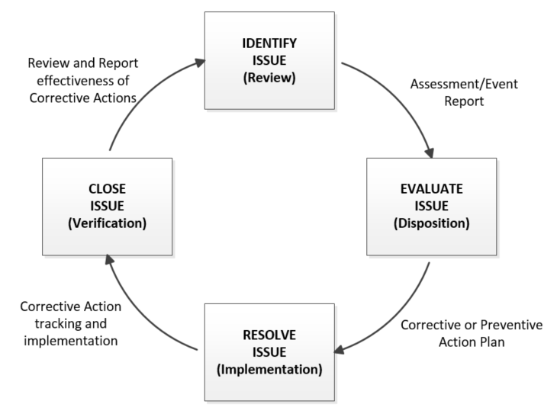

Figure 1. Feedback and Improvement

The sequence begins with the identification and reporting of a non-conformance or management concern. Non-conformities and management concerns are identified from formalized activities where reports are typically generated, as described in QAM 12030, iTrack Procedures & Risk Analysis.

All employees, contractors, subcontractors, and Fermilab users are encouraged to report any non-conformances or concerns to their immediate supervisor regardless of how it was discovered. Non-conformances may be identified during routine item inspections and tests, reviews, assessments, investigations, or audits as mentioned above. Persons leading such reviews, assessments, investigations, or audits may request CAPA’s from affected line management to resolve open issues. In some cases, the ESH&Q Section (ESH&Q) may request CAPA’s from line management on behalf of persons who led a Fermilab review, assessment, investigation, or audit. ESH&Q may also request CAPA’s as a result of an assessment conducted by or sponsored by ESH&Q. The issues management database, (iTrack) is the lab-wide approved tool to track actions until completion. See QAM 12030, for detailed information regarding the use of iTrack.

The persons responsible for resolving a non-conformance or management concern must submit a corrective or preventive action plan with an implementation date in iTrack. This responsible party shall also ensure that the facts supporting the identification of root causes, actions taken to resolve the issue, and lessons learned (where applicable) are documented with the issue in iTrack.

A graded approach is used to perform root cause analysis. This approach matches the risk level and severity of the non-conformance or management concern with the level of resources and depth of examination used to perform the root cause analysis. See QAM 12050, Fermilab Root Cause Analysis Procedure for guidance on conducting a root cause analysis.

During a root cause analysis, the responsible person may question not only if existing controls need to be updated but also whether the activity has the most appropriate controls under current operating conditions. Under these circumstances, QAM 12070, Fermilab Graded Approach Procedure, may be applied where the responsible person determines that corrective or preventive actions require a more formal approach to risk evaluation and control selection.

The CAPA should contain a description of actions that will be undertaken to prevent the occurrence of similar events in similar situations when such opportunities are identified. If corrective actions will require significant time to complete and implement, the CAPA must include interim corrective and/or remedial measures that will be implemented pending completion of the corrective action to reduce the possibility of the event or condition recurrence.

Once the CAPA is established and agreed upon, the responsible person implements the necessary actions. The responsible person closes the corrective action request in iTrack.

After a corrective action request is closed in iTrack, it is subject to an effectiveness review by the responsible person. iTrack automatically sends a request for the responsible party to complete an effectiveness review on the actions taken. This information is updated and kept in iTrack. See QAM 12030, iTrack Procedures & Risk Assignment for detailed information on how this process works. Corrective actions are effective when the causal chain of events leading up to the problem are broken and remain broken. Degree of validation will be commensurate with complexity, risk and cycle time associated with affected processes. Some actions may be validated formally by inspections, tests, reviews, surveillances, audits or other assessments. Other issues may simply be monitored to ensure the ongoing effectiveness of the actions taken.

Management Review of Corrective & Preventive Action Data
Line management shall analyze individual and collective problems or management concerns to identify trends or systemic weaknesses. Line management shall also review plans and actions taken to evaluate effectiveness as well as to identify if additional areas where improvements may be required.

RECORDS

Corrective & Preventive Action Plans in iTrack
Effectiveness Reviews in iTrack
Records of Reviews, Assessments, Audits, Inspections, and Tests

