 | Quality Assurance Manual | QAM 12020  January 2021

QAM 12020: SUSPECT/COUNTERFEIT ITEM (S/CI) PROGRAM

Revision History

Author | Description of Change | Revision Date
T.J. Sarlina | - Updated definitions and responsibilities.  - Added flowchart for S/CI process. | January 2021
T.J. Sarlina | - Added SURF applicability statement.  - Corrected outdated hyperlinks. | July 2018
Rafael Coll | Initial release of QAM 12020 replacing procedure 1006 of the former Office of Quality and Best Practices.  OQBP 1006 is obsolete upon publication of this chapter. | September 2013

 | Quality Assurance Manual | QAM 12020  January 2021

TABLE OF CONTENTS

1.0 INTRODUCTION AND SCOPE 3
2.0 DEFINITIONS 3
  - RESPONSIBILITIES 3
  - Laboratory Director 3
  - Quality Section Head 3
  - Suspect/Counterfeit Item Program Manager 3
  - Procurement Manager for Operations (PMO) 4
  - Procurement Specialist 4
  - Division/Section Heads and Project Managers (D/S/P) 4
  - Suspect/Counterfeit Item Coordinators 4
  - Supervisors, Construction Coordinators and Task Managers 4
  - Employees and Users 4
  - PROCEDURES FOR CONTROLLING IDENTIFIED S/CI 5
  - Preventing S/CI Through Engineering 5
  - Identification of S/CI 5
  - Segregate S/CI, Notify D/S/P S/CI Coordinator and S/CI Program Manager 5
  - Safety Risk 5
  - Enter S/CI in iTrack 6
  - Investigate S/CI 6
  - Determine Disposition 6
  - Update iTrack 6
  - Notification to the DOE Office of the Inspector General 6
  - Suspect/Counterfeit Item Notification Received by FRA 6
  - Suspect/Counterfeit Item Process Flowchart 7
5.0 REFERENCES 8
6.0 TECHNICAL APPENDIX A – Identifying S/CI 9
7.0 TECHNICAL APPENDIX B - S/CI Counterfeit Bolt Headmark List 12
8.0 TECHNICAL APPENDIX C - S/CI Tags 13

 | Quality Assurance Manual | QAM 12020  January 2021

1.0 INTRODUCTION AND SCOPE

It is the policy of Fermi Research Alliance (FRA) to make every reasonable effort to prevent the use of Suspect/Counterfeit Items (S/CI) to ensure personnel protection, public safety, and environmental integrity, while safeguarding investments that affect the laboratory's mission. This chapter applies to all activities at the main site in Batavia, Illinois and all Fermilab leased spaces.

This chapter describes the activities required to identify and control the use of suspect/counterfeit items at Fermilab. All new and existing items, equipment, products, or parts at Fermilab are within the scope of this document.

DEFINITIONS

Counterfeit item – An item that has been copied or substituted without legal right or authority to do so or one whose material, performance, or characteristics are knowingly misrepresented by the vendor, supplier, distributor, or manufacturer.

Nonconforming item – Any item that does not meet specified requirements. Items that do not conform to established requirements are not normally considered S/CIs if non-conformity results from one or more of the following conditions:
    - defects resulting from inadequate design or production quality control;
    - damage during shipping, handling, or storage;
    - improper installation;
    - deterioration during service;
    - degradation during removal;
    - failure resulting from aging or misapplication; or, other controllable causes.

Suspect item - An item identified through visual inspection, testing, or other means that does not appear to conform to established Government or industry-accepted specifications or national consensus standards. Or, items whose documentation, appearance, performance, material, or other characteristics may have been knowingly misrepresented by the vendor, supplier, distributor, or manufacturer.

RESPONSIBILITIES

Laboratory Director
    - Delegates authority for the S/CI Program to the Quality Section Head.

Quality Section Head
    - Appoints the S/CI Program Manager.

Suspect/Counterfeit Item Program Manager
    - Recommends S/CI notification to the OIG via the Fermi Site Office (FSO) when required.
    - Is the point of contact for Procurement in the event of an S/CI investigation.
    - Provides support to line management, S/CI Coordinators, and Division Safety Officers (DSO’s) in resolving open S/CI issues.

 | Quality Assurance Manual | QAM 12020  January 2021

    - Requests subject matter expert (SME) guidance from the relevant laboratory safety subcommittee chairs when S/CI discoveries or reports require a laboratory response.
    - Provides periodic status reports to the Laboratory Director, Quality Section Head, Chief Safety Officer, Fermi Site Office, FESHCom, line managers, and others as appropriate.
    - Maintains training materials and provides training as required.

Procurement Manager for Operations (PMO)
    - Perform searches of Purchase order database at the request of the S/CI Program Manager to determine if there is evidence that S/CI components have been ordered and/or received on site.

Procurement Specialist
    - Act as the liaison between FRA and suppliers to determine actions to be taken (i.e. credit, refund, or replacement) in the event that S/CI components are identified on site.

Division/Section Heads and Project Managers (D/S/P)
    - Ensure compliance with this procedure for their areas of responsibility including flow down of requirements and awareness.
    - Ensure individuals within their D/S/P are trained in S/CI where required.
    - Appoint S/CI Coordinator(s) for their organization.

Suspect/Counterfeit Item Coordinators
    - Complete the required S/CI training course.
    - Inform appropriate line management when an S/CI event occurs.
    - Coordinate S/CI investigations with line management and S/CI Program Manager.
    - Verify suspect parts are tagged/identified and segregated or isolated from inadvertent use.
    - Notify S/CI Program Manager and DSO if parts are deemed a safety risk.
    - Ensure required entries are made to iTrack and that reported S/CIs are tracked to completion.
    - List of current D/S/P S/CI Coordinators

Supervisors, Construction Coordinators and Task Managers
    - Notify S/CI Program Manager and relevant D/S/P S/CI Coordinator of potential S/CI.
    - Complete the S/CI training course.
    - Ensure that S/CI-related information is provided to all employees, subcontractors and users working under their direction as appropriate, either through formal training or documented transfer of information by an S/CI-trained FRA employee.

Employees and Users
    - Be vigilant to detect and report suspect/counterfeit items according to FRA procedures.
    - Understand the consequences of incorporating suspect/counterfeit material into the laboratory operations.
    - Be aware of items that are likely to be suspect/counterfeit as appropriate for their job duties.
    - Attend training in S/CI awareness as it pertains to their work.
    - Notify their immediate supervisor when a potential S/CI is discovered.

 | Quality Assurance Manual | QAM 12020  January 2021

PROCEDURES FOR CONTROLLING IDENTIFIED S/CI

This section describes the step by step procedure for managing S/CI upon identification. For a discussion of items which are prone to be counterfeited, refer to Technical Appendix A below.

For an item to be considered S/CI, it must first be nonconforming to specified requirements. Therefore, all confirmed S/CI are nonconforming items, but all nonconforming items are not necessarily S/CI. The nonconforming item is not automatically suspect unless there is evidence suggesting that it meets the definition of a suspect item or counterfeit item in the Definitions above.

Purchasing equipment from what is defined as reputable companies is not in itself protection against S/CI. Many reputable companies purchase components from outside suppliers and may fall victim to unscrupulous practices.

Note: FRA personnel SHALL NOT contact the supplier of a potential S/CI without concurrence from the Chief Safety Officer, the Quality Section Head, and the Head of Procurement.

Preventing S/CI Through Engineering
The first step in preventing suspect/counterfeit items from entering the production process lies with engineering controls. Engineering involvement in the development of procurement specifications and the selection of industry consensus standards play key roles in controlling S/CI.

Identification of S/CI
An individual identifies a potential S/CI, stops work associated with the S/CI, and notifies their immediate supervisor.

Segregate S/CI, Notify D/S/P S/CI Coordinator and S/CI Program Manager
The supervisor notifies the appropriate S/CI Coordinator of the S/CI, segregates the S/CI where practicable, and identifies the item with a standard FRA S/CI Tag, available in the stockroom, to prevent further use.

If it is not practicable to segregate the item (due to the nature of the item or because it is installed), line management will notify others in the area about the presence of S/CI. The supervisor ensures that work associated with the item is not resumed until an investigation has been completed and the item has been evaluated by engineering or some other subject matter expert (SME). The engineer or SME will assist in determining the items final disposition.

Safety Risk
The supervisor and S/CI Coordinator determine if there is a safety risk present. If there is no potential safety risk present, go to step 4.5.

If there is a potential safety risk present, the Division Safety Officer (DSO) shall be notified immediately by line management. The S/CI Coordinator and DSO proceed with an investigation and determine what potential safety-related risks are posed by the S/CI. The S/CI Program Manager and line management must be notified with the conclusions of the safety risks identified during the investigation so that if further actions can be taken if necessary.

 | Quality Assurance Manual | QAM 12020  January 2021

Enter S/CI in iTrack
The D/S/P S/CI Coordinator has the responsibility to ensure the item is entered into iTrack, including determination of any safety risks and actions taken from step 4.3. The iTrack item number shall be recorded on the S/CI tag, if possible.

Investigate S/CI
The S/CI Program Manager, S/CI Coordinator and line management, with SME and engineering participation as appropriate, complete an investigation and reach a conclusion indicating whether the item is suspect/counterfeit or just nonconforming. Two conditions must be met to conclude that the item is suspect/counterfeit:
    - It must be nonconforming to requirements specified during procurement, and
    - Its documentation, appearance, performance, material, or other characteristics may have been knowingly misrepresented.

Determine Disposition
Disposition of the S/CI is recommended by engineering and/or SME based on evaluation of the likelihood of injury to personnel, damage to the environment, damage to other equipment, and other technical and operational considerations. The disposition recommendation is sent to the S/CI Program Manager for approval, and then communicated to line management and DSOs.

If the S/CI is determined to be suspect or counterfeit, the S/CI Program Manager determines whether it is communicated through the DOE complex and if it is destroyed or retained for future training purposes.

If the S/CI is determined to be simply nonconforming then line management shall follow Procurement procedures to notify the vendor of the nonconforming item.

Update iTrack
The D/S/P S/CI Coordinator ensures iTrack is updated with the final disposition of the S/CI as well as what actions were taken and verifies the item is closed out.

Notification to the DOE Office of the Inspector General
DOE Order 221.1B requires DOE contractors to report instances of suspected fraud, waste, and abuse to the OIG. This all-encompassing requirement includes S/CIs. Reporting S/CIs pursuant to other DOE directives (i.e. ORPS) does not substitute for reporting S/CIs to the OIG. This requirement can be found in DOE G 414.1-2B, Section 5.5.

Suspect/Counterfeit Item Notification Received by FRA
If the Quality Section receives notice of S/CI discovered elsewhere, they will contact S/CI Coordinators to ensure an inspection is conducted. If items are discovered during the inspection, the S/CI Coordinator and line management ensure that it is managed in accordance with the procedures outlined in this chapter.

 | Quality Assurance Manual | QAM 12020  January 2021

Suspect/Counterfeit Item Process Flowchart
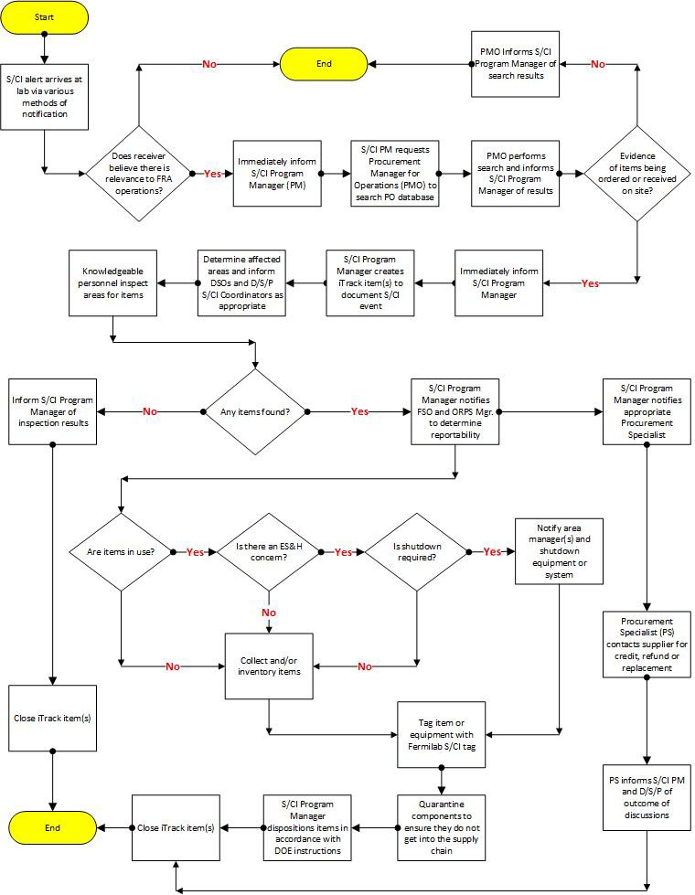

 | Quality Assurance Manual | QAM 12020  January 2021

REFERENCES

    - Fermilab Environment Safety & Health Manual (FESHM) Chapter 3010, Significant and Reportable Occurrences
    - DOE O 221.1B Reporting Fraud, Waste and Abuse to the Office of Inspector General

 | Quality Assurance Manual | QAM 12020TA  January 2021

TECHNICAL APPENDIX A – Identifying S/CI
Disclaimer
This appendix provides information on individual components identified as suspect/counterfeit items (S/CI). Without additional information, the manufacturers or suppliers identified should not be considered as to have engaged in any wrongdoing. It is not necessarily a negative reflection on a supplier or manufacturer if their products are reported as S/CI. Reputable manufacturers and suppliers have a vital interest in preventing the manufacture and distribution of S/CI associated with their names. The company may have been victimized and is pursuing S/CI associated with its products in an aggressive, prudent, and professional manner to get these items off the market. Therefore, each particular case must be examined on its own merit without making premature conclusions about the fault or culpability of the manufacturer or supplier whose name is associated with the S/CI.

Items prone to be counterfeited:
    - Moderate - or low-cost, high-demand/high turnover use items
    - Items easily copied by secondary market suppliers
    - Items that often bypass the vendor (seller or manufacturer) and are drop shipped to the requestor
    - Items that are not typically inspected
    - Items that are sold by un-authorized distributors
Typical Suspect/Counterfeit Items are:
    - Used, rebuilt, or reconditioned items sold as new
    - Fraudulently marked or labeled as being manufactured by a recognized reputable company, or certified by a regulatory or certifying agency
    - Manufactured with misrepresented inferior materials, or processes that create a potential for failure and exposure to hazards.
Industrial types of items, materials, parts, and components that have been counterfeited include, but are not limited to:
    - Hoists, as well as other hoisting, lifting, and rigging equipment
    - Pumps, valves, pipe, pipe fittings, plates, couplings, plugs, spacers, nozzles, supports, hangars, and flanges
    - Pre-formed metal, elastomers (O-rings, seals), spare replacement kits from suppliers other than the original equipment manufacturer, weld-filler material, diesel generator speed governors
    - Fasteners: Metallic screw, nut, bolt, or stud having internal or external threads with a nominal diameter of 1/4 inch (6 mm) or greater. Washer that is through-hardened or represented as meeting a consensus standard that calls for through-hardening, and that is grade identification marked or represented as meeting a consensus standard that requires grade identification marking. e.g., J429 standard for automotive and related industries - below grade 5 (plus grade
8.1 studs) no grade-mark required. However, all bolts and screws shall bear the manufacturer identification symbol.
    - Electrical equipment and devices, including circuit breakers, transformers, fuses, relays, resistors, capacitors, semiconductors, connectors, switch gear, power supplies, inverters, transmitters, and motors
    - Metal plates, bars, shapes, channel members, and other structural items

 | Quality Assurance Manual | QAM 12020TA  January 2021

    - Welding rods and electrodes

The listing of commercial grade items that have been counterfeited is extensive. A partial listing is:
    - Batteries: household, camera, and cell phone
    - Extension cords
    - Surge suppressors
    - Fire extinguishers
    - Automotive components, including oil filters and brake pads
    - Computer components, semiconductors, software
    - Pharmaceuticals

SUSPECT ITEM INDICATOR LIST
Note: This information alone does not constitute an item or material as being S/CI. Further research, such as a review of purchase orders, specifications, and certification / documentation is required before an item can be categorized as S/CI.

GENERAL INDICATORS
Visual Inspection
  - Nameplates, labels, or tags have been altered, photocopied, or painted over; are not secured well; are unusual in location and method of attaching; have incomplete data; or are missing.
  - Preprinted labels that show typed entries.
  - Item has wear marks or scratches on external surfaces.
  - Obvious attempts at repair or beautification have been made, such as excess painting or wire brushing; evidence of hand-painting (touch-up), painted stainless steel; non-ferrous metals (e.g., copper, brass, bronze) are clean and bright indicating recent polishing.
  - Handmade parts are evident; gaskets are rough-cut; shims and thin metal part edges show evidence of cutting or dressing by hand tools (filing, hacksaw marks, tin snips, or nippers).
  - Assembled items fit poorly.
  - Metallic items are pitted or corroded.
  - Heat discoloration marks.
  - Casting markings have been ground off and the item has been re-stamped with other markings.
  - Configuration is not consistent with other items from the same supplier or varies from that indicated in supplier literature or drawings.
  - Inconsistency between vendor (seller/manufacturer) name on the item, and shipping container.
  - Visual Inspection continued
  - Nameplates attached with inconsistent fasteners, such as screws instead of rivets, or a combination of rivets and screws.
  - Nameplates attached in a different location than normal.
  - Warning labels with grammatical errors and conflicts with information found elsewhere on the packaging.
  - Nameplates missing manufacturer’s standard markings, stamps, or logos, and with irregular stamping or inconsistent type (font).
  - Inconsistent appearances of items in the same shipment.
  - Shipping boxes / totes containing mixed batch numbers, expiration dates, and uniform product codes (UPC).

 | Quality Assurance Manual | QAM 12020TA  January 2021

  - The item or component matches the description of one that is listed on a suspect item list (e.g., DOE Suspect/Counterfeit Fastener Headmark List).
  - Unusual packaging and boxing of items. Packaging is inconsistent with the manufacturer’s normal packaging or documentation requirements.
  - Questionable or meaningless numbers on the item(s) or packaging.
  - Signs of weld repairs
  - Country of origin is China1, Taiwan, India, Korea, or Mexico.
  - Underwriters Laboratories (UL) marks missing one or more of the four elements (UL trademark, the word LISTED in capital letters, product identity, and a control number)2; a UL mark on the package – but not on the product.
Procurement
  - Quoted price for the item is unusually discounted or low.3
  - Unusual disclaimers, or denials, of responsibility for the accuracy of the test results, etc.
  - The supplier is not a manufacturer’s authorized distributor.
  - Dimensions of the item are inconsistent with the specification requested on the purchase order, and those provided by the manufacturer at the time of the shipment.

There have been reports of counterfeiters raising prices to just below OEM levels in order to prevent such concerns.

DOCUMENTATION
Documentation may be suspect or fraudulent when:
  - The use of correction fluid or correction tape is evident.
  - Type style, size, or pitch change is evident.
  - Documentation is not signed or initialed when required.
  - It is excessively faded or unclear (indicating multiple, sequential copying), or data is missing.
  - The name of the document approver, or title, cannot be determined; the document has missing or illegible signature, initials; the approvers name and signature does not match.
  - Technical data is inconsistent with code or standard requirements.
  - Certification or test results are identical between items when normal variations should be expected.
  - Document is not traceable to the items procured.
  - Corrections are not properly lined-out, initialed and dated.
  - Documentation is not delivered as required on the purchase order or is in an unusual format.
  - Lines on forms are bent, broken, or interrupted indicating data has been deleted or exchanged by “cut and paste”.
  - Handwritten entries are on the same document where there is typed or preprinted data.
  - Text on page ends abruptly and the number of pages conflicts with the transmittal.
  - Data on a single line is located at different heights.

 | Quality Assurance Manual | QAM 12020TA  January 2021

7.0 TECHNICAL APPENDIX B - S/CI Counterfeit Bolt Headmark List
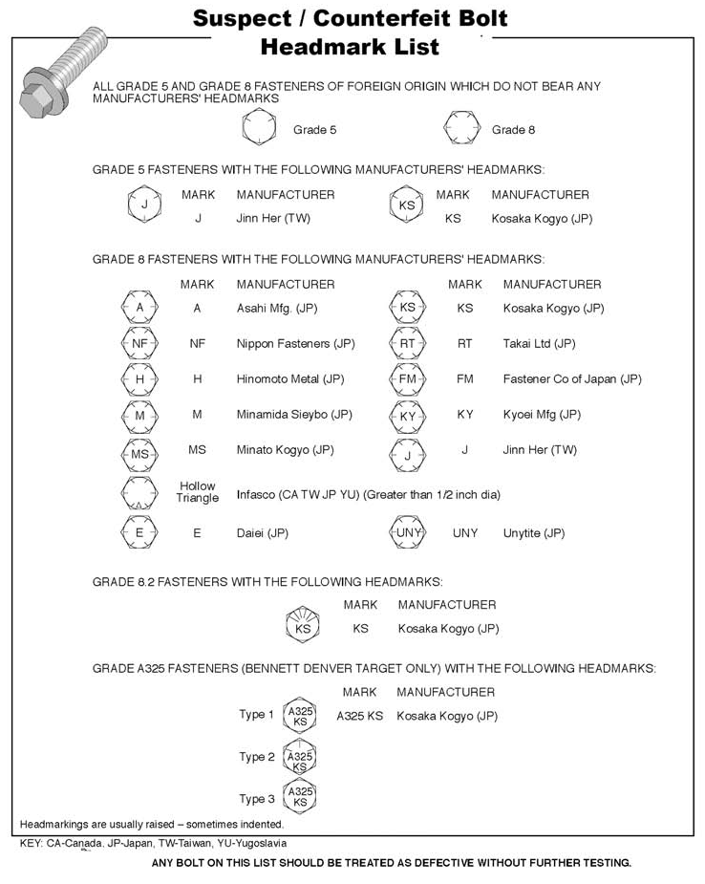

 | Quality Assurance Manual | QAM 12020TA  January 2021

8.0 TECHNICAL APPENDIX C - S/CI Tags

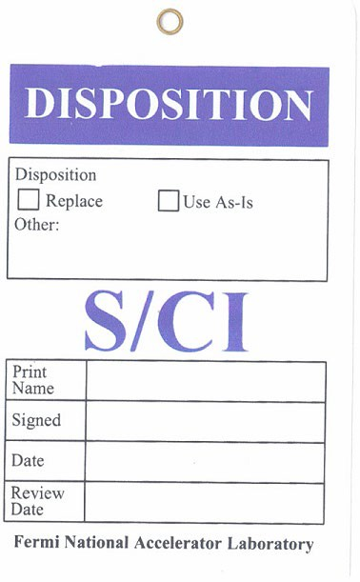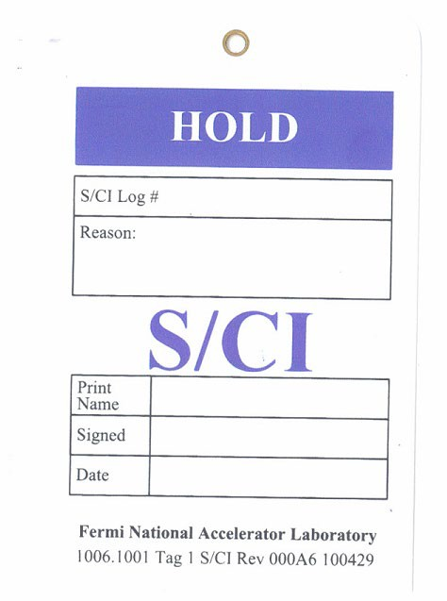FRONT S/CI Tag

BACK S/CI Tag

2650-402500 TAG, S/CI, RIGID VINYL, CUSTOM, 3-1/2 IN. X 5-1/2 IN. X .015 IN., W/ HANGER WIRE ATTTACHED, MFG. COLOR LOV-568 PURPLE, PACKAGE B1, 25 EA. PER PKG., PAMCO P/N MS-GW- MED ONLY -

