FESHM 8041: POLYCHLORINATED BIPHENYLS

Revision History

Author | Description of Change | Revision Date
- Pavnica | - Added Program Description and elements  - Edited responsibilities  - Reviewed chapter for accuracy.  - Removed references to ESH&Q. | April 2022
D. Hockin | - Added statement of applicability to Fermilab Leased Spaces.  - Removed reference to AD Waste Coordinator. Various minor editorial changes throughout document. | February 2018
E. Mieland | - Added Accelerator Division responsibility and oversight for groundwater contamination at TEV service buildings.  - Added technical appendix further describing service building groundwater contamination management. | December 2014
B. Fritz | - Added Centers (D/S/C) to organizational structure references throughout the document.  - Included controlled document statement to footer.  - Various minor editorial changes throughout document. | September 2009

TABLE OF CONTENTS

1.0 INTRODUCTION 3
2.0 DEFINITIONS 3
3.0 RESPONSIBILITIES 4
3.1 Division/Section Heads/Project Managers 4
3.2 Accelerator Division 5
3.3 Individuals Working with or Managing PCB-Containing Equipment 5
3.4 ES&H Section Hazard Control Technology Team 5
3.5 ES&H Section Environmental Protection Group 5
4.0 PROGRAM DESCRIPTION 5
5.0 REFERENCES 7
6.0 TECHNICAL APPENDIX 7
6.1 Restrictions Pertaining to Main Ring Service Buildings B-1 and B-4 7

1.0 INTRODUCTION

Polychlorinated biphenyls (PCBs) were manufactured primarily for dielectric oil used in electrical equipment such as transformers, capacitors, circuit breakers, electromagnets, and re-closers. PCBs were also used as a component in some hydraulic and heat transfer fluids. Because of their toxicity and persistence, the distribution in commerce of PCBs was severely restricted in 1979. This chapter describes Fermilab's program to ensure that PCBs are managed in compliance with applicable regulations and in a manner that protects human health and the environment. PCBs are regulated by the Toxic Substances Control Act (TSCA) and requirements pertaining to the manufacture, processing, use, storage, spill cleanup, and disposal of PCBs are found in 40 CFR Part 761.

The reclamation or disposal of any equipment or material containing measurable concentrations of PCBs (>1 ppm) shall be accomplished in accordance with the requirements of Chapter 8021 of this manual and be coordinated with the ES&H Section. This includes small PCB capacitors and those fluorescent light ballasts that contain small PCB capacitors or PCBs in the potting material.

This chapter only applies to the Fermilab site. Leased spaces will follow the rules and regulations set forth by the partnering institute and/or state, local or federal codes and standards.

2.0 DEFINITIONS

TSCA definitions are found in 40 CFR 761.3. A few definitions from § 761.3, abbreviated or annotated in some cases, that are particularly important:

Disposal – intentionally or accidentally to discard, throw away, or otherwise complete or terminate the useful life of PCBs or PCB items. Disposal includes spills, leaks, and other uncontrolled discharges of PCBs.

Fluorescent Light Ballast – a device that electrically controls a fluorescent light fixture and that includes a capacitor containing 0.1 kg (.22 lb.) or less of dielectric.

Leak – any instance in which a PCB article, PCB container, or PCB equipment has any PCBs on any portion of its external surface.

PCB Contaminated Equipment – transformers and other electrical equipment that contain ≥50 ppm PCBs, but <500 ppm PCBs. Pole-top transformers that were manufactured prior to July 2, 1979, or for which the date of manufacture is not known, are presumed to be in this category if they have not been tested (§ 761.2(a)(2)).

PCB Transformer – any transformer that contains >500 ppm PCBs.

Small Capacitor – a capacitor that contains <3 lb. of dielectric fluid, or has a total volume of <100 in³, or has a total volume of ≤200 in³ and weighs <9 lb.

Large Capacitor - a capacitor that contains ≥3 lb. of dielectric fluid, or has a total volume of >200 in³, or has a total volume ≥100 in³ and weighs ≥9 lb.

Large High Voltage Capacitor - a large capacitor that operates at 2,000 volts (A.C. or D.C.) or above is considered a large high voltage capacitor and may be used only in very limited circumstances (see § 761.30(l)(1)). In the absence of other data, capacitors manufactured prior to July 2, 1979, or whose date of manufacture is not known, must be assumed to contain ≥500 ppm PCB (§ 761.2(a)(4)).

3.0 RESPONSIBILITIES

3.1 Division/Section Heads/Project Managers
- Division/Section Heads/Project Managers (D/S/P) shall ensure compliance with applicable regulations by developing and maintaining a plan that includes all of the program elements.

- Ensure training and guidance to personnel who work with or are responsible for PCB containing equipment.

- Expeditiously arrange for transfer of generated PCB waste to the HCTT. In the event that PCB waste will be shipped off site directly from the point of generation, coordinate the shipment with the HCTT.

- Periodically inspect PCB containing equipment to verify compliance with applicable requirements.

- Inform the HCTT of any proposed contract involving disposal of PCB containing waste materials.

3.2 Accelerator Division
- Maintain protocols for the management of historical low-concentration PCB groundwater contamination at B-1 and B-4 Main Ring service buildings. See Technical Appendix 5.1 for further description.

- Coordinate with the ES&H Environmental Protection Group (EP Group) for notifications to regulatory agencies in the event of excavation of the affected areas.

3.3 Individuals Working with or Managing PCB-Containing Equipment
- Maintain inventory of PCB containing equipment according to 40 CFR 761.35

- Mark or attach labels to PCB containing equipment being used or removed from service

- Ensure that property sold, sent to surplus or transferred by Fermilab is free of PCBs unless specifically approved by the Laboratory Director.

- Ensure proper disposal, according to FESHM 8021, Technical Appendix, Section B.

3.4 ES&H Section Hazard Control Technology Team
- Collect, store and make arrangements for the disposal of PCB containing waste material from D/S/P upon request, and/or coordinate the shipment for disposal of PCB waste material from the point of generation.

3.5 ES&H Section Environmental Protection Group
- Coordinate PCB related inspections of Fermilab by DOE Fermi Site Office (FSO) or outside regulatory agencies.

- Coordinate communications with FSO and outside regulatory agencies regarding PCB issues, including any required spill reporting.

4.0 PROGRAM DESCRIPTION
Elements of the PCB Program include:
- Ensure that property purchased by Fermilab is free of PCBs unless specifically approved by the Laboratory Director or designee.

- Identify and mark all equipment or materials containing PCBs in accordance with applicable requirements (40 CFR 761.40). If item is removed from service, indicate the date on which the item was removed from service; distinguish whether the item is intended for reuse or disposal. Mark PCB waste with both PCB and Special Waste labels.

- Maintain an inventory of all PCB containing equipment, including description (manufacturer, model, serial #), location, and quantity of PCBs (weight or volume and concentration).

- Comply with the provisions of 40 CFR 761.35 for PCB items that are not in active use but are needed as spares. Items may be stored locally for a limited time as long as the items have an intended use. However, if an equivalent non-PCB substitute is commercially available at reasonable cost, replacement and disposal of the PCB item is the preferred course of action. Once an item is no longer needed, it shall be marked with the date on which that decision was made. At this point, it becomes waste and is now in storage for disposal.

- Expeditiously characterize any electrical equipment suspected to contain PCBs.

- Ensure that personnel who work with or are responsible for PCB containing equipment are trained to comply with applicable requirements.

- Impose protective measures and containment, as practicable, to prevent or minimize human exposure and the impact of a release or spill of PCBs into the environment.

- Report any uncontrolled PCB spill or release into the environment to the
Communications Center via the 3131 emergency telephone number. Report minor leaks to Division Safety Officer (DSO). Spills must be cleaned up in accordance with 40 CFR 761, Subpart G. Spill cleanups must be performed by qualified HAZWOPER trained employees or subcontractors.

- Facilitate prompt pick-up of all PCB waste by contacting the Hazard Control Technology Team (HCTT). This should be done at the time the work is planned. PCB wastes may be stored locally in a labeled area for no longer than 30 days. A Waste Pickup Request Form must be completed and submitted to the HCTT upon generation of PCB waste to ensure that the 30-day storage limit is not exceeded.

5.0 REFERENCES

Toxic Substances and Control Act

Title 40, CFR, Part 117, Determination of Reportable Quantities for Hazardous Substances

Title 40, CFR, Part 302, Designation, Reportable Quantities, and Notification

Title 40, CFR, Part 761, Polychlorinated Biphenyls (PCBs) Manufacturing, Processing, Distribution in Commerce, and Use Prohibitions

6.0 TECHNICAL APPENDIX

6.1 Restrictions Pertaining to Main Ring Service Buildings B-1 and B-4
The groundwater at Main Ring Service Buildings B-1 and B-4 is potentially contaminated with residual polychlorinated biphenyl (PCB). See area pictures below and as noted in the FESS Geographic Information System (GIS) Land Planning layer. The U.S. EPA has given Fermilab permission to consider the residual PCB contamination at these locations as “disposed in place” pursuant to sampling and risk analysis. This permission is contingent upon Fermilab notifying the U.S. EPA in writing, at least 10 days prior to excavating any soil or any other material in the area where contaminated groundwater exists. Accelerator Division is the owner of B-1 and B-4 and has instituted protocols for the management of the potentially contaminated areas.

Excavation at either of these areas requires notification to the EP Group and DSO. The EP Group will coordinate with FSO on notifications to the U.S. EPA. Responsible parties should allow at least two weeks for the notification to proceed through the EP Group and FSO. In the event of an emergency requiring immediate excavation, the EP Group must be notified immediately, by contacting the Main Control Room and/or the Communications Center.

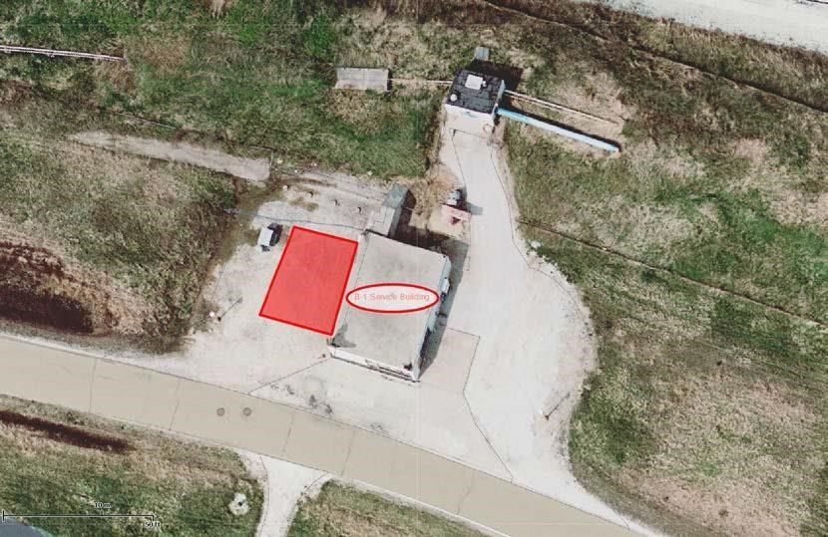
B-4 Service Building
Affected Area
B
-
1
Service Building

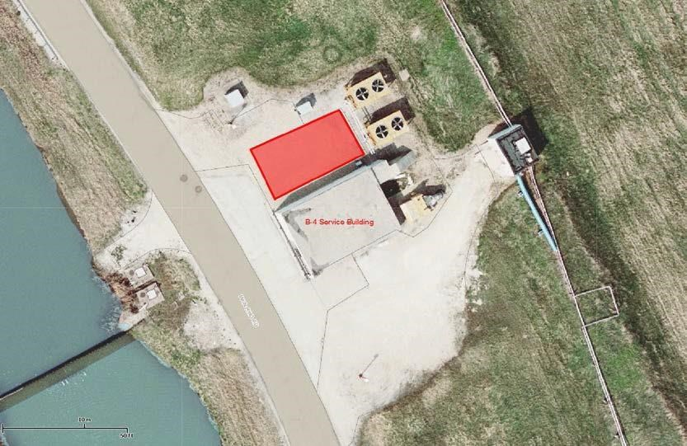
Affected Area

