FESHM 6020.4: CONCEPTS OF EGRESS

Revision History

Author | Description of Change | Revision Date
J. Niehoff | Updated code reference editions; added Roles and Responsibilities | May 2018
J. Niehoff & J. Priest | Renamed chapter from “Minimum Aisle and Door Widths for Safe Egress” to “Concepts of Egress” to reflect actual contents; Applied FESHM Chapter format template; Added Means of Egress, Exit, and Exit Discharge to definitions; Added 4.3 Exterior Door Numbering section. | February 2013
W. James | Initial release Chapter 6020.4 | March 2010

TABLE OF CONTENTS

1.0 INTRODUCTION 3

2.0 DEFINITIONS 3

3.0 RESPONSIBILITIES 3

3.1 Building Manager 3
3.2 ESH&Q- Fire Protection Engineer or FHS 3
3.3 Facilities Engineering Service Section (FESS) Engineering Department or Project 4

4.0 PROGRAM 4

4.1 Overview of Occupancy & Means of Egress 4
4.2 Overview of Doorways 5
4.3 Exterior Door Numbering 6

5.0 REFERENCES 7

INTRODUCTION

Aisle widths in Laboratory buildings shall conform to the requirements of NFPA 101, Life Safety Code, and International Building Code (IBC) to provide safe exiting from a building in case of fire. These requirements are summarized below. In the event of a discrepancy between the summary given below and the requirements of NFPA 101, the requirements of NFPA 101 take precedence. The occupancy use group is determined by IBC and NFPA 101.

Illinois and Federal regulations that govern egress and area refuge may supersede these requirements.

DEFINITIONS

- Means of Egress - A continuous and unobstructed way of travel from any point in a building or structure to a public way consisting of three separate and distinct parts: (1) the exit access, (2) the exit, and (3) the exit discharge.
- Exit Access – Portion of a means of egress that leads to the entrance of an exit and consists of three components: (1) Travel Distance – Measured at the most remote point of the room or floor, to travel to an exit, such as an enclosed fire rated stair, (2) Common Path of Travel – Length to travel to make a decision on what exit to use, and (3) Dead End Corridor/Aisle – An extension of a corridor/aisle beyond an exit or an access to exits that forms a pocket in which occupants may be trapped, delaying the egress time.
- Exit – Portion of means of egress that is separated from the area of the building from which escape is to be made by walls, floors, or other means that provide the protected path necessary for the occupants to proceed with reasonable safety to the exterior of the building. An exit may consist of vertical (e.g. stairs and in special cases, elevators) and horizontal means (e.g. passageways and labyrinths).
- Exit Discharge – Portion of a means of egress between the termination of the exit and a public way. Fermilab defines public way as outside facility, sidewalk, parking lots, etc.
- Occupancy - The purpose for which a building or portion thereof is used or intended to be used.
- Means of Egress - A continuous and unobstructed way of travel from any point in a building.

RESPONSIBILITIES

Building Manager

- The Building Managers assigned to specific buildings ensure that egress routes are clear and maintained.
- The Building Manager or designee at the request of the Fire Department, shall make arrangements to number exterior and interior doors in accordance with this chapter.

ESH&Q- Fire Protection Engineer or FHS

- Assists FESS\Engineering Department or Project as requested during the design, installation, testing, and final acceptance.

PROGRAM

Overview of Occupancy & Means of Egress

- Minimum corridor or aisle width, clear of any obstructions, must be sufficient to accommodate the required occupant load, but cannot be less than the following Table No. 1.

Table No. 1
Occupancy | Minimum Width Corridors | Travel Distance | Common Path of Travel | Dead End
Assembly (A), Educational (E), Consult FESS Engineering Department for further requirements | A = Varies  E = 72-inches | 200-Ft / 250-Ft* | 75Ft / 100Ft* | 20-Ft
Business Use Groups (B) | 44-inches | 200-Ft / 300-Ft* | 75Ft / 100Ft* | 20Ft / 50Ft*
Industrial Moderate Hazard (F-1) & Storage Moderate Hazard (S-1) | 36-inches  If <50 occupants | 200Ft/250Ft*  /400Ft* | 75Ft /100Ft* | 20Ft
Industrial Low (F-2) & Storage Low Hazard (S-2), | 36-inches  If <50 occupants | 300FT / 400FT* | 75Ft /100Ft* | 20Ft
Special or High Hazard (H-1 through H-5) Consult ESH&Q or FHS for further requirements | 44-inches | 75Ft | 25 Ft | 0
Lodging & Rooms  Hotels/Dorms | 36-inches  44-inches | 75Ft / 100Ft* | 75Ft / 100Ft* | 20Ft
*If sprinkler protection is provided, then travel distance can be extended.

Overview of Doorways

- Minimum doorway widths cannot be less than the following Table No. 2.

Table No. 2
Occupancy | Minimum Aisle Width | NFPA 101 Reference(s) & OSHA
Existing Buildings | 28 inches | 7.2.1.2.4
Existing, minimum width of any way of exit access | 28 inches | 29 CFR OSHA 1910.36(g)(2)*
New Buildings (except as modified below)* | 32 inches (Door Clearance) | 7.2.1.2.4
Lodging & Rooming Houses | 28 inches | 26.2.3.1
One & Two-Family Dwellings | 28 inches | 24.2.4.1
One & Two-Family Dwellings – Bathroom Doors | 24 inches | 24.2.4.2
*Preference is 36-inches and below grade 44-inches

Exterior Door Numbering

- Prior to labeling door, review scheme with Fermilab’s Fire Department.
- Larger buildings and, under the direction of the Fermilab’s Fire Department, exterior man doors will be numbered at the top right, starting at the front, street side, and then clockwise around the building, see Figure No. 1. Additional requirements are:
  - Arabic Numbers, minimum of 4-inches in height with a minimum stroke width of 0.5 inches;
  - Numbers shall be visible and contrast with the building’s background;
  - Contrasting color, retro-reflective material for low light.
  - Door numbers shall be added to the HazMaps.
4
5
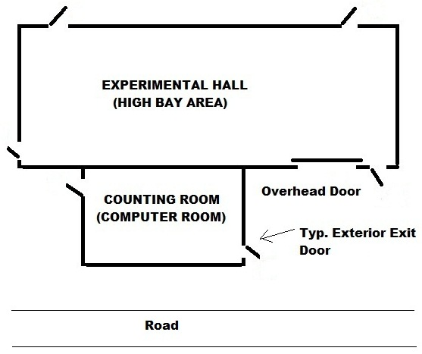
3
2
1
6
Figure No.1: Sample of Door numbering

REFERENCES

- FESHM Chapter 6010, Fire Protection Program
- FESHM Chapter 6016, Hazardous Map Program
- FESHM Chapter 7010, ES&H Program for Construction
- International Building Code (IBC), Chapter 10, 2015 Edition
- International Fire Code, Section 505, 2015 Edition
- NFPA 101, Life Safety Code, Chapter 7, 2015 Edition
- Fire Protection Handbook, Twentieth Edition
- Fermilab’s Facilities Engineering Services Section’s Design Guides

