FESHM 2110: Ensuring Equivalent Safety Performance when
Using International Codes and Standards

Revision History

Author | Description of Change | Revision Date
Martha Michels | Updated to clarify that this is an alternate standard acceptance process policy, not an equivalency process policy. Changed the name of the chapter. | January, 2017
Martha Michels | Initial release of chapter | June 1, 2016

TABLE OF CONTENTS

1.0 INTRODUCTION 3
2.0 DEFINITIONS 3
2.1 Appropriate U.S. Governing Code 3
2.2 An International Code or Standard 3
2.3 Code Equivalency Review 3
2.4 White Paper 3
2.5 Qualified Person 3
3.0 RESPONSIBILITIES 4
3.1 Chief Safety Officer (CSO) 4
3.2 D/S/P Head 4
3.3 Division Safety Officer/Project Safety Officer 4
3.4 FESHCom Subcommittee Chairs 4
3.5 DOE Fermi Site Office (FSO) 4
4.0 PROGRAM DESCRIPTION 4
4.1. Writing a White Paper 5
4.2. CSO Approval and FSO concurrence 6
4.3. Modification of existing FESHM chapter or creation of new FESHM chapter allowing code equivalency between international and U.S. codes and standards. 6

INTRODUCTION

This FESHM chapter describes the process used to establish equivalent safety performance between U.S. and International engineering design codes and standards. This will enable the Laboratory to accept in kind contributions from International partners or purchase equipment designed per International standards while assuring an equivalent or greater level of safety. This may be applicable to activities at Fermilab and at remote sites as well (e.g. Sanford Underground Research Facility)

DEFINITIONS

Appropriate U.S. Governing Code
A national, state or local engineering code or standard that specifies design, fabrication, and operation requirements and practices that must be followed for systems within their respective scopes.

An International Code or Standard
A recognized international (non-U.S.) code or standard, for example European harmonized standards of European Pressure Equipment Directive (97/23/EC) or Low Voltage Directive (2006/95/EC).

Equivalency Review
Equivalency of safety performance of the equipment designed, manufactured, tested and marked per one, or several, harmonized European standards versus similar equipment designed, manufactured, tested and marked per appropriate US code(s) or standard(s). The goal of the review is to provide evidence, or lack of such, that the safety of equipment designed, fabricated, installed and operated per an international standard is equal or greater than the safety of same equipment if designed, fabricated, installed and operated per appropriate U.S. governing code or standard. See Figure 1 for details of the process.

White Paper
A written analysis supporting safety performance equivalency of the international code or standard to the appropriate U.S. code or standard already accepted by Fermilab. The analysis must provide evidence that the safety of equipment designed, fabricated, installed and operated per an international standard is equal or greater than the safety of same equipment if designed, fabricated, installed and operated per appropriate U.S. governing code or standard. See Figure 1 for details of the process.

Qualified Person
A qualified person is a person who, by possession of a recognized degree or certificate of professional standing and by extensive knowledge, training and experience, has successfully demonstrated the ability to solve or resolve problems relating to the subject matter and work, and therefore can be considered a Subject Matter Expert (SME). A group of qualified people of the right level of expertise is typically needed to establish the level of safety provided in the code is equivalent between international and U.S. codes and standards. It may be necessary to engage qualified persons from outside the laboratory for some equivalency reviews.

RESPONSIBILITIES

Chief Safety Officer (CSO)
The Chief Safety Officer is responsible for the development of this policy and oversight of its implementation, including seeking concurrence from DOE Site Office manager that the laboratory has adequately used their process to establish safety equivalency between international and U.S. codes and standards.

D/S/P Head
The D/S/P Head (or designees) is responsible for the implementation of this chapter’s requirements in their organization or on their Project by allocating resources for investigative work of internal and external qualified persons necessary to establish safety performance equivalency between international and U.S. codes and standards.

Division Safety Officer/Project Safety Officer
The DSO assists the D/S/P Head in ensuring the requirements of this chapter are implemented in their organization.

FESHCom Subcommittee Chairs
The chairperson for each relevant FESHCom shall ensure that the right level of expertise is involved in the safety performance equivalency review. The Chair is also responsible for selecting the qualified persons who will write the documentation that will serve as the justification for accepting an equivalency.

DOE Fermi Site Office (FSO)
DOE Fermi Site Office (FSO) is responsible for review of recommendations submitted by CSO and making a decision on concurrence in a timely fashion.

PROGRAM DESCRIPTION

Fermilab requires global engineering design for neutrino detectors, linear accelerators, and other scientific installations. In many instances, such projects are international and involve collaboration and partnership with many scientific institutions and universities from all over the world. These institutions may contribute equipment for installation at Fermilab or at Fermilab experiments. Additionally, in effort to obtain superior and safe technology at lower costs, Fermilab may bid to procure equipment from international companies. When such equipment is built, it is typically built per one of the international Standards or Directives. For example, equipment built to European standards is CE-marked to declare its conformity to such standards.

Procedures for design and acceptance of mechanical and electrical equipment utilizing ASME, ANSI, OSHA and other applicable U.S. standards are well established and incorporated into other parts of this manual. However, experience with procurement from Europe shows that the benefits of using an alternative to U.S. Standards (e.g. EN Standards) are not being fully utilized, which results in excessive costs, duplicated effort and ineffective use of resources for integrating mechanical and electrical equipment designed and built by non-U.S. laboratories and international manufacturers.

The safety performance equivalency process is the formal engineering analysis that captures the comparisons of the U.S. Codes and Standards vs. a particular international standard and the conclusion of safety performance equivalency or not. Establishing the safety performance equivalency between the standards will enable the laboratory to accept equipment from international partners or companies without fear of increased risk or noncompliance. The safety performance equivalency process utilizes a group of qualified persons to create and review a White Paper. See Figure 1 for details of the process.

4.1. Writing a White Paper

FESHCom subcommittees establish a SME group of qualified persons to investigate whether a U.S. appropriate code or standard exists and can be used to establish safety performance equivalency with the international code or standard that is used for design of specific type of equipment.

In cases, where multiple codes or standards are used to design same equipment, or multiple or ambiguous levels of safety performance equivalency can be established, then the group of experts must come up with a clear scope and equivalency pairs. For example, if a vessel is designed and stamped per EN13445, an equivalent U.S. code must be identified and listed, e.g. ASME BPVC Section VIII. If equipment is designed per one governing code, but supplied with protective devices per another governing code, a safety performance equivalency should be established for that protective device separately.

A typical White paper includes:

(1) Abstract
(2) Placeholder for signatures of qualified people forming an investigating or advisory group
(3) List of work group members and consultants and their roles
(4) Goals
(5) Findings
(6) Recommendations
(7) References and supporting documents

Additionally, the White Paper may include:
- Independent technical verification by experts from outside Fermilab
- Examples from industry or other DOE labs showing safe use of equipment designed per international standards
- Research and investigations done by industry and other DOE labs proving safety performance equivalency
- Design drawings, sketches, and calculations in support of findings
- Examinations and inspections of materials, in-process fabrications, non-destructive tests, and acceptance test in support of findings
- Documentation, traceability, and accountability for each unique system, including descriptions of design, testing, inspection, operation, repair, and maintenance in support of findings.

The White Paper must provide recommendations to the CSO of safety performance equivalency between the codes, including any exceptions or exclusions between international and U.S. codes or standards. The White Paper must be signed by all qualified persons who authored the white paper.

4.2. CSO Approval and FSO concurrence

If safety performance equivalency between the codes can be established by the SME group, the findings of the White Paper will be discussed and reviewed by a wider audience of experts, typically the members of the appropriate FESHCom Subcommittee. In some cases, two or more FESHCom Subcommittees may participate in the review if multiple areas of expertise are required. Typically, for a review by the FESHCom subcommittee, the group of subject matter experts must also propose a modification of the existing FESHM chapter to indicate safety performance equivalency between the codes. The FESHCom Subcommittee Chair(s) are responsible for organizing feedback from their committees and delivering the feedback to the authors of the White Paper. Finally, if a White Paper passes review process by the FESHCom subcommittee(s), then it should be submitted to the CSO for approval and subsequent submittal to FSO for concurrence.

If safety performance equivalency between the codes is too ambiguous or cannot be established, then the group of SMEs must report such findings to the CSO. In such a scenario, each and every piece of equipment designed per international code must be reviewed per established criteria of FESHM to establish its safety and acceptance for operations with a possibility of exception granted by the Authority Having Jurisdiction.

4.3. Modification of existing FESHM chapter or creation of new FESHM chapter allowing safety performance equivalency between international and U.S. codes and standards.

If safety performance equivalency between the codes is established and recommendations of the White Paper are approved by the CSO and the FSO concurs that the Laboratory followed their due process, an existing FESHM chapter can be amended/modified per established procedure to list international standards as appropriate standards for certain equipment. A typical example would be FESHM 5031 “Pressure Vessels” or 5031.1 “Process Piping”. Alternatively, a new FESHM chapter can be established to specifically list equipment (or part of equipment) designed per international code or standard. A typical example would be FESHM 5031.7 “Membrane cryostats”.

A chart on Figure 1 below describes the process flow for accepting international code or standard code safety performance equivalency and paths leading to accepting non-US coded equipment for use at Fermilab and at remote sites.

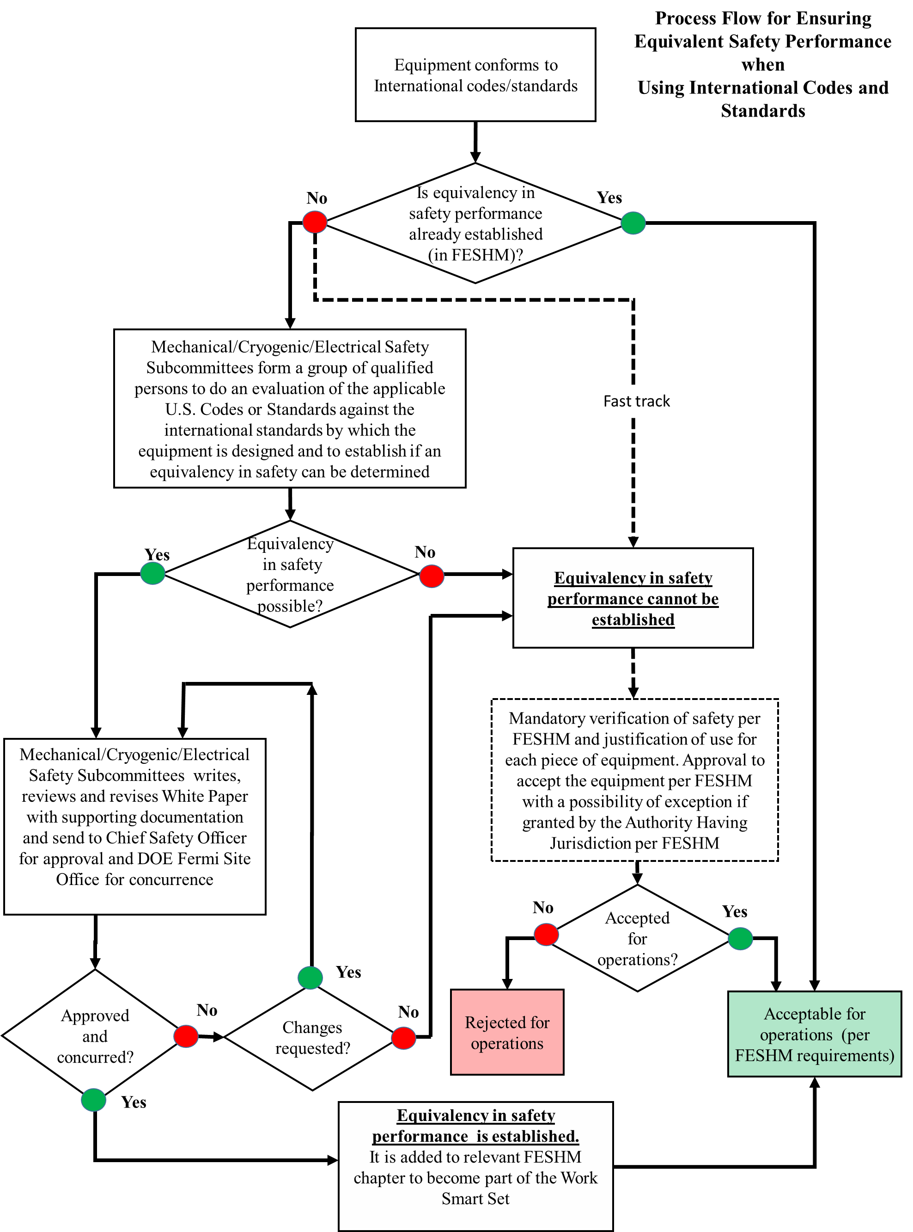

Figure 1 Process flow for accepting equivalency in safety performance

