Atmospheric Testing

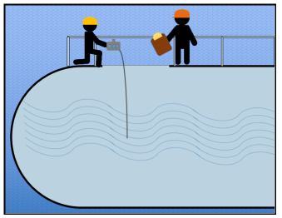
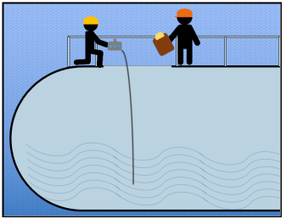
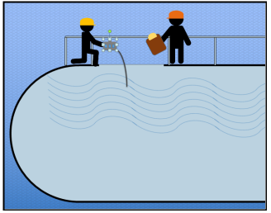

Methane Combustible Gas Hydrogen Sulfide (H2S) Carbon Monoxide (CO)
(Lighter than air) (Slightly heavier than air) (Slightly lighter than air)

As the diagrams above indicate, depending on their weights, hazardous gases could be at the bottom, middle or top of a given confined space. Therefore, all levels of the confined space must be tested. Note: The MSA Altair pump samples at one foot per second. The sensor recognizes hazardous atmospheres within 15 seconds. Therefore, conservatively, the instrument's response time using a 10 foot hose is 25 seconds per sampling location.

Atmospheric Testing
Comparison of Gases
This table shows gases that are lighter and heavier than air. The ratio of the gases molecular weight compared to air is called its vapor density. With air being equal to 1, gases with vapor densities below 1 are then lighter than air and gases with vapor densities greater than 1 are heavier than air. The gases in bold and larger print are those commonly found at Fermilab.
Weights of various gases compared to air
The following gases are lighter than air:
Name | Vapor Density (Air=1)
Acetylene | 0.9
Ammonia | 0.6
Carbon Monoxide | ~1.0
Ethylene(Ethene) | ~1.0
Helium | 0.1
Hydrogen | 0.1
Methane | 0.6
Nitrogen | ~1.0

The following gases are heavier than air:
Name | Vapor Density (Air=1)
Argon | 1.4
Butane | 2.0
Carbon Dioxide | 1.5
Chlorine | 2.5
Ethane | ~1.0
Hexane | 3.0
Hydrogen Sulfide | 1.2
Methyl Ethyl Ketone | 2.5
Methyl Mercaptan | 1.7
Nitrogen Dioxide | 1.6
Nitrogen Oxide | 1.5
Oxygen | 1.1
Propane | 1.6
Propylene | 1.5
Sulfur Dioxide | 2.2

LEL Correlation Data Table
Methane is the gas used to calibrate the Altair multi-gas meter. The table provided shows the correlation of the LEL of Methane gas to other potential gases you may encounter at the lab.
 | Gas | Methane
G | Acetone | 1.7
a | Acetylene | 1.3
s | Ammonia | 0.8
 | Benzene | 1.9
 | Butane | 1.7
 | Carbon Monoxide | 1.1
B | Dodecane | 3.0
e | Ethane | 1.3
i | Ethanol | 1.5
n | Ethylene | 1.3
g | Hexane | 2.3
 | Hydrogen | 1.0
 | Isopropanol | 1.9
S | Methane | 1.0
a | Methanol | 1.1
m | Pentane | 1.9
p | Propane | 1.6
l | Styrene | 2.2
e | Toluene | 2.1
d | Vinyl Chloride | 2.5
 | Xylene | 2.5

