FESHM 9100: FERMILAB ELECTRICAL SAFETY PROGRAM

Revision History

Author | Description of Change | Revision Date
David Mertz | - Added section 6.1, Hazardous Electrical Energy, which required minor revisions to 6.2, 6.3, and 6.7 as well. | June 2020
David Mertz | - Entire document revised to NFPA 70E 2018 and to conform to the present FESHM Chapter template.  - Added sections 3.1, 3.2, 3.5, 3.6, first paragraph of 5.0, 5.3 to 5.7, all of sections 6 and 7 and fifth paragraph of 8.1.  - Extensive re-writes of training portion of section 4.0, sections 5.1, 5.2, and 8.3.  - Minor edits to update code references and improve clarity and readability. | Five-year review  May 2019
David Mertz | - Replaced 100 µA reference in section 5.0 with 5 mA to be consistent with Work Smart Set standards.  - Changed D/S/C to D/S/P in multiple locations  - Added reference to LOTO 1 and Electrical Safety Orientation in section 4  - Replaced compensatory measures for daisy-chained extension cords in the TA with a prohibition.  - Clarified the application of daisy-chain prohibition with regard to multiple outlet assemblies. | August 2017
Mike Utes | - Section 6.1, added: “Maximum load on a multiple outlet strip shall not exceed that indicated by the rating label on the strip; if the strip is unlabeled consult with the Division/ Section Electrical Coordinator before use.” Regarding multiple outlet strips | July 2012
Mike Utes | - Clarified definitions of multiple outlet strips and multi-outlet assemblies.  - Added: “RPTs may be fastened to benches or racks so long as they can be removed without the use of tools.”  - Added photos of Multiple Outlet Strips and Multi Outlet Assemblies | April 2012
Mike Utes | Clarified references to NFPA 70E | Reviewed  December, 2011
Mike Utes | 1. Corrected titles in the electrical standards list  2. Changed D/S to D/S/C and Changed LSC to FESHCom  3. Removed reference to obsolete electrical safety training document  4. Changed text for voltages less than 50 volts to consider thermal hazards from high ampacity circuits  5. Defined who is allowed inside the Limited Approach Boundaries  6. Clarified Flash Protection Boundary text  7. Added text addressing usage of proper gauge of removable cords for utilization equipment.  8. Changed “ON or NEAR” to “within the limited approach boundary”  9. Minor grammatical changes based on comments posted. | December 2010

TABLE OF CONTENTS

1.0 INTRODUCTION 4
2.0 DEFINITIONS 4
3.0 DEFINITIONS 4
4.0 RESPONSIBLILITIES 5
4.1 Head of the Fermi Site Office 5
4.2 Electrical Safety Officer 5
4.3 Electrical Safety Subcommittee 5
4.4 Division/Section/Project (D/S/P) Heads 5
4.5 Electrical Coordinators 6
4.6 Qualified Electrical Workers (QEW) 6
4.7 Personnel 6
5.0 PROGRAM DESCRIPTION 6
6.0 ELECTRICAL WORK ACTIVITIES 7
6.1 Hazardous Electrical Energy 7
6.2 Electrically Safe Work Condition 8
6.3 Energized Work 9
6.4 Electrical Inspections 10
6.5 Electrical Maintenance 10
6.6 Electrical Equipment Approvals 10
6.7 Stored Electrical Energy 11
6.8 Electrical Incidents 11
7.0 ELECTRICAL SAFETY PROGRAM AUDITS 11
7.1 Electrical Safety Program Audit 11
7.2 Field Work Audit 11
7.3 Lockout / Tagout Program and Procedure Audit 11
7.4 Arc-flash Analysis Audit 12
8.0 ELECTRICAL SYSTEM DOCUMENTATION 12
8.1 Single Line Electrical Diagrams (SLEDs) 12
8.2 Panel Schedules 12
8.3 Equipment and Electrical Outlet Labels 13
9.0 TECHNICAL APPENDIX TO FERMILAB ELECTRICAL SAFETY PROGRAM: ELECTRICAL SAFETY INSPECTION GUIDANCE 14
9.1 Electrical Cords 14
9.2 Electrical Connectors 17
9.3 GFCI Protection 18
9.4 Electrical Enclosures 18
9.5 Exposed Electrical Conductors 19

INTRODUCTION

Electrical systems of all types, from high voltage power distribution systems to low voltage electronic circuits, are an integral part of the research and associated support work done at Fermilab. Electrical systems have the potential for causing shock and burn injuries to personnel and fires and explosions due to arcing and overheating. This Chapter presents the basic policy, responsibilities, and description of the Fermilab Electrical Safety Program (ESP) for control of the hazards presented by electrical systems and associated work activities. Fermilab ES&H Manual (FESHM) Chapters 9110 through 9190 and 2100 contain additional requirements specific to Fermilab and its organization for implementing the Electrical Safety Program.

DEFINITIONS

Definitions of terminology used in this Chapter and are presented in the body of this Chapter. Many of these same terms are also defined in the applicable electrical standards listed in Article 3.1 below. Where definitions contained in the standards differ from the ones presented here or in other ESP FESHM Chapters, the ones presented here shall be regarded to present additional explanations or requirements and shall not be construed to create an exemption to the requirements of the standards.

POLICY

1. Electrical systems and equipment and all design, construction, installation, inspection, testing, and operations activities shall be in accordance with DOE mandatory electrical safety standards to the extent that these standards apply. These standards are:

29 CFR 1910, Subpart S, OSHA General Industry Standards, Electrical

29 CFR 1910.137, OSHA General Industry Standards, Electrical Protective Devices

29 CFR 1926, Subpart K, OSHA Safety and Health Regulations for Construction, Electrical

National Electrical Code, NFPA 70, 2017 Edition

National Electrical Safety Code, ANSI/IEEE C2

Standard for Electrical Safety in the Workplace, NFPA 70E, 2015 Edition. Fermilab has adopted the 2018 edition as providing an equivalent level of protection while offering certain improvements over the 2015 edition.

Electrical Standard for Industrial Machinery, NFPA 79

2. Where systems or equipment lie outside the scope of the mandatory standards, specially developed Laboratory or Division/Section/Project (D/S/P) policies and procedures, prudent engineering judgment, peer review, and available industry guidance shall be employed to ensure safety of personnel and property.

3. The Fermilab Electrical Safety Program shall promote an electrically safe workplace free from unauthorized exposure to electrical hazards. If not eliminated, exposures to electrical hazards shall present the lowest reasonably possible risks to workers.

- Article 120 of NFPA 70E requires that Energized parts to which an employee might be exposed shall be put into an electrically safe work condition before an employee works within the limited approach boundary as stated in table 130.4(D)(a) and 130.4(D)(b), unless it can be demonstrated that de-energization introduces additional or increased hazards or is infeasible due to equipment design or operational limitations. Accordingly, all electrical work activities at Fermilab are preferentially performed on de-energized circuits. Implementation of Lockout/Tagout (LOTO) procedures (ref. FESHM 2100) is central to this policy.

RESPONSIBLILITIES

The following special responsibilities are assigned by the ESP that are in addition to those given in FESHM 1010:

Head of the Fermi Site Office

The Authority Having Jurisdiction functions defined in NFPA 70 and NFPA 70E are “inherently governmental functions” that may not be conferred to DOE Contractors. As the DOE Field Element Manager, the Head of the Fermi Site Office may designate Contractor personnel as a Chief Electrical Inspector to administer and enforce the requirements of the Codes.

Electrical Safety Officer

The Electrical Safety Officer (ESO) is the Contractor employee designated by the Head of the Fermi Site Office, in conjunction with the Laboratory Director and Chief Safety Officer, to perform the work of the Chief Electrical Inspector. This role is also known as the Contractor Electrical Authority Having Jurisdiction, and the Electrical Safety Authority as defined in NFPA 70E 350.4. The Electrical Safety Officer may further designate authority to perform certain functions to other qualified personnel. The Electrical Safety Officer chairs the Electrical Safety Subcommittee of the Fermilab Environmental, Safety, and Health Committee (FESHCom).

Electrical Safety Subcommittee

The Electrical Safety Subcommittee (ESS) of the Fermilab Environment, Safety, & Health Committee (FESHcom), in conjunction with the Laboratory Director, Chief Safety Officer, and ESO has oversight responsibility for the on-going direction and content of the Laboratory's ESP. The ESS is responsible for providing guidance, interpretation, approval, and recommendations related to Program implementation.

Division/Section/Project (D/S/P) Heads

1. It is the responsibility of D/S/P heads to ensure that all employees of their D/S/P are given training in electrical safety that is commensurate with their work assignments.

2. D/S/P heads are responsible for the safe condition of electrical systems and equipment within their areas of responsibility.

Electrical Coordinators

Electrical Coordinators are responsible for authorizing work on the electrical distribution system in their D/S/P and for inspecting the work both during and upon completion of the work for compliance with the NEC and laboratory policy, and for updating panel schedules, single line diagrams, and performing arc-flash study updates or having them performed.

Qualified Electrical Workers (QEW)

QEWs are responsible for their safe performance of electrical work in compliance with ESP. QEWs are responsible for ensuring that they have the requisite knowledge, training and experience to work safely on equipment they service and to notify supervision if they believe their qualifications are not adequate to perform the work they have been assigned.

Personnel

Personnel are responsible for their own safe conduct of operations and that of those under their supervision, and to notify supervision of deficient electrical conditions of which they become aware.

PROGRAM DESCRIPTION

The Fermilab ESP is made up of various policies, responsibilities, requirements, procedures, practices, and training related to electrical safety.

Most visibly, the Program is implemented by this and other associated FESHM chapters and by the oversight responsibility of the ESS of FESHCom. More importantly the Program is realized by D/S/Ps in the conscientious and integrated implementation of these chapters, the development and use of safe work practices and procedures, inspections and other assessments, and the training of personnel to be Qualified Electrical Workers in the specifics of electrical equipment and safe work activities.

A Qualified Electrical Worker (QEW), or Qualified Person as applied to electrical work activities, is an individual trained and knowledgeable of the construction and operation of equipment or a specific work method and trained to recognize and avoid the electrical hazards that might be present with respect to that equipment or work method. A QEW possesses the skills and techniques necessary to distinguish exposed energized electrical conductors and circuit parts from other parts of the electrical equipment; and the individual is able to determine the nominal voltage of the exposed energized electrical conductors and circuit parts. Additional requirements for the QEW are set forth in NFPA 70E Article 110.2 (A)(1). A person can be considered qualified with respect to certain equipment and methods, yet be unqualified for others.

As part of necessary training, the Laboratory has developed training for both non-qualified and Qualified Persons. New employees, users, and subcontractor personnel receive “Electrical Safety Orientation” (FN000387), which includes LOTO awareness (LOTO 1). "Basic Electrical Safety" (FN000235) and "Electrical Safety in the Workplace (NFPA 70E)" (FN000385) are available to all personnel. Training for the Fermilab Hazardous Energy Control Program (Lockout/Tagout) (FN000212) is also available. Depending on job responsibilities, QEWs may also be required to take Cardiopulmonary Resuscitation / Automatic Electric Defibrillator (CPR / AED) training (FN000001) and Electrical Contact Release training. This training may be supplemented by training on NEC requirements, and on other hazards such confined spaces. Refresher training intervals are set as prescribed by standards or as found to be appropriate by the ESS. Training is selected by a person’s ITNA supervisor when an Individual Training Needs Assessment (ITNA) is completed.

Retraining intervals shall not exceed these intervals:
Electrical Safety Orientation (with LOTO 1): Not required
Basic Electrical Safety and LOTO 1: 3 years
Electrical Safety in the Workplace (NFPA 70E): 3 years
CPR/AED: As required by the certifying body (presently 2 years)
Electrical Contact Release: 1 year

Completion of training courses and periodic retraining is tracked in the TRAIN system.

ELECTRICAL WORK ACTIVITIES

Electrical work shall be planned and performed in accordance with FESHM Chapter 2060, Work Planning and Hazard Analysis. Following the Hierarchy of Controls for exposures to occupational hazards as published by the National Institute for Occupational Safety and Health (NIOSH) is mandated by NFPA 70E. The Hierarchy establishes that the effectiveness of hazard mitigation methods, ranked from most to least effective, are Elimination, Substitution, Engineering Controls, Awareness, Administrative Controls, and Personal Protective Equipment (PPE). Further information on the Hierarchy may be obtained from NIOSH.

Electrical work activities on either electrical utilization equipment or the AC power distribution system commonly involve both energized and de-energized circuits. While most electrical work activities involve de-energized circuits that are locked out and in an Electrically Safe Work Condition, some necessarily involve energized circuits and are described as Energized Work. NFPA 70E Articles 120 and 130 set forth specific requirements related to establishing an Electrically Safe Work Condition and Work Involving Electrical Hazards.

Hazardous Electrical Energy

Electrical energy poses a lethal shock hazard to the human body when the following thresholds are exceeded:

Per the 2018 NFPA 70E, Article 130.2(A)(3), a source that operates at or above 50 volts direct current (DC) or 50 volts RMS alternating current (AC) and is able to supply more than 0.005 amperes of current under normal or fault conditions.

For Research and Development work only, as defined in the 2018 NFPA 70E Article 350.9, a source that operates at or above 100 volts DC and is able to supply more than 0.04 amperes of current under normal or fault conditions

Capacitively stored electrical charge, in capacitors and in circuit elements such as charged plates, coaxial and shielded cables, that exceed the following values, as will be published in Article 360 of 2021 NFPA 70E:
- 100 Joules in any circuit
- 1 Joule on a circuit with a normal peak potential over 100 volts
- 0.25 Joule on a circuit with a normal peak potential over 400 volts

Thresholds for inductive electrical energy shock hazards are being developed by third-party organizations. Until such thresholds are published, 10 Joules of inductively stored energy is the threshold value used at Fermilab.

Sources that do not meet these thresholds, particularly high voltage sources that are limited to very low currents, can deliver a noticeable shock that may provoke a startle reaction. In certain circumstances, involuntary startle reactions can cause loss of balance or contact with objects, producing indirect injuries. Work planning and control should evaluate and mitigate this type of hazard as well.

Thresholds for electrical arc-flash energy hazards are defined in FESHM Chapter 9180.

Circuits that have significant potential to deliver energy can pose a thermal burn or ignition hazard independent of shock hazard potential. Because the amount of thermal energy needed to pose a hazard varies widely depending on the design of the equipment and environment in which it is used, thermal risks shall be evaluated on a case-by-case basis.

Exposure hazards to radio frequency (RF) are frequency dependent. For the purposes of the Fermilab Electrical Safety Program, radio frequencies are defined as being those in excess of 3 kiloHertz (kHz). Lower frequency exposures are evaluated using the threshold for alternating current. Because RF energy hazards occur from exposure to electromagnetic fields rather than contact with conductors or fault event exposures, RF hazards are covered under the Fermilab Industrial Hygiene Program in FESHM Chapter 4320.

Electrically Safe Work Condition

An Electrically Safe Work Condition is a state describing an electrical circuit that could produce an exposure to Hazardous Electrical Energy in which the conductors or circuit parts to be worked ON or NEAR have been disconnected from energized parts, locked/tagged (LOTO) in accordance with established standards, tested to insure the absence of hazardous voltage, and grounded if determined necessary. FESHM Chapter 2100, Fermilab Energy Control Program (Lockout/Tagout) is the established implementation of OSHA 1910.147, The Control of Hazardous Energy (lockout/tagout), and Article 120 of NFPA 70E, Establishing an Electrically Safe Work Condition, at Fermilab for LOTO activities relative to the control of hazardous electrical energy. Additional training in safe electrical work practices as found in "Electrical Safety in the Workplace (NFPA 70E)" (FN000385) is required to perform verification of the isolation of electrical energy. Proper implementation of the Fermilab LOTO Program is central to bringing equipment and circuits to an Electrically Safe Work Condition.

Energized Work

Energized Work is interpreted as any activity ON or NEAR exposed conductors that could produce an exposure to Hazardous Electrical Energy that have not been placed under LOTO and proven to be de-energized where a real hazard exists from contact or equipment failure that can result in electric shock, arc flash burn, thermal burn or blast. The work does not have to be performed directly upon the electrical equipment for the hazard to exist, e.g., installing thermal insulation in close proximity to exposed overhead crane power rails.

Under normal conditions, energized electrical conductors operating at less than 50 volts do not present an electrical shock hazard. However, a thermal hazard can exist in circuits that have a significant capacity to deliver energy, even when the voltage is less than 50 volts. Circuits or conductors energized at 50 volts or more must be assumed to present a shock and/or thermal arc flash hazard unless their ampacity is limited to less than 5 milliamps under all operating and fault conditions.

The electrical safe work practices for QEWs are contained in FESHM Chapter 9180, Hazard Mitigation for Electrical Workers. For personnel who are not QEWs, three electrical work boundaries may affect their work activities. When performing work with electrical hazards, the QEW will establish a Limited Approach Boundary (LAB), a Restricted Approach Boundary (RAB), and an Arc Flash Boundary (AFB). Occupancy of the area inside these boundaries is limited to QEWs. Where there is a need for an unqualified person(s) to cross the Limited Approach Boundary, a qualified person shall advise him or her of the possible hazards and continually escort the unqualified person(s) while inside the Limited Approach Boundary. Under no circumstances shall the escorted unqualified person(s) be permitted to cross the Restricted Approach Boundary. Unqualified persons may not cross the Flash Protection Boundary unless there is a demonstrated need and the unqualified person is attired in the required arc-rated PPE and continually escorted as is required for crossing the Limited Approach Boundary.

Energized Electrical Work is classified as either Diagnostic or Manipulative. Diagnostic Energized Work activities are permitted only when it is not feasible to perform the work with the equipment in an Electrically Safe Work Condition. Manipulative Energized Work is prohibited at Fermilab unless it can be demonstrated that de-energization introduces additional or increased hazards or is infeasible due to equipment design or operational limitations. If justified, Manipulative Energized Work shall be performed by written permit only and subject to approval by the Fermilab Directorate. All energized work is performed by QEWs utilizing appropriately rated tools, equipment, and measurement and test devices and the required personal protective equipment.

Diagnostic Energized Work includes activities such as inspection, testing, voltage and/or current measurements, phase alignment, troubleshooting, circuit & signal tracing, thermal imaging, etc., that are performed on or near exposed live parts within the Limited Approach Boundary. The verification step associated with certain LOTO procedures, where metering with probes is used to verify the absence of hazardous electrical energy, is included in the definition of Diagnostic Energized Work.

Manipulative Energized Work describes all other activities within the Limited Approach Boundary, other than Diagnostic, that typically involve making, tightening or breaking electrical connections or the replacement/removal/addition of electrical or mechanical components.

The Electrical Hazard Analysis and Work Permit (EHAWP) must be completed and all approvals received before Manipulative Energized Work is performed. The completion of the EHAWP is encouraged for all Diagnostic Energized Work as a work planning tool. The EHAWP is included in the Electrical Safety section of FESHM.

Minor changes and servicing taking place during R&D as permitted by NFPA 70E Article 350.10 are permitted under the following conditions:

- The tasks are not feasible with the equipment de-energized.
- The worker’s direct-line supervisor at a Department Head or higher level has approved an Electrical Hazard Analysis and Work Permit (EHAWP) which thoroughly describes the hazards and mitigations as well as detailed procedures for performing the minor changes and servicing.

Electrical Inspections

Inspections are required for all additions, modifications, and removals of portions of the electrical distribution system. For systems with nominal maximum voltages between conductors of 600 volts and under, the Electrical Coordinator for the D/S/P shall inspect the work and approve when the installation is complete and is compliant with the National Electrical Code and Fermilab standards before energization is permitted. For work on systems over 600 volts, the FESS Utilities and Engineering Department High Voltage Group must also inspect and approve the installation. Depending on the type and scope of work, inspections of the work in progress may be required.

Electrical Maintenance

To protect personnel and property, protective devices such as fuses, circuit breakers, GFCIs, and relaying for high voltage equipment, must operate correctly to interrupt abnormal conditions. Periodic maintenance, and where adjustments can be made, calibration, can help ensure correct operation. Proper maintenance can also increase electrical system reliability, but documents such a NFPA 70B with reliability objectives may require more than safety goals alone may dictate.

Electrical Equipment Approvals

Utilization equipment is required to be approved by the electrical AHJ. Equipment that has been listed by a Nationally Recognized Testing Laboratory (NRTL) is acceptable when used in compliance with the manufacturer’s instructions. Specialized power supplies and test and measurement equipment for accelerator and detector operations are often not available with a NRTL listing. AHJ approval for non-listed equipment shall follow the procedures to be established in a new FESHM Chapter for Electrical Equipment Approval.

Stored Electrical Energy

Electrical equipment may contain or be connected to capacitors and inductors that may store electrical energy even when the equipment is disconnected from a power source. The thresholds for stored energy are found in section 6.1 of this chapter. The sudden discharge of this energy can also pose an explosive hazard, and the chemicals in certain capacitors may be toxic or flammable. Work planning shall address the mitigation of these hazards.

Electrical Incidents

NFPA 70E requires that the Electrical Safety Program include elements to investigate electrical incidents, including “close call” or “near miss” events. Electrical incidents shall be investigated in compliance with the methods prescribed in FESHM 3020, Incident Investigation and Analysis.

ELECTRICAL SAFETY PROGRAM AUDITS

Audits of the Electrical Safety Program are required by NFPA 70E. Documentation of these audits shall be recorded in the ESH&Q docDB system and findings and corrective actions documented using the iTrack, or the successors to these systems. Electrical Safety Program audits will be prompted and tracked through the Quality Assurance Assessment Schedule. Findings and mitigations will be recorded in iTrack.

Electrical Safety Program Audit

A triennial audit of the program is required “to verify that the principles and procedures of the electrical safety program are in compliance with this [NFPA 70E] standard.” This audit should be conducted in the calendar year following the issuance of a new edition of NFPA 70E.

Field Work Audit

An annual audit is required “to verify that the requirements contained in the procedures of the electrical safety program are being followed.” Corrections to training or procedures will be made to mitigate any non-compliances. Retraining of workers may also be required in compliance with NFPA 70E Article 110.2(A)(3)(1).

Lockout / Tagout Program and Procedure Audit

An annual audit is required to both verify program compliance with NFPA 70E Article 120, training, and at least one LOTO procedure execution in progress.

Arc-flash Analysis Audit

These are audits of the single line electrical diagrams to identify system modifications that were not identified when they were made. These inspections may be made part of other inspections, such as Highly Protected Risk (HPR) inspections (reference FESHM Chapter 6015). Tracking of individual facility inspections shall be performed. Arc-flash reports shall be reviewed against these audited SLEDs and updated to reflect current system configuration and most recent arc-flash calculation standards, such as IEEE 1584.

ELECTRICAL SYSTEM DOCUMENTATION

Accurate documentation of electrical distribution systems is an important resource for performing electrical work safely and determining the severity of arc flash hazards. There are three primary types of records at Fermilab: Single Line Electrical Diagrams (SLEDs), Panel Schedules, and Equipment and Electrical Outlet Labels. Personnel who supervise work that adds to, modifies, or removes portions of the electrical system, whether by Fermilab employees or subcontractors, are responsible for ensuring that these records are updated in a reasonably short period of time. Divisions and Sections with responsibility for buildings or other site facilities are responsible for maintaining these records in a file or directory readily available to the personnel who may supervise such work.

Single Line Electrical Diagrams (SLEDs)

SLEDs shall be maintained as described in 7.0 and shall be attached to work planning documents when needed to perform switching operations in support of system work and LOTO. Workers modifying the electrical system shall record the sizes, lengths, and quantities of wires, cables, and busway installed for feeders and branch circuits with motor loads of 25 HP or more, wire sizes of 6 AWG or larger, and serving equipment such as power supplies or machinery with control panels where it is reasonable to expect that diagnostic electrical work will be performed and the arc-flash hazard at 18 inches will exceed 1.2 cal/cm². When electrical distribution equipment such as switchboards, panelboards, switchgear, and motor control centers (MCCs) are modified, the cable data listed above and the manufacturer, model number, ratings, and fault current interrupting capability of the circuit breakers and fuses serving feeders and the load types described above shall be recorded if not already present on the SLED. This information shall be used to keep the electrical system models and arc-flash analyses updated.

Panel Schedules

Panel schedules shall be updated when work is performed on switchboards, panelboards, switchgear, and MCCs that renders the schedule inaccurate. The preferred method is to have duplicate printed schedules at the equipment that allows the workers to hand-mark revisions on both copies, leaving one in the equipment enclosure and deliver one to supervision to generate a revised printed schedule. Some panels have load circuit information recorded in more than one location, such as printed schedules, hand-written schedule cards supplied by the manufacturer, and information marked directly in the enclosure with ink or adhesive labels. These multiple records create opportunities for inconsistent and conflicting information. It is the responsibility of personnel working on such equipment to identify such problems and of their supervision to direct corrective measures.

Equipment and Electrical Outlet Labels

As an aid to electrical work and diagnostics, Fermilab labels electrical distribution equipment, safety (disconnect) switches, light switches, receptacles, and permanently-wired electrical utilization equipment with the distribution equipment, e.g, panelboard, and circuit number(s) that supply electric power to it, as described in the Technical Amendment to FESHM Chapter 9120. When electrical work adds or changes sources of electric supply, these labels shall be revised accordingly. If it is not feasible to revise the labeling at the time the work is done, the now-inaccurate labeling shall be removed or obscured.

TECHNICAL APPENDIX TO FERMILAB ELECTRICAL SAFETY PROGRAM: ELECTRICAL SAFETY INSPECTION GUIDANCE

This Technical Appendix to the Fermilab Electrical Safety Program Chapter was originally drafted by the Electrical Safety Subcommittee as guidance for a special electrical safety inspection that was conducted by Building/Area Managers and safety personnel. The developed guidance covers both utilization equipment and the AC Electrical Power Distribution (Premises Wiring) System. Reference to Fermilab ES&H Manual Chapters 9110 and 9120 is suggested for definition of terms. Edited from its original form, the guidance presents a variety of requirements and interpretations that continue to be useful as inspection criteria. This guidance is also considered useful to the general population of the Laboratory to identify electrical hazards and instances of non-compliance to established standards and practices. Confirmed or suspected deficiencies should be brought to the attention of the local Division Safety Officer (DSO) and/or the D/S/P Electrical Coordinator.

Electrical Cords

The determination of safe and permitted uses of electrical cords is difficult in that certain uses of cords appear to be safe, yet are prohibited by applicable codes. This section addresses common deficiencies related to flexible cords, extension cords, and multiple outlet strips.

Flexible cords should not be used in place of permanent facility wiring. For example, permanently mounted ceiling or wall light fixtures should be powered through conduit. A local and permanently wired point of outlet should be provided for permanent equipment to avoid the necessity of extension cords.

Permitted uses of flexible cords include pendants and the energization of equipment that may be moved, such as workbenches and wheeled instrument racks. Cords shall not be run through holes in walls, ceilings, or floors. Neither should they be run through windows, doors, or similar openings except for short periods and emergencies. The use of cords should not present a trip hazard. Cords should be protected from physical damage. A common deficiency here is the lack of grommeting around sharp edges over which cords pass. Cords that are subject to frequent use or physical damage should be routinely inspected. Be aware that the individual conductor insulation of SO-type cords often becomes brittle with age.

Extension cords are permitted for temporary use only. Extension cords are not permitted to be daisy chained, nor may they be daisy chained with relocatable power taps (“power strips”). If an extension cord longer than 100 feet is required, a custom cord with conductors sized to compensate for the additional voltage drop may be permitted. Extension cords shall not be constructed using knock-out (1900) boxes. Though such boxes are UL listed, the listing is for permanent attachment to a structure.

The product listing and DOE policy forbid serving high-wattage loads through extension cords or power strips. At Fermilab, these high-wattage loads are most commonly space heaters, laser-type printers and copiers used by more than one person, and kitchen-type appliances. Single-receptacle, heavy-gauge, limited length cords described as “appliance cords” may be used to serve high-wattage loads where permanent receptacles are not close to where these loads need to be used.

A non-permanently attached equipment cord, such as those having a male plug on one end and a female plug on the other end which plugs directly into a power inlet on the utilization equipment enclosure, is a cordset, not an extension cord. The common removable power cords are available in 14, 16 and 18AWG and can easily be interchanged. It is the responsibility of the person replacing a cordset to use the proper gauge cord for the current draw requirements of the utilization equipment.

All cordsets power strips, and appliance and extension cords shall be inspected for damage, missing ground prongs, and damaged or overheated contacts. If an appliance or extension cord is damaged, spliced or repaired by tape, it must be replaced or thrown out. If the plug or receptacle connector is damaged, it may be replaced (refer to Electrical Connector Section).

All foreign power plugs shall be replaced with U.S. standard connectors if they are to be plugged into the Fermilab premises wiring system. Building receptacles may not be modified to accept foreign plugs.

Relocatable Power Taps or "RPT"s (a.k.a multiple outlet strips, outlet strips, strip plugs or power taps) (Figure 1) are used extensively at 120 VAC, 20A or less, to provide the connection of multiple proximate and low current loads. The premises wiring outlet from which the strip is fed is protected against overloads, and thus the strip itself is also protected if adequately wired. Maximum load on a multiple outlet strip shall not exceed that indicated by the rating label on the strip; if the strip is unlabeled consult with the D//S/P Electrical Coordinator before use. Strips rated at 15A may be fed from 20A outlets. Strips that have overcurrent protection by means of integral fuses or circuit breakers are preferred. RPTs must be directly connected to a permanently installed receptacle. RPTs are not permitted to be series connected (daisy-chained) to other RPTs or to be connected to extension cords. RPTs are also not permitted at construction sites other than in site office trailers. RPTs may be fastened to benches or racks so long as they can be removed without the use of tools.

Multi-outlet assemblies (Figure 2), such as the Plugmold or Hubbell units available in stock (#1110-100100 et. al.), may be securely fastened to the interior of relay/equipment racks or to a workbench or other moveable equipment. These multi-outlet assemblies may be powered by either conduit or flexible cord and plug. For cord and plug connections, the cord must be three conductor, 12 AWG or 14 AWG, and not greater than ten feet in length. Construction of multi- outlet assemblies is allowed if performed by Qualified Persons using listed components, following relevant NEC standards, and following standard color coding. Multi-outlet assemblies direct-wired or plug-connected to a branch circuit dedicated to only that multi-outlet assembly are considered permanent outlets for the purpose of identifying daisy-chained extension cords and RPTs. Multi-outlet assemblies connected to non-dedicated receptacles shall be considered as RPTs for the purpose of identifying daisy chains.

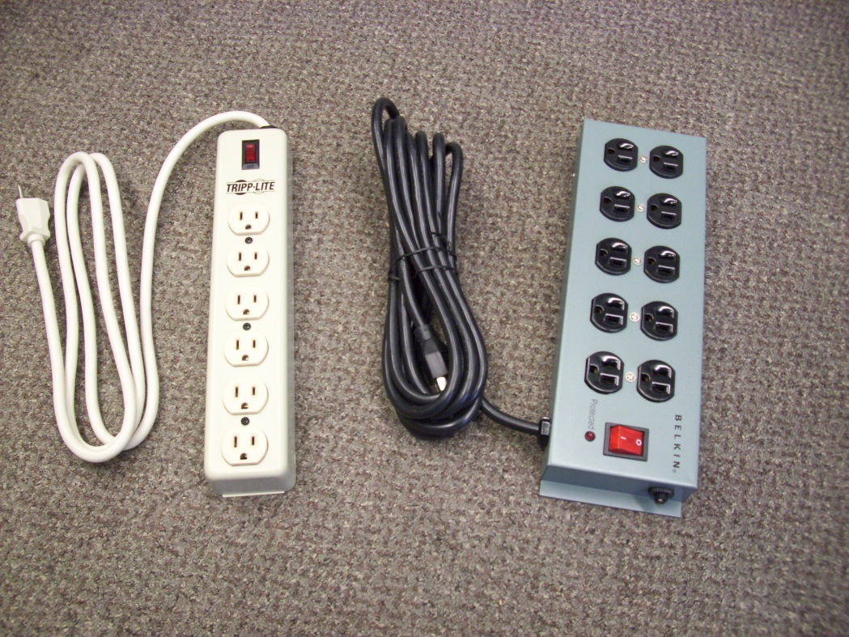
Figure 1. Multiple Outlet Strips, otherwise known as Relocatable Power Taps (RPTs).

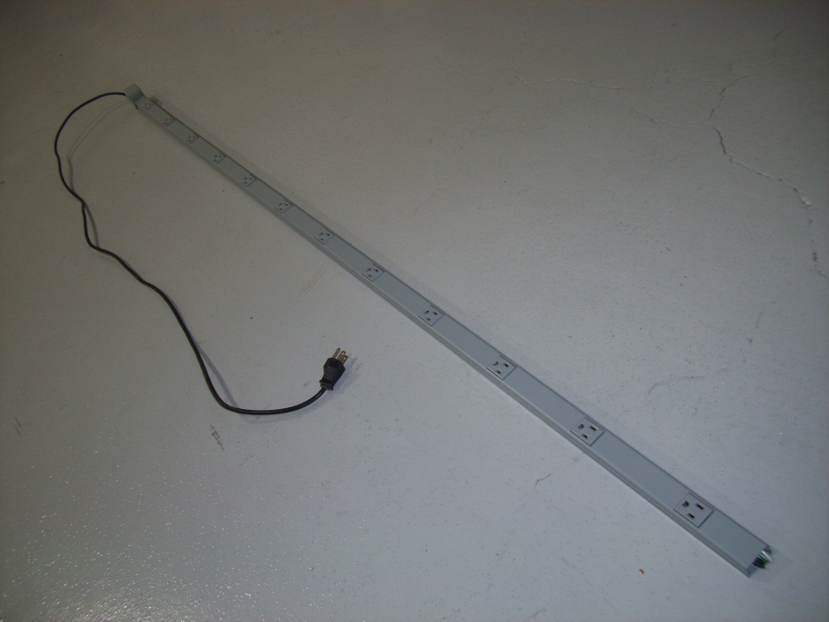
Figure 2. Multi-Outlet Assembly

Multiple outlet strips, multi-outlet assemblies, and extension cords can be tested for correct wiring with a wiring tester that is available from stock (#1145-500000). If a strip indicates lack of proper ground, it may be of an older style that relied on a mechanical connection between the receptacle to the metal enclosure for ground rather than a dedicated ground wire. Such strips should be removed from service and replaced. The point of connection between the flexible cord and strip should be periodically inspected for mechanical integrity and exposed conductors.

Electrical Connectors

The use of electrical connectors that are improperly assembled or that are not suitable for the application can present fire and shock hazards. The most common types of connectors that should be inspected are the two and three prong plugs used on flexible electrical cords for connecting to 120 VAC circuits. In addition, there are a variety of plugs used to connect to higher voltage single-phase and multiple phase outlets. Extension cords and some special purpose cords have a receptacle connector in addition to the plug connector. When inspecting electrical connectors, look for the following:

• The cord should be held firmly by a strain relief clamp so that stress from pulling on the cord is not transmitted to the electrical attachment point of the cord conductors to the connector conductors.

• The insulating jacket should completely enter the connector so that the individually insulated conductors are not visible when the connector is fully assembled.

• The insulating jacket should be in good condition where the cord enters the connector. There should be no cracks, splits, or cuts in the insulation. The strain relief shall not cut into the insulation.

• Connector that have burn marks, soot deposits, or signs of arcing and melting. Shall be removed from service and repaired or replaced. A connector that feels warmer than ambient is a sign of impending failure and should be repaired or replaced.

• Receptacles and receptacle connectors that do not firmly retain an inserted plug do not make good electrical contact should be replaced because poor electrical connections often lead to arcing and overheating failures.

• Connectors must be of "dead-front" design. Connectors that are not of dead front design typically have an insulating disk that fits over the prongs to cover the screws that secure the cord conductors. A dead-front design is one "without live parts exposed to a person on the operating side of the equipment" (29 CFR 1910.399). Connectors which are not dead-front should be replaced.

If a cord needs a new connector, but the cord is in good condition otherwise, the connector may be replaced with a NRTL listed connector that is suitable for the intended use. This applies to cords with molded connectors (connectors which cannot be removed except by cutting the cord) and to cords with removable connectors. The ampacity rating of the connector must be adequate for the cord. For example, use a 15A connector on a 14 AWG cord intended for use with 15A utilization equipment, and use a 20A connector on a 12 AWG cord intended for use with 20A utilization equipment. Attachment of connectors to cords shall follow relevant NEC standards and the use of standard color coding. A variety of connectors is available from the stockroom. Qualified Persons have the skills and knowledge necessary to properly replace or re-terminate faulty connectors. Cords with replaced connectors shall be tested for continuity, proper polarity and lack of shorts between conductors before use.

GFCI Protection

The use of Ground Fault Circuit Interrupters (GFCIs) is intended to protect individuals from electrical shock hazards when unintended ground paths develop in electrical circuits. In its simplest form, a GFCI in series with an electrical load compares the current leaving the "hot" wire of the circuit to the current returning on the "neutral" wire. If an imbalance of more than 4 to 6 milliamperes is detected, the GFCI trips and interrupts the current path. GFCI protection devices are available as circuit breakers, duplex receptacles, and portable units.

NEC and OSHA specify the use of GFCIs for certain areas in and around existing buildings and for new construction activities. Tools and equipment used for facility construction must be protected by GFCIs. Article 210.8 of the NEC now specifies that GFCIs must protect the same types of branch circuits for both dwelling units and non-dwelling occupancies. These include bathrooms, kitchens, rooftops, outdoors, within 6 feet of the nearest edge of a sink, laundry areas, indoor wet locations, lockers, vehicle service areas, crawl spaces (including lighting), and unfinished portions of basements.

Few exceptions remain to the requirement of GFCI protection. Drinking water fountains, either plumbed-in or bottle variety, are NRTL listed devices and often employ internal GFCI protection. Plumbed-in fountains without internal GFCI protection shall be supplied by a GFCI-protected receptacle or circuit or removed from service. GFCI protection is not required in the vicinity of eyewash stations, provided no other conditions that require a GFCI are present.

Electrical Enclosures

Electrical enclosures include the various distribution and circuit breaker panels, junction boxes, switch boxes, disconnects, outlet boxes, lighting fixtures, etc. which are constituent parts of the premises wiring system or utilization equipment for voltages of 120 VAC and above. Telephone, intercom, HVAC low voltage control, and computer network fixtures are not included in this classification. It is important that electrical fixtures be closed to present a barrier to inadvertent contact with energized conductors. When inspecting electrical fixtures, look for the following:

• All covers/doors must be properly installed with all of the fasteners in place. There should be no evidence of pinched conductors between the fixture and its cover.

• Make sure that any unused knockout holes are plugged. Circular snap-in blanks with a range of trade sizes from 1/2 to 2-1/2 inches are available from the stockroom.

• When examining electrical panels, make sure that any unused circuit breaker holes are plugged. Deficiencies here should be referred to the local D//P Electrical Coordinator or FESS Work Central x3434.

• Check for the minimum 3 foot working clearance in front of electrical equipment that is generally required by OSHA and the NEC. NEC Article 110.26 and Part 3 of the Technical Appendix of FESHM Chapter 9120 provide further guidance on this issue.

• Check to see that circuit breaker panelboards are properly labeled and that branch circuits are correctly identified.

• Lamps for general illumination shall be protected from accidental contact or breakage. Protection shall be provided by elevation of 8 feet or more above the floor or working surface or by enclosures or guards. Ref. OSHA 1910.303(g)(2)(i) and (ii). Diffusion covers, wire screens or plastic fluorescent tube covers are among acceptable guarding means. General illumination for areas subject to ionizing radiation require special consideration in selecting lamps and fixtures.

Exposed Electrical Conductors

While the very nature of activities at Fermilab presents many instances of exposed conductors, not all of these instances present significant hazards. Consultation with knowledgeable personnel in assessing the hazards posed by specific instances of exposed conductors is advised. Conductors that present significant levels of hazard because of voltage or current that can lead to shock or arcing must be covered or otherwise protected against inadvertent contact by appropriate barriers. Common physical barriers include insulation, guards, covers, screens, terminal strip covers, interlocked equipment doors, and access control to accelerator, beamline or experimental enclosures. Placement of barriers is best effected by the Qualified Person(s) responsible for the equipment or installation.

