FESHM 6020.2: HOT WORK - WELDING, BURNING, BRAZING, & SPARK PRODUCING OPERATIONS

Revision History

Author | Description of Change | Revision Date
Jim Niehoff | Revamped chapter to be inclusive of issuing hot work permits other than Fermilab site. Revised Hot Work (Burn) Permit. Added definitions of hot work operator, designated hot work area, Permit Authorizing Individual (Entity), Fire Watch. Added Technical Appendix 6.0. | June 2021
Jim Niehoff | Revised 25-ft. to 35-ft. distance from flammable and combustibles to comply with NFPA 51B and ANSI Z-49.1 | April 2018
Jim Niehoff | Added applicability statement for Fermilab Leased Spaces | December 2017
Chuck Kuhn & Jim Priest | Changed SSO to DSO. Revised chapter to include spark producing operations such as grinding and cutting activities in the presence of combustibles. | October 2015
Chuck Kuhn & Jim Priest | Applied FESHM Chapter format template. | February 2013
Bill James | Initial release Chapter 6020.2 | March 2010

TABLE OF CONTENTS

1.0 INTRODUCTION 3
2.0 DEFINITIONS 3
3.0 RESPONSIBLILITIES 4
3.1 Permit Authorizing Individual (PAI) 4
3.2 Hot Work Operator 5
3.3 Fire Watch 6
3.4 Task Manager, Construction Coordinator, or Service Coordinator 6
3.5 Employee 6
4.0 PROGRAM 7
4.1 Issuing Hot Work Permit Process 7
4.2 Designated Hot Work Area Process 7
4.3 Safety Precautions 8
5.0 REFERENCES 9
6.0 TECHNICAL APPENDIX 10
Propane flash Propane Flashback Arrestor 11

INTRODUCTION

Hot work is a process that involves welding, soldering, brazing, cutting, grinding, drilling, and burning or melting metals or other substances such as glass. Use of open flame, or sparks, or such ignition tools are considered hot work procedures. These types of work are fire hazards when flammable material is present or not. Hot work procedures require a hot work permit from the Permit Authorizing Entity before the workers begin.

All types of hot work are fire hazards irrespective of presence of any flammable material in the vicinity. Examples of potentially hazardous areas are well heads, fuel tanks, mud tanks, tank batteries, gas separators, oil treating equipment or devices, and confined spaces. A hot work permit is required for maintenance operations involving cutting, welding, brazing, soldering, grinding, spark producing, and open flames in any area. It also may be necessary to test for the presence of flammable gases in the work area before starting any hot work.

The tools associated with the hot work include electric, oxyacetylene, laser or similar welding or cutting equipment, grinders, gas torches or blow lamps for brazing, soldering, thawing pipes, torch applied flooring or roofing materials or removal of any materials. This chapter is utilized to ensure that the individuals performing the work are aware of the hazards associated with hot work and that they implement control measures to help mitigate risks. The hot work permit also provides a step-by-step check list for hot work and a reminder to employers and workers of their fire prevention responsibilities.

This system allows for risk evaluation, required controls, and approval by authorized personnel. This chapter describes procedures for the issuance of permits for such activity operations by Fermilab employees, subcontractors, and experimenters. This chapter only applies to the Fermilab site and. Leased spaces.

DEFINITIONS

- Burn (Hot Work) Permit - a set of precautions to be followed, verification of training, and provisions for supervision to assure safe work practices (same as a Hot Work Permit).
- Combustible Material - Capable of reacting with oxygen and burning if ignited. Examples include oil, paper, various chemicals products, wood, plastic, textile fibers such as carpet and cardboard.
- Designated Hot Work Area - A permanent or temporary non-hazardous location designed or approved for hot work operations. Examples: Maintenance shops or fab areas. Equipment Owner – is a person/group assigned to an area / department that normally controls and operates the equipment.
- Fire Protection-Authority Having Jurisdiction (FP-AHJ) – An organization, office, or individual responsible for enforcing the requirements of code or standard, or approving equipment, materials, an installation or a procedure.
- Fire Watch – An individual or individuals responsible for continuously observing the hot work area maintaining fire-safe conditions, and responsible to emergencies during hot work operations and established period following.
- Flammable Atmosphere - A mixture of dangerous substances with air, under atmospheric conditions, in the form of gases, vapors, mist or dust which are ignitable and after ignition has occurred, combustion spreads to the entire unburned mixture.
- Hot Work - Any operation that can produce a spark, arc or flame hot enough to cause the ignition of ordinary combustible materials, combustible dusts, flammable gasses or vapors. Examples of hot work include welding & cutting, burning, resistance welding, soldering, brazing, torch applied roofing, grinding, abrasive wheel cutting, servicing of electrical equipment capable of producing sparks or other operations that are capable of initiating fires or explosions.
- Hot Work Operator – An employee or subcontractor performing the work activity requiring a Hot Work Permit.
- Incipient Fire – The initial or beginning stage of a fire, which can be controlled or extinguished by portable fire extinguishers without the need for protective clothing or breathing apparatus.
- Lower Explosive Limit (LEL) - The lower limit of flammability of a gas or vapor at ordinary ambient temperatures expressed in a percent of the gas or vapor in air by volume. For the purposes of this procedure, the %LEL limit for hot work permit authorization is 0.0% LEL. A variance must be obtained prior to conducting work with readings above 0.0% LEL.
- Permit Authorizing Individual (PAI) – The individual or department designated by FP-AHJ to authorize hot work.
- Spark Producing Operations - Any activity that produces or has the potential to produce sparks, such as, but not limited to welding, brazing, soldering, torch or arc gouging, cutting, grinding, sandblasting, and the use of power tools. Department supervision should consider the possibility of sparks resulting from scraping, hammering, pneumatic tools and other operations, and the advisability of obtaining a hot work permit to cover such work.
- Welding blanket/curtain - A heat-resistant fabric designed to be placed in the vicinity of a hot work operation with light moderate exposures such as that resulting from chipping, grinding, heat treating, sand blasting, and light welding. Designed to protect machinery and prevent ignition of combustible materials such as wood that are located adjacent to the underside of the blanket.
- Welding Pad - A heat-resistant fabric designed to be placed directly under a hot work operation such as welding and cutting. It is intended for use in horizontal applications with severe exposures such as that resulting from molten substances or heavy horizontal welding designed to prevent the ignition of combustible materials that are located adjacent to the underside of the pad.

RESPONSIBLILITIES

Permit Authorizing Individual (PAI)
- The Permit Authorizing Individual (PAI) is either the Fermilab Fire Department (FFD) or LBNF Far Site Designee.
- Issuing Hot Work (burn) permits.
- Providing fire safety instruction for welding, burning, brazing and/or spark producing operations.
- Temporary permits (30 day) will be issued by the PAI when requested with the option of a single 30-day extension. For permits over 60 days, the PAI may issue a continuous permit. The location of the continuous permit will be decided upon by the PAI.
- No permit will be issued without all the proper equipment being at the work site. Permits must be visible or available upon request.

Hot Work Operator
- The operator shall have the PAI’s approval.
- The operator shall consider:
  - Define the hot work area as 35 ft. (11.0 m) horizontally from all hot work sites and a minimum of 35 ft. (11.0 m) above all hot work sites. When performing elevated work or work in drafty environment, consider extending the hot work area horizontally to 50ft.
  - Remove combustibles from the hot work area. If combustibles are non-movable, isolate material from ignition sources by shielding/covering them with NRTL (UL or FM) welding blankets or pads.
  - Remove combustible accumulations from within the hot work area (e.g., combustible debris, oil residues, combustible dust/lint).
  - Identify and isolate potential sources of flammable gas, ignitable liquid and/or combustible dust/lint that may be released into the hot work area. In addition, a Hazard Analysis per FESM Chapter 2060 or 7010 should be conducted to identify sources of these materials and whether additional measures are required to mitigate these hazards.
  - Protect or shut-down ventilation or any type of conveying systems that may transport combustible material into the hot work area or hot work ignition sources outside the control area.
  - Torch-applied roofing systems including installation of repair of or alteration to the roof cover (e.g., develop a specific fire emergency response plan that includes conditions under which the fire department should be called and verify fire department access to the site, stop work immediately if material appears to be smoking call (630) 840-3131. Locate the asphalt kettle a minimum of 35ft (11.0 m) away from the building and combustibles.
- The operator shall verify appropriate training of the fire watch including fire extinguisher training.
- The operator shall examine all equipment to ensure it is safe operating condition, reference Technical Appendix.
- The operator shall cease operations if unsafe conditions develop.
- The operator shall provide 10-pound (minimum) A-B-C dry chemical fire extinguisher.
- The operator shall verify that the fire extinguisher has current annual and monthly inspections, and the appropriate hydrostatic test as necessary, in accordance with NFPA 10.
- See Section 4.3 for additional safety precautions.
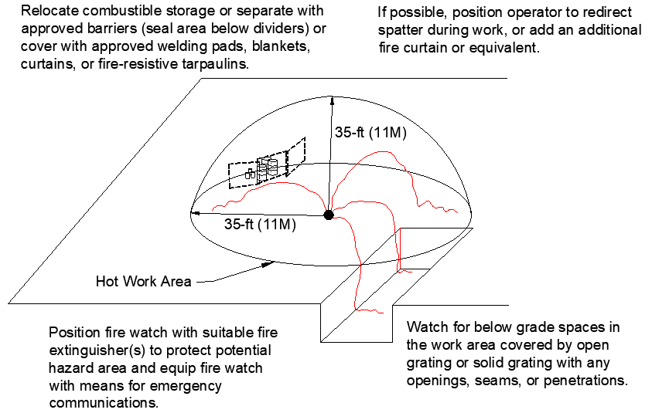

Figure 1 – Hot Work Area Illustration

Fire Watch
- The fire watch shall be trained to recognize the inherent hazards of the work site and hot work operations.
- The fire watch shall ensure safe conditions are maintained during hot work operations.
- The fire watch shall have the authority to stop hot work operations if unsafe conditions develop.
- The fire watch shall have fire-extinguisher equipment readily available and shall be trained in it use.

Task Manager, Construction Coordinator, or Service Coordinator
- Obtaining a Hot Work Permit for any welding-burning-brazing activity, spark producing cutting or grinding in buildings containing combustibles or unprotected insulation, for example, foam insulation on cryogenic tanks, or floors, or walls.
- Contacting Facilities Engineering and Services - Fire System Maintenance (FSM) Technicians for disablement of fire detection systems.

Employee
- Obtaining a Hot Work Permit for any welding-burning-brazing activity, spark producing cutting or grinding in buildings containing combustibles or unprotected insulation, for example, foam insulation on cryogenic tanks, or floors, or walls.
- Contacting Facilities Engineering and Services - Fire System Maintenance (FSM) Technicians for disablement of fire detection systems.

PROGRAM

Issuing Hot Work Permit Process
- Task Manager, Construction Coordinator, or Service Coordinator shall contact the PAI on behalf of the subcontractor prior to any welding, burning, or brazing, or spark producing operations. PAI will examine the proposed operation, prescribe precautions, review safety procedures with the employee and/or subcontractor, and then issue a written Burn Permit. When required, hazards and precautions must also be listed in the hazard analysis or work procedure prior to commencing the work.
- Additional safety review and approval may be required by the appropriate Division/Radiological Safety Officer if work involves radioactive materials or if work will be conducted in a confined space or other hazardous operations area.
- PAI and FP-AHJ approval shall be obtained for work within 35 feet of any flammable liquid or gas hazard and near combustibles including spark producing cutting/grinding including near dry brush or grasses.
- When it is likely that a fire detection system will be activated by a welding, burning, brazing or spark producing operations, the system may be temporarily disabled or shielded by the FSM Technicians. All planned and emergency requests for disablement shall be made in accordance with FESHM Chapter 6030.
- The use of key switches or buttons for disabling detection systems (for example the air sampling smoke detection (VESDA) system) by a designated individual shall be preceded by contacting Security (Ext. 3414) or from a cell phone (630-840-3414) and Fire Department (Ext. 3428) or from a cell phone (630)-840-3428, the building manager and other interested parties. Enabling the key switch or button(s) shall be completed at the end of the normal workday preceded by contacting Security, the Fire Department, the building manager, and the other interested parties.

Designated Hot Work Area Process
- Employee shall contact the PAI on behalf of the hot work operator prior to any welding, burning, or brazing, or spark producing operations. PAI will examine the proposed operation, prescribe precautions, review safety procedures with the employee and/or subcontractor, and then issue a written Hazardous Operations (long-term) Permit. When required, hazards and precautions must also be listed in the hazard analysis or work procedure prior to commencing the work.
- Additional safety review and approval may be required by the appropriate Division/Radiological Safety Officer if work involves radioactive materials or if work will be conducted in a confined space or other hazardous operations area.
- PAI and FP-AHJ approval shall be obtained for work within 35 feet of any flammable liquid or gas hazard and near combustibles including spark producing cutting/grinding including near dry brush or grasses.
- Hazardous Operations (long-term) Permits may be issued for areas that contain frequent or continuous welding-burning-brazing or spark producing operations. The Fire Department inspects continuous welding areas monthly and has the authority to revoke permits in non-complying areas.
- Continuous Hazardous Operations (long-term) Permits will be issued for jobs/task that are expected to last six months or longer. The permit will include the following information.
  - Permit number
  - Department / Building / Area
  - Date issued
  - Expiration date: this will be three years from the date of issue.
  - Type of hazards: Check any boxes that apply.
    - Job description: Describe the job that the permit will cover.
    - To be completed by: This would list the welder or company assigned to the task.
  - Responsible party and Division: This would be the Fermi construction coordinator or task manager.
  - Complete the area checklist: Check all boxes that apply.
  - Issued by: Signed by the Black Shift Battalion Chief or his designee.
  - Fermilab Site only, affix a Bar Code number: A fire Department bar code label will be placed on the issued permit. The same number will be written on the fire department copy.
- Fermilab site only, Hazardous Operation (long-term) Permit Inspection
  - Each continuous welding location will be inspected monthly to ensure that the area conditions have not changed and that flashback arrestors are present.
- Fermilab site only, Hazardous Operation (long-term) Permit Review Process
  - Each permit will be reviewed by the Black Shift Lieutenant every 3 years.
  - If the above information is not correct a new permit will be issued by the Black Shift Battalion Chief.
  - The issued date will be entered into the FELIX database and placed on a three-year review cycle.

Safety Precautions
- All hot work operators shall have UL or FM listed check valves and flash back arrestors attached to the regulator side of their oxyacetylene cutting units.
- To prevent flashbacks, flashback arrestors must be installed on the outlets of both regulators on the tank, regardless if the arrestor is at the torch inlets or interictal to the torch. This protects the work and protects the hose and tanks where there are long hose runs and working overhead and where the hose can be damaged from hot debris.

- A check valve can only prevent the reverse gas flow. However, a Flash Back Arrestor prevents reverse gas flow AND arrests the flashback. A check valve cannot arrest a flash back. This could allow the flame to get past the torch and into the hoses.

  - Check valves are designed to allow gases only to pass in one direction. If your check valves are working properly, you won’t have premixed gases upstream of your equipment’s designed gas mixing chamber.
  - A check valve will not stop a flashback; however, properly functioning check valves will stop back-flow of fuel gas and/or oxygen thus preventing the conditions required for a flashback to occur. Most flash arrestors have internal check valves.

- An extremely hazardous situation can develop when oxygen and fuel gases are mixed inside the hoses. Reverse flow check valves alone will not stop a flashback in the system. When conducting oxyfuel cutting and welding operations, can experience backfires or flashbacks. A backfire is defined as the momentary retrogression of the flame back into the torch tip. The user hears a “pop” and the flame is extinguished. This an happen at high gas exit velocities at the torch nozzle/tip or if the nozzle/tip gets too close to the work piece. This is not normally a safety concern, and, in fact, many manufacturers include backfires during design and production tests to ensure flame integrity of torchers. A flashback is a momentary or sustained retrogression of the flame upstream of the mixer usually in the torch or hoses. Flashback is potentially hazardous situation, particularly if the flame reaches the hoses where an explosion will result causing a rupture or separation of the hose. A flashback is generally caused by the reverse flow of gases upstream into the hoses or other equipment.
- Hot work operators shall furnish their own fire extinguishers.
  - 10-pound (minimum) A-B-C dry chemical fire extinguisher.
  - Confined Space Hot Work, must verify atmosphere is not hazardous and selection of fire extinguisher selection for the suitable situation, e.g., carbon dioxide fire extinguisher may displace oxygen in enclosed/confined space.
  - Fire extinguisher must have current hydrostatic test date.
  - Inspections tags and seals shall be current for all extinguishers used on all jobs.

REFERENCES

- FESHM Chapter 2060, Work Planning & Hazard Analysis
- FESHM Chapter 6010, Fire Protection Program
- FESHM Chapter 6014, Fire Watch
- FESHM Chapter 6030, Disablement of Fire Protection Systems
- FESHM Chapter 7010, ES&H Program for Construction
- OSHA 1910.252, Subpart Q, Welding, Cutting, and Brazing
- OSHA 1910.253, Oxygen Fuel Gas Welding & Cutting
- Factory Mutual Global Data Sheet 10-3, 2020, Hot Work Management
- Fermilab’s Fire Department procedure FD-RO-202
- American National Standard (ANSI) Z-49.1 Safety in Welding, Cutting and Allied Processes, which identifies safety precautions, including personal protective equipment.
- National Fire Protection Association (NFPA) 10, Standard for Portable Fire Extinguishers, 2018 Edition.
- NFPA 51B, Standard for Fire Prevention During Welding, Cutting, & Other Hot Work, 2019
Edition
- Safety and Health Fact Sheet No. 28, American Welding Society, April 2005.

TECHNICAL APPENDIX

Flashback in Oxy-Fuel gas equipment

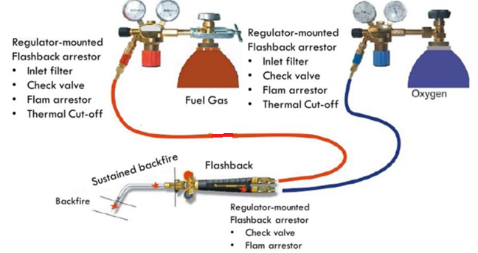

Figure No. 1 (Source image from Health, Safety, Security & Environment)

Commentary: There are two types of sintered element arrestors. One is mounted onto the outlet of regulators and the other is mounted onto the inlet of torches. Regulator arrestors are typically larger and have a higher flow capacity than torch models because the sintered element has more surface area allowing for more flow. The sizes of torch mount arrestors are limited so as not to make the torch too cumbersome to handle. Both Torch and Regulator are preferred. Torch arrestors are preferred because their location is ideal for preventing reverse flow flashbacks into the hoses. When used with a regulator mount arrestor it prevents, flashbacks from occurring in the hoses with a high potential for injury. Regulator mount arrestors protect even when higher flows are needed, and these will protect regulators and cylinders from the effects of flashback.

- Non-Return Valve: this stops the reverse flow (back surge) of gas
- Sintered Flame Filter: this blocks the flame
- Thermal Activated Cut-Off Valve: (fitted to regulator mounted models only). In case of a sustained (continuous) flashback or backfire, this valve will close and stop the flow of gas in any direction.

Propane flash Propane Flashback Arrestor
Flashback arrestors are not needed when propane or butane is used with air.

Flashback arrestors help prevent reverse gas flow and flashback (flame burning back through the torch, hose, regulator and tank.) By utilizing an internal reverse flow check valve and a flame arrestor that quenches the flashback flame.
Connects between regulators and hose. The flashback arrestor is for mounting on regulators. Standard "B" fitting. You will notice this arrestor is red. Red = Propane.

