FESHM 10120: POWERED INDUSTRIAL TRUCKS (PITs) AND OTHER NON-POWERED MATERIAL HANDLING EQUIPMENT

Revision History

Author | Description of Change | Revision Date
Angela Aparicio  Giuseppe Gallo  Charles Orozco  Paul Satti | Revised Introduction and Scope  Added reference to new Powered Industrial Truck Attachment Load Test Checklist (10120 Form 4) in Section 7.4  Created new section for manual material lifting devices | March 2022
Angela Aparicio  Marcel Borcean  Brian Niesman | Added reference to new Lift Plan FESHM chapter.  Updated refresher training requirements (removed retraining every three years) and added back in the Lead Evaluator Program and requirements.  Added technical appendix that addresses material lifts. | September 2020
Mike Bonkalski | Added language requiring D/S approval of inspection work orders | November 2018
John P. Cassidy | Removed the Lead Evaluator Program and updated the Fermilab Forklift Operator Evaluator Form | July 2013
Thomas Page | Added FESHM Chapter template; added 5th bullet under “Prohibited and Restricted Work Practices” dealing with radios, headsets, and audio devices. | February 2012

TABLE OF CONTENTS

1.0 INTRODUCTION AND SCOPE 3
2.0 DEFINITIONS 4
3.0 RESPONSIBILITIES 6
3.1 Division/Section/Project (D/S/P) Heads 6
3.2 Facility Engineering Services Section 6
3.3 The Qualified Operator 6
3.4 Mechanical Safety Subcommittee 6
3.5 ES&H Section 6
4.0 PROGRAM DESCRIPTION 7
5.0 TRAINING AND QUALIFICATIONS 7
5.1 Employee 7
5.2 Non-Employee 7
5.3 Qualification Training 7
5.4 Certification Records 8
5.5 Remedial Training 8
5.6 Evaluator Program 8
6.0 INSPECTIONS 9
6.1 Daily Pre-use Inspections 9
6.2 Preventative Maintenance Inspection 9
6.3 Attachment Periodic Inspection 9
7.0 PIT ATTACHMENTS 9
7.1 Scope 9
7.2 Engineering Note Procedure 9
7.3 Attachment/PIT Identification 11
7.4 Attachment Load Test 11
7.5 Attachment Inspections 11
8.0 OPERATIONS 12
8.1 Installation of Operator Restraint Systems (Seat Belts) 12
8.2 Use of Seat Belts 12
8.3 Prohibited and Restricted Work Practices 12
8.4 Procurement or Significant Modification 13
8.5 PIT Nameplate(s), Markings, and Operator’s Manuals 13
8.6 Repair 13
8.7 Acceptance Testing 13
8.8 Control of Access to Powered Industrial Trucks 13
8.9 Damage to Powered Industrial Trucks 13
9.0 PREVENTATIVE MAINTENANCE AND REPAIR PROGRAM 14
10.0 LOANING OF POWERED INDUSTRIAL TRUCKS 14
11.0 DRIVING POWERED INDUSTRIAL TRUCKS ON FERMILAB MAIN ROADS 14
12.0 MANUAL MATERIAL LIFTING DEVICES 15
12.1 Material Lifts 15
12.1.1. Training Requirements 15
12.1.2. Operation Expectations 15
12.1.3. Inspection, Maintenance, and Repair Requirements 15
12.1.4. Images of Material Lifts 16
13.0 REFERENCES 16
14.0 TECHNICAL APPENDICES 17

INTRODUCTION AND SCOPE

Powered industrial trucks, commonly called forklifts or lift trucks, are used in many industries, primarily to move materials. They can also be used to raise, lower, or remove large objects or several smaller objects on pallets or in boxes, crates, or other containers. Powered industrial trucks can either be ridden by the operator or controlled by a walking operator and are used throughout Fermilab to perform a variety of functions. The use of powered industrial trucks creates a potential for serious injury and property loss.

This chapter contains procedures to ensure that the operation, inspection, and maintenance of powered industrial trucks are conducted in a safe manner and that operators are qualified to operate the truck safely.

This chapter applies to any class of powered industrial truck used at Fermilab and powered industrial trucks funded by DOE and managed by Fermi Research Alliance (FRA).

Powered industrial truck classes used at Fermilab (see Technical Appendix):

- Class I: Electric Motor Rider Trucks
- Class II: Electric Motor Narrow Aisle Trucks
- Class III: Electric Motor Hand Trucks or Hand/Rider Trucks
- Class IV: Internal Combustion Engine Trucks (Solid/Cushion Tires)
- Class V: Internal Combustion Engine Trucks (Pneumatic Tires)
- Class VI: Electric and Internal Combustion Engine Tractors
- Class VII: Rough Terrain Forklift Trucks

Excluded from the scope of this chapter are construction, grounds keeping, and farm equipment such as wheel loaders, mobile cranes, bulldozers, crawler loaders, snowplows, hay bale loaders and tree removal equipment. Over-the-road haulage trucks and earth-moving equipment that has been modified to accept forks are not considered powered industrial trucks.

Powered industrial truck designations - the Occupational Safety and Health Administration (OSHA) provides guidance on selecting powered industrial trucks for use in different operating environments. The OSHA standard specifies 11 designations of powered industrial trucks [29 CFR 1910.178(b)]:
- D. Diesel powered units with minimal acceptable safeguards against inherent fire hazards.
- DS. Diesel powered units with additional safeguards to the exhaust, fuel, and electrical systems.
- DY. Diesel powered units that have all the safeguards of DS units, plus do not have any electrical equipment including the ignition. They have temperature limitation features.
- E. Electrically powered units with minimal acceptable safeguards against inherent fire hazards.
- ES. Electrically powered units with additional safeguards to the electrical system to prevent emission of hazardous sparks and to limit surface temperatures.
- EE. Electrically powered units that have all the safeguards of the E and ES units, plus the electric motor and all other electrical equipment are completely enclosed.
- EX. Electrically powered units with electrical fittings and equipment designed, constructed, and assembled so that the units can be used in certain atmospheres containing flammable vapors or dusts.
- G. Gasoline powered units with minimal acceptable safeguards against inherent fire hazards.
- GS. Gasoline powered units with additional safeguards to the exhaust, fuel, and electrical systems.
- LP. Liquefied petroleum gas units with minimal acceptable safeguards against inherent fire hazards.
- LPS. Liquefied petroleum gas units with additional safeguards to the exhaust, fuel, and electrical systems.

DEFINITIONS

Attachments – A device added to the PIT, either designed and built by the user, purchased from a commercial supplier, or provided by the manufacturer of the PIT, other than the conventional forks, and intended to carry the load. Examples include non-conventional forks, fork extensions, extension booms, non-conventional or special or unique load handlers, rotating devices, side shifters, load stabilizers and jib crane booms. A removable attachment is an attachment that can be mounted on the forks, or in place of the forks on the carriage, by means of such conventional fasteners as bolts, pins, etc., and does not require the disassembly of any other portion of the lifting system to install or remove.

Bulldozing - The action that results when an operator would have one pallet on the forks, then use the load to push other pallets ahead of the truck. Bulldozing may also involve having two pallets arranged vertically on the forks plus pushing up to six pallets (single or double stacked) out in front of the truck. Bulldozing is prohibited.

Critical Lift –
A lift that meets any of the following:
- Loss of control of the item being lifted would likely result in the declaration of an emergency.
- The load or item is unique and, if damaged, would be irreplaceable or not repairable and is vital to a system, facility, or project operation.
- The cost to replace or repair the load item damaged would have negative impact on facility, organizational, or DOE budgets to the extent that it would affect program commitments.
- Lifts made with more than one forklift.
NOTE: See full definition and lift planning requirements in FESHM 10200 – Lift Plans. If your lift meets any of the above, you must develop a written lift plan.

Employee - For the purpose of this chapter includes Fermilab direct hired personnel, term and temporary employees and contract technicians.

Forklift Operator Evaluator- a qualified person who has been nominated by the D/S/P and so designated by ES&H.

Free Rigging – The direct attachment to or placement of rigging equipment (slings, shackles, rings, etc.) onto the forks of a PIT for a below-the-forks lift. This type of lift does not use an approved lifting attachment. Free rigging is prohibited.

Magnet Movers - A vehicle or tractor-trailer combination, which is equipped for the purpose of lifting, moving, and setting beam line magnets or other such large heavy objects in the beam line enclosures. The trailer may be pulled or pushed by the tractor. Lift tables on wheels are excluded from this definition unless they are towed by a tractor while carrying a load.

Material Lift – A device used to lift or move material. Examples include load lifters, manual material lifts.

Non-employee - This category includes subcontractor employees, users, experimenters, graduate students, experimental collaborators, visiting or guest scientists and engineers, and DOE employees.

Operator Evaluator – Individual assigned by the division, section, or project to evaluate the performance phase of an operator’s training.

Powered Industrial Trucks (PIT) – A mobile, power-propelled truck used to carry, push, pull, lift, stack, or tier materials. Powered industrial trucks, often called forklifts, or lift trucks, can be ridden or controlled by a walking operator. Excluded from this definition are vehicles used for earth moving or over-the-road haulage.

Qualified Operator - An individual deemed competent by management after successfully completing the Training and Qualification requirements of this chapter.

Qualified Person - A person who, by possession of a recognized degree in an applicable field or a certificate of professional standing, or who by extensive knowledge, training, and experience, has successfully demonstrated the ability to solve or resolve problems related to the subject matter or work.

Split-forking - The action that results when the operator moves two palletized loads by inserting one fork in each pallet. Split-forking is prohibited.

RESPONSIBILITIES

Division/Section/Project (D/S/P) Heads
- Implement the requirements associated with the use of powered industrial trucks.
- Ensure powered industrial truck operators are trained and qualified to perform assigned duties and have a valid driver’s license from any of the 50 states.
- Nominate a qualified individual to serve as the D/S/P forklift operator evaluator.
- Ensure that inspections are performed and there is D/S/P acceptance of maintenance work orders.
- Arrange for the review of attachment Engineering Notes by qualified persons or committee.
- Keep an open file of all Engineering Notes for attachments used in their division/section/project.

Facility Engineering Services Section
- Responsible for the maintenance and maintenance records of all powered industrial trucks and attachments owned and operated by Fermilab. Must ensure qualified personnel perform maintenance, repair, adjustment, and inspections of the powered industrial trucks and attachments.
- Distribute inspection, testing and maintenance reports to the D/S/P head upon request.

The Qualified Operator
The Qualified Operator is responsible for:
      - Recognizing if a lift is within their capability based on previous experience or training. If level of training or experience is insufficient to assure a safe lift, the operator must state this to their supervisor and not proceed with the task.
      - Following best practices to assure a safe lift.
      - Identify hazards and mitigations associated with the hazard, including appropriate personal protective equipment (PPE).
      - Conducting a pre-use inspection (see Section 6.1). If a problem or situation appears to be unsafe, or if the forklift is not operating properly, the Qualified Operator should contact FESS Fleet Management to have a pre-lift inspection/repair completed by a subcontractor.
      - Performing the lift in accordance with any formal hazard analysis (HA). (See FESHM Chapter 2060) or written lift plan (See FESHM Chapter 10200), if one exists.

Mechanical Safety Subcommittee
The Mechanical Safety Subcommittee will serve in a consulting capacity to ES&H and D/S/P in all matters concerning the inspection, maintenance, and operation of powered industrial trucks.

ES&H Section
- Implement a training program that satisfies the requirements of 29 CFR 1910.178 (l).
- Maintain the lesson plan and training materials.
- Maintain documentation of all classroom training, on-the-job training, and evaluations.
- Designate a Lead Evaluator to conduct evaluations of D/S/P-designated evaluators.

PROGRAM DESCRIPTION

The operation, inspection, maintenance, and testing of powered industrial trucks and associated equipment shall be in accordance with mandatory standards. For powered industrial trucks, these standards are:
- 29 CFR 1910, Subpart N, OSHA General Industry Standards, Materials Handling and Storage
- 29 CFR 1926.602 (c), (d) – Material Handling Equipment
- ASME B56.1 - Safety Standard for Low Lift and High Lift Trucks

Requirements applicable to all powered industrial trucks are highlighted in this Chapter. Other requirements may exist that are specific to a certain style, size, or use of a particular piece or type of equipment. The appropriate standards are to be consulted by those assigned responsibility for powered industrial truck operations to identify specific requirements, recommendations, and guidance for the safe operation and use of this equipment. Assistance with the implementation of these standards can be provided by the Division Safety Officer (DSO) or the ES&H Section.

TRAINING AND QUALIFICATIONS

Employee

Operator training and qualification shall include those requirements identified in regulatory standards (29 CFR 1910.178). In addition, the prospective powered industrial truck operator must hold a valid driver’s license from any of the fifty states.

Non-Employee

Qualification of non-employees requesting to operate powered industrial trucks owned by Fermilab shall be made by completing Fermilab’s Powered Industrial Truck training (FN000014 - Forklift Operator Training). In addition, the prospective powered industrial truck operator must hold a valid driver’s license from any of the fifty states, or an international driver’s license if a temporary/short-term visitor/user.

In the case of subcontractor personnel follow the procedures under the section “Loaning of Powered Industrial Trucks.”

Qualification Training

Qualification training shall include both a classroom and a performance/evaluation phase. At a minimum, the training shall meet the learning objectives specified in Fermilab Training Course No. FN000014/Forklift Operator Training. Demonstration of the operator's abilities to perform all activities expected or anticipated for the job will be part of the qualification process during the performance phase.

The performance evaluation must be conducted in the environment similar to where the employee is expected to operate the PIT. Employees who operate powered industrial trucks in several locations throughout the Laboratory are required to be evaluated on one representative PIT that the employee is expected to operate.

Magnet Mover operators are to be evaluated in the tunnels and enclosures.

A designated division/section/project Operator Evaluator shall observe such demonstrations and document the performance results on the “Fermilab – Forklift Operator Evaluation Form.” Documents reflecting successful demonstration of operator abilities shall be maintained in the TRAIN database. Operator qualification is for a period of three (3) years unless withdrawn within that period by the operator’s supervisor. Re-qualification will include a performance evaluation, documented on the “Fermilab – Forklift Operator Evaluation Form.” Refresher training will not be required, but all operators are expected to complete evaluations every three years.

Certification Records

Training records certifying operator qualification shall include the name of the trainee, date of training, and the signature of the trainer or evaluator.

Remedial Training

Remedial training will be required for individuals who do not successfully pass the qualification course. The course instructor or Operator Evaluator will determine the level of remedial training required. Remedial training will also be required for operators involved in an accident, a near-miss incident, or who are observed operating a forklift in an unsafe manner. The employee’s supervisor in consultation with the DSO will determine the level of remedial training needed.

Evaluator Program

The ES&H Section will designate a Fermilab Lead Evaluator in writing. This Lead Evaluator will
in turn conduct evaluations every three years of the designated division/section/project Operator
Evaluators [FN000375]. The intent of this program is to standardize the manner and rigor in which evaluations are administered. The lead evaluator will submit evaluations to the ES&H Section. The evaluations will list the name, employee number, div/sec, the type of trucks the evaluator can conduct evaluations for, and a signature of the person evaluated.

INSPECTIONS

Daily Pre-use Inspections

A safety inspection shall be completed for each powered industrial truck and any attachment prior to the start of each shift, or prior to the first use of the day for equipment not in continuous service. A qualified operator shall conduct the inspection, and preferably one that is familiar with the specific equipment. The inspector shall review the elements listed on the checklist, FESHM Form 10120-01. Daily pre-use inspections may be documented as a best practice.

Daily inspections are not required for equipment that is not in service. Prior to being placed back into service, the daily inspection shall be completed by a qualified operator.

Preventative Maintenance Inspection

A documented inspection shall occur at least annually as part of the Preventative Maintenance and Repair program described in this chapter, managed by FESS. FESS will verify the inspectors are qualified to maintain, repair, adjust, and inspect industrial trucks.

Attachment Periodic Inspection

The D/S/P must schedule a documented, annual inspection through FESS. Inspection frequency may be modified if specified in the engineering note, see Section 7.5.

PIT ATTACHMENTS

Scope

All PIT attachments owned by Fermilab or by collaborating institutions and used at Fermilab or for DOE-funded work managed by FRA shall meet all requirements of this FESHM chapter.

PIT attachments provided and used by outside contractors in execution of their contract work are outside the scope of the following engineering note procedure but must adhere to the balance of this FESHM Chapter.

Engineering Note Procedure

      - Engineering Notes: An Engineering Note shall be prepared by a qualified person for all PIT attachments owned by Fermilab or by collaborating institutions and used at Fermilab whether purchased or fabricated at Fermilab or a collaborating institution.

        - Engineering Notes for all attachments shall include:
- Attachment unique identifier.
- Identification of PIT(s) or class of PIT(s) for which it is designed.
- Allowable operating parameters: load rating, operation envelope, etc.
- Operating instructions, if required for safe operation.
- Inspection frequency and criteria.

        - Engineering Notes for attachments designed at Fermilab or other non-commercial institutions (such as Universities or other Laboratories) shall include design compliance calculations to verify that the attachment meets, as a minimum, the requirements of ASME B56.1 and 29 CFR 1910, as well as demonstrating a safety factor greater than or equal to 3 on minimum yield strength for all load bearing components.

        - Engineering Notes for attachments purchased from a commercial source engaged in the manufacturing of PIT attachments shall include any manufacturer’s documentation (Certificate of Test, copies of the Operator’s Manual, Inspections and Maintenance Instructions, etc.)

        - Engineering Notes for all attachments that affect the capacity and safe operation of the PIT(s) for which they are designed shall include written approval from the PIT(s) manufacturer(s) or record of the PIT(s) manufacturer’s negative or non-response to request for approval. A negative or non-response from the manufacturer does not necessarily disqualify the engineering note from approval.

        - Engineering Notes for all attachments must specifically address the stability of the PIT/attachment/load combination as required by ASME B56.1 unless written approval from the PIT(s) manufacturer(s) has been obtained (see (d) above).

        - Engineering Notes for all attachments must specifically address the strength of all load bearing PIT components unless written approval from the PIT(s) manufacturer(s) has been obtained (see (d) above).

        - Modifications to PIT attachments (whether designed at Fermilab or other non-commercial institutions such as Universities or other Laboratories or purchased from a commercial source engaged in the manufacturing of lifting fixtures) shall be documented in the Engineering Note package.

        - Load tests shall be documented in the Engineering Note.

      - Review of Engineering Notes: All PIT attachment Engineering Notes shall be reviewed by a qualified person for compliance with the requirements of this chapter.

      - Amendment of Engineering Notes: All subsequent changes in usage that could affect the safety of personnel, or the capability of the attachment performance shall require an amendment to the original Engineering Note. The amended note shall be reviewed the same as the original note.

      - Similar Attachments: Attachments that are manufactured or fabricated to meet previously engineered, fabricated, and reviewed attachments need not have the full engineering analysis repeated. Documentation shall be provided by reference to an existing approved Engineering Note and the detailing of all differences. A load test shall still be required.

Attachment/PIT Identification

      - All attachments will be assigned a unique identifying ID by the responsible division/section/project to facilitate periodic inspections.

      - All attachments shall display the ID, maximum elevation with the load laterally centered, the attachment weight, and where applicable, the attachment load rating.

      - Removable attachments shall be labeled to list the PIT or class of PIT(s) for which the attachment has been designed.

      - For attachments that affect the capacity or safe operation of the PIT(s) for which they are designed, capacity, operation, and maintenance instruction plates, tags, or decals on the PIT(s) shall be modified accordingly.

      - Attachments shall be removed from service if the required markings are not legible.

Attachment Load Test

      - All PIT attachments shall be acceptance load tested prior to initial use. The load rating should not be more than 80% of the maximum load utilized during the test. The test shall be documented on the Engineering Note Cover Page (FESHM 10120 – Form 2) including signature of the qualified person overseeing the test.
        - A load test checklist is available (See FESHM 10120 - Form 4) with guidance to ensure all steps for the test have been completed.

      - Specialized commercially manufactured PIT attachments which have certificates of test or existing devices which have documented evidence of having successfully passed a load test do not need to be re-load tested. Supporting documentation shall be included in the Engineering Note. The only deviation to this occurs when the attachment has been altered, repaired, or modified. In this case, a qualified person must be consulted, and they may require further testing.

Attachment Inspections

All attachments used while operating a powered industrial truck must be inspected periodically and used in accordance with ASME B56.1 and the manufacturer’s requirements and recommendations. Inspection frequency shall be determined by the engineer and/or user-based on the service. Minimum inspection criteria shall incorporate the items as noted in this chapter and ASME B56.1. At a minimum, each attachment will be inspected visually before each use. The D/S/P shall contact FESS Fleet Management to schedule the periodic inspection of attachments.

OPERATIONS

Powered Industrial trucks shall only be used in the environment, atmospheres, and surfaces for which they are designated by the manufacturer for use.

Note: See 29 CFR 1910.178(c)

Installation of Operator Restraint Systems (Seat Belts)

All powered industrial trucks with seats shall be fitted with seatbelts. Any PIT for which retrofit kits are not available are exempt from this requirement. Division/Section/Project Heads shall notify the ES&H Section of any powered industrial truck that cannot be retrofitted.

Use of Seat Belts

Seat belt use is mandatory at all times when the operator is seated on the truck and the truck is equipped with seat belts. Notify the building manager if seatbelts were installed but are missing and tag the truck “Out of Service” until seat belts can be installed.

Exception: Magnet movers when used in tunnels and enclosures.

Prohibited and Restricted Work Practices

- The practice of split-forking is prohibited.
- The practice of bulldozing is prohibited without prior ES&H approval. Only stable or safely arranged loads shall be handled. Caution shall be exercised when handling off-center loads which cannot be centered.
- The use of a spinner knob on the steering wheel is not allowed except on stand-up rider trucks where steering is designed to be accomplished with one hand and a steering wheel is used or, if the powered industrial truck is equipped with an anti-kickback device on the steering mechanism. The operator must exercise caution when using a spinner knob to avoid over-controlling the vehicle that would cause the vehicle to tip over.
- Free rigging is prohibited as attachments for rigging are readily available.
- Operators shall not wear radio headsets, carry, or listen to audio devices such as radios and media players, wear headsets or use cellular phones or portable radios except for equipment issued by the Department for safety or communication.

Procurement or Significant Modification

Divisions/Sections/Projects wishing to purchase or modify existing PITs shall prepare the technical specifications in consultation with FESS Fleet Management to ensure the standardization of equipment and that provisions are in place to address maintenance requirements.

PIT Nameplate(s), Markings, and Operator’s Manuals

Every PIT shall have a durable, corrosion-resistant nameplate, legibly inscribed with the following information: model number, serial number, PIT weight and designation of compliance with the mandatory requirements of ASME B56.1, Safety Standard for Low and High Lift Trucks, applicable to the manufacturer and rated capacity.

Each PIT must have the operator’s manual readily available, e.g., stored on the truck. Effort must be made to order manuals for older equipment not supplied with the manual.

Repair

Repairs on all powered industrial trucks will be conducted by the Fleet Management Department of FESS, or, as their agent, a qualified vendor working under the direction of the Fleet Management Department.

Acceptance Testing

The FESS Fleet Management shall arrange for documented inspection and testing of a new powered industrial truck before placing in service or after extensive repairs to a damaged one are made. The owner shall be provided with copies of acceptance testing documentation.

Control of Access to Powered Industrial Trucks

Means shall be provided to prevent forklifts, tow-motors, and other powered industrial trucks from use by unqualified personnel (e.g., restricting access, locking operating controls, removing ignition keys, posting each truck with a sign that states: “Trained Personnel Only” or other appropriate measures). This is the responsibility of the division/section/project that owns the equipment.

Damage to Powered Industrial Trucks

When a powered industrial truck is damaged as a result of use or storage, it shall be isolated, tagged “out of service” and reported by the division/section/project responsible for the equipment. FESS Fleet Management shall be notified so the PIT can be inspected by the qualified subcontractor before allowing back into service. Owners will investigate and document incidents resulting in damage to a powered industrial truck. Do not return to service until repaired and, if applicable, until acceptance testing has been completed (See Acceptance Testing paragraph above).

PREVENTATIVE MAINTENANCE AND REPAIR PROGRAM

The Facility Engineering Services Section (FESS) will administer a maintenance and repair program for all powered industrial trucks owned by Fermilab divisions, sections, and projects. This program will provide for semi-annual preventive inspections and maintenance for all equipment; and for any unforeseen maintenance and repair work necessary to keep the equipment in safe operating condition.

Frequency of preventive maintenance inspections, other than semi-annual, will be determined by the owner based on use.

These services shall be conducted by the Fleet Management Department or, as their agent, a qualified maintenance contractor determined by a "Request for Proposal (RFP) with Qualifications" to assure professional services. The program will be carried out in conjunction with the division/section/project head responsible for the equipment. The D/S/P Head is responsible for ensuring that all powered industrial trucks within their areas of responsibility are included in the program and shall establish and inform FESS of times of availability. The D/S/P Heads also must assure that work orders are approved after maintenance activities are complete. All costs for inspection, testing, and maintenance shall be the responsibility of the division/section/project that owns the equipment.

Note: Maintenance and repair of rental powered industrial trucks and associated equipment is the responsibility of the vendor as per contract documents unless the division/section/project administering the contract specifies otherwise.

LOANING OF POWERED INDUSTRIAL TRUCKS

Loaning of a powered industrial truck to sub-contractor personnel must follow the requirements found in FESHM 7010. The owner of the PIT must fill out the Sub-Contractor Acceptance And Use Of Fermilab Tools/Equipment form found in FESHM 7010 Associated Forms List and verify that the operator meets the training requirements established in this chapter or the training requirements published in the Code of Federal Regulations.

DRIVING POWERED INDUSTRIAL TRUCKS ON FERMILAB MAIN ROADS

At times it may be necessary to drive a powered industrial truck on Fermilab roads. These are slow moving vehicles that may introduce a collision hazard because of their slow speeds. The owner of the truck shall request an escort from the security services to follow the truck to its destination. The security vehicle needs to have all security emergency lights and strobes ON. Another vehicle may provide escort if Security is not able to provide the service. The escort vehicle must have the emergency flashers ON. A powered industrial truck equipped with a rotating yellow light or yellow strobe light and an operating horn does not need an escort as long as the rotating yellow light or yellow strobe and the horn are in working condition and the lights turned ON. A powered industrial truck without a yellow strobe or rotating beacon requires an escort when transiting.

Escort duties are only required when transiting:
Wilson Road
Pine Street
Batavia Road
Eola Road
Discovery Road (Road A)
Road B

MANUAL MATERIAL LIFTING DEVICES

Material Lifts
This section applies to manual material lifts, including, but not limited to, manual material lifts, and load lifters.

Training Requirements
Department level on-the-job training is required to operate material lifts and must include a review of the manufacturer’s operating instructions and safety precautions.

Operation Expectations
Operation of material lifts may only be by operators who have an understanding of the product, its operating characteristics, and safety operating instructions before use.

Inspection, Maintenance, and Repair Requirements
A visual inspection must be made before each use of a material lift by following the manufacturer’s recommendations (e.g., cable frays or kinks, bends in the forks, legs or base, winch operating freely, and other damaged, loose, or missing parts).

Any signs of damage or defect must be reported to the area supervisor. The affected machine must be tagged out of service and FESS Fleet Management shall be contacted to coordinate repairs of the machine.

Images of Material Lifts

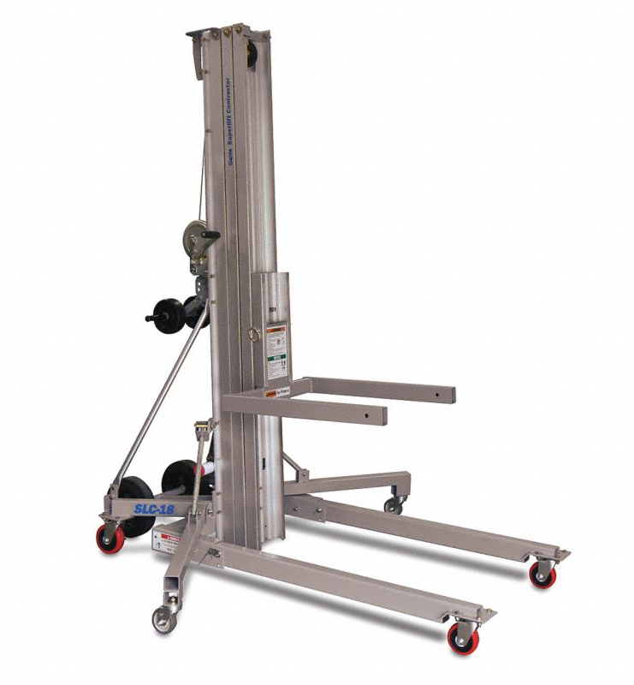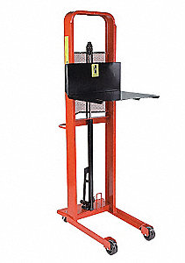

REFERENCES

- 29 CFR 1910, Subpart N, OSHA General Industry Standards, Materials Handling and Storage
- 29 CFR 1926.602 (c), (d) – Material Handling Equipment
- ASME B56.1 - Safety Standard for Low Lift and High Lift Trucks
- DOE Hoisting and Rigging Standard

TECHNICAL APPENDICES

Class I: Electric Motor Rider Trucks

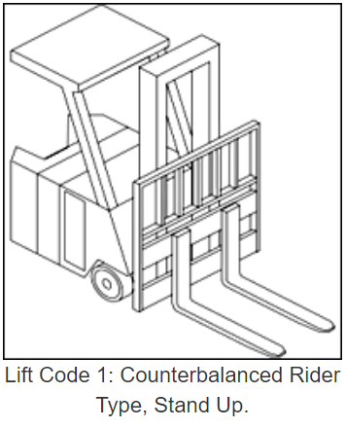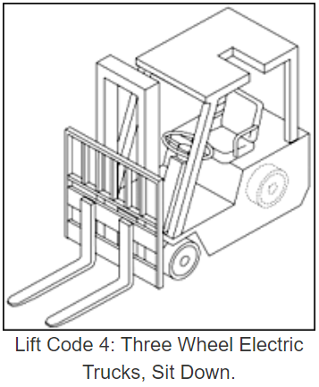

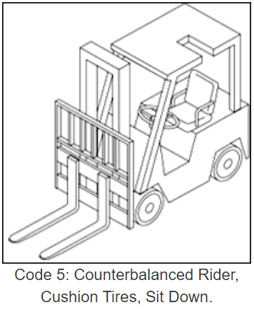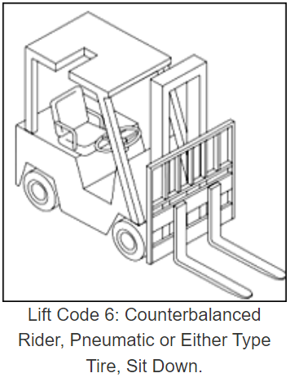

Class II: Electric Motor Narrow Aisle Trucks

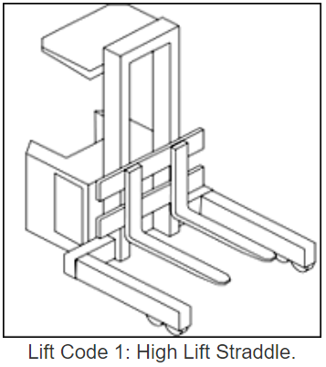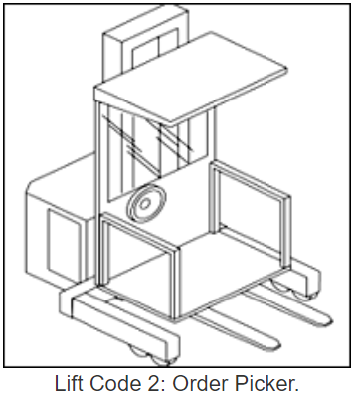

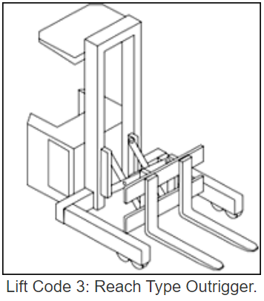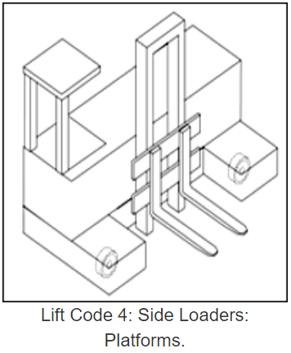

Class II: Electric Motor Narrow Aisle Trucks (continued)

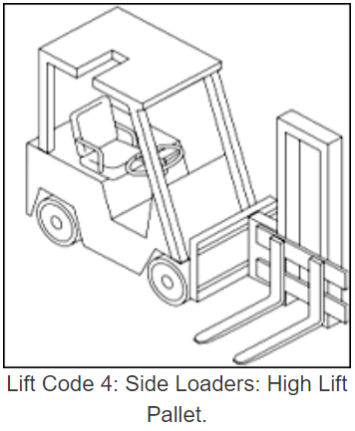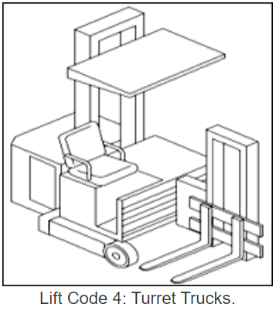

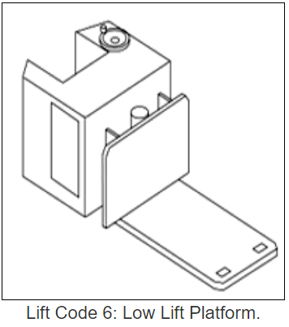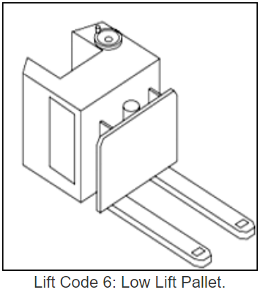

Class III: Electric Motor Hand Trucks or Hand/Rider Trucks

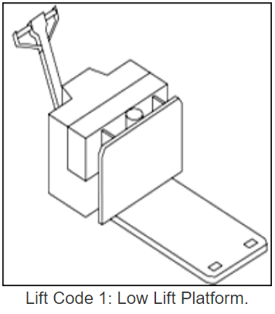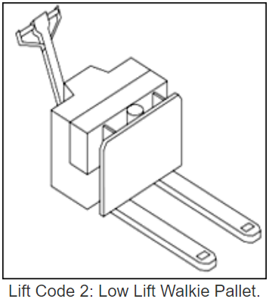

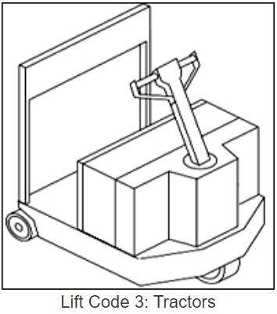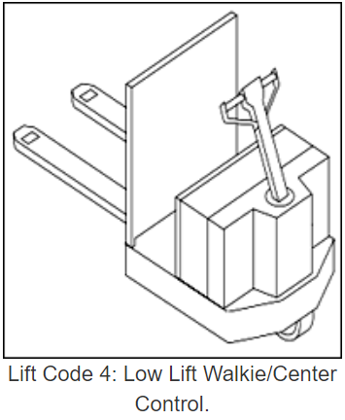

Class III: Electric Motor Hand Trucks or Hand/Rider Trucks (continued)

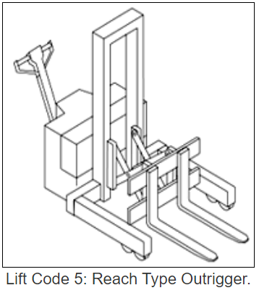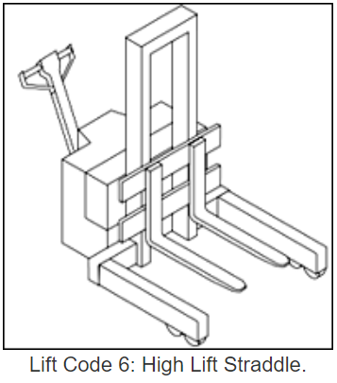

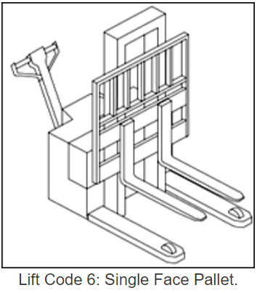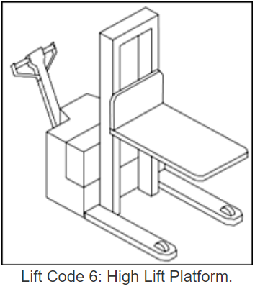

Class III: Electric Motor Hand Trucks or Hand/Rider Trucks (continued)

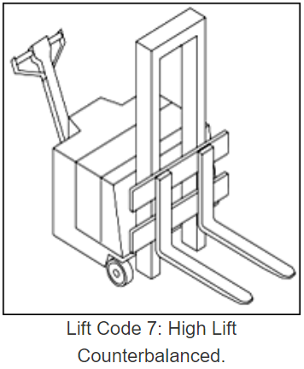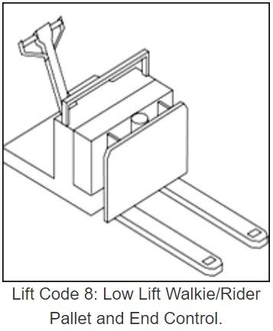

Class IV: Internal Combustion Engine Trucks (Solid/Cushion Tires)

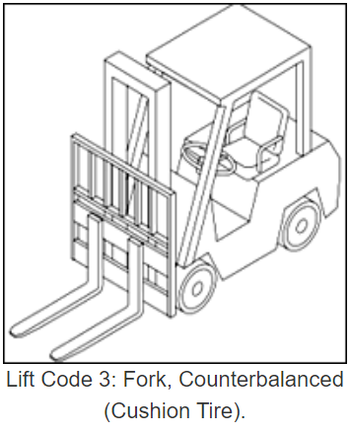

Class V: Internal Combustion Engine Trucks (Pneumatic Tires)

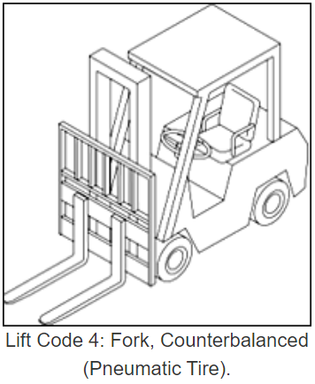

Class VI: Electric and Internal Combustion Engine Tractors

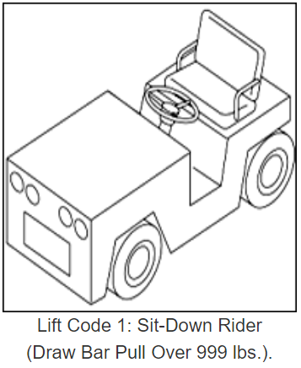

Class VII: Rough Terrain Forklift Trucks

Rough terrain forklift is a generic term used to describe forklifts typically intended for use on unimproved natural terrain and disturbed terrain construction sites. However, the term “rough terrain” does not imply that the forklift can be safely operated on every conceivable type of terrain.

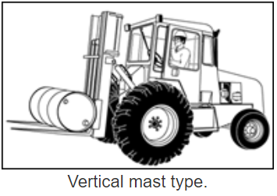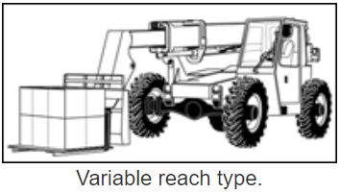

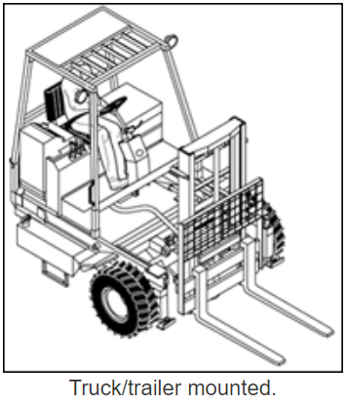
Manually Operated Material Lifts

