FESHM 10160: TRAFFIC SAFETY

Revision History

Author | Description of Change | Revision Date
Chuck Morrison | - Updated Excessive Speed definition | January 2019
T.J. Sarlina | - Removed prohibition regarding hands-free phone use while on site to align with Illinois Rules of the Road.  - Added a flowchart to define the process to request specialized parking spaces.  - Updated Driving Under the Influence (DUI) definition. | August 2017
Chuck Morrison | - Prohibited riding in the bed or cargo area of trucks.  - Aligned non-highway vehicle use with policy for safe operations. | January 2016
John Cassidy | - Added Parking requirements: restricted parking areas; long term parking; abandoned vehicles.  - Vehicle sticker clarification. | March 2015
Martha Michels | Added language to Section 4 about the proper way to park vehicles within the parking line.  Deleted Section 6.0 App. B and added wording to Section 4 clarifying safeguards for construction and maintenance. | May 2013
Nancy Grossman | Summarizing changes:  - Removed suggested text for automatically generated letters – Appendix B.  - Updated appeals process:  - Removed language that users could not appeal.  - Appeals committee will consist of high level management personnel and WDRS.  - Grieving an appeal is no longer allowed. | October 2011
Nancy Grossman | Summarizing changes:  - Changed number of suspension days.  - Clarified e-mails and updated links in the e-mails.  - Updated pull-down boxes in traffic citation database. | July 2011

TABLE OF CONTENTS

1.0 INTRODUCTION 3
2.0 DEFINITIONS 3
3.0 RESPONSIBLILITIES 4
4.0 PROCEDURES 5
4.1 Accidents 5
4.2 Operating Vehicles 5
4.3 Parking 5
4.4 Bicyclists 7
4.5 Citations 7
5.0 APPENDIX A – Violations, Progressive Discipline and Appeals Process 8
5.1 Parking Violations 8
5.2 Moving Violations 8
5.3 Appeals Process 10
6.0 APPENDIX B – Safeguards for Construction and Maintenance Activities 11
7.0 APPENDIX C – Operating Non-Highway Vehicles on Fermilab Roads 12

INTRODUCTION AND SCOPE

The driving and parking of motorized vehicles on the Fermilab campus can pose a serious safety risk to motorists as well as bicyclists and pedestrians. To reduce these risks, Fermilab has adopted the applicable portions of the State of Illinois Vehicle Code and the Rules of the Road into its Work Smart Set. Motorists are legally obligated to observe these regulations when operating vehicles on public roadways in Illinois. The Lab reserves the right to employ more stringent standards when necessary. Laboratory disciplinary action can and will be taken against offenders. This chapter highlights the standards, assigns responsibilities, and defines a uniform progressive disciplinary program.

Traffic signals and signs on the Fermilab campus shall conform to the State of Illinois standards for type, size, shape and placement. All construction work, road repairs, or road closures shall follow the Manual on Uniform Traffic Control Devices and FESHM 2060, Work Planning and Hazard Analysis.

This chapter only applies to the Fermilab site. Leased spaces will follow the rules and regulations of the state in which they are located.

DEFINITIONS

Commercial driver's license (CDL) - means a license issued by a state or other jurisdiction, in accordance with the standards contained in 49 CFR part 383, to an individual which authorizes the individual to operate a class of a commercial motor vehicle.

Commercial motor vehicle (CMV) - means a motor vehicle or combination of motor vehicles used in commerce to transport passengers or property if the motor vehicle:
(a) Has a gross combination weight rating of 11,794 kilograms or more (26,001 pounds or more) inclusive of a towed unit(s) with a gross vehicle weight rating of more than 4,536 kilograms (10,000 pounds); or
(b) Has a gross vehicle weight rating of 11,794 or more kilograms (26,001 pounds or more); or
(c) Is designed to transport 16 or more passengers, including the driver; or
(d) Is of any size and used in the transportation of hazardous materials as defined in 49CFR383.5.

Driving - means operating a motor vehicle on an active roadway, including while temporarily stationary because of traffic, a traffic light or stop sign, or otherwise. It does not include operating a motor vehicle with or without the motor running when one has pulled over to the side of, or off, an active roadway and has halted in a location where one can safely remain stationary.

Driving Under the Influence (DUI) - means operating a motor vehicle while impaired by alcohol, drugs or intoxicating compounds. Drivers are legally considered to be under the influence if they have a blood-alcohol content (BAC) of .08 or more, a tetrahydrocannabinol concentration (THC) of either 5 nanograms or more per milliliter of whole blood or 10 nanograms or more per milliliter of other bodily substance, have used any other controlled substance or are impaired by medication.

Excessive Speed – means traveling 15 mph or greater above the posted speed limit.

Electronic Communication Device - means an electronic device (including but not limited to a wireless telephone, personal digital assistant, or a portable or mobile computer) being used for the purpose of composing, reading, or sending an electronic message. Exclusion: A mobile (electronic/communication) device does not include audio equipment or any equipment physically or electronically integrated into the motor vehicle to provide navigation (GPS) or emergency information to the driver, or video entertainment exclusively to passengers in the back seat. Nor does a mobile device include two-way mobile radio transmitters or receivers used by licensees of the Federal Communications Commission in the Amateur Radio Service.

Electronic Message - means a self-contained piece of digital communication designed or intended to be transmitted between physical devices. "Electronic message" includes, but is not limited to electronic mail, a text message, an instant message, or a command or request to access an Internet site.

RESPONSIBLILITIES

Employees, Users, Visiting Scientists, Subcontractors, and Guests shall comply with the traffic safety rules contained in this FESHM Chapter, the State of Illinois Vehicle Code as well as the publications, Illinois Rules of the Road, Illinois Motorcycle Operator Manual, and Illinois Bicycle Rules of the Road. Failure to do so may result in the issuance of citations and disciplinary action, or in the case of a bicycle on loan to an individual, loss of the bicycle. All individuals in accidents involving motorized vehicles (this includes, for example, forklifts) or bicycles must report to ext. 3414 as soon as possible so that an incident investigation and report can be completed, and must report to Occupational Medical Office if injured or directed to do so by the Security Officer. If a medical emergency situation is involved, call ext. 3131 immediately.

Division/Section Heads and Project Managers (D/S/P) shall enforce the progressive disciplinary measures identified in this chapter. It is the responsibility of each D/S/P to ensure that only authorized and properly licensed personnel use government-supplied vehicles on or off the Fermilab campus. Also, it is the responsibility of each D/S/P initiating an activity that presents a temporary obstruction of roadway traffic to see that the special safety provisions identified in Appendix B are carried out.

Security Officers of the Contract Protective Force are authorized to enforce the traffic safety rules by issuing citations to violators. Officers shall not engage in any high-speed pursuits or attempt any maneuver that places themselves or any other motorist, bicyclist, or pedestrian in danger. Under all circumstances, officers are expected to remain calm and courteous in their interactions with operators of motorized vehicles or bicycles when they are investigating accidents or issuing citations. Concerns or issues regarding the qualifications, competency or professional conduct of security officers should be brought to the immediate attention of the Security Chief via the Security Dispatcher at X-3414.

Security Department shall:
- Manage the Contract Protective Force employees,
- Maintain a database of citations, and
- Recommend solutions to enhance and improve safety for pedestrians, cyclists and motorists on the Fermilab Site via the Fermilab Emergency Management Sub-Committee.

Roads and Grounds Department of the Facilities Engineering Services Section is responsible for determining the appropriateness of traffic safety signs and controls as well as their placement, or replacement when damaged, on the Fermilab campus. They are also maintain roads and pedestrian/bike paths and shall make every effort to keep them in a serviceable and safe condition.

Traffic Citation Review personnel are responsible for reviewing traffic appeals by objectively listening to the facts and coming to a determination consistent with lab policy.

PROCEDURES

Accidents

- All accidents involving motorized vehicles or bicyclists must be reported to ext. 3414 as soon as possible so that an incident investigation and report can be made. If a medical emergency situation is involved, ext. 3131 should be called.

Operating Vehicles

- Operators of motorized vehicles and bicycles shall abide by the traffic safety rules contained in the State of Illinois Vehicle Code as well as the publication, Rules of the Road. Copies of these standards, which are contained in Fermilab’s Work Smart Set, can be found in the Fermilab Library, at any Illinois Secretary of State Driver Services Facility and at: https://www.cyberdriveillinois.com/publications/motorist/rorts.html

- Employees who operate a Commercial Motor Vehicle must hold a Commercial Driver’s License and comply with the applicable requirements of 49 CFR 382-399.

- Motorists must remain on established roadways unless specific authorization is given or is otherwise required for the performance of assigned tasks. Motorized vehicles shall only be parked in authorized parking spaces or in safe, graveled, roadside locations that do not impede the flow of traffic or endanger pedestrians.

Parking

- Vehicles must park parallel to the lines designating the parking space. Parking perpendicular to the lines is not allowed, regardless of the size of the vehicle.

- Some parking spaces are reserved (i.e., handicapped, emergency vehicle, etc.) and shall not be used by others. In addition, many parking spaces have time limits imposed upon them which shall not be exceeded.

- Restricted Parking: To park in a space marked “Restricted Parking” at Feynman Computing Center and Wilson Hall, you need a current Fermilab issued vehicle sticker. Without this, you are not authorized to park in a Restricted Parking space. Personnel can obtain a sticker from the Key and ID office in Wilson Hall on the ground Floor.

- Long Term Parking: Fermilab has designated Long Term Parking spaces at Building 327, D0 Outback, SiDet, and the Wilson Hall overflow parking lot at the Lederman Science Center for employees on business travel. Employees can park in a satellite location if they will be on travel for two weeks or less. Employees who will be away from the Lab longer than two weeks must use the Long Term Parking Lot located in the Village. To park in these spots, please fill out a Long Term Parking form and take it to the Communication Center, Wilson Hall Ground Floor.

- Due to the changing nature of laboratory operations and relocation of work centers and/or personnel, specialized parking spaces are sometimes required. The proper procedures for requesting specialized spaces are outlined in Figure 1 below.

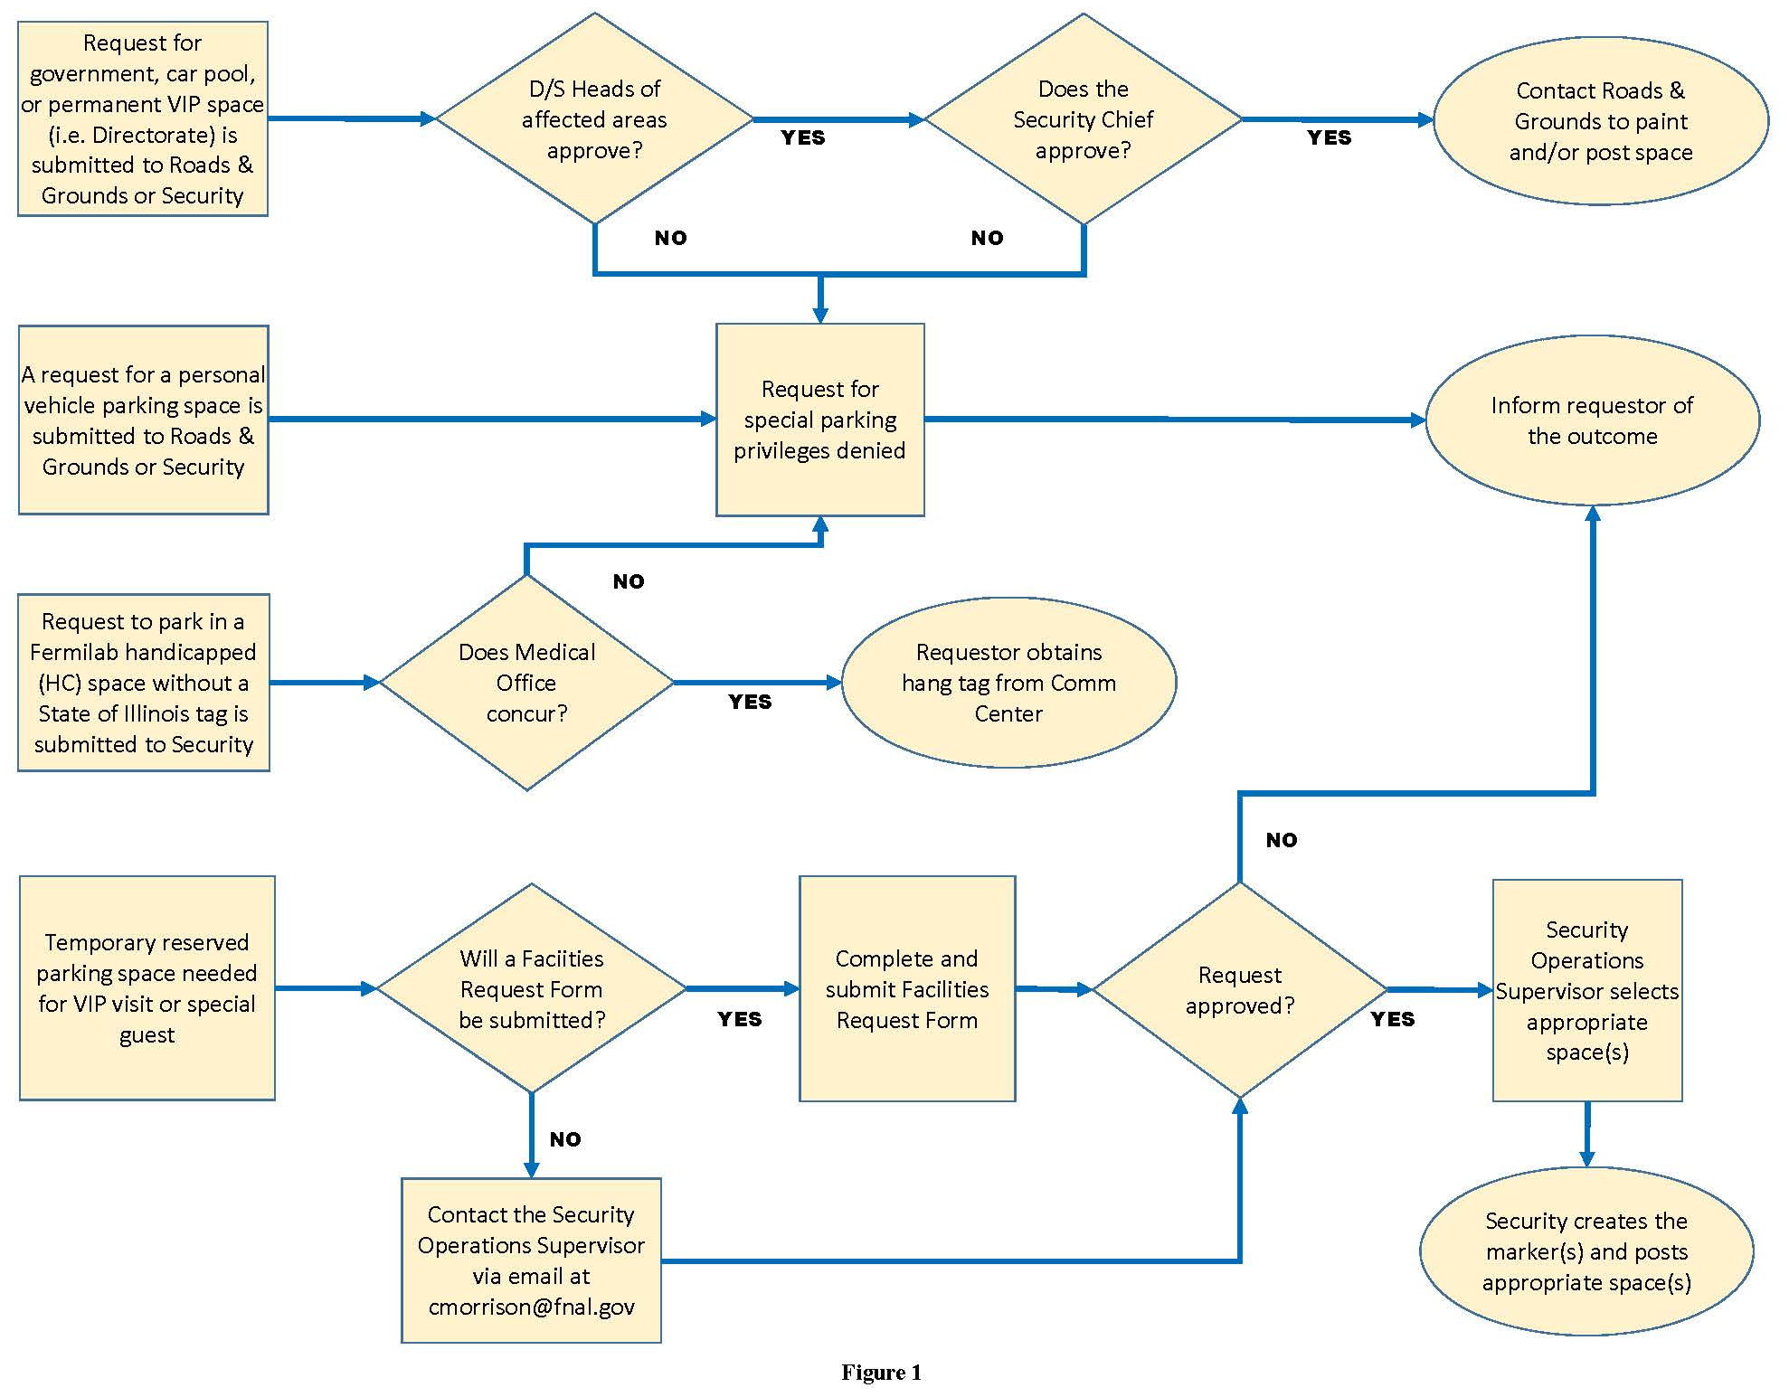

Bicyclists

Bicyclists are permitted to use either roadways or bicycle/pedestrian paths in accordance with the Illinois Rules of the Road and are required to follow the same traffic safety rules as the motorists. Individuals who ride a bicycle on loan from Fermilab, or ride a personal bicycle in the performance of their work duties, are required to wear a helmet certified by either CPSC (Consumer Product Safety Commission) or ASTM (American Society of Testing and Materials). Therefore, when an individual is using a bicycle on loan from the Lab or using a bicycle of any ownership for official duties they are required to wear a helmet as described above and it is the responsibility of the individual’s supervisor or point of contact to ensure that helmets are acquired and worn. (Note: Helmets may be purchased with a ProCard, but will require prior approval from a Division/Section ES&H representative since a bicycle helmet is considered personal protective equipment, and as such, is an ES&H sensitive item.)

Citations

Citations issued to operators of motor vehicles and bicycles will result in progressive discipline (Appendix A).

APPENDIX A – Violations, Progressive Discipline and Appeals Process

The corrective action process for both parking and moving violations is described below. Fermilab reserves the right in its sole discretion to impose different disciplinary measures in specific cases. Sanctions for non-employees will be determined on a case-by-case basis by Fermilab management and may include restricted parking permission, limited site access, banishment from the site, cancellation of contracts for subcontractors, or termination of an assignment for temporary staff.

Parking Violations

Some parking violations have serious safety consequences associated with them, such as parking in marked fire lanes or next to fire hydrants. Fermilab reserves the right to bypass any of the steps identified below and to take more aggressive disciplinary action. For each citation, the violator will automatically receive an e-mail after the 5 day appeal period has passed. If they appeal early enough in the 5 day period, the automatic e-mail will be stopped. Citations have a statement clearly written on them that one has 5 business days to appeal.

1. One citation in any 90-day period: Issuance of a printed citation by Fermilab Security is considered a verbal warning. A copy of the citation will be provided to the employee’s supervisor. After the 5 day appeal period, an automatic e-mail (or letter if the employee does not have e-mail) will be sent to the employee stating the discipline policy and appeals process with a link to FESHM 10160.

2. Two citations in any 90-day period: Issuance of a printed citation by Fermilab Security is considered to be a second verbal warning. A copy of the citation will be provided to the employee’s supervisor. After the 5 day appeal period, an automatic e-mail (or letter if the employee does not have e-mail) will be sent to the employee stating the discipline policy and appeals process with a link to FESHM 10160.

3. Three citations within any 90 day period: During a meeting with the employee and his/her supervisor, a written warning will be given to the employee, signed by the employee, acknowledging receipt, and placed in the employee’s personnel file. The employee will be informed that if a fourth parking violation occurs within the 90 day period, they will be subject to taking a minimum one day suspension without pay on a day(s) prescribed by their D/S/P.

4. Four citations within any 90 day period: A written letter will be issued and the employee will be required to take a minimum one day suspension without pay on day(s) prescribed by their D/S/P. This letter, along with a statement of the circumstances, is placed in the employee’s personnel file.

5. Five citations within any 90 day period: The employee will be subject to severe disciplinary action up to and including termination for failure to follow Fermilab rules and regulations.

Moving Violations

The following are examples of common moving violations, but the list is not intended to be inclusive of all moving violations for which citations may be issued.

- Driving at unsafe speeds in pedestrian areas such as parking lots.
- Exceeding the posted speed limit on Fermilab roadways.
- Not coming to a complete stop at posted stop signs.
- Failure to yield right-of-way to pedestrians in or approaching a marked crosswalk.
- Operating a truck with passengers in the bed or cargo area.
- Crossing a double yellow line to pass any vehicle except for slow moving equipment and vehicles after being signaled by the driver or operator that it is safe to pass.
- Operating any vehicle after sundown or before sunrise without lights, or without lighted escort vehicles or persons.
- Operating any vehicle off of the existing road network (including fence line roads) on the Fermilab Site without specific permission of the Facilities Engineering Services Section.
- Operating any vehicle in an inherently unsafe manner that would endanger the life or health of any person, or the property of any person, or of Fermilab or any other organization, company, or university, or the property of the U.S. Department of Energy.
- Operating any vehicle while under the influence of alcohol or other drugs.
- Driving any motor vehicle on the Fermilab site while using a hand-held electronic communication device (i.e. cell phone) as outlined in the Illinois Rules of the Road. Exceptions include operators of emergency vehicles while performing official duties, two-way radios provided by the Laboratory for official business, and two-way mobile radio transmitters or receivers used by licensees of the Federal Communications Commission in the Amateur Radio Service.

All moving violations occurring on the Fermilab Site are possible life-threatening situations. Based on the severity of the violation, Fermilab reserves the right to forego any or all of the steps in the disciplinary process and initiate immediate action up to and including termination for gross misconduct. For every citation written, the violator will automatically receive an e-mail after the 5 day appeal period has passed. If they appeal early enough in the 5 day period, the automatic e-mail will be stopped. Citations have a statement clearly written on them that one has 5 business days to appeal.

1. One citation in any 180 day period: Issuance of a printed citation by a Fermilab Security Officer regarding the offense is considered a verbal warning. A copy of the citation will be provided to the employee’s supervisor. After the 5 day appeal period has passed, an automatic e-mail (or letter if the employee does not have e-mail) will be sent to the employee stating the discipline policy and appeals process in FESHM 10160, with a link to FESHM 10160.

2. Two citations within any 180 day period: During a meeting with the employee and his/her supervisor, a written warning will be given to the employee, signed by the employee, acknowledging receipt, and will be placed in the employee’s personnel file. The employee will be informed that if a third moving violation occurs within the 180 day period, they will be subject to taking a minimum of 2 days suspension without pay on days prescribed by their D/S/P.

3. Three citations within any 180 day period: A written letter will be issued and the employee will be required to take a minimum of two days suspension without pay on days prescribed by their D/S/P. This letter, along with a statement of the circumstances, is placed in the employee’s personnel file.

4. Four citations within any 180 day period: The employee will be subject to severe disciplinary action up to and including termination for failure to follow Fermilab rules and regulations.

5. Excessive Speed citation (15 mph or more over the posted speed limit): The employee’s supervisor will discuss the situation with him/her and present a written warning letter. A copy will be placed in the employee’s personnel file. Users and Authorized Guests will receive a written warning from the Fermilab Director or his/her designee. Subcontractors will receive a written warning from their Organization leader.

6. DUI Arrest on Site: Users, Subcontractors and Authorized Guests arrested by a person with police authority for DUI on Fermilab property will have their access to the site revoked for a minimum of 30 days, up to indefinitely, depending on the circumstances of the incident.

Employees arrested for DUI on Fermilab property will be required to take a five day suspension without pay on days to be prescribed by their D/S/P. Depending on the circumstances of the incident, the employee may be placed on unpaid disciplinary suspension beyond the five days, pending investigation results, and may result in disciplinary action up to and including termination. The employee will also be required to attend an initial consultation with the Fermilab Employee Assistance Program (EAP) provider and follow the recommended treatment plan (if applicable) in order to receive a return to work authorization.

Employees who hold a CDL due to job requirements will be subject to the terms of applicable policies and state and federal regulations for CDL holders.

Appeals Process

Security officers are expected to be professional and fair in the issuance of citations, but it is recognized that there can be honest differences of opinion regarding a situation. For this reason, an appeals process has been developed so a person can have his/her disagreement reviewed. Cited individuals have five business days to appeal. Citations will not be posted during this time. To appeal, the cited person sends an e-mail to Traffic_Citation@fnal.gov with the subject “Citation Appeal”. Or if they do not have access to a computer, contacts the ESH&Q Section admin at x5811 to make them aware of the appeal. They then complete the Traffic Citation Appeal Form and the send it to esh_admin@fnal.gov or MS 119 within 5 business days of receiving the citation.

Traffic Citation Review personnel will review the appeal and talk with appropriate people to determine the facts. The ruling on the validity of the citation and appeal will be final. If the citation is considered invalid, the record will be purged; if it is considered valid, the appropriate sanction will be imposed.

APPENDIX B – Safeguards for Construction and Maintenance Activities

The following safeguards shall be taken during construction or maintenance activities that may affect the flow of traffic on campus roads.

- Signs shall be posted indicating road work in progress. Reflective signs and/or flashing lights are required for night visibility.

- Traffic cones shall be set up to divert traffic safely away from or through the work area.

- A flag person shall be assigned to the area if the work is to be performed in any area where driver visibility is obstructed, e.g., by heavy equipment. The flag person shall wear a hard hat, a brightly colored reflective vest and use an orange flag or hand-held stop/slow sign to direct traffic. In some circumstances, two flag persons may be necessary.

- The fire and security crews shall be notified in advance of the temporary road conditions.

For impaired roadways (totally blocked):

- The fire and security crews shall be notified at least three days in advance so that appropriate notifications and emergency arrangements can be made for fire and security emergency services.

- “Road Closed” and “Detour” signs shall be posted. Reflective signs and/or flashing lights are required for night visibility.

- The area shall be fully barricaded to prevent inadvertent access.

APPENDIX C – Operating Non-Highway Vehicles on Fermilab Roads

As used in this Appendix, “non-highway vehicle” means a motor vehicle not specifically designed to be used on a public highway. These vehicles can be further defined as any motorized off-highway device designed to travel primarily off-highway, 64 inches or less in width, having a manufacturer’s dry weight of 2,000 pounds or less, traveling on 4 or more non-highway tires, designed with a non-straddle seat and a steering wheel for steering control, except equipment such as lawnmowers (ILCS 5/1-168.8). Some common non-highway vehicles employed at Fermilab are;
- Bobcat Utility Vehicles
- Global Electric Cart
- John Deer Gator Series
- Kubota Utility Truck RTV Series
- Polaris Utility Vehicle Ranger Series
No non-highway vehicle may be operated on a Fermilab roadway unless, at a minimum, it has the following safety equipment:
- Brakes
- Seat belts
- Steering Wheel
- Rearview mirror
- Headlights
- Tail lights
- Brake lights
- Slow moving emblem on the rear or lit rotating beacon
Non-highway vehicles that do not meet the minimum requirements above include tunnel utility carts:
- Cushman Carts
- Nordco Marketeers
- Taylor Dunn Carts
- US Electric Car Carts
At times it may be necessary to drive a tunnel utility cart on Fermilab roads. These are slow moving carts that may introduce a collision hazard. The operator of the cart shall request an escort from a licensed government vehicle and shall not carry passengers. The escort vehicle must have the emergency flashers ON while escorting the cart.

