FESHM 6010: FIRE PROTECTION PROGRAM

Revision History

Author | Description of Change | Revision Date
Jim Niehoff | Added the Technical Appendix 7 titled “Fire Protection Design Standards”. Changed ESH&Q to ES&H, and changed FPE to AHJ-FP. Added definition of pyrophoric materials & reference DOE Handbook 1081. Incorporated FESHM 6020.1, 6020.4, 6040.1, 6040.2, & 6040.3 into Technical Appendix 7 titled “Fire Protection Design Requirements.” Removed site-specific and made that a standalone document. | September 2019
Jim Niehoff | Added reference to DOE Standard 1066 & ESHQS-SA1 Procedure; Added regular facility fire inspections to Section 3.15 Responsibilities Matrix; Added FESHM Chapter 2005, ORC to Section 4.2. Updated Appendix A to latest codes and standards and Added Appendix B, Overview of Site-Specific Fire Protection Program | May 2018
Jim Niehoff | Added applicability statement for Fermilab Leased Spaces. | December 2017
Jim Priest & Jim Niehoff | Added Wildfire and updated NFPA references in Technical Appendix. Updated template and changes to reflect the laboratory’s reorganization, i.e., changed SSO to DSO. | September 2015
Jim Priest & Jim Niehoff | Added SAD & User definitions; Removed term “Elements” from chapter title; Applied the FESHM Template; Incorporated references to other section’s documents comprising the lab’s Fire Protection Program; Updated Technical Appendix A with recent code editions | March 2013

TABLE OF CONTENTS
1.0 INTRODUCTION 5
2.0 DEFINITIONS 5
3.0 ROLES & RESPONSIBLILITIES 6
3.1 Laboratory Directorate 6
3.2 Division/Section Heads/ Project Manager (D/S/P) 6
3.3 Building Manager or Area Manager 7
3.4 Environment, Safety, and Health (ES&H) 7
3.5 ES&H Fire Protection AHJ 8
3.6 Fermilab Fire Department 8
3.7 Fermilab Security Department 9
3.8 Communications Center 9
3.9 Division Safety Officer 9
3.10 Facilities Engineering Service Section (FESS) Engineering Department or Project 9
3.11 FESS Fire Systems Maintenance (FSM) Technicians 9
3.12 FESS Facility Management\Operations & Maintenance (FESS\O) 9
3.13 FESS Services\Roads and Grounds 9
3.14 Landlord 10
3.15 Users/Experimenters (Everyone) 10
3.16 Responsibilities Matrix 10
4.0 PROGRAM 11
4.1 Design and Review of Fire Protection Systems 11
4.2 Users/Experimenters Reviews 11
4.3 Highly Protected Risk – Facility Inspections 11
4.4 Inspection and Maintenance of Fire Protection Systems (Irregularity Report System) 12
4.5 Facility Incident Monitoring and Communication 12
4.6 Response to Fire Emergencies 12
5.0 REFERENCES 12
6.0 TECHINCAL APPENDIX A: INSPECTION, TESTING AND MAINTENANCE OF FIRE PROTECTION SYSTEMS 14

7.0 TECHINCAL APPENDIX B: FIRE PROTECTION DESIGN REQUIREMENTS 28
I. Introduction 30
A. Definitions 30
B. Applicable Codes & Standards 31
II. Experiments, Facilities, and Accelerator Operations 34
A. Reference Material 34
B. Operational Readiness Clearance (ORC) 34
C. Flammable Gas: 34
D. Foam boards: 34
E. Wood 35
F. Storage of wood or plastic pallets or packing material 35
G. Plastics 35
H. Cable Jackets 36
I. Current Protection for both AC and DC Powered Installations (Fire/Smoke Hazard) 37
J. Rack Protection 37
K. Listing Agency 37
L. Fire Retardant Application 38
M. Summary 38
III. Facility Safety 39
A. Design Considerations 39
B. Design Criteria Site Evaluation 39
C. Design Criteria Facility Evaluation 40
D. Installation, Fabrication, and Construction 46
IV. Fire Alarm 47
A. Design/Construction Submittals 47
B. Design Criteria and Evaluation 47
C. Installation, Fabrication, and Construction 49
V. Automatic Sprinkler Systems 51
A. Design/Construction Submittals 51
B. Design Criteria and Evaluation 51
C. Products, Materials, and Equipment 52
D. Installation, Fabrication, and Construction 53
VI. Special – Fixed Fire Extinguishing Systems 54
A. Design/Construction Submittals 54
B. Design Criteria and Evaluation 54
C. Products, Materials, and Equipment 54
D. Installation, Fabrication, and Construction 54
VII. Fire Extinguisher 55
A. Design/Construction Documents 55
B. Design Criteria and Evaluation 55
C. Products, Materials, and Equipment 56
D. Installation, Fabrication, and Construction 56
Attachment A – Emergency Power Off Systems 57
Attachment B - Water Supply 66

INTRODUCTION

The objective of US Department of Energy (DOE) is to provide a level of safety protection consistent with “highly protected risk” class of Industrial risks. This objective requires significant facilities and processes to be protected by an overlapping combination of robust fire protection physical features, highly developed emergency response capabilities, and well organized programmatic and procedural infrastructures. Such measures often promote fire protection mitigation to a greater degree than building and fire codes. In addition, there is an expectation for these various fire safety constructs to interlace with other safety programs and systems to create an overarching safety environment within DOE’s Integrated Safety Management System (ISMS).
To that end, the 6000 series of the Fermilab Environment, Safety, and Health Manual (FESHM) chapters describe the organization and structure of the laboratory’s fire protection program. This program is to provide a level of fire protection and fire suppressions capability sufficient to minimize losses from fire and related hazards consistent with the best protected class of industrial risks, that is, Highly Protected Risk (HPR). Other related FESHM chapters include, but are not necessarily limited to, 1010, 1050, 1070, 2001, 2005, and 2010.
This chapter only applies to the Fermilab site. Leased spaces will follow the rules and regulations set forth by the partnering institute(s) and/or state or local codes and Technical Appendix 7, “Fire Protection Standards”.

DEFINITIONS

- International Code Council (ICC) – recognized publisher of building and fire codes.
- Building Manager (BM) or Area Manager (AM) - Designated FRA employee for each building or group of buildings on site that will serve as the contact point for all activities that will affect that building as a result of daily operations or services requested from both internal and external sources.
- Division Safety Officer (DSO) - An individual who is assigned duties as the principal ES&H advisor to the division/center/section head.
- Fermilab Fire Department (FFD) – Individuals of an organization trained and tasked with emergency care, preventing, and extinguishing fires, and other emergency responses, such as Oxygen Deficiency Hazard (ODH).
- Fire Hazard Subcommittee (FHS) – Subcommittee of the Fermilab ES&H Committee is delegated the Alternate Authority Having Jurisdiction (AHJ). The FHS is responsible for fire safety, life safety aspects of facilities, processes and experiments, and flammable and compressed gas systems.
- Fire Protection AHJ (FP-AHJ) – Is delegated as the primary Authority Having Jurisdiction (AHJ) and approved by FSO. The FP-AHJ will be responsible for overseeing the overall implementation and development of the Fermilab fire protection program.
- Fire Systems Maintenance (FSM) Technician – Individuals trained in the inspection, testing, and minor maintenance of fire protection systems throughout the Laboratory (including Water Based Systems, Fire Alarm Systems, and Special Hazards Systems).
- Facility Incident Reporting and Utility System (FIRUS) - Lab-wide system that monitors building fire alarm systems and transmits alarms to the Communications Center in Wilson Hall.
- Highly Protected Risk (HPR) - A facility that is characterized by a level of fire protection of the best protected class of industrial risks.
- Irregularity Report - A form issued by Facilities Engineering Services Section (FESS) Fire Systems Maintenance (FSM) technicians and Fermilab Fire Department (FFD) personnel to communicate critical deficiencies in fire protection systems to the ES&H Fire Protection AHJ (ES&H-FP-AHJ). The form is presented in chapter 6010.
- Landlord - The Division/Section (D/S) responsible for the facility or space where work is planned or occurring.
- National Fire Protection Association (NFPA) – Organization dedicated to fire safety through creating consensus standards and codes.
- ORC – Operational Readiness Clearance (ORC).
- Prescribed Fire – Any fire ignited by management actions under certain, predetermined conditions to meet specific objectives related to hazardous fuels or habitat improvement.
- Prescribed Fire Plan (Burn Plan) – A document/procedure providing the information needed to implement an individual prescribed fire project.
- Pyrophoric Material – Gas, liquid, or solid form, are capable of spontaneous ignition at low temperatures. Pyrophoric materials, regardless of their state, may spontaneously ignite when exposed to air at normal or slightly elevated temperatures. Many pyrophoric materials are also highly reactive with water or moist air.
- Safety Assessment Document (SAD) Accelerator Readiness Review Documentation - A formal review document describing the analysis of Fermilab projects, operations and experiments for hazards and their final method of mitigation.
- Users/Experimenters – Individuals responsible for maintenance and operation of an experiment.
- TSW – Technical Scope of Work (TSW).
- Wildland Fire – Any nonstructural fire, other than prescribed fire, that occurs in wildland.

ROLES & RESPONSIBLILITIES

Laboratory Directorate

- Overall responsibility for the fire protection program resides with the Directorate's Office.
- The Directorate assures that adequate resources are available to carry out the elements of the fire protection program as delineated in this chapter.

Division/Section Heads/ Project Manager (D/S/P)

- Implementation of the fire protection program within the areas for which they have responsibility. This includes assuring that all assessments, inspections, tests, and maintenance of fire detection and suppression equipment are conducted by support organizations in accordance with the requirements hereafter set forth.
- General facility audits or audits of inspection reports, irregularity reports, or other documentation (e.g., using the Self-Assessment process as defined by Fermilab Quality Assurance Manual Chapter 12080) to ensure compliance with the various elements of the Fire Protection Program.
- For all fire protection system designs, it is the responsibility of the D/S/P landlord. The D/S/P is responsible to assure that
  - Reviews are performed which assure that a satisfactory level of protection is being provided,
  - That the installation is satisfactory
  - That acceptance tests are adequate to assure proper operation of the fire protection system;
  - That the system has been properly tested prior to being put into service, and;
  - Proper maintenance and operations costs are included in D/S/P budgets.
- D/S/P personnel must periodically audit assigned fire protection systems through the Tripartite Assessment process.
- Ensuring the ORC process is followed per FESHM Chapter 2005.
- Ensuring appropriate preventative measures are in place to prevent spontaneous ignition of pyrophoric materials, reference DOE Handbook 1081, 2014, Primer on Spontaneous Heating and Pyrophoricity.

Building Manager or Area Manager

- The Building Managers/Area Managers assigned to specific buildings within each D/S is responsible for periodic inspections of fire protection system components in accordance with Technical Appendix A.
- The Building Managers/Area Manager assigned to specific buildings ensure that new facility interior materials meets the requirements set forth in this chapter.
- Conducts regular schedule walk through of all spaces with fire rated assemblies and documents walk through and findings.
- Any deficiencies noted during the inspections must be corrected by 1) creating a requisition or work order to correct the condition or 2) contacting the FESS FSM technicians, FFD, or ES&H-FP-AHJ directly for immediate assistance.
- Manage the emergency preparedness, including exiting and evacuation plans, drills, and readiness in accordance with FESHM 2050.

Environment, Safety, and Health (ES&H)

- The FP-AHJ reviews all fire protection system designs to assure that:
  - A satisfactory level of protection is being provided
  - The applicable fire protection provisions of the IBC International Building Code, the International Fire Code, and National Fire Protection Association Standards (NFPA) are being met
  - The installation plan is satisfactory
  - Acceptance tests are adequate to assure proper operation of the fire protection systems.
- The ES&H Section will periodically audit fire protection systems as part of the Tripartite Assessment process.

ES&H Fire Protection AHJ

- Assists FESS\Engineering Department or Project as requested during the design, installation, testing, and acceptance of fire protection systems.
- Reviews conventional facilities construction drawings and participants in the ORC & TSW processes as delineated in FESHM Chapter 2005.
- Conducts periodic assessments of Fermilab facilities to evaluate compliance of each facility with the requirements of the best protected class of industrial risks, or highly protected risks (HPR).
- Monitors system operation, effectiveness, and failures (including the FIRUS system) found during routine testing via the Irregularity Report system and audits.
- Reviews Fermilab Fire Department (FFD) Run Reports.
- Will be notified by telephone, regardless of day or time, of all FFD Runs involving:
    - Loss of water protection (i.e. broken water lines).
    - Loss of electrical power resulting in fire detection and/or FIRUS systems relying on backup power.
    - Any fire related event that results in physical damage to structures or equipment that had the potential for endangering personnel.
- Notification of the FP-AHJ will be made by the Communications Center upon direction of the Senior Fire Department Officer. This notification will not be made ahead of any time- urgent emergency response notifications or efforts.

Fermilab Fire Department

- Responds to fire emergencies.
- Assists the FESS FSM technicians by performing required testing of the fire protection systems, as specified in Technical Appendix A.
- Issue Irregularity Reports as required.
- May witness acceptance of fire protection/detection systems.
- Generates a Fire Department Run Report, which documents the details of all responses to fire alarms and emergencies.
- Conducts a general fire inspection for all buildings semi-annually and issues a report of findings to the Building Manager or Area Manager.
- Conducts a general inspection of all fire pump rooms monthly.
- Performs fire inspections, see FESHM Chapter 6015 for further details.
- Inspects all Village housing units semi-annually (includes alarm systems, CO detectors, GFCI tests, and fire extinguishers) and issues a report to the Building Manager.
- Reviews and oversees the Hazard Map Program.
- Maintains the Baseline Needs Assessment in conjunction with the FP-AHJ.
- May participate in reviews and witnessing of fire protection system testing.

Fermilab Security Department

- Oversees and directs the operation of the Communications Center, including testing of FIRUS (see Technical Appendix A).

Communications Center

- Monitors FIRUS on a 24-hour basis.
- Dispatches emergency response personnel as directed by received FIRUS messages.
- Notifying Duty personnel (FSM Techs, Mechanics, Electricians, etc.) as directed by received FIRUS messages.
- Maintains appropriate and accurate call lists for all D/S buildings.
- Informs personnel on specified call lists referenced on received FIRUS messages.
- Provides timely status updates to the FP-AHJ and Fire Department when reported FIRUS problems cannot be resolved in a timely manner.
- Provides timely status updates to the FP-AHJ and Fire Department when unexpected issues arise with the FIRUS system.

Division Safety Officer

- The DSO, or designee for each division, will review Fire Department Run Reports and investigate the incident as needed.
- Reviews the Fire Safety Inspection Report issued by the FFD and addresses any findings, as appropriate.

Facilities Engineering Service Section (FESS) Engineering Department or Project

- The Facilities Engineering Services Section engineering staff (FESS\E) or project staff provides design and consulting services, and oversees the installation and acceptance testing of fire protection systems for both new construction and modifications to existing facilities.
- .

FESS Fire Systems Maintenance (FSM) Technicians

- Responsible for the inspection, testing and maintenance activities for all installed fire protection systems throughout the Laboratory as specified in Technical Appendix A.
- Witnesses and participants in the acceptance testing of fire protection/detection systems.
- They will issue Irregularity Reports, as required.

FESS Facility Management\Operations & Maintenance (FESS\O)

- FESS\O personnel provide maintenance and testing for the underground water mains and fire hydrants, as well as other duties specified in Technical Appendix A.

FESS Services\Roads and Grounds

- Maintains and implements the prescribed fire program as part of the land management program.

Landlord

It is the responsibility of landlord divisions/sections to ensure that acceptable fire assemblies are installed and properly maintained as required in all their assigned facilities.

Fire assemblies, including fire stopping documentation will be maintained by the landlord division/section.

Penetrations through or into Hazardous (Classified) locations will be approved by the FP-AHJ. When necessary, sealing wiring entering into locations deemed hazardous will meet applicable National Electric Code (NEC) (NFPA 70) Article 500 requirements.

Users/Experimenters (Everyone)

- Monitors areas for fire safety.
- Contact Facilities Engineering Services Section (FSM ext. 2924) regarding issues or problems with fire protection systems.
- Provides information about unresolved fire safety problems to the FP-AHJ.

Responsibilities Matrix

 | DIR | D/S/P | BM/AM | DSO | AD | FESS** | FSM | FP-AHJ | FFD
Overall Responsibility | X | X
FPS Assessments |  | X |  |  |  |  |  | X
FPS Design/Review |  | ** |  |  |  | X | X | X | *
FPS Installation |  | ** |  |  |  | X | X | * | *
FPS Testing |  | ** |  |  |  |  | X | * | *
FPS Acceptance |  | ** |  |  |  |  | X | * | *
FPS Code & Compliance Review |  |  |  |  |  | X |  | X | *
FPS Maintenance/Test/ Inspection |  | X | X |  |  | X | X |  | X
FIRUS Maintenance |  |  |  |  | X
Comm Center |  |  |  |  |  |  |  |  | X
Fire Incident Response |  |  |  |  |  |  |  |  | X
FFD Run Reports |  |  |  | X |  |  |  | X | X
Irregularity Reports |  |  |  |  |  |  | X | X | X
Fire Safety Inspections |  |  |  |  |  |  |  |  | X
HPR Assessments |  |  |  |  |  |  |  | X | *
Prescribe Fire Program |  |  |  |  |  | X |  | * | X
* may participate
**may also be Project’s Responsibility
FPS denotes Fire Protection/Suppression and/or Detection System

PROGRAM

The fire protection program encompasses all aspects of fire protection at the Laboratory. The program includes fire prevention practices and procedures, quality construction, protecting buildings and facilities with fixed fire detection and suppression systems, procedures for testing and maintenance of fire protection systems and equipment, providing firefighting devices as appropriate, providing adequate water supplies for fire control, a system of oversight that ensures that DOE orders and mandatory standards applicable to fire protection are met, a staffed and equipped fire department, and most importantly, participation by all personnel from the directorate level down to managers, scientists, engineers, technicians, and supporting employees.

In general, the “code of record” (the building or design code in effect at the time of start of design) will remain in effect for the life of the facility. In the event that a facility undergoes a major renovation, change of use or identification of significant hazard that endangers the building occupants (as determined by the FP-AHJ), the facility will be required to meet the current code requirements.

Design and Review of Fire Protection Systems

- Fire Protection systems will be designed to meet the design codes, guidance and best practices as contained in Technical Appendix
- Fire Protection system designs are subject to the review process detailed in FESHM 2010.
- FESHM 2001 procedures are also used to review project design and drawings of both new construction and modifications to existing facilities, including fire protection systems. These projects may be completed by subcontractors or may be "turn-key" services from a vendor.
- The FP-AHJ reviews all fire protection systems as described in Section 3.5.

Users/Experimenters Reviews

- Users/Experimenters are encouraged to include the -FP-AHJ during the early stages of the design process to ensure that applicable codes and best practices are adequately addressed and incorporated.
- The FP-AHJ reviews experiments though ORC/TSW process to assure a satisfactory level of protection is being provided and that the applicable fire protection provisions of the International Building Code, the International Fire Code, and National Fire Protection Association Standards (NFPA) are being met. The FP-AHJ is responsible for documenting these reviews.
- Flammable liquids, gases and other hazardous materials will be evaluated to ensure the safety of building occupants. Documentation and review will follow the processes of the SAD and FHS Subcommittee (reference FESHM Chapters 2005, 2010, and 6020.3)

Highly Protected Risk – Facility Inspections

- The Laboratory maintains facilities that are characterized as a “best protected” class of industrial risk (Highly Protected Risk), equipped with an appropriate level of fire protection.
- Inspection frequency depends on the mission criticality of a facility to the Laboratory mission. The loss of those facilities that would have an adverse impact on the Laboratory would have a higher frequency of inspection. Inspection schedules ranges from annually to once every 5 years. The FP-AHJ oversees the inspection process and maintains the inspection schedule.

Inspection and Maintenance of Fire Protection Systems (Irregularity Report System)

- Technical Appendix A specifies the schedule and responsibilities for the inspection, testing and maintenance activities for all installed fire protection systems throughout the Laboratory. Building Managers that detect serious irregularities must notify the FSM Technicians of those conditions. FSM technicians (and FFD) must submit all irregularities (using the Irregularity Report System) to the FP-AHJ. The FSM technicians or FP-AHJ will communicate with the affected division/section and suggest corrective strategies. The D/S must then document the deficiency in iTrack and make the needed corrections.

Facility Incident Monitoring and Communication

- The Facility Incident Reporting and Utility System (FIRUS), a proprietary supervising station system, monitors fire protection, security and utility systems at Fermilab.
- FIRUS system alarms are monitored in the Fermilab Communications Center (Comm Center), located on the ground floor of Wilson Hall.
- The Comm Center also receives telephone calls reporting fires. The Comm Center dispatches the FFD and security personnel.
- The Security Department oversees and directs the operation of the Comm Center. The FFD generates a Fire Department Run Report, which documents the details of all responses to fire alarms and emergencies.
- The FP-AHJ and the affected Division Safety Officer reviews the Fire Department Run Reports and investigates as needed.

Response to Fire Emergencies

The FFD and Security Department will respond to all fire emergencies. If needed, additional assistance will be provided by nearby municipal fire departments through mutual aid agreements

REFERENCES

- 10 CFR 851 Worker Safety and Health Program
- 29 CFR 1910 Subpart L Fire Protection
- 29 CFR 1910.164 and 1910.165 Other Fire Protective Systems
- 29 CFR 1926.24 Fire Protection and Prevention, 1926.34 Means of Egress
- US Department of Energy Standard 1066, Fire Protection, 2016 Edition
- US Department of Energy Handbook 1081, Primer on Spontaneous Heating & Pyrophoricity, 2014
- International Building Code (IBC), 2018
- International Fire Code (IFC), 2018
- National Fire Protection Association (NFPA)
- ES&H Emergency Management Procedure Manual
- FESHM Chapter 2001, Environment Safety & Health for Projects
- FESHM Chapter 2005, Operational Readiness Clearance
- FESHM Chapter 2010, Planning & Review of Accelerator Facilities & Their Operations
- FESHM Chapter 2040, Emergency Management Program
- FESHM Chapter 7005, Authorization for Possession & Use
- FESHM Chapter 7010, ES&H Program for Construction
- FESHM Chapter 9100, Fermilab Electrical Safety Program
- Fermilab’s Facilities Engineering Services Section Fire System Maintenance Procedures
- Fermilab’s Facilities Engineering Services Section Prescribe Fire (Burn Plan)

Additional Fire Protection Programs and their associated FESHM chapters are:
- 6011 – Periodic Testing of Emergency Lights, Exit Signage, & Site-wide Emergency Alert
- 6012 – Periodic Inspection of Fire Doors
- 6013 – Facility Incident Reporting Utility System (FIRUS)
- 6014 – Fire Watch
- 6015 – Highly Protected Risk Inspection Program
- 6016 – Hazard Map Program (Pre-Incident Planning)
- 6020.1 – Incorporated into Technical Appendix 7
- 6020.2 – Welding, Burning, and Brazing (Welding, Burning, and Brazing Permit)
- 6020.3 – Storage and Use of Flammable Gases
- 6020.4 – Concepts of Egress
- 6020.5 – Flammable & Combustible Liquids
- 6030 – Disablement of Fire Protection Systems and Other Related Safety Systems
- 6040.1 – Incorporated into Technical Appendix 7
- 6040.2 – Incorporated into Technical Appendix 7
- 6040.3 – Incorporated into Technical Appendix 7
- Highly Protected Risk, A Best Practice – Developed by EFCOG Fire Protection Task Group, October 24, 2017

TECHINCAL APPENDIX A: INSPECTION, TESTING AND MAINTENANCE OF FIRE PROTECTION SYSTEMS

The following matrices address the NFPA code requirements for inspection, testing and maintenance of fire protection systems installed at Fermilab. The requirements of the following standards are included:

AWWA M44 Distribution Valves Selection, installation, field testing and maintenance, Fourth edition

FM 2-81 Factory Mutual Global, Fire Protection System Inspection, 2012 edition

NFPA 12 Standard on Carbon Dioxide Systems, 2015 edition
NFPA 12A Standard on Halon 1301 Fire Extinguishing Systems, 2015 edition
NFPA 13 Standard for the Installation of Sprinkler Systems, 2016 edition
NFPA 14 Standard for the Installation of Standpipe and Hose Systems, 2013 edition
NFPA 15 Standard for Water Spray Fixed Systems for Fire Protection, 2012 edition
NFPA 17 Standard for Dry Chemical Extinguishing Systems, 2013 edition
NFPA 17A Standard for Wet Chemical Extinguishing Systems, 2013 edition
NFPA 20 Standard for the Installation of Centrifugal Fire Pumps, 2013 edition
NFPA 24 Standard for the Installation of Private Fire Service Mains & Their Appurtenances, 2013 edition
NFPA 25 Standard for the Inspection, Testing, & Maintenance of Water-Based Fire Protection Sys., 2017
NFPA 72 National Fire Alarm & Signaling Code, 2016 edition
NFPA 80 Standard for Fire Doors and Other Opening Protective, 2015 edition
NFPA 90A Standard for the Installation of Air-Conditioning & Ventilating System, 2015 edition
NFPA 101 Life Safety Code, 2015 edition
NFPA 110 Standard for Emergency & Standby Power Systems, 2013 edition
NFPA 204 Standard for Smoke and Heat Venting, 2015 edition
NFPA 221 Standard for Fire Walls and Fire Barrier Walls, 2015 edition
NFPA 750 Standard on Water Mist Fire Protection Systems, 2015 edition
NFPA 1962 Standard for the Inspection, Care & Use of Fire Hose, Couplings & Nozzles, 2013 edition
NFPA 2001 Standard on Clean Agent Fire Extinguishing Systems, 2015 edition

FESHM 6011 Periodic Testing of Emergency and Exit Lights
FESHM 6012 Periodic Testing of Fire Doors
FESHM 6013 Facility Incident Utility System (FIRUS)

The specific testing methods or inspection procedures can be obtained from the ES&H Fire Protection, the FESS Fire System Maintenance Group, or the Fermilab Fire Department.

Abbreviations are as follows:

HPR Highly Protected Risk, reference FESHM 6015
FSM Fire Systems Maintenance Group
FFD Fermilab’s Fire Department
ES&H ES&H Fire Protection Staff
COMM Communications Center
BM Building/Area Manager, reference FESHM 2050
DSO Division Safety Officer, reference FESHM 2010
FESS-OPS FESS Facilities Management Department’s Operations Group

*Frequency or method deviates from Code or Standard
RECOMMENDED NFPA TESTING FREQUENCIES MATRIX - WATER BASED SYSTEMS

 | Code
ITEM | Reference | ACTIVITY | Frequency | Responsibility
SPRINKLER SYSTEMS NFPA 25
Sprinkler head | 5.21 | Inspection | At same frequency as HPR assessment. (Floor-level visual examination of a representative sample)* | ES&H
Spare sprinkler head | 5.2.1.3 | Inspection | At same frequency as HPR assessment* | FSM
Sprinkler Head | 5.3.1 | Testing | Sample tests: Standard sprinkler 50 years, or quick response 20 years, dry pendent/sidewall 10 years | FSM
Sprinkler System Piping | 5.2.2 | Inspection | At same frequency as HPR assessment* | ES&H
Pipe hangers | 5.2.3 | Inspection | At same frequency as HPR assessment* | ES&H
Gauges,  wet pipe system | Table 5.1.1.12 | Inspection | FFD Quarterly, FSM Annually | Building/Area Manager;  FFD and FSM during testing.
Gauges,  dry pipe system | 13.2.7.13.2 | Inspection | FFD Quarterly, FSM Annually | Building/Area Manager;  FFD and FSM during testing.
Hydraulic nameplate on sprinkler systems | 5.2.5 | Inspection | At same frequency as HPR assessment* | ES&H
Antifreeze System Solutions | 5.3.3 | Test | Annually | FSM
Dry Pipe System Compressors & Air Dryers | 5.4.2  5.4.2.4 | Maintenance | Annually | FSM
STANDPIPE & HOSE SYSTEMS NFPA 25 and NFPA 1962
Control Valves, locked or supervised | Table 13.1.1.2 | Inspection | FFD Quarterly, FSM Annually  BM Monthly | Building/Area Manager,  FFD and FSM
Piping | Table 6.1 6.2.1 | Inspection | At same frequency as HPR assessment* | ES&H
Hose Connections, Non-restricting | 13.6.1 | Inspection | Quarterly | FFD
Hose Connections, Non-pressure reducing Attached to Sprinkler System | 13.4.6.2.2.1 | Test | Every three years – (This only applies to Class III hose connections, Fermilab has Class I hose services installed in NuMI Tunnel & Wilson Hall | Not applicable
Hose Connections, Non-pressure reducing | 13.6 | Maintenance | As needed based on FFD inspection | FSM
Hose (Valve) Connections, Pressure restricting | 13.6.1 | Inspection | Annual Exercise – See NFPA Interpretation normal valve – FMS has documentation | FSM
Hose Connections, Pressure reducing | 13.5.2 | Test Full Flow | Every five years | Not applicable
Hose Connections, Pressure reducing | 13.5.3 | Test Partial Flow | Annually | Not applicable
Hose Connections, Pressure reducing | 13.5.3.2.1 | Maintenance | As needed based on FFD inspection | FSM
Hose | Table 6.1.1.2 | Not Applicable | Not Applicable | All Class III hoses from cabinets have been removed
Hose Nozzles | 6.2.6 | Not Applicable | Not Applicable | All Class III hoses from cabinets have been removed
Hose storage | 6.2.7 | Not Applicable | Not Applicable | All Class III hoses from cabinets have been removed
Flow Test | 6.3.1 | Test | 5 Years | FESS/Engineering and FSM
Main Drain Test | 6.3.1.6 | Test | Annually | FSM
Private Fire Service Mains NFPA 25
Hydrants (dry barrel) | AWWA M44 & NFPA 25, 7.2.2.4 | Inspection | Annually | FFD
Hydrants (dry barrel) | AWWA M44 & NFPA 25, 7.3.2, 7.4.2 Table 7.5.1 | Flush and Maintenance | Annually | FESS/Operations
Mainline Strainers | 7.2.2.3 | Inspection | Monthly 16-inch strainers at Casey’s, configured with automatic backwash* | FESS/Operations
Mainline Strainers | Table 7.5.1 | Maintenance | Annually and after significant flow if inspection indicates need* | FESS/Operations
Piping (exposed) | Table 7.1.1.2 | Inspection | Daily at pump house* | FESS/Operations
Piping | Table 7.1.1.2 | Flow Test | 5 years or after significant change | ES&H
Fire PUMPS NFPA 25
Pump House, heating | 8.2.2(1) | Inspection | Weekly | FESS/Operations
Pump House, ventilating louvers | 8.2.2(1) | Inspection | Weekly | FESS/Operations
Fire Pump System | 8.2.2(2) | Inspection | Electric Monthly, Diesel Weekly (Based on NFPA 25 2011 Edition) | FESS/Operations
Pump Operations, no flow condition | 8.3.1 | Test | Weekly | FESS/Operations
Pump Operations, flow condition | 8.3.3.1 | Flow Test | Annually – Except churn test to be conducted every 3 years – Reference Schirmer Engineering’s Letter on file with FMS | FSM/Contractor
Electrical System | 8.5 | Maintenance | Annually | FESS/Operations
Controller | 8.5 | Maintenance | Annually | FESS/Operations
Motor | 8.5 | Maintenance | Annually | FESS/Operations
Water Spray Fixed Systems NFPA 25
Drainage,  Inspection | 10.2.8 | Inspection | Annually – The presence or lack of adequate drainage will not affect the ability of the system to extinguish fire; it is a secondary effect only, with possible environmental impact* | FSM
Pipe | 10.2.3.1 | Inspection | At same frequency that HPR facility assessment is required* | ES&H
Fittings | 10.2.3.1 | Inspection | At same frequency that HPR facility assessment is required* | ES&H
Hangers | 10.2.3.2 | Inspection | At same frequency that HPR facility assessment is required* | ES&H
Supports | 10.2.3.2 | Inspection | At same frequency that HPR facility assessment is required* | ES&H
Nozzles | 10.2.4 | Inspection | Annually (part of annual test) | FSM
Nozzles | 10.3.3 | Test | Annually | FSM
Strainers | 10.2.6 | Inspection | Domestic water source – every 3 yrs. following the full flow trip test  Raw water source - annually, and after each operation of the system | FSM
Strainers | 10.2.6.1 | Test | Annually | FSM
Strainers | 10.2.6.3 and 10.2.6.4 | Maintenance | Domestic water source – every 3 yrs. following the full flow trip test  Raw water source - annually, and after each operation of the system | FSM
Manual Release | 10.3.5 | Test | Annually | FSM
Water Spray System | 10.3, Chapter 13 | Test | Annually | FSM
Water Spray System | 10.2.1,4, Chapter 13 | Maintenance | Annually | FSM
Valves and FD Connections NFPA 25
Control Valves, locked or supervised | Table 13.1 13.3.2.1.1 | Inspection | FFD – Quarterly, Isolation control valves  FSM – Annually, Isolation control valves | FFD and FSM during water flow testing.
Post Indicator Valves, position | AWWA M44 & NFPA 25 13.3.3.3 | Inspection / Test | FFD – Annually inspect after FESS/Ops test/exercise  FESS/Ops – Annually Operation Test/Exercise (during annual ICW main flushing) | Inspect - FFD  Test - -FESS/Operations
Valve Box (Buffalo Box) | AWWA M44 & NFPA 25 13.3.3.3 | Test | Annually (DWS & ICW) | FESS Operations
Control Valves, operation | Table 13.1 | Test | Annually | FSM
Control Valves, supervisory | Table 13.1 13.3.3.5 | Test | Annually  (These valves are locked in the open position) | FSM
Control Valves | Table 13.1 | Maintenance | As needed  Based on inspection and test* | FSM  FESS/Operations
Alarm Valves |  |  | See Check Valves | All alarm valves on site have been converted to simple check valves - no alarm functions
Check Valves, interior | Table 13.1 | Inspection | As needed  Based on inspections and tests of systems* | FSM
Preaction/Deluge/Dry Pipe Valves, exterior | Table 13.1 13.4.3.1.6 13.4.4.1.4 | Inspection | FSM - Annually (as part of the test)  BM – Quarterly | FSM, Building/Area Manager
Preaction/Deluge Valves interior | 13.4.3.1.7.1 | Inspection | As needed* | FSM
Dry Pipe Valves, interior | Table 13.1 | Inspection | Annually | FSM
Preaction/Deluge/Dry Pipe Valves priming water | Table 13.1 | Test | Annually | FSM
Preaction/Deluge/Dry Pipe Valves low air pressure alarm | Table 13.1 | Test | Annually | FSM
Dry Pipe Valve Compressor Meters | No code reference | Inspection | Monthly  These meters monitor compressor cycling to identify if systems have air leak problems | BM
Preaction/Deluge, full flow | Table 13.1 13.4.3.2.2 | Test | Water Spray (Deluge)  Annual (use test valve to isolate system where available if raw water source or high value or if access to system drains is not available due to accelerator operation)  Full flow - minimum of 3 years* | FSM
Dry Pipe Valves/Quick Opening Devices, test | Table 13.1  13.4.4.2.4 | Test | Quarterly | FSM
Dry Pipe Valves/Quick Opening Devices, trip test | Table 13.1  13.4.4.2.2 | Test | Annually | FSM
Dry Pipe Valves/Quick Opening Devices, full flow trip test | Table 13.1  13.4.4.2.2.2 | Test | Every three years* | FSM
Dry Pipe Systems, air leak test | 13.4.4.2.9 | Test | Every three years | In-Lieu of testing, counter boxes have been installed and tested annually by FSM. In addition, air compressors are monitored by FIRUS
System Strainers, Filters, Orifices – Preaction/Deluge/Dry Pile Valves | Table 13.1  13.4.3.1.8  13.4.1.6 | Inspection | Every three years after the Full Flow Trip Test* | FSM
Pressure Reducing and Relief Valves, sprinkler/standpipe (Sprinkler Relief Valves) | Table 13.1  13.5.1.1 | Inspection | Annually, or when gage inspection indicates excessive pressure* | FSM
Pressure Relief Valves, Fire Pump | 13.5.6.1.2  13.5.6.1.1  13.5.6.2.1 | Inspection | Weekly | FESS/Operations
Pressure Relief Valves, sprinkler systems | 13.5.1.3 | Test | Annually | FSM
Fire Department Connections | 13.7.1 | Inspection | FFD Annually*  FSM Annually | FFD
Main Drain | Table 13.1  13.3.3.4 | Test | Annually and after system disablement (including disablement of supply mains)* | FSM
wATER MIST SYSTEMS NFPA 750
Water Tank, Supervised | 12.2.2 | Inspection | Annually* | FSM
Water Tank | 12.2.2 | Maintenance | Annually, including drain and refill | FSM
Air Pressure Cylinders, Supervised | 12.2.2 | Inspection | Annually* | FSM
System Operating Components, Supervised | 12.2.2 | Inspection | Annually | FSM
Batteries, Control Panel, Interface Equipment | 12.2.2 | Inspection | Annually | FSM
Batteries | 12.2.2 | Test | Annually | FSM
Strainers and Filters | 13.4.3.1.8 | Inspection | Annually | FSM
Strainers and Filters | 12.2.2 | Maintenance | After system operation | FSM
Control Equipment, Supervised | NFPA 72 | Inspection | Annually | FSM
Control Equipment, Supervised | NFPA 72 | Test | Annually | FSM
Piping, Fittings, Nozzles, Hangers, tubing | 12.2.2 | Inspection | At same frequency that HPR facility assessment is required. Also after operation* | ES&H  FSM after operation
Pressure Relief Valve | 13.5.6.2.2 | Test | Annually | FSM
Water Level Switch | 12.2.2 | Test | Annually | FSM
Release Mechanisms | 12.2.2 | Test | Annually | FSM
Control Unit/Program Logic Control | 12.2.2 | Test | Annually | FSM
Water | 12.2.2 | Test | Annually. This is an analysis of the water content*. | FSM
System, Flow Test | 10.1 | Test | Annually. | FSM
System, Flushing | 12.2.2 | Maintenance | Annually | FSM
Pressure Cylinders | 12.2.2 | Test | Before recharge if >5 yrs.  From last test - 12 yrs. max. | FSM (Sub-Contracted)
Automatic Nozzles | 12.2.2 | Test | 20 yrs. | FSM (Sub-Contracted)
Backflow Prevention Device | Table 12.2.2 | Test | Annually – Illinois Plumbing Code, Cross Connection Control Device Inspector | FSM/FESS-Operations

RECOMENDED NFPA TESTING FREQUENCIES MATRIX - FIRE ALARM SYSTEMS

 | Code
ITEM | Reference | ACTIVITY | Frequency | Responsibility
CONTROL EQUIPMENT (Monitored) NFPA 72
Function | Table 14.4.2.2 | Test | Annually | FSM
Fuses | Table 14.3.1  Table 14.4.2.2 | Insp. & Test | Annually | FSM
Interface Equipment | Table 14.3.1 Table 14.4.3.2 | Insp. & Test | Annually | FSM
Lamps & LED’s | Table 14.3.1  Table 14.4.3.2 | Insp. & Test | Annually | FSM
Primary Power Supply | Table 14.3.1  Table 14.4.3.2 | Insp. & Test | Annually | FSM
Transponders | 7-3.2,  Table 7-3.2 | Test | Annually | FSM
ENGINE DRIVEN GENERATORS NFPA 110
Appurtenant components (batteries, fuel Level, etc.) | 8.4.1 | Inspection | Weekly | BM
Emergency standby power (Diesel Generator) | 8.4.2 | Test | Monthly Exercise with Load | FESS/Operations
BATTERIES - FIRE ALARM SYSTEM NFPA 72
Battery, Sealed Lead-Acid | 14.3.1 | Inspection | Semiannual for Dorados.  Annual for all others (they are remotely monitored)* | FSM
Battery, Sealed Lead-Acid | 14.4.3.2 | Replacement | Every 4 years* | FSM
Charger | 14.4.3.2 | Test | Annually* | FSM
Discharge, Sealed Lead-Acid | 14.4.3.2 | Test, 30 min. | Annually* | FSM
Load Voltage, Sealed Lead-Acid | 14.4.3.2 | Test | Annually* | FSM
TRANSIENT SUPPRESSORS NFPA 72
 | 14.3.1 | Inspection | Annually. Supervised for operation* | FSM
CONTROL PANEL TROUBLE SIGNALS NFPA 72
LEDs Indicating lights | 14.3.1 | Inspection | Annually. Supervised for operation* | FSM
LEDs Indicating lights LCD Screens | 14.4.3.2 | Test | Annually | FSM
EMERGENCY VOICE/ALARM COMMUNICATIONS EQUIPMENT NFPA 72
Speakers | 14.3.1 | Inspection | Annually | FSM/ES&H
Speakers/Amplifiers | 14.4.2.2 | Test | Annually | FSM
REMOTE ANNUNCIATORS NFPA 72
Keypad Annunciator | 14.3.1 | Inspection | Annually* | FSM
Keypad/CPU Annunciator | 14.4.2.2 | Test | Annually | FSM
INITIATING DEVICES NFPA 72
Air Sampling | 14.3.1 | Inspection | Annually. Systems are remotely supervised* | FSM
Air Sampling | 14.4.2.2 | Test | Annually | FSM
Duct Detectors | 14.3.1 | Inspection | Annually  Systems are remotely supervised* | FSM
Duct Detectors | 14.4.2.2 | Test | Annually | FSM
Electromechanical Releasing Devices | 14.3.1 | Inspection | Annually* | FSM
Electromechanical Releasing Devices | 14.4.2.2 | Test | Annually | FSM
Fire Suppression System Switches | 14.3.1 | Inspection | Annually  Systems are remotely supervised* | FSM
Fire Suppression System Switches | 14.4.2.2 | Test | Annually | FSM
Fire Alarm Boxes | 14.3.1 | Inspection | Annually* | FSM
Fire Alarm Boxes | 14.4.2.2 | Test | Annually | FSM
Heat Detectors | 14.3.1 | Inspection | Annually  Systems are remotely supervised* | FSM
Heat Detectors | 14.4.2.2 | Test | Annually | FSM
Radiant Energy Fire Detectors | 14.3.1 | Inspection | Annually  Currently None on site* | FSM
Radiant Energy Fire Detectors | 14.4.3.2 | Test | Annually  Currently None on site* | FSM
Smoke Detectors | 14.3.1 | Inspection | Annually  Systems are remotely supervised* | FSM
Smoke Detectors, Functional | 14.4.3.2 | Test | Annually | FSM
Smoke Detectors, Sensitivity | 14.4.3.2 | Test | Annually  Done only on systems capable of giving a Sensitivity Report, clean-environments, such as residential and offices, every 3rd year clean, all other areas clean annually. Perform functional test annually | FSM
Fire-Gas and Other Detectors | 14.4.3.2 | Test | Annually | Reference FESHM 6013
Supervisory Signal Devices | 14.3.1 | Inspection | Annually  Systems are remotely supervised* | FSM
Supervisory Signal Devices, except valve tamper | 14.4.3.2 | Test | Annually  Systems are remotely supervised. | FSM
Supervisory Signal Devices, valve tamper | NFPA 25, 13.3.5.1 | Test | Annually  Systems are remotely supervised and valves are locked* | FSM
Waterflow Devices | 14.3.1 | Inspection | Annually, during test* | FSM
Waterflow Devices | 14.4.3.2 | Test | FFD Quarterly, FSM Annually  Maintain current frequency based on water quality and past history of failures during testing | FFD and FSM
INTERFACE EQUIPMENT NFPA 72
Elevator recall, HVAC Shut-down, etc. | 14.3.1 | Inspection | Annually* | FSM
Elevator recall, HVAC Shut-down, etc. | 14.4.3.2 | Test | Annually | FSM
SPECIAL HAZARD EQUIPMENT NFPA 72
Abort switch, release solenoid, cross-zone circuit, etc. | 14.4.2.2 | Test | Annually | FSM
ALARM NOTIFICATION APPLIANCES – Supervised NFPA 72
Audible & Visual Devices | 14.3.1 | Inspection | Annually* | FSM
Audible & Visual Devices | 14.4.2.2 | Test | Annually* | FSM
SUPERVISING STATION FIRE ALARM SYSTEM NFPA 72
Transmitter | 14.3.1 | Inspection | Annually* | FSM
Transmitter | 14.4.2.2 | Test | Annually | FSM
Receivers | 14.3.1 | Inspection | Semiannually | COMM
Receivers | 14.4.2.2 | Test | Monthly  Reference FESHM 6013 | FSM/COMM
SPECIAL PROCEDURES NFPA 72
Alarm Verification | 14.3.1 | Inspection | Annually.  Systems are remotely supervised* | FSM
Multiplex Systems | 14.4.2.2 | Test | Annually | FSM

RECOMMENDED NFPA TESTING FREQUENCIES MATRIX – SPECIAL FIRE SUPPRESSION SYSTEMS

ITEM | CODE Reference | ACTIVITY | Frequency | Responsibility
CARBON DIOXIDE SYSTEMS NFPA 12
System, Condition | 4.8.1 | Inspection | Monthly | FFD
System, Operation | 4.8.1 | Insp. & Test | Annually | FSM
Hoses | 4.8.2.2 | Test | Replace hose every 5 Years. | FSM
High Pressure Cylinders | 4.8.3.5.1 | Weighing | Semiannually  (There are no gages on the CO₂ cylinders) | FSM
HALON 1301 SYSTEMS NFPA 12A
System | 6.1 | Inspection | Monthly* | FFD
System | 6.1 | Test | Annually* | FSM
Cylinders | 6.2.1 | Inspection | Annually  Maintain current procedure to inspect at annual test or after a discharge* | FSM – Sub-Contracted if Discharge
Cylinders | 6.2.1 | Test | When Discharged* | FSM (Sub-Contracted)
Hose | 6.3.1 | Test | Replace hose every 5 Years* | FSM
Protected Enclosure | 6.4.1 | Inspection | Same frequency that HPR facility assessment is required* | ES&H
Protected Enclosure | 6.4.1 | Integrity Test | As indicated | FESS (Sub-Contracted)
DRY CHEMICAL SYSTEMS NFPA 17
System | 11.2.1 | Inspection | Monthly | FFD
Protected Hazard | 11.3.1.1 | Inspection | At same frequency that HPR facility assessment is required* | ES&H
System Components | 11.3.1 | Maintenance | Annually* | FSM
Dry Chemical | 11.3.1.2 | Inspection | Every 6 years | FSM
System, including Releasing Devices | 11.3.1 | Test | Annually | FSM
Fixed-temperature Fusible metal alloy temperature sensors | 11.3.2.1 | Replacement | Annually | FSM
Other fixed-temperature sensors | 11.3.3 | Maintenance | Annually | FSM
Cylinders | 11.5.1 | Hydro Test | 12 years | FSM (Sub-Contracted)
Hose | 11.5.2 | Hydro Test | Replace hose every 12 Years | FSM
WET CHEMICAL SYSTEMS NFPA 17A
System | 7.2.1 | Inspection | Monthly | FFD
Protected Hazard | 7.2.2 | Inspection | Semiannually | FSM (Sub-Contracted)
System Components | 7.2.2 | Maintenance | Semiannually | FSM (Sub-Contracted
System, including Releasing Devices | 7.2.2 | Test | Semiannually | FSM (Sub-Contracted)
Fixed-temperature Fusible metal alloy temperature sensors | 7.3.3.2 | Replacement | Annually* | FSM (Sub-Contracted)
Other fixed-temperature sensors | 7.3.4 | Maintenance | Annually* | FSM (Sub-Contracted)
Cylinders | 7.5.1 | Hydro Test | 12 years | FSM (Sub-Contracted)
Hose | 7.5.1 | Hydro Test | Replace hose every 12 years | FSM
CLEAN AGENT SYSTEMS NFPA 2001
System | 7.1.1 | Inspection | Monthly* | FFD
System | 7.1.1 | Insp. & Test | Annually | FSM
Agent Quantity | 7.1.3 | Inspection | Annually* | FSM
Refillable Container Pressure | 7.1.4 | Inspection | Semiannually when accessible. | FSM
Cylinders | 7.2.2 | Inspection | Annually  Maintain current procedure to inspect at  annual test or after a discharge* | FSM – (Sub-Contracted if Discharge)
Cylinders | 7.2.2 | Test | When discharged if over 5 years from last test* | FSM (Sub-Contracted)
Hose | 7.3.1 | Inspection | Annually | FSM
Hose | 7.3.2.1 | Test | Replace hose every 5 Years | FSM
Protected Enclosure | 7.4.1 | Inspection | At same frequency that HPR facility assessment is required* | ES&H
Protected Enclosure | 7.4.1 | Integrity Test | As indicated | FESS (Sub-Contracted)
EMERGENCY LIGHTING/EXIT SIGNAGE NFPA 101
Emergency Lighting | 7.8 & 7.9 | Testing | Reference FESHM 6011 | BM
Exit Lighting | 7.8 & 7.9 | Testing | Reference FESHM 6011 | BM
FIRE BARRIER ASSEMBLIES NFPA 80, NFPA 204, NFPA 221
Penetrations | NFPA 221, 4.4.4 | Inspection | Same frequency that HPR facility assessment is required* | ES&H
Smoke Partitions | NFPA 221, 4.4.4 | Inspection | In accordance with FESS/Engineering Project No. 13-1-48 | Not applicable
Fire/Smoke Vents | NFPA 204, 12.3.2.2 | Inspection | Annually | FESS
Doors | NFPA 80,  5.2.1 | Inspection | Annually,  Reference FESHM 6012 | BM
Fire/Smoke Dampers | NFPA 80, 19.4.1.1 | Inspection | Annually per FESS/Engineering Project No. 13-1-48 | FSM

TECHINCAL APPENDIX B: FIRE PROTECTION DESIGN REQUIREMENTS
Table of Contents
I. Introduction 30
A. Definitions 30
B. Applicable Codes & Standards 31
II. Experiments, Facilities, and Accelerator Operations 34
A. Reference Material 34
B. Operational Readiness Clearance (ORC) 34
C. Flammable Gas: 34
D. Foam boards: 34
E. Wood 35
F. Storage of wood or plastic pallets or packing material 35
G. Plastics 35
H. Cable Jackets 36
I. Current Protection for both AC and DC Powered Installations (Fire/Smoke) 37
J. Rack Protection 37
K. Listing Agency 37
L. Fire Retardant Application 38
M. Summary 38
III. Facility Safety 39
A. Design Considerations 39
B. Design Criteria Site Evaluation 39
C. Design Criteria Interior Evaluation 40
D. Installation, Fabrication, and Construction 46
IV. Fire Alarm 47
A. Design/Construction Submittals 47
B. Design Criteria and Evaluation 47
C. Installation, Fabrication, and Construction 49
V. Automatic Sprinkler Systems 51
A. Design/Construction Submittals 51
B. Design Criteria and Evaluation 51
C. Products, Materials, and Equipment 52
D. Installation, Fabrication, and Construction 53
VI. Special – Fixed Fire Extinguishing Systems 54
A. Design/Construction Submittals 54
B. Design Criteria and Evaluation 54
C. Products, Materials, and Equipment 54
D. Installation, Fabrication, and Construction 54
VII. Fire Extinguisher 55
A. Design/Construction Documents 55
B. Design Criteria and Evaluation 55
C. Products, Materials, and Equipment 56
D. Installation, Fabrication, and Construction 56
Attachment A Emergency Power Off System Requirements 57
Attachment B - Water Supply 66

Figure 1 – Sample of Door Numbering 40
Figure 2 – Combination Heat/Smoke Vent 42
Figure 3 – Elevator & Ambulance Cot 43
Figure 4 - Fire Alarm Power Configuration 48
Figure 5 - Typical Wet Type Sprinkler Riser 52

Table 1 - Summary of Wall/Ceiling Interior Finished (ASTME E84) 44
Table 2 – Flooring Interior Finishing Including Trim & Base (ASTM E648) 44
Table 3 - Summary of Vertical Flammability (UL-94) 44
Table 4 - Summary of Occupancy Type 47
Table 5 - Summary of Means of Egress 48
Table 6 - Summary of Minimum Doorway 48
Table 7 – Effective Fire Extinguisher for Burning Materials 57

Introduction
The objective of US Department of Energy (DOE) is to provide a level of safety protection consistent with “Highly Protected Risk” (HPR) class of Industrial risks. This objective requires significant facilities and processes to be protected by a robust fire protection physical feature. Such measures often promote fire protection mitigation to a greater degree than building and fire codes. Additionally, designing a new facility or building, considers all features, processes or the experiment and assembly of the experiment, that affect fire safety. To achieve an HPR, the projects scope and specifications must include high design and equipment quality standards; appropriate statutory project design and construction that account for program interruptions and potential maximum fire loss. Considerations should include:
- Preliminary hazard assessment (PHAR)and formal hazard identification and mitigation studies;
- Major hazard facility assessment includes access/egress facility is considered a major hazardous facility;
- Program Interruption, fire loss, and risk assessment incorporating fire study;
- Project safety management plan
To that end, the Fire Protection Design Standards are intended for design professionals to facilitate design of experiments and facilities fire safety systems. The Fire Protection Design Standards are considered supplementary to the Fermilab ES&H Manual (FESHM) and Work Smart Set. As such, the design professional should consult first the FESHM and Work Smart Set for safety considerations.

Definitions
- International Code Council (ICC) – recognized publisher of building and fire codes.
- Fermilab Fire Department (FFD) – Individuals of an organization trained and tasked with emergency care, preventing, and extinguishing fires, and other emergency responses, such as oxygen depletion hazard (ODH).
- Fire Hazard Safety Subcommittee (FHS) – Subcommittee of the Fermilab ES&H Committee is delegated the Alternate Authority Having Jurisdiction (AHJ) in absence of the primary AHJ Site Fire Protection Engineer approved by Fermi Site Office (FSO). The FHS is responsible for fire safety, life safety aspects of facilities, processes and experiments, and flammable and compressed gas systems.
- Fire Protection AHJ (FP-AHJ) – Is delegated as the primary Authority Having Jurisdiction (AHJ) and approved by FSO. The FP-AHJ will be highly trained and educated professional responsible for overseeing the overall implementation and development of the Fermilab fire protection program.
- Fire Systems Maintenance (FSM) Technician – Individuals trained in the inspection, testing, and minor maintenance of fire protection systems throughout the Laboratory (including Water Based Systems, Fire Alarm Systems, and Special Hazards Systems).
- Facility Incident Reporting and Utility System (FIRUS) - Lab-wide system that monitors building fire alarm systems and transmits alarms to the Communications Center in Wilson Hall.
- Highly Protected Risk (HPR) - A facility that is characterized by a level of fire protection of the best protected class of industrial risks.
- Landlord - The Division/Section (D/S) - Responsible for the facility or space where work is planned or occurring.
- Means of Egress - A continuous and unobstructed way of travel from any point in a building or structure to a public way consisting of three separate and distinct parts: (1) the exit access, (2) the exit, and (3) the exit discharge.
  - Exit Access – Portion of a means of egress that leads to the entrance of an exit and consists of three components: (1) Travel Distance – Measured at the most remote point of the room or floor, to travel to an exit, such as an enclosed fire rated stair, (2) Common Path of Travel – Length to travel to make a decision on what exit to use, and (3) Dead End Corridor/Aisle – An extension of a corridor/aisle beyond an exit or an access to exits that forms a pocket in which occupants may be trapped, delaying the egress time.
  - Exit – Portion of means of egress that is separated from the area of the building from which escape is to be made by walls, floors, or other means that provide the protected path necessary for the occupants to proceed with reasonable safety to the exterior of the building. An exit may consist of vertical (e.g. stairs and in special cases, elevators) and horizontal means (e.g. passageways and labyrinths).
  - Exit Discharge – Portion of a means of egress between the termination of the exit and a public way. Fermilab defines public way as outside facility, sidewalk, parking lots, etc.
- National Fire Protection Association (NFPA) – Organization dedicated to fire safety through creating consensus standards and codes.
- Occupancy - The purpose for which a building or portion thereof is used or intended to be used.
- ORC– Operational Readiness Clearance (ORC).
- TSW - Technical Scope of Work.

Applicable Codes & Standards
- 10 CFR 851 Worker Safety and Health Program
- 29 CFR 1910 Subpart L Fire Protection
- 29 CFR 1910.164 and 1910.165 Other Fire Protective Systems
- 29 CFR 1926.24 Fire Protection and Prevention, 1926.34 Means of Egress
- US Department of Energy Order 420.2C, Safety of Accelerator Facilities
- US Department of Energy Standard 1066, Fire Protection, 2016 Edition
- International Building Code (IBC), 2018
- International Fire Code (IFC), 2018 (Except for quantities and limitations for Flammable/Combustible liquids)
- American Society of Mechanical Engineering
- ASME D 2850, Standard Test Method for Ignition Characteristics of Finished Textile Floor Covering Materials, 2006
- American Society for Testing and Material
- ASTM E 84, Standard Test Method for Surface Burning Characteristics of Building Materials, 2010
- American National Standard Institute
- ANSI Z359.1, Safety Requirements for Personal Fall Arrest Systems, Subsystems and Components
- ANSI/UL 723, Standard for Test for Surface Burning Characteristics at Building Materials, 2010
- ANSI/UL 94, Standard for Tests for Flammability of Plastic Materials for Parts in Devices and Appliances, 2013
- Federal Emergency Management Agency
- FEMA 453, Safe Rooms and Shelters Protecting People Against Terrorist Attacks
- Publication P-431, Tornado Protection: Selecting Refuge Area in Buildings
- National Fire Protection Association (NFPA)
- NFPA 1, Fire Code, 2018
- NFPA 3, Standard for Commissioning of Fire Protection and Life Systems, 2018
- NFPA 4, Standard Integrated Fire Protection & Life Safety Systems Testing, 2018
- NFPA 13, Automatic Sprinkler Systems, 2019
- NFPA 15, Fixed Water Spray Systems, 2017
- NFPA 17A, Wet Chemical Extinguishing Systems, 2017
- NFPA 25, Inspection and Testing of Fire Suppression Systems, 2017
- NFPA 30, Flammable and Combustible Liquids Code, 2018
- NFPA 70, National Electrical Code, 2017
- NFPA 72, National Fire Alarm and Signaling Code, 2019
- NFPA 75, Standard for the Fire Protection of Information Technology, 2017
- NFPA 101, Life Safety Code, 2018
- NFPA 221, Standard for Fire Walls and Fire Barrier Walls, 2009 Edition
- NFPA 253, Standard Method of Test for Critical Radiant Flux of Floor Covering System Using Radiant Heat Energy Source, 2011 Edition
- NFPA 255, Standard Method of Test of Surface Burning Characteristics of Building Materials, 2006 Edition.
- NFPA 261, Standard Method of Test for Determining Resistance of Mock-up Upholstered Furniture Material Assemblies to Ignition by Smoldering Cigarettes, 2013 Edition
- NFPA 265, Standard Methods of Tests for Evaluating Room Fire Growth Contribution of Textile Covering on Full Height Panels and Walls, 2011 Edition
- NFPA 286, Standard Methods of Fire Tests for Evaluating Contribution of Wall and Ceiling Interior Finish to Room Fire Growth, 2011 Edition
- NFPA 520, Standard on Subterranean Spaces, 2015
- NFPA 701, Standard Methods of Fire Tests for Flame Propagation of Textiles and Films, 2010 Edition
- NFPA 703, Standard for Fire-Retardant Treated Wood and Fire-Retardant Coatings for Building Materials, 2015 Edition.
- NFPA 750, Water Mist Fire Protection Systems, 2019
- NFPA 318, Standard for the Protection of Semiconductor Fabrication Facilitates, 2018
- NFPA 801, Standard for Fire Protection for Facilities Handling Radioactive Materials, 2014
- NFPA 2001, Clean Agent Fire Extinguishing Systems, 2018
- NFPA 2010, Standard for Fixed Aerosol Fire Extinguishing Systems, 2015

Experiments, Facilities, and Accelerator Operations
The purpose of this document is to provide guidance on experiment installation in relation to fire, life safety, property protection, and program impact throughout Fermilab. Including leased space. The following must be considered for experiments and accelerator operations.
- The fire properties of materials (plastics, wire, foam board or foam) chemicals that are toxic, combustible or flammable and flammable gasses).
- Your experiment in relation to other experiments in the area.
- Your experiments total loss or damage on the programmatic impact to Fermilab’s mission.
- How a fire and corrosive smoke in your experiment would affect adjacent experiments and or flammable gas use in the area.
- Position of equipment, how you route and the means you use to secure your cables affects being able to exit the area safely.
- Fire Department access and ability to suppress a fire or reach an injured person.
- If specifications and fire rating for the materials and cables and gasses used cannot be produced, then special mediation requirements and additional reviews and requirements and testing of the materials and maybe necessary.

Reference Material
The primary sources for these fundamental rules for the electrical safety of electrical installations at Fermilab are listed below:

- FESHM Chapter 6020.3: Storage and Use of Flammable Gases
- FESHM Chapter 6020.5: Flammable & Combustible Liquids
- Electrical Design Standards for Electronics to be used in Experiment Apparatus at Fermilab Found in Technical Appendix of FESHM Chapter 2005
- Fermilab ES&H Manual Chapter 9000 series, Fermilab Electrical Safety Program

Operational Readiness Clearance (ORC)
The ORC review is a complete review of all aspects of an installation of which the fire/life safety are just a part. FESHM Chapter 2005 Operational Readiness Clearance provides guidance when an ORC review would be required. Advisory reviews can be requested for any setup, no matter how complex. If there are any questions about safe operation and what should be done to ensure its safe operation, both for the knowledgeable persons and for persons who are not directly responsible for a setup’s design or operation ask. Remember: if in doubt, please ask your Division Safety Officer.

Flammable Gas:
When using a flammable gas or a non-flammable gas mixed with one component of the gas being flammable, the requester must submit to the chair of the Fire Safety Committee all paperwork required by FESHM Chapter 6020.3. This should be done as early as possible prior to starting the installation of the equipment.

Foam boards:
Foam boards are required to be fire rated (Class A) or covered/coated to remediate the hazard with an appropriate substance. Common situations include but are not limited to:
- Pink construction-type foam used to make boxes to hold experiments. The pink construction-type foam is not fire-rated. By coded they are required to be covered by 5/8-inch gypsum board, which is generally not practical in experiment use.
- Herculite or foil may be approved to cover the material as a remediation based on the exposure to ignition sources.
- Display boards that are black are typically not fire rated.
- Display board that are white are typically fire-rated and are typically available in 4 x 8 ft. sheets. Using this board, however, requires the edges to be covered in metal tape or a silicone edge to be applied.
- Sheets of extra foam board should be removed from the experiment area and covered with Fire-Retardant (FR) Herculite or some other approved fire resistive material.
- Some foam is fire-resistant however there are normally restrictions on how it is installed and may require an exterior covering (encapsulation). It may have an UL rating of (HF-1, HF-2, HBF) and thin films (VTM-0, VTM-1, VTM-2). Or if used as a building material; Class A, B, or C.
- Always ask the Fermilab ORC Point of Contact if you are not sure on if or how a certain material can be used or contact the Fire Hazard Safety Subcommittee.

Wood
- Fire retardant wood is preferred.
- Un-treated wood can be painted with fire retardant paint or clear coat which is available in the Fermilab stockroom.
  - If painted offsite a label must be applied to the wood with the type of coating and a photo of the paint or coating material.

Storage of wood or plastic pallets or packing material
- Should be removed from the area as soon as possible.
- Material kept on site should be stored in a safe manner.
- Material may be required to be covered with FR Herculite to limit exposure.

Plastics
Increasing amounts of plastics are available with fire resistive properties. Plastics which are non-halogenated are preferred with an Underwriters Laboratories, Inc. (UL) with a classification of 94V-1, 94V-0 or Class A (if used as a building material). UL 94 is a plastic flammability standard released by Underwriters Laboratories of the USA. The standard classifies plastics according to how they burn in various orientations and thicknesses. Reference Section III titled Facility Safety for further descriptions. From lowest (least flame-retardant) to highest (most flame-retardant), the classifications are:
  - HB: slow burning on a horizontal specimen; burning rate < 76 mm/min for thickness < 3 mm.
  - V2: burning stops within 30 seconds on a vertical specimen; drips of flaming particles are allowed.
  - V1: burning stops within 30 seconds on a vertical specimen; drips of particles allowed as long as they are not inflamed.
  - V0: burning stops within 10 seconds on a vertical specimen; drips of particles allowed as long as they are not inflamed.
  - 5VB: burning stops within 60 seconds on a vertical specimen; no drips allowed; plaque specimens may develop a hole.

Cable Jackets
In spaces with air movement, such as drifts or enclosures the preferred cable type is Plenum and in vertical installations, riser type. In all cases, the cable jackets will comply with NFPA 70, National Electrical Code (NEC).

Plenum (CMP) Rated Cable
Plenum rated cables comply with NFPA-262 and UL-910 and meets the following requirements:
- Are required to be used in spaces defined as air plenums such as raised flooring systems and air handling ducts.
- Must self-extinguish and not reignite.
- Produce less smoke than tradition PVC cables.

Riser (CMR) Rated Cable
Riser rated cables comply with UL-1666 and meets the following requirements:
- Used in vertical installation, applications such as cable runs between floors through cable risers or in elevator shafts.
- Cables must self-extinguish and must also prevent the flame from traveling up the gable in vertical burn test.

General Purpose (CM, CMG, CMx) Cable
Complies with UL-1581 testing and meets the following requirements: .
- Will burn and partially self-extinguish.
- Not for use between build floors.

Other Cable Ratings:
Low Smoke Zero Halogen (LSZH) Rated Cable typically used in high radiation areas where the fluoridated cable jackets can break down from beam or high radiation exposure. The characteristics of LSZH cables are:
- LSZH rating provides low toxic or acidic smoke and fumes; however, burns longer and has the potential to “drip” which then can ignite other cables or combustible materials.
- Low smoke means the cable does not produce heavy black soot and smoke common with PVC cables; it however, does not mean that it does not produce less toxic smoke than plenum or riser rated cabling.
- Most of the currently available LSZH cables jackets will self-extinguish at a much greater time and burn distance than the traditional PVC cable jackets.
- Currently, LSZH does not met UL-910 or UL-1666 for plenum or riser rating Cabling and therefore; normally does not tested to meet NEC (NFPA 70) mechanical requirements, e.g., LSZH cable jackets may be larger requiring special connectors.
- Requires approval by the Electrical Safety and Fire Hazard Safety Subcommittees prior to use at Fermilab.

Current Protection for both AC and DC Powered Installations (Fire/Smoke Hazard)
All powered electrical equipment (non-commercial / non-UL listed) and conductors carrying that power to the equipment need to have protection as defined below:
- Protection can be in form of a current protection device (i.e. Fuse or Circuit Breaker)
- DC Power coming from a power supply without fuse protection must be current-limited. No part of the installation can get current in excess of the rated capacity.
- Limiting ability of the power supply should not be easily changed by inadvertent contact with the power supply’s controls.
- Fuse required at or near the source of power if can be easily changed.
- Devices designed for current protection should provide current protection.
- Do not use or depend on low-current rated components (such as an undersized resistor) to provide disconnection or “open up” in the event of an over-current condition.
For additional guidance, see “Electrical Safety ORC Review Guidelines, FESM Chapter 2005, Appendix Material.

Rack Protection
Fermilab normally does not require rack protection with interlocks for installations. Customized rack protection is required unless it is commercial equipment located in a non-programmatic experiment in a sprinklered area; will not produce damage to adjoining experiment or equipment. Additional considerations are
- Underground installations,

- ODH spaces,
- interlocked areas with limited access by the Fire Department
Other methods of rack protection, such as groups of racks maybe controlled and shutdown utilizing air sampling smoke detection rather than individual racks. As always, ask the Fermilab ORC Point of Contact if you are not sure or contact the Fire Hazard Safety Subcommittee.

Listing Agency
Underwriters Laboratories* approved coatings, applicable for intended use, i.e., interior or exterior, should be used. Such coatings will be marked as follows:

Exterior Use: Underwriters Laboratories, Inc. R
Classified
General Purpose Coating
Fire Hazard Classification

Interior Use: Underwriters Laboratories, Inc. R
Classified
Fire Retardant Coatings

An acceptable interior flat white latex paint for non-combustible walls is available from the Site 38 Stockroom (Stock No. 1825-391000).

An acceptable interior flat white fire-retardant paint for combustible walls is available from the Site 38 Stockroom (Stock No. 1825-392000).

*Note: Approved coatings, applicable for intended use, i.e., interior, or exterior, may be used if approved by Factory Mutual, ETL Intertek Laboratories, or other equivalent testing laboratories, or if the coating meet with the appropriate American Society for Testing and Materials /International Organization for Standardization similar fire ratings.

Fire Retardant Application

The fire hazard classification is applicable only when the coating is applied at the rates of coverage and to the type or kind of surfaces indicated when the coating is applied in accordance with the directions supplied with the container, and when the coating is maintained.

Summary
Materials cannot be substituted for the sake of convenience. The proper materials and gases must be used in the appropriate location as required by code and practice. What was approved in one experiment may not be the same in another. Always check with the Fermilab ORC Point of Contact if you are not sure or contact the Fire Hazard Safety Subcommittee.

Facility Safety
This section applies to the design of buildings and underground enclosures related to fire safety. No construction or alterations should reduce the level of fire protection or life safety provided by an existing condition.

Design Considerations
- Fermilab uses the International Building Code and NFPA 101 Life Safety Code. In addition, Fermilab follows NFPA 30 in lieu of the quantities and limitations set forth by IBC and IFC, reference also the FESS Civil Utilities Design Guides.
- For Subterranean spaces reference DOE Standard 1066 for subterranean guidelines.
- Conceptual Design Reports (CDR) involving new beam-line enclosures and/or new buildings should be reviewed and the criteria established by project design team’s life safety/fire protection licensed professional consultant. This Life Safety/Fire Protection Design Analysis should be submitted to the laboratory’s site Authority Having Jurisdiction (AHJ) for Fire Protection (FP). All major renovations should be reviewed by the Fire Hazard Safety Subcommittee and project design team’s staff.
- If a proposed facility is handling radioactive materials and deemed necessary by the site AHJ-FP and/or site Radiological Safety Officer (RSO), then a fire protection design/Fire Hazard Analysis should be included in the design documents, reference DOE Standard 1066 for further guidance.

Design Criteria Site Evaluation
- Fire hydrants should be spaced 300 feet apart, per NFPA 1. Fire hydrants should be a minimum distance of 40 feet from a building.
- Oil filled transformers in excess of 500 gallons and up to 5,000 gallons must have a 25 feet separation from building or provide a 2-hour fire wall, in accordance with NFPA 70 and NFPA 850.
- New facilities located at the surface, exceeding 5,000 sq. ft. of floor area should be a minimum of Type IIB, construction type as defined by IBC. In addition, facilities exceeding 5,000 sq. ft. should be provided with automatic fire suppression system, reference DOE Standard 1066.
- Larger buildings and, under the direction of the Fermilab’s Fire Department, exterior man doors will be numbered at the top right, starting at the front, street side, and then clockwise around the building, see Figure No. 1. Additional requirements are:
  - Arabic Numbers, minimum of 4-inches in height with a minimum stroke width of 0.5 inches;
  - Numbers will be visible and contrast with the building’s background;
  - Contrasting color, retro-reflective material for low light.
  - Door numbers will be added to the HazMaps.

4
5
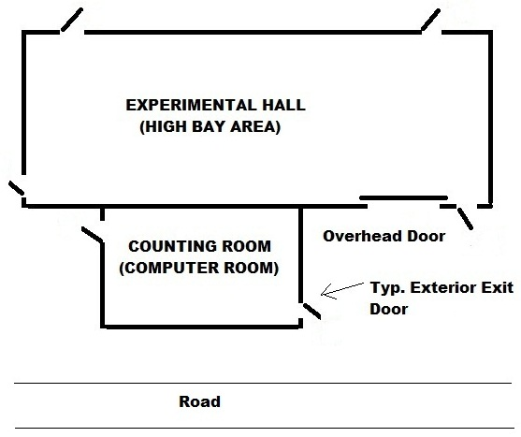
3
2
1
6

Figure 1 – Sample of Door Numbering

Design Criteria Facility Evaluation

The fire rating of fire stop materials will meet or exceed that of the fire barriers in which they are used.

Only Underwriters Laboratory (UL) Listed and/or Factory Mutual (FM) Global Approved fire stop materials will be used. Installation will be performed by qualified installers and in accordance to manufacturer's specifications.

In new construction, fire barriers should be labeled with the hour rating.
- Dry transformers should be used indoors. Dry transformers over 112.5kw require 1-hour fire rated room with self-closing door, in accordance with NFPA 70 Article 450.21.
- Electrical room(s) serving more than 800 amps will have exit door that swings out with panic hardware or similar mechanism, in accordance with NFPA 70, Article 110.26.(c) (3).
- Delayed egress locks are allowed, in accordance with NFPA 101, in such cases as computer rooms, these should unlock within 30 seconds from a manual release mechanism. Security locks must unlock upon fire alarm activation to allow Fire Department personnel entrance.
- Labyrinths should be a minimum of 2-hour fire rated construction with 44 inches in width.
- Curtain Walls should comply with NFPA 286, Standard Methods of Fire Test for Evaluating Contribution of Wall and Ceiling Interior Finish to Room Fire Growth.
- Building roof material should be Class A, in accordance with NFPA 256, Standard Methods of Fire Test of Roof Coverings.
- In order to limit the potential for fast spreading fires and the development of large quantities of toxic combustion products, it is preferable to use interior finish materials Class A which have "flame spread" ratings of 25 or less and "smoke developed" ratings of 450 or less as determined by the American Society for Testing Materials (ASTM). Of particular concern are thermal and acoustic insulating materials manufactured with expanded foam, most of which greatly exceed these values.

Class A - 25/450 Flame Spread/Smoke Development Rating
If practical, interior finish materials should have a flame spread rating of 25 or less and a smoke developed rating of 450 or less as determined by the ASTM E-84 (NFPA 255) test. (Note: Manufacturers often avoid presenting results in terms of these ratings when their products "fail'' the ASTM E 84 test.) AHJ-FP must review proposed installation involving foam insulation boards or spray foams when used outside manufacturer’s installation specifications.
Class B or C - Greater than 25/450 Flame Spread/Smoke Development Rating
Materials with a flame spread rating >25 and smoke developed rating >450 may be covered by a rigid noncombustible thermal barrier such as sheetrock to mitigate the consequences of the higher flame spread and smoke development properties. In order to be effective, the material should be in direct contact with the barrier. If Class B or C materials are proposed, then AHJ-FP approval is required.

Table 1 - Summary of Wall/Ceiling Interior Finished (ASTME E84)
Rating | Flame Spread | Smoke Developed
Class A | 0-25 | 0-450
Class B | 26-75 | 0-450
Class C | 76-200 | 0-450
Plenum | 25 | 50

Table 2 – Flooring Interior Finishing Including Trim & Base (ASTM E648)
Rating | Description
Class I | Critical radiant flux of not less than 0.45W/cm²
Class II | Critical radiant flux of not less than 0.22 W/cm² but less than 0.45W/cm²

Plastic Material for Devices and Appliance

Vertical Flammability Classification
The after-flame time for each individual specimen is less than 10 seconds. The total after-flame time for any condition set is less than 50 seconds. The cotton indicator is not ignited by flaming particles or drops. AHJ-FP must review proposed installation involving V-1 classifications or higher.

Table 3 - Summary of Vertical Flammability (UL-94)
Rating | Description
5VA  Surface Burn | Burning stops within 60 seconds after five applications of five seconds each of a flame (larger than that used in Vertical Burn testing) to a test bar. Test specimens MAY NOT have a burn-through (no hole). This is the highest (most flame retardant) UL94 rating.
5VB  Surface Burn | Burning stops within 60 seconds after five applications of five seconds each of a flame (larger than that used in Vertical Burn testing) to a test bar. Test specimens MAY HAVE a burn-through (a hole).
V-0  Vertical Burn | Burning stops within 10 seconds after two applications of ten seconds each of a flame to a test bar. NO flaming drips are allowed.
V-1  Vertical Burn | Burning stops within 60 seconds after two applications of ten seconds each of a flame to a test bar. NO flaming drips are allowed.
V-2  Vertical Burn | Burning stops within 60 seconds after two applications of ten seconds each of a flame to a test bar. Flaming drips ARE allowed.
H-B  Horizontal  Burn | Slow horizontal burning on a 3mm thick specimen with a burning rate is less than 3"/min or stops burning before the 5" mark. H-B rated materials are considered "self-extinguishing".

- Experimental Halls should be provided with a means of smoke ventilation at the roof. If combination heat smoke ventilation roof hatches are provided, fusible links should be rated 300ºF, so not to interfere with the operating temperature of the automatic sprinklers, see figure no. 2.

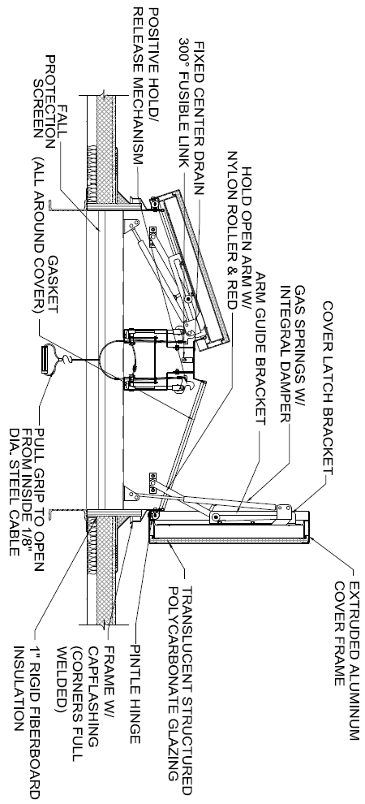

Figure 2 – Combination Heat/Smoke Vent

- Rooms or spaces that are classified as Assembly Occupancy should be posted with maximum occupant load.
- Elevator firefighter’s operational controls and Elevator Key box should be keyed alike in accordance with ASME A17.1.
- Elevators for passengers serving 3 stories or less, reference Figure 2 below. For higher stories, must consult with Fermilab’s Fire Department.
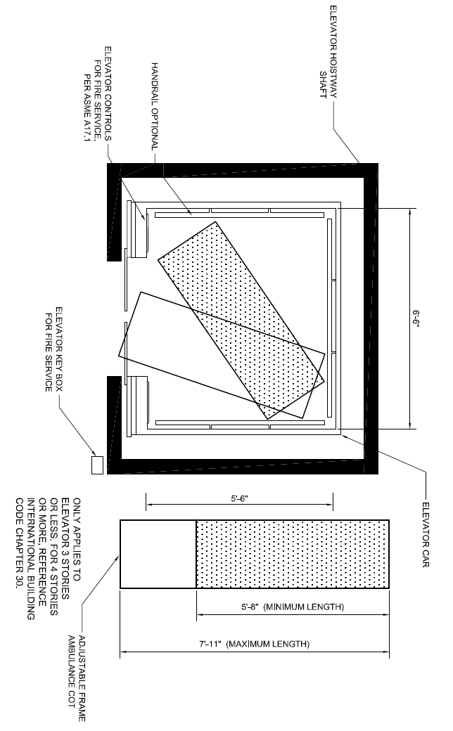
Figure 3 – Elevator & Ambulance Cot

- Typically building codes and NFPA standards do not require fire dampers in 1-hour fire rated walls, except for shaft enclosures and it is desirable to minimize the quantity and location of fire dampers, reference FESS Engineering Project No. 13-1-48.
- Where required during the design process, fall protection anchorage will be designed to withstand 5,000 pounds in accordance with ANSI Z359 series.
- Where required during the design process, safe room and/or shelter will be defined in accordance with the FEMA publications.
- All electronic locks, locking system and components should be UL listed.
- Commercial emergency power off systems should be provided in network/computer rooms over 500 sq. ft., in accordance with Memorandum dated July 2011, attached herein as Appendix A.
- The following tables are an overview of occupancy naming conventions and travel distance derived from NFPA 101 Table A7.5.6 & IBC Table 1016.1 and is summarized for guidance in determining the occupancy classification.

IBC, – Chapter 3 | NFPA 101
Use Group B (Business) | Business
Use Group F-1 (Moderate Hazard Factory Industrial) | Industrial General
Use Group F-2 (Low Hazard Factory Industrial) | Industrial Special Purpose
High Hazard  H1 – Pose a detonation hazard  H2 – Pose a deflagration hazard  H3 – Pose a combustible or physical hazard  H4 – Pose a health hazard  H5 – Production materials hazard | High Hazard (such as flammable liquids.)
Use Group U (Utility & Miscellaneous) 406.1.1

- Overview of naming and classifications: (NFPA 101 Table A7.5.6 & IBC Table 1016.1)
Table 4 - Summary of Occupancy Type
IBC & NFPA 101  Use Group/Occupancy | Min. Width Corridors | Travel Distance | Common Travel | Dead End
Assembly (A), Educational (E), Consult FESS Engineering Department for further requirements | A = Varies  E = 72-inches | 200-Ft / 250-Ft* | 75Ft / 100Ft* | 20-Ft
Business Use Groups (B) or  Underground Spaces | 44-inches | 200-Ft / 300-Ft* | 75Ft / 100Ft* | 20Ft / 50Ft*
F-1 & S-1 (industrial General *& Storage Ordinary Hazard) – Except for Underground Spaces | 36-inches If <50 occupants | 200Ft/250Ft* | 75Ft /100Ft* | 20Ft /  50Ft*
F-2, S-2, & U (Industrial Special & Storage Low Hazard) | 36-inches If  <50 occupants | 300FT/400FT* | 75Ft /100Ft* | 20Ft /  50Ft*
H-1 (Must be Sprinklered) | 44-inches | 75Ft * | 25 Ft* | 0
H-2 (Must be Sprinklered) | 44-inches | 100 Ft* | 25 Ft* | 0
H-3 (Must be Sprinklered) | 44-inches | 150Ft* | 25 Ft* | 0
H-4 (Must be Sprinklered) | 44-inches | 175Ft* | 75 Ft * | 0
H-5 (Must be Sprinklered) | 44-inches | 200Ft * | 75 Ft* | 0
Lodging & Rooms  Hotels/Dorms | 36-inches  44-inches | 75Ft / 100Ft* | 75Ft / 100Ft* | 20Ft
* Fully supervised sprinklered building and/or smoke tight corridors
Notes: 28-inches for access to and utilization of electrical, mechanical, or plumbing systems

- Minimum doorway widths cannot be less than the following Table No. 3.

Table 5 - Summary of Means of Egress
Occupancy | Minimum Aisle Width | NFPA 101 Reference(s) & OSHA
Existing Buildings | 28 inches | 7.2.1.2.4
Existing, minimum width of any way of exit access | 28 inches | 29 CFR OSHA 1910.36(g)(2)*
New Buildings (except as modified below)* | 32 inches (Door Clearance) | 7.2.1.2.4
Lodging & Rooming Houses | 28 inches | 26.2.3.1
One & Two-Family Dwellings | 28 inches | 24.2.4.1
One & Two-Family Dwellings – Bathroom Doors | 24 inches | 24.2.4.2
*Preference is 36-inches and below grade 44-inches

The following simplified table is the required hourly fire protection rating of components in which the assemblies are located, reference NFPA 101, Life Safety Code, 2012 Edition, Table 8.3.4.2 for further fire protection rating for opening protective in fire barriers.

Table 6 - Summary of Minimum Doorway
Component | Partitions (Hour rating) | Fire Door Assemblies (Minutes) | Door Vision Panel Maximum Size (Inches)
Elevator Hostway | 1 | 45 or 60 | 155
 | 2 | 90 | 155
Vertical Shafts, including stairways, exits, and refuse chutes | 1 | 45 or 60 | Max. Size Tested
 | 2 | 90 | Max. Size Tested
Fire Barriers (walls) | 1 | 45 or 60 | Max. Size Tested
 | 2 | 90 | Max. Size Tested
Exit corridors/ passageway exits/ Labyrinth | 1 | 45 or 60 | Max. Size Tested
 | 2 | 90 | Max. Size Tested

- At the discretion of the Fermilab’s Fire Department, building door numbering may be required, reference FESHM Chapter 6020.4 - Exterior Door Numbering:
- Prior to labeling door, review scheme with Fermilab’s Fire Department.
- Larger buildings and, under the direction of the Fermilab’s Fire Department, exterior man doors will be numbered at the top right, starting at fire alarm control panel, then clockwise around the building
- Fermilab Security will install the electronic automated card access systems. Provisions will be made to provide raceway, minimum ½-inch EMT conduit, where required and at all exterior doors with associated junction boxes and fittings.
- During design, coordinate with Fermilab Security Department for camera placement & technical specifications.
- During design, coordinate with Fermilab Security Department regarding door hardware and locking systems.
- Areas of Refuge will be provided with two-way communication in accordance with IFC.

Installation, Fabrication, and Construction
Install, fabricate or construct the facilities in accordance with manufacturer’s recommendations/instructions and standard “trade” industry practices.

Fire Alarm
The Fermilab site uses a custom Facility Information Reporting Utility System (FIRUS) that is on a secure network and monitors the status of fire, security, and utility sensors throughout the laboratory. FIRUS signals Fermilab’s Communication Center (Comm Center) which is staffed with operators 24/7. The Comm Center dispatches the appropriate emergency response personal. Leased space will use other means and methods on remote monitoring of alarm systems and will be determined by the project design team.

The fire alarm system, in many cases, is directly connected to other equipment, e.g., HVAC shut-down, dampers, smoke abatement, elevator recall & power shut-down, security access doors, door holders, and Oxygen Deficiency Hazard Controls. The fire alarm contacts may or may not be configured in a “fail safe” operation. In addition, the contacts may be normally open (NO) or normally closed (NC) depending on the equipment operation. Every effort will be made to separate low voltage (less than 50 volts) from the high voltage (greater than 50 volts) by using an interface relay.

Design/Construction Submittals
Working plans, battery, and voltage drop calculations should be in accordance with NFPA 72.

Design Criteria and Evaluation
- All new fire alarm systems should be intelligent addressable type, unless directed otherwise by the project design team.
- All new fire alarm systems should be reviewed and considered for emergency voice alarm system capable of integrating with Fermilab Site-wide Emergency Warning System. This determination will be made by the project team, Fire Hazard Safety Subcommittee and the project design team.
- All voice fire alarm systems will be provided with Federal Signal Informer capable of interfacing with the voice alarm system, programmed per Fermilab narrow band frequency.
- The project design and shall consult with fire protection if the voice alarm system will active tone or voice instruction for fire alarm conditions.
- All fire alarm control panels (FACP) should be provided with a T-45 key and lock assembly.
- FACPs will be provided with by-pass switches or function keys for custom control of notification devices and sub-functions (may exclude FIRUS) for testing and maintenance purposes (including Fire Department Test Mode) as determined by the Fire Systems Maintenance Group.
- When designing an addressable system, in duct smoke detectors should provide a supervisory signal at the fire alarm control panel and signal output should be supervisory to FIRUS.
- The voice fire alarm system should be designed with additional speakers set at low volume to accommodate live voice messages.
- All fire alarm systems will be connected to Fermilab's FIRUS systems, capable of indicating FIRE ALARM, SUPERVISORY, and TROUBLE signals.
- All FACPs will be provided with a walk-test feature.
- All FACPs will be provided with smoke verification feature.
- The fire alarm control panel or supplement power panels will be provided with a designated 120V circuit with switch and handle guard, see figure no. 3 below.
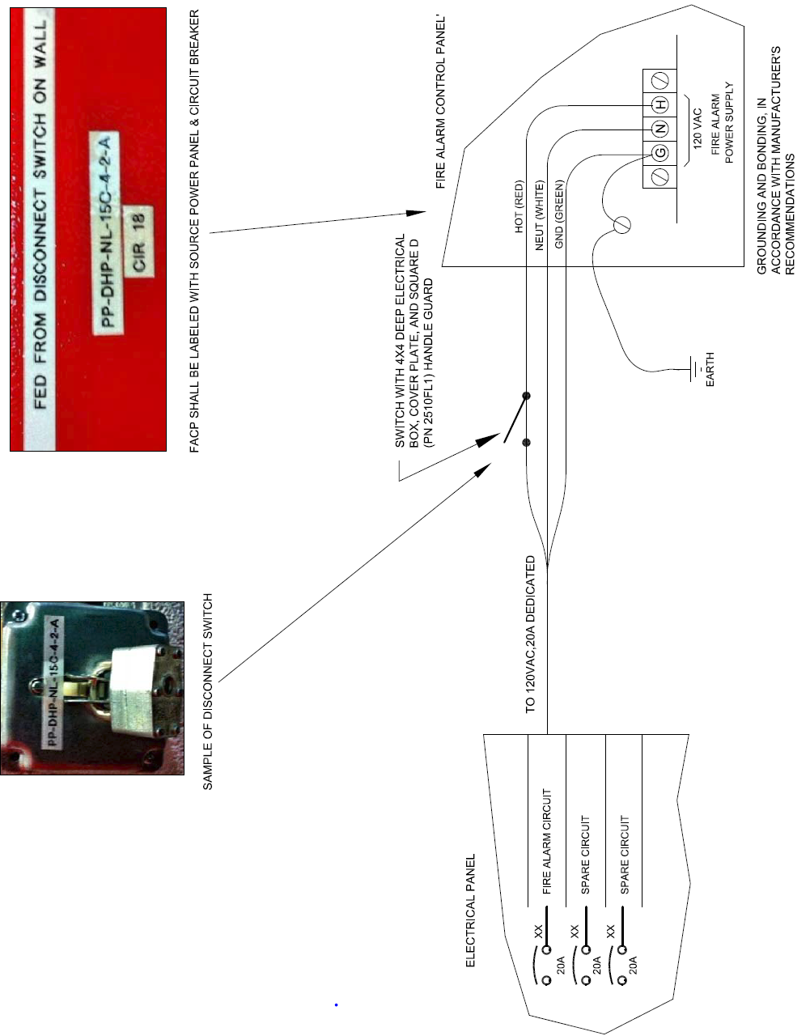

Figure 4 - Fire Alarm Power Configuration

- All programming and addressable device descriptions will be reviewed by the Fire Department and Fire Systems Maintenance Group prior to download of program into FACP. In addition, a hard copy of software programming, electronic programming files, and electronic as-built documents will be provided to FESS.
- FACP should be capable of self-restoring in power outage troubles and selectable for latching all other trouble or supervisory signals.
- Upon completion, the fire alarm manufacturer should provide on-site factory training for the fire system maintenance group.
- Products, Materials, and Equipment
- Acceptable equipment manufacturers for addressable fire alarm control panels are Siemens, unless approved otherwise by FHS and project design team.
- Acceptable equipment manufacturers for conventional (non-addressable) fire alarm control panels are Siemens or Honeywell Silent Knight, unless approved otherwise by FHS and project design team.
- Line type heat detection, manufactured by Protectowire®, should be installed in beam enclosures.
- Air sampling smoke detection manufactured by Xtralis™ (VESDA).
- Fire Alarm Documents Box shall be UL Listed, constructed of 18 gauge cold rolled steel. It shall have a powder coat finish. The cover shall be permanently screed with lettering "FIRE ALARM DOCUMENTS" with white indelible ink. The access door shall be locked with a 3/4" barrel lock and there will be a 12" stainless steel piano hinge utilizing a T-45 Key and lock assembly.
- All sub-panels including air sampling smoke detector, line type heat detection, excluding remote panels, Trouble and Supervisory will be monitored by FIRUS and not the fire alarm system.

Installation, Fabrication, and Construction
- Addressable circuits should be a minimum of 18 AWG solid twisted jacketed cable and must meet manufacturer’s requirements. Conventional (Hardwire) initiating circuits should be a minimum of 18 AWG solid cables. Notification appliance circuits should be a minimum of 14 AWG solid cables. Combination horn and strobe devices can be two-wire; however, combination speaker and strobe devices will be 4-wire with audible circuit (e.g., red) a different color then the visual circuit (e.g., blue).
- All cabling should be installed in conduit, minimum 3/4-inch EMT. Provide IMC as required by NFPA 70 (NEC).
- All manual pull stations should be dual action type and able to be reset with a T-45 key or an Allen wrench.
- Air sampling smoke detection test station and special configurations:
  - A test connection with cap and test hole will be located approximately 6-feet above finished floor.
  - For hazardous spaces such as Cleanrooms and Radiation Spaces, the air sampling smoke detector should be located outside the hazard and air return should be piped back into the hazard space.
  - In hazards spaces as described above, provide test valve in addition to the test port located approximately 6-feet above finished floor.
- All fire alarm system will be connected to Fermilab’s FIRUS system, capable of indicating FIRE, SUPERVISORY, and TROUBLE signals via independent Form C relays.
- All fire alarm cabling should be located in raceways. Reference the FESS electrical design guides for type of conduct/raceways.
- All junction boxes with blank covers must be identified as “Fire Alarm”, “FA”, or painted red.
- All sources of AC power greater than 24 volts supplying power to the FACP or other fire alarm control units, power supply must have cabinets labeled with the identification of the power distribution panel and circuit breaker.
- All sources of AC power greater than 24 volts supplying power to the FACP or other fire alarm control units, power supply must have a barrier installed to protect a worker from an electrical shock hazard.
- At no time is it allowable to install control wiring with voltages greater than 24 volts (except for the dedicated circuit for the panel or power supply) inside of any control panel.
- Any control circuit using voltages greater than 50 volts must use a junction box (other than the FACP or fire alarm control unit) and interface relay (reference Background Section). The relay contacts must have a barrier installed to protect a worker from an electrical shock hazard. The junction box must also be clearly identifying the voltage and source information of the power distribution panel and circuit breaker.
- At a minimum, all work must comply with NFPA 70 and 72.
- Install according to manufacturer’s recommendations/instructions and standard “trade” industry practices.
- If lighting controls are provided, the fire alarm should be integrated to turn on lights during an alarm activation

Automatic Sprinkler Systems
Main site fire protection supply water is from Fermilab’s Industrial Cooling Water (ICW). The ICW system is non-potable and comes from an open pond reservoir and therefore; is considered a “raw water source” as designated by NFPA 13. The Fermilab’s Village area fire protection supply water is from Village of Warrenville and is a potable water source. Leased space fire protection water supply will be different and will be determined by on the project design team.

Design/Construction Submittals
Working plans and hydraulic calculations will be in accordance with NFPA 13

Design Criteria and Evaluation
- The minimum design density will be based on Ordinary Hazard Group I.
- Hydraulically designed sprinkler systems will be designed for not less than 10-psi below the ICW water supply curve, see Attachment at the end of this document. The Village area will be at the discretion of the design team.
- The minimum sprinkler spacing will be 130 square feet and 100 square feet for experimental, assembly, collision hall and general industrial high bay areas.
- Preference in utilizing standard spray, quick response sprinklers should be utilized.
- In general, high bay areas, such as assembly, experimental halls, etc., the minimum sprinkler K factor of 8.0 should be utilized at a design density of Ordinary Hazard Group II, reference NFPA 13.
- Return bends (arm-overs) will be provided on all pendent sprinklers.
- All wet type automatic sprinkler system pipes will be schedule 40 steel. Dry type automatic sprinkler system pipes will be either schedule 40 steel or galvanized schedule 40 pipe, determination by the design team.
- 1/2" or 3/4" Pipe should be galvanized steel, schedule 40 when retrofitting existing upright sprinkler outlets supplying new pendent type sprinklers.
- Water-flow alarm detectors (switches) should be provided with double pole, double throw contacts, rated at 120 VAC at 3 amps.
- Preaction sprinkler systems should be configured as double interlocked. In addition, the air supervisory switch should be cross zoned with the releasing detection.
- Collision Hall sprinkler system should be dual action preaction type.
- Clean rooms should be designed with quick response sprinklers with an operational design of 0.2 gpm over 3,000 sq. ft., NFPA 318.
- Water-flow supply test information can be obtained from the FESS-Engineering Department.
- All control valves should be provided with electronic valve supervisory (tamper) switches.
- Flushing valve arrangement should be provided through the fire department connection, see Figure 5 below.
- Provide isolation valve with supervisory switch for branch line supplying sprinklers in Elevator shaft.
- As-built documents will be provided to Fermilab in accordance with the project’s technical specifications.
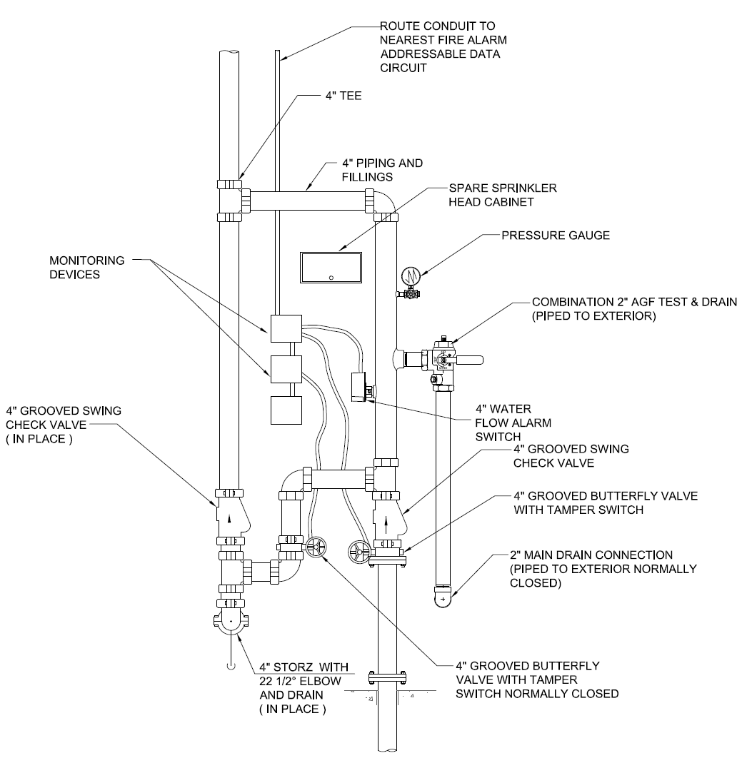
Figure 5 - Typical Wet Type Sprinkler Riser

Products, Materials, and Equipment
- All devices and equipment will be U.L. Listed and/or FM Approved.
- Spray sprinklers, valves, check valves, including deluge and preaction valve assemblies, should be manufactured by Viking® or Tyco.
- Backflow preventers as required by the design team should be manufactured by Watts - FEBCO®, series 880V.
- Fire Department connection should be a 4-inch "Locking Storz" quick connect with a 22¼-degree straight-galvanized or anodized aluminum elbow on the exterior inlet pipe to the Storz connection. Also, the gasket will be removed from the Storz cap.
- Fire Department Hose Valve should be Giacomini or Potter Roemer, angled pressure (adjustable flow) reducing valve, female NPT to male hose thread, 2-1/2-inch, and installed at a 45-degree angle.
- Combination auxiliary and inspector’s test connections should be provided on sprinkler risers, manufactured by AGF Test and Drain Assembly.

Installation, Fabrication, and Construction
- A control valve should be provided after the preaction valve assembly, to facilitate testing without introducing water throughout the piping network.
- If feasible, air compressors should be mounted above the point of connection with flexible tubing, such as rubber hose.
- Consider installing ¾-inch relief valves on small, service building, type sprinkler systems to alleviate the potential of solar heating on static pressures in wet-type sprinkler systems.

Special – Fixed Fire Extinguishing Systems
Fermilab uses special fixed fire extinguishing systems to protect experiments, programmatic functions, etc. This includes water mist fire suppression systems, gaseous fire extinguishing systems, and deluge water spray systems.

Design/Construction Submittals
Working plans, calculations, battery, and voltage drop calculations should be in accordance with NFPA applicable standards.

Design Criteria and Evaluation
- CO₂ fire suppression system should be avoided.
- If air sampling is the method of detection, then the air sampling display should be programmed so that 100% at 40 seconds sends a signal via FIRUS indicating that FIRST LEVEL OF AIR SAMPLING IN ALARM. Release of agent should be at 100% for 60 seconds.
- If cross-zone detection is provided, then additional signal outputs from the releasing control panel to FIRUS should indicate FIRST DETECTOR ZONE IN ALARM and SECOND DETECTOR ZONE IN ALARM.
- The manifold pressure switch should connect directly into FIRUS and indicate AGENT RELEASED.
- Provide a time delay after second alarm prior to releasing agent to facilitate HVAC shut down.
- Equipment shut down, such as dampers and electronics should be from a manifold pressure switch.
- Manifold pressure switches should be provided with a minimum of double pole and double throw contacts.
- HVAC shut-down should occur at second alarm of cross-zone.

Products, Materials, and Equipment
- All devices and equipment must be listed or approved by a recognized testing laboratory
- UTC Fire & Security - Water Mist Marioff
- UTC Fire & Security – Kidde - Fenwal

Installation, Fabrication, and Construction
Install according to manufacturer’s recommendations/instructions and standard “trade” industry practices.

Fire Extinguisher
Every new design will incorporate the size and location of fire extinguishers. Placement of fire extinguishers will be reviewed by the fire department prior to installation.

During construction of primary beam/detector enclosures (or any other enclosure in which radiation is of concern) temporary fire extinguishers will be provided during assembly of beam components or detector components. It is, however, the policy of Fermilab that portable fire extinguishers will not be located in these areas during normal unoccupied beam/detector operations.

Design/Construction Documents
Provide industry standard documents.

Design Criteria and Evaluation
- Fermilab’s Fire Department will provide guidance on placement and type of fire extinguisher in new facilities.
- Forged, non-slip discharge hose ethylene propylene diamine (EPDM) rubber, aluminum handle positions
- Tank will be stainless steel for H₂O and formulated type for specialized extinguishing agents, such as the clean agent fire extinguishers for data centers, as specified by the fire extinguisher manufacturer.
- Tank will be welded steel tube for dry chemical applications
- If caps are provided with indicators, then stems should be the pop-up type.
- Forged aluminum fill caps
- Suggested areas:
Table 7 – Effective Fire Extinguisher for Burning Materials
Burning Materials | Extinguisher
Ordinary combustible materials, such as cellulose products, wood, paper, cloth, plastics, or rubber | Water, multipurpose dry chemical (Class A:B:C)
Flammable or combustible liquids, such as oils, gasoline, alcohol, and solvents | Clean agent or dry chemical (Class B:C or Class A:B:C)
Energized electrical equipment or wiring | Clean agent or dry chemical (Class B:C or Class A:B:C)
Water reactive: Burning magnesium, lithium, thorium, uranium, potassium, or sodium metals | G-1 powder (special graphite), Met-L-X (sodium chloride), or Lith-X
Pyrophoric chemicals | Class D (for burning metals) with Class A:B C nearby for other combustibles
Fires in cooking appliances involving combustible media (oils and fats) | Wet chemical (Class K)

  - General Areas (Office, Corridors, Mechanical Spaces)
- Dry chemical, made of Monoammonium phosphate, Class ABC type fire extinguisher, 10 lb. Capacity
  - Computer Rooms
    - Clean Agent, Class C type extinguisher, 9.5 lb. (DuPont FE-36)
  - Kitchen Areas
    - Wet agent, Class K type fire extinguisher, 1.6-gallon capacity
  - Flammable Liquids and Gas Areas
    - Dry chemical, Class B type fire capacity

Products, Materials, and Equipment
- Fire extinguishers must be U.L. Listed and/or FM Approved; approved manufactures are:
  - Ansul
  - Amerex®

Installation, Fabrication, and Construction
- For semi-recessed or surface mounted cabinets, reference FESS architectural design guides.
- Install according to manufacturer’s recommendations/instructions and standard “trade” industry practices.

Attachment A
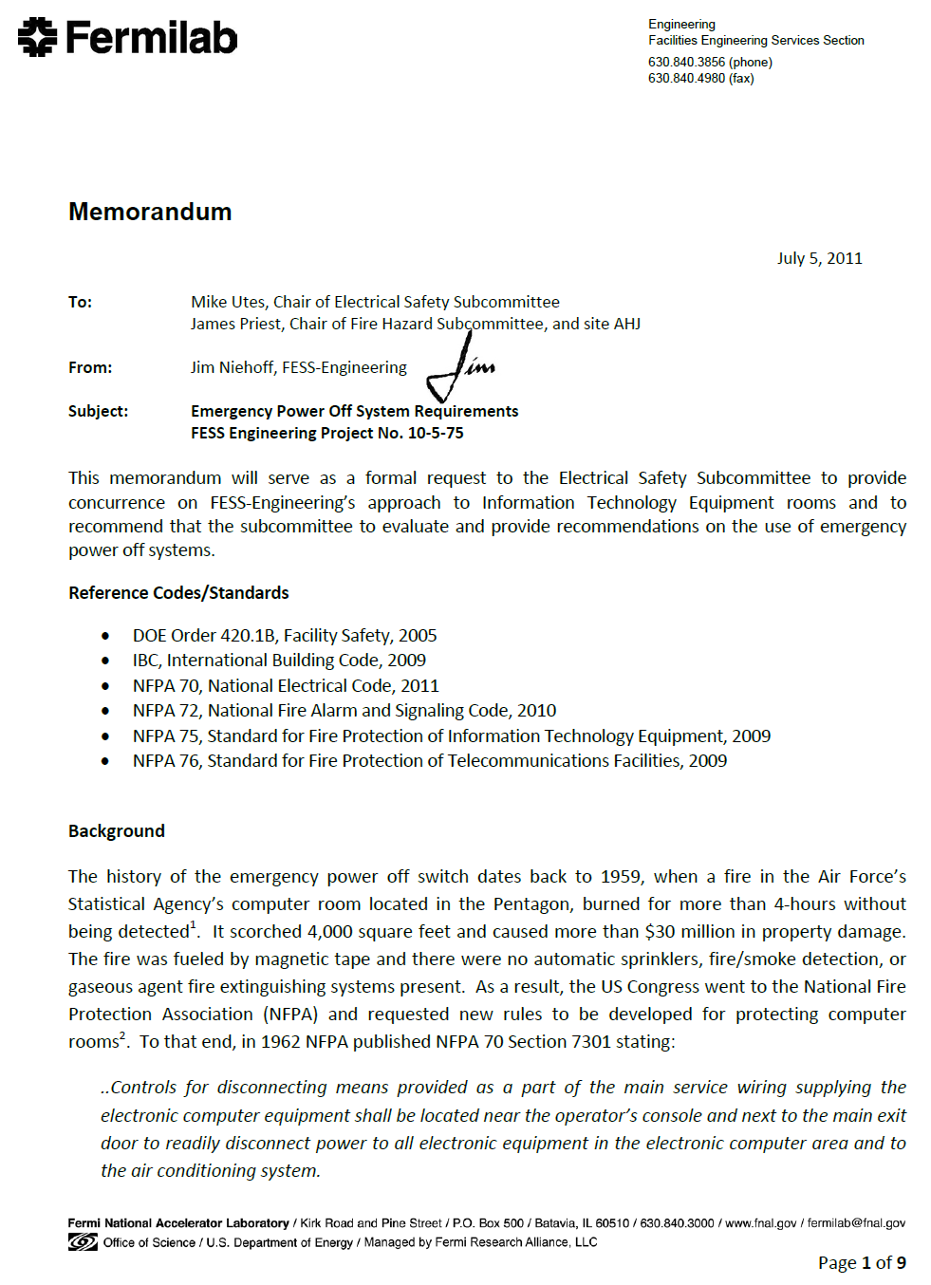
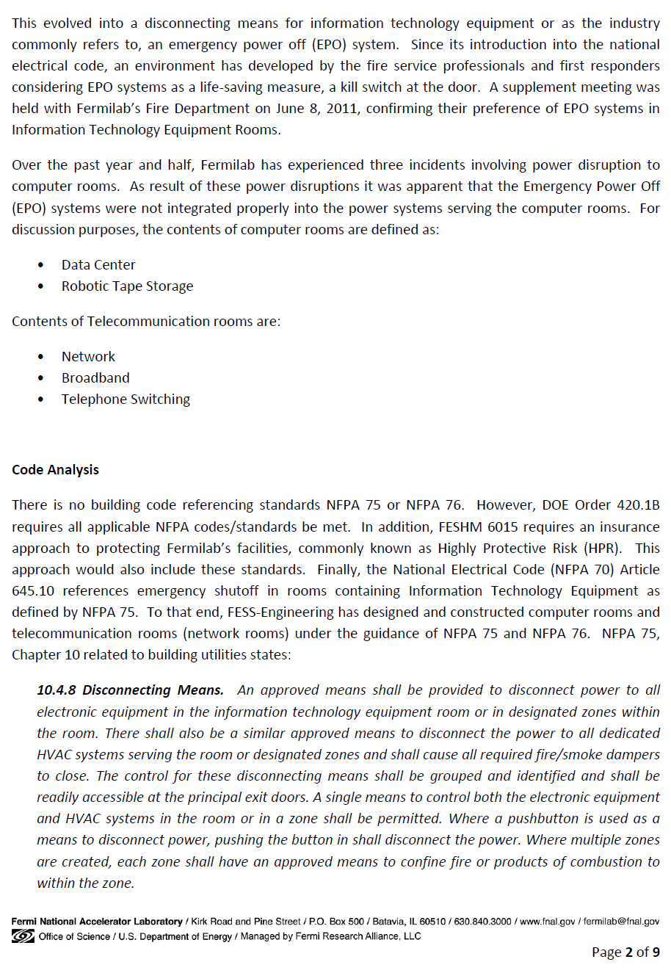
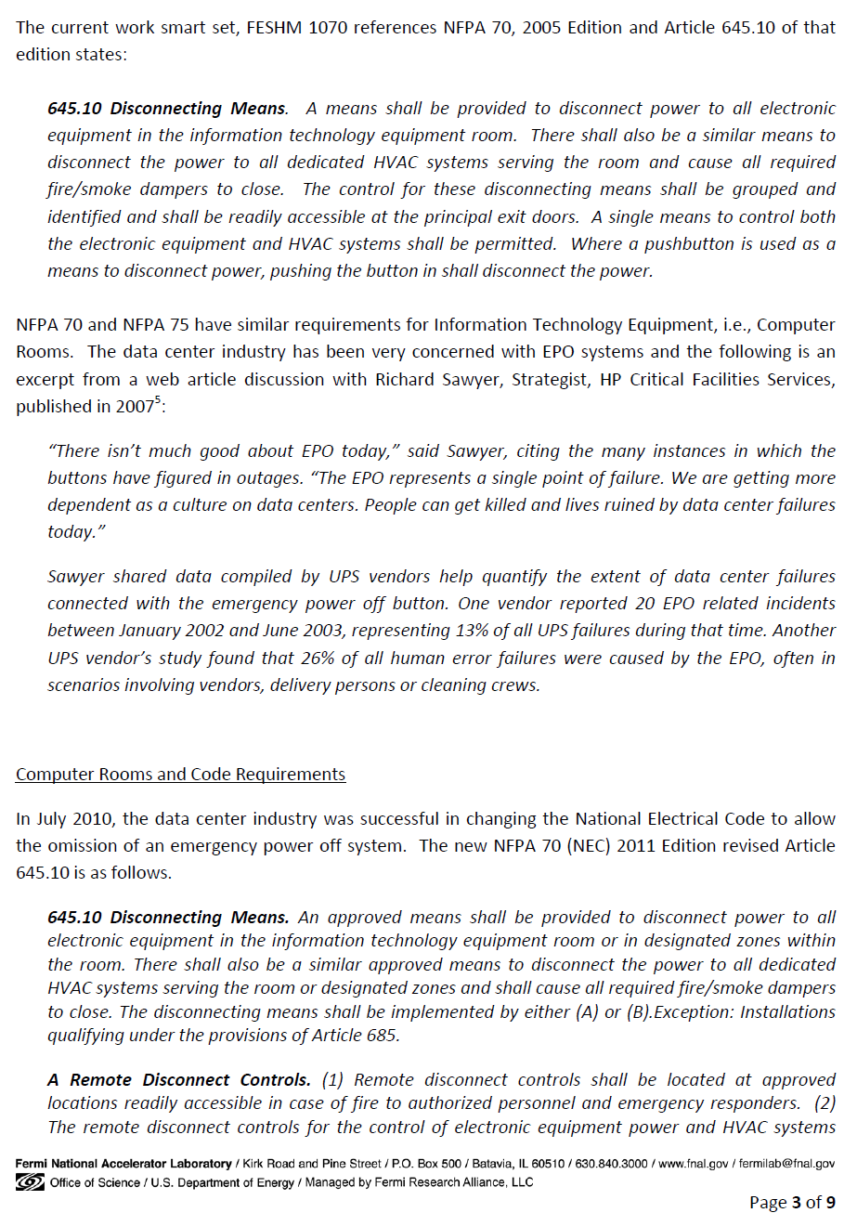
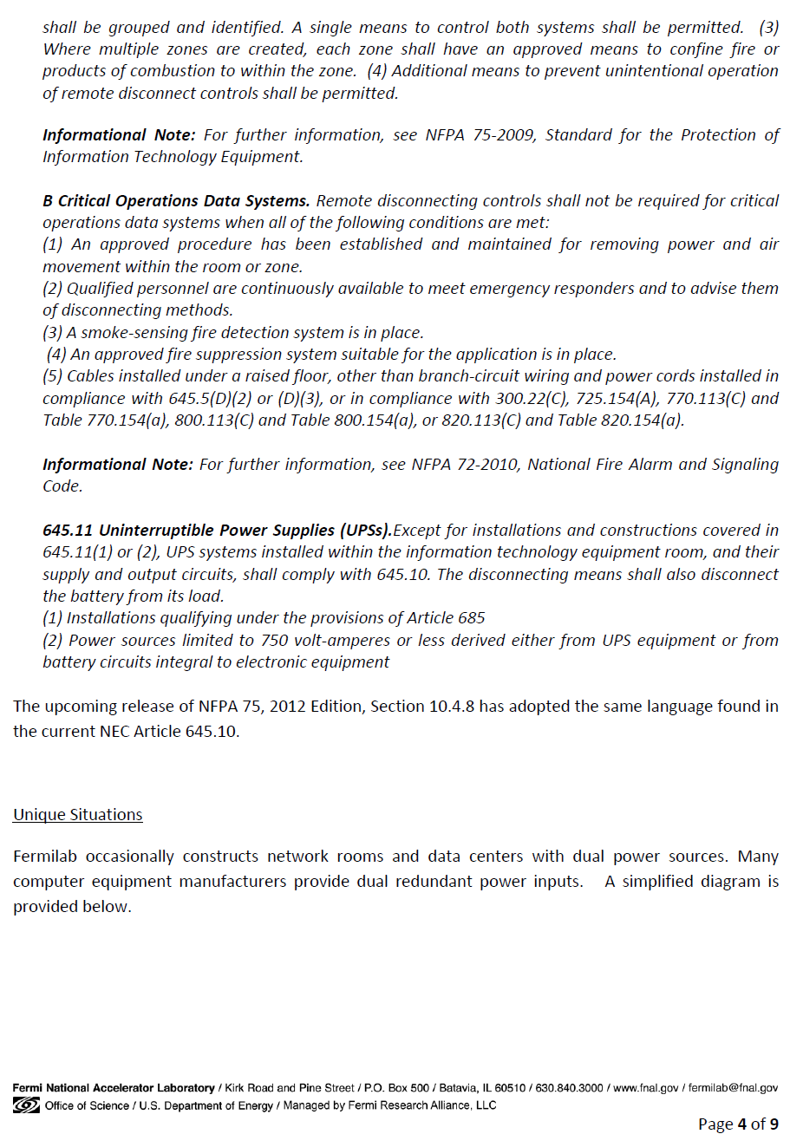
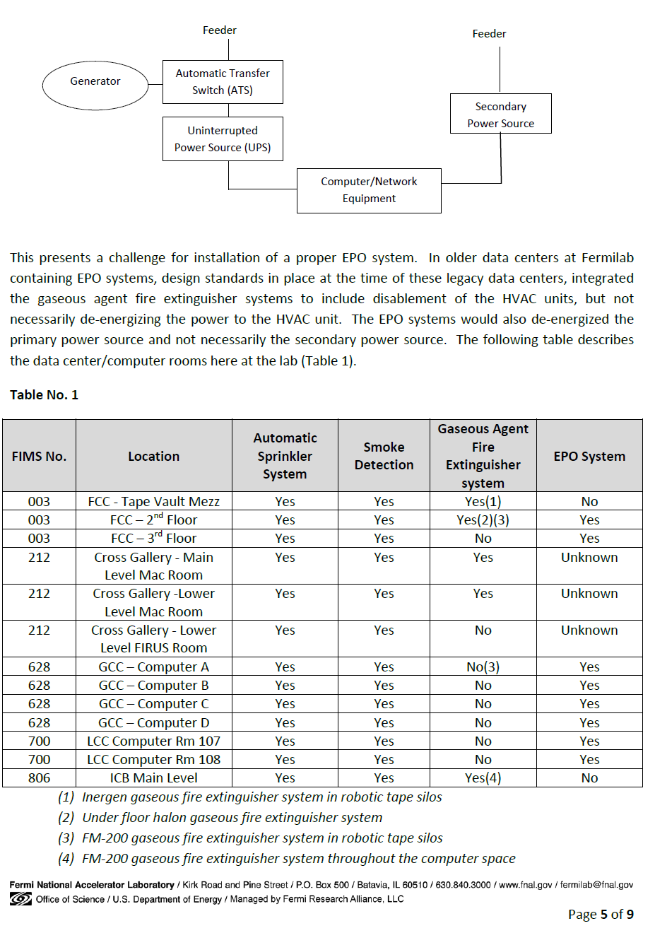
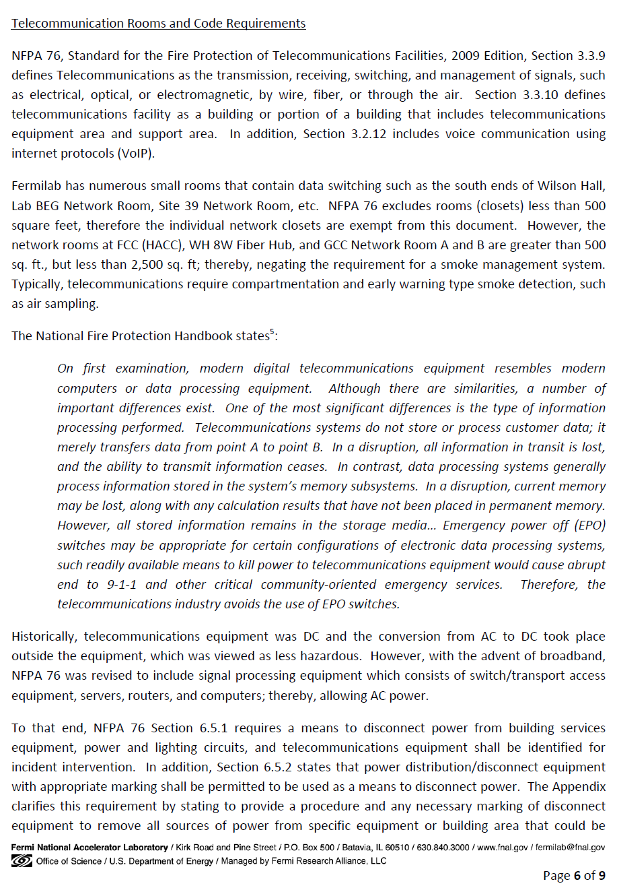
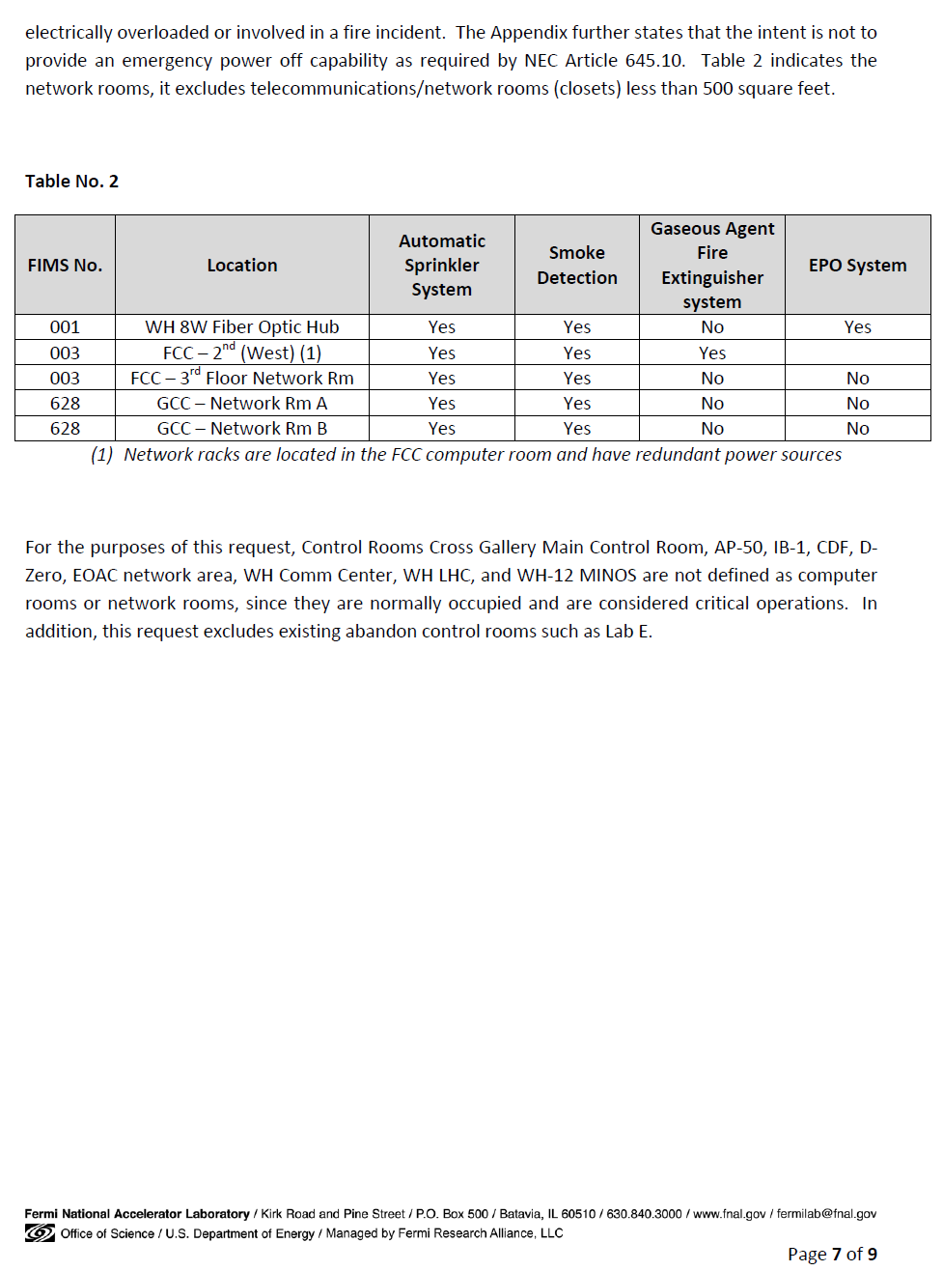

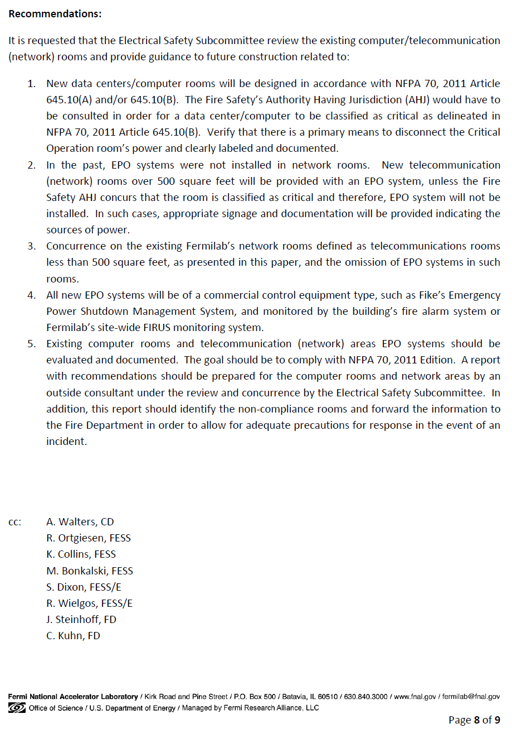
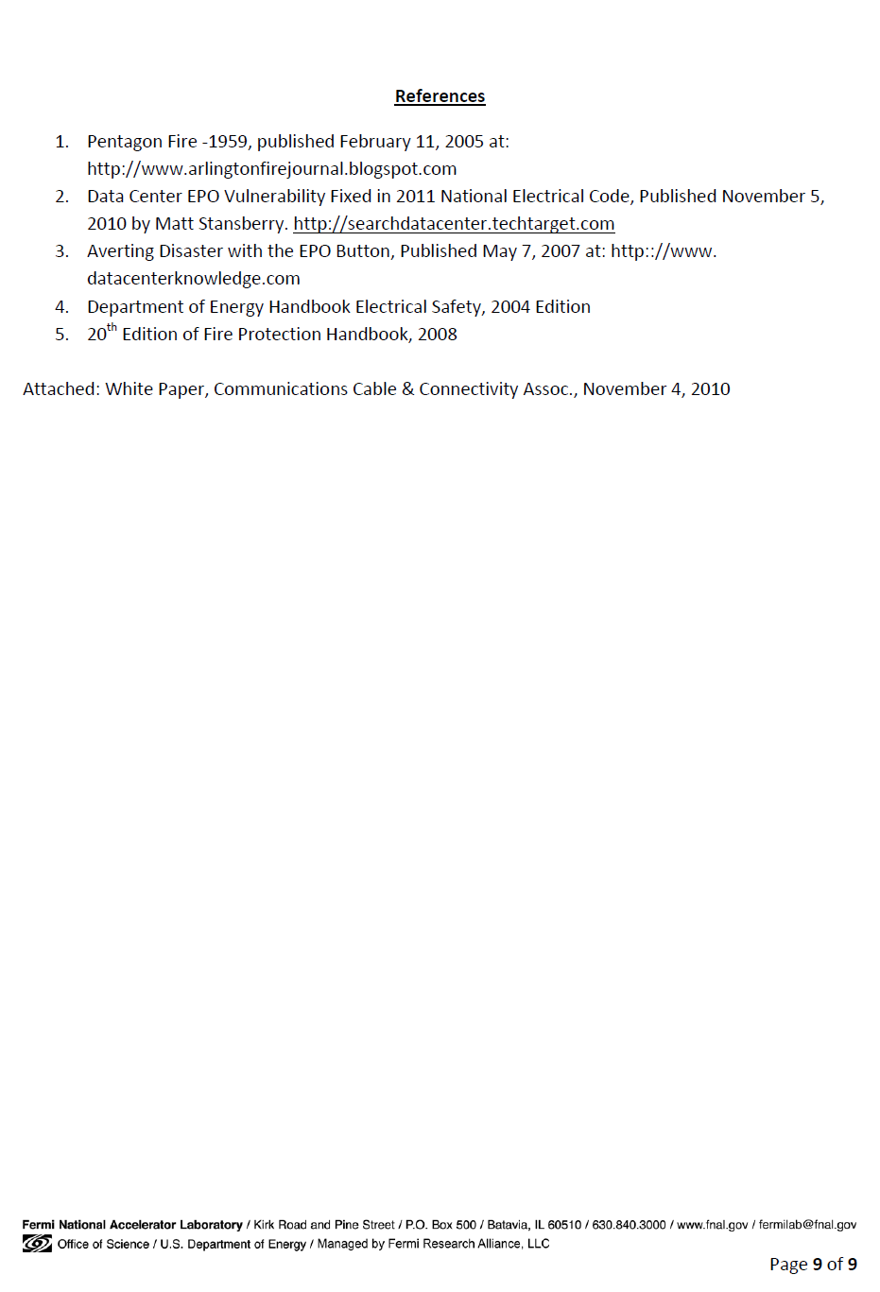

Attachment B - Water Supply
The purpose of this analysis is to provide the design water flow supply curves for designing water-based fire suppressions systems. This data was derived from the Industrial Cooling Water Vulnerability Analysis originally conducted in 2006 by Crawford, Murphy, & Tilly, Inc. (CMT) and later updated in 2014. This analysis was conducted using WaterCAD hydraulic model software and actual water flow test performed to calibrate the model. In similar regions of the lab, the data was analyzed to find the minimum flow rate in the regions. This flow rate was used in creation of a pressure and flow graphs, which used the average minimum static pressure and the average minimum residual pressure between generated models of 2006 and 2014 by CMT. Using these values created a conservative estimation. This approximation created individual graphs for nine (9) different regions in the laboratory, see site map on following page. The following water flow design table has been derived.

Site Location | Static Pressure [PSI] | Flow at 20 PSI [GPM] | Flow at 0 PSI [GPM]
Lab A-G Campus Area | 75 | 2015 | 2382
Muon Experiments Area | 76 | 1488 | 1755
Site 38 and Site 39 Area | 66 | 1215 | 1476
IB and CDF Area | 74 | 1425 | 1689
D0 Area | 68 | 1425 | 1719
Central Campus Area | 75 | 1215 | 1436
West Main Ring | 74 | 961 | 1139
Minos and Science Center | 73 | 961 | 1142
Main Injector Area | 69 | 1215 | 1462

This analysis of the design water flows is a conservative approach and the actual water flows may be higher, especially from the peak (summer) cooling demands. Though this analysis does not necessarily omit the requirement for a water flow test in accordance with NFPA 13, caution should be used when assessing the water flow test information due to the variable speed pumps at Casey’s pump house to compensate for an open port on a hydrant. In addition, the cooling loads from the ICW system vary during the season, i.e., summer to winter months.

Source Documentation:

CMT August 2014 Report
Fermilab – ICW Modeling Scenarios
FESS Engineering Project Number 3-5-174

CMT November 2006 Report
ICW Vulnerability Analysis Hydraulic Model Update
FESS Engineering Project Number 3-5-143

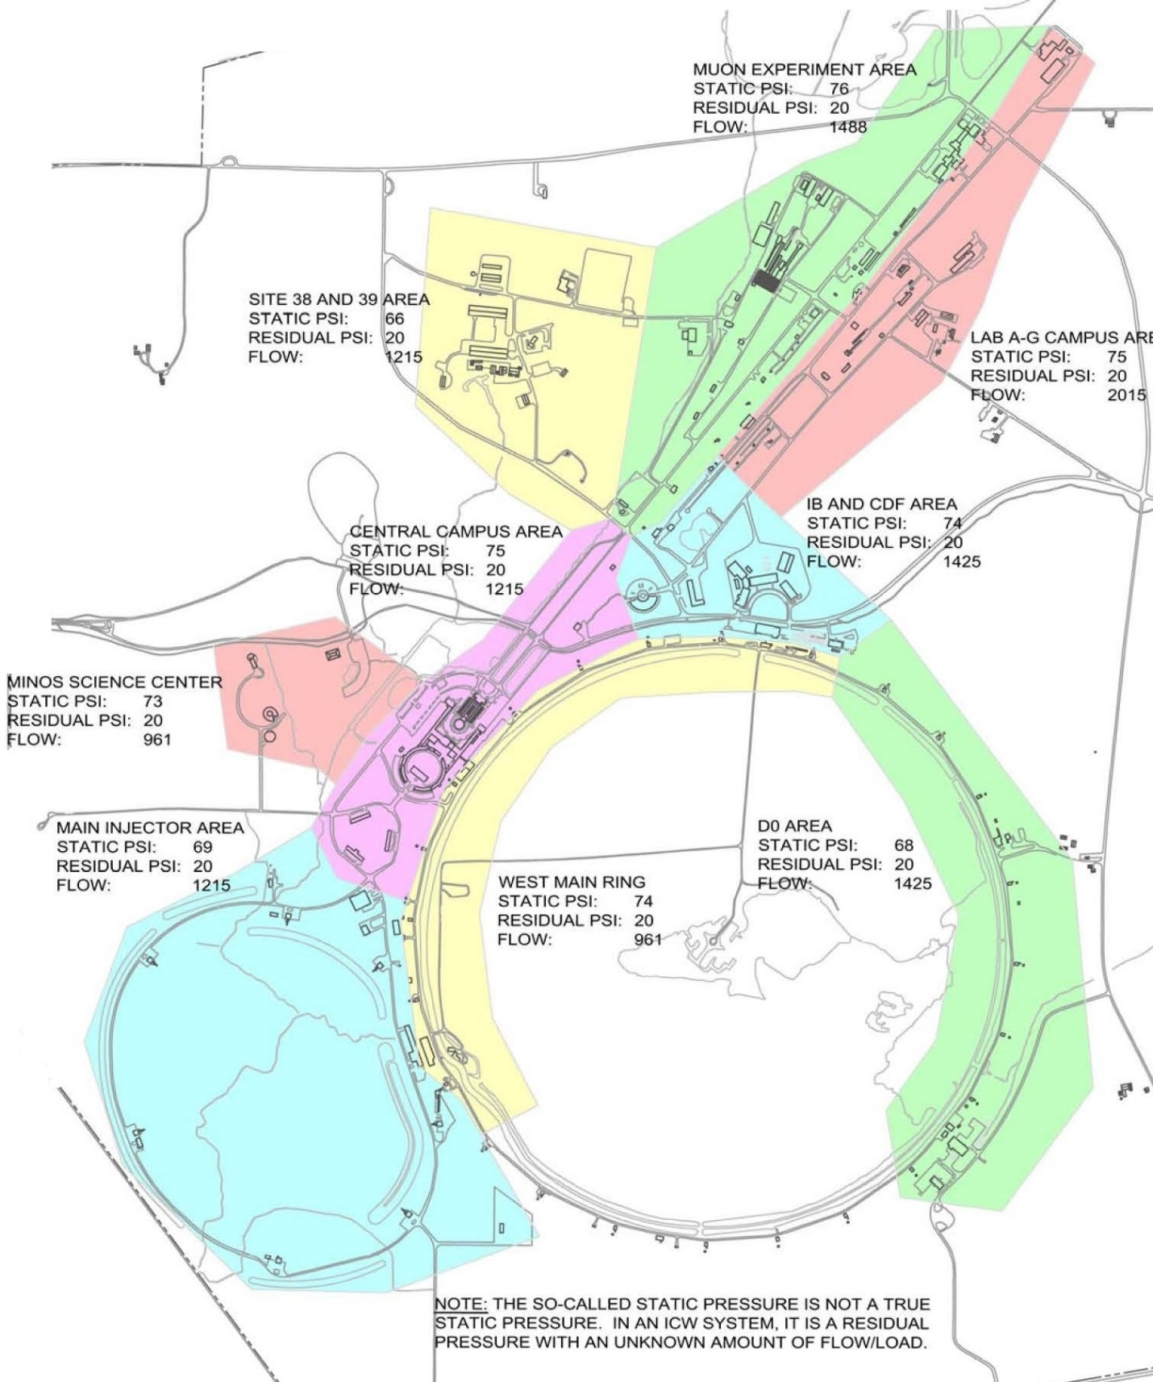

Figure – Site Map

