FESHM 4280: ULTRAVIOLET RADIATION EXPOSURE

Revision History

Author | Description of Change | Revision Date
Rich Ruthe | - Editorial changes, including the addition of clarifying information  - Content changes based on the current version of the ACGIH TLVs® and BEIs® | January 2018
David Baird | - Formatted the chapter according to ESHS requirements.  - Minor Edits  - Removed definition of Laser Safety Officer which was deemed unnecessary. | June 2012

TABLE OF CONTENTS

1.0 INTRODUCTION 3
2.0 DEFINITIONS 3
3.0 RESPONSIBILITIES 4
3.1 Division/Section/Project (D/S/P) Heads 4
3.2 Managers and Supervisors 4
3.3 ESH&Q Section 4
3.4 Division Safety Officer (DSO) or designee 4
4.0 PROGRAM DESCRIPTION 4
5.0 REFERENCES 5

INTRODUCTION

Workers can be exposed to natural or man-made ultraviolet (UV) radiation. Like all light energy, UV radiation travels through space in waves and is categorized based on the length of those waves in nanometers (nm). UV radiation is divided into three categories by wavelength; UVA (315 to 400 nm), UVB (280 to 315 nm), and UVC (180 to 280 nm). UV waves are too short to be visible to the human eyes. When it comes to solar exposure, UV is the most damaging component. Cumulative exposure to UV radiation can cause damage to corneas, potentially leading to cataracts, and may pose a hazard to the retina. UV-A sources are a lens and retinal hazard. All UV sources are a hazard to the cornea. Natural exposures (solar) of UV light are a concern for people working in the outdoors during the workday. Man-made UV exposures are of great concern at Fermilab due to the prevalence of their use and the portion of the light spectrums used. UV radiation is used in many applications, for example curing adhesives and Light Emitting Diodes (LEDs). Exposure to UV radiation can also occur from welding, burning and brazing operations.

This chapter does not cover laser sources, as these forms of electromagnetic energy require special consideration. Guidance on lasers can be found in FESHM Chapter 4260.

DEFINITIONS
Interlocked – Regarding a UV radiation enclosure, “interlocked” means that UV radiation levels are automatically reduced to harmless levels when a protective enclosure is opened. If the interlock is not failsafe, an appropriate warning label must also be attached to the enclosure.
LED – Light-emitting diode: a semiconductor diode that emits light when conducting current and is used in electronic equipment, especially for displaying readings on digital watches, calculators, etc.
Threshold Limit Values (TLVs®) - Recommended guidelines published by the American Conference of Governmental Industrial Hygienists (ACGIH) for occupational exposure to airborne contaminants, or as in the case of this chapter, a physical agent. The TLVs® are used as guides in the control of exposure to UV sources and should not be regarded as fine lines between safe and dangerous levels. The UV radiation TLV represents conditions under which it is believed that nearly all healthy workers may be repeatedly exposed without acute adverse effects.
Tool - Regarding a UV radiation enclosure, the requirement for a “tool,” when used in conjunction with a warning label greatly reduces the likelihood of inadvertent access to hazardous UV radiation levels. A key to a lock is considered a tool for the purposes of this chapter.
Ultraviolet (UV) radiation - electromagnetic radiation with a wavelength shorter than that of visible light, but longer than soft X-rays. UV radiation can be divided into categories based on wavelength; UVA (315 to 400 nm), UVB (280 to 315 nm), and UVC (180 to 280 nm).

RESPONSIBILITIES

Division/Section/Project (D/S/P) Heads
- Division/Section/Project Heads will ensure the requirements of this chapter are fulfilled regarding UV radiation exposure.

Managers and Supervisors
- Notify Division Safety Officers (DSO’s) of any changes in working conditions that may contribute to workers' exposure to UV radiation and ensure that UV radiation devices are used properly.

ESH&Q Section
- Consult and oversee the lab-wide evaluation and control of UV hazards including system classification, procedures, protective equipment, warning systems, facilities, and training.
- Provide guidance, technical information and assistance to DSOs upon request.

Division Safety Officer (DSO) or designee
- Play a consultative and oversight role for UV hazards, pertaining to the division/section of responsibility.
- Work with division/section personnel to identify, label, and provide safety guidelines for operations that may emit hazardous UV radiation.
- Contacts the IH Group to perform sampling and assists in investigations of incidents involving UV radiation.

PROGRAM DESCRIPTION

Below is a summary of Fermilab’s UV radiation safety requirements. Precautions for UV hazards are presented according to light spectrum and are based on the latest version of the applicable guidance, ACGIH TLVs® and BEIs®. Though general in nature, this information provides a basis for understanding the required actions. Detailed guidance is available in the ACGIH TLVs® and BEIs® 2017.

UV LED and Other UV Light Sources (Required)

- Notify the ESH&Q Section Industrial Hygiene Group when operating UV radiation sources (180-400nm). A new UV radiation source may require an Operational Readiness Clearance approval process as outlined in FESHM 2005.

- Enclose UV radiation source operations when possible to protect workers from an exposure. The enclosure shall be interlocked or require a tool to access the UV radiation source. Label the enclosure with a UV radiation warning label (Figure 1). The warning label can be obtained from the ESH&Q Section Industrial Hygiene Group.

If the UV light source must be operated outside of the enclosure, check the current ACGIH TLVs® and BEIs® for exposure durations and wear personal protective equipment (PPE) such as UV blocking glasses/goggles, full coverage clothing or sunscreen. Be sure that the PPE (primarily glasses/goggles) is rated for the spectrum of UV radiation that is in operation.

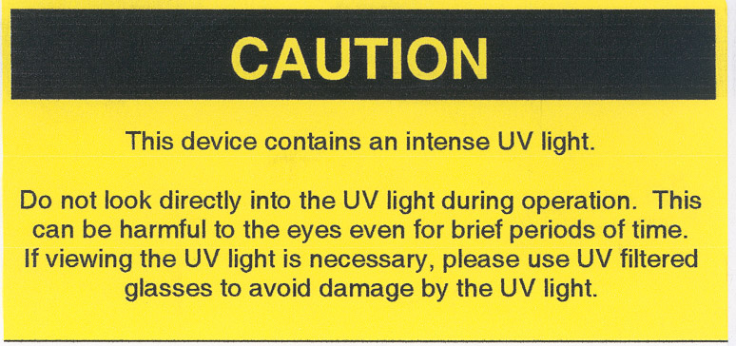
Figure 1

Welding, Burning and Brazing (Required)
Fermilab employees shall follow the requirements found in FESHM Chapter 6020.2 Welding, Burning and Brazing & Spark Producing Operations which identifies safety precautions, including PPE, curtains and screens that will provide protection from UV radiation.

Outdoor Work (Strong Recommendation)
Whenever practical, wear long sleeves, long pants and a brimmed hat for outdoor work where eyes and skin may be exposed to UV radiation. When the skin will be exposed to the sun, apply generous amounts of sun block with an SPF rating of at least 15. Apply the sun block at least 30 minutes before going outdoors. Wear UV blocking sunglasses, those labeled as "UV 400", which block all light rays with wavelengths up to 400 nm.

(Note: Polarized sunglasses do not block UV radiation. UV coatings on prescription clear lenses are as effective as UV blocking sunglasses. It is not the dark tint that is important. Plastic lenses need to have a UV coating applied. Polycarbonate lenses on the other hand block UV rays without an additional coating.)

REFERENCES

American Conference of Governmental Industrial Hygienists (ACGIH) Threshold Limit Values (TLVs®) and Biological Exposure Indices (BEIs-®) 2017

