QAM 12050: Root Cause Analysis (RCA)

Revision History

Author | Description of Change | Revision Date
Jemila Adetunji  Tom DiGrazia | - Refined and clarified language throughout the document; alignment with other QAM Chapters.  - Added a new section (5.9) that provides additional guidance on performing an “extent of condition” exercise. | March 2020
Kathy Vuletich | - Replaced item type “Finding” with “Non-conformance” as they have identical definitions. Finding has been removed from use in iTrack.  - Removed reference to outdated Computing procedures that are no longer relevant to the root cause analysis procedure.  - Removed Barrier Analysis Process procedure from the Technical Appendix. | January 2018
Kathy Zappia | Initial release of QAM 12050 replaces the OQBP Root Cause Analysis Procedure 1004.1002 rev. 002.2. | December 2013

TABLE OF CONTENTS

1.0 INTRODUCTION 3
2.0 DEFINITIONS 3
2.1 Contributing causes 3
2.2 Corrective Action 3
2.3 Direct cause 3
2.4 Extent of condition 3
2.5 Unexpected Outcome 3
2.6 Non-conformance 3
2.7 Preventive Action 3
2.8 Remedial Action 4
2.9 Root Cause 4
2.10 Root Cause Analysis (RCA) 4
3.0 RESPONSIBILITIES 4
3.1 Division/Section/ Project Line Management 4
3.2 Quality Section Head 4
3.3 Employees, Contractors, Subcontractors, and Users 4
3.4 Supervisors 4
3.5 Division Safety Officers and Quality Section Liaisons 4
4.0 CAUSAL ANALYSIS ELEMENTS 4
4.1 Output 4
4.2 Knowledge/Experience 5
4.3 Containment 5
4.4 Graded Approach 5
5.0 PERFORMING THE INVESTIGATION 5
5.1 Define the problem 5
5.2 Understand the Process 5
5.3 Grade the Process & Identify RCA Method 5
5.4 Identify Possible Causes 6
5.5 Collect Data 6
5.6 Analyze the Data 6
5.7 Refine Problem & Root Cause 6
5.8 Corrective and Preventive Actions (CAPA) 7
5.9 Extent of Condition 7
5.10 Documentation 7
5.11 Communicate Lessons Learned 7
6.0 TECHNICAL APPENDIX - Tools for RCA Problem Solving, Data Collection, & Analysis 8

INTRODUCTION

This chapter describes the activities required to properly perform Root Cause Analysis (RCA). This chapter applies to all Fermilab employees, subcontractors, and users performing root cause analysis. It is applied to root cause investigations of incidents and events as defined in FESHM 3020, Incident Investigation and Analysis, unexpected outcomes, items categorized as a nonconformance or management concern in iTrack, or recurring events defined in QAM 12030, iTrack Procedures and Risk Assignment.

This procedure is applicable to personnel at Fermilab and any leased spaces.

DEFINITIONS

Contributing causes
The causes which did not initiate the problem, but had they not existed the problem could not have occurred or would have been less severe. They raise the probability of a problem.

Corrective Action
An action to eliminate the cause of a detected nonconformance or another undesirable situation.

Note: There can be more than one cause for nonconformance. Corrective action is taken to prevent recurrence whereas preventive action is taken to prevent occurrence.

Direct cause
The cause which immediately resulted in the problem, also known as the physical or proximate cause.

Extent of condition
Determination of the degree to which a problem or cause may exist in other portions of the system or similar systems.

Unexpected Outcome
An occurrence which deviates from planned requirements (activities or results) or expected outcomes which may range from a simple procedural noncompliance with minimal risk to an accident/event having substantial risk to personnel. For ESH incidents refer to FESHM 3020.

Non-conformance
Non-fulfillment of a requirement.

Note: A non-conformance can be any deviation from work standards, practices, procedures, legal requirements, or applicable code of federal regulations.

Preventive Action
Action to eliminate the cause of a potential non-conformance or another undesirable potential situation.

Note: There can be more than one cause for a potential nonconformance. Preventive action is taken to prevent occurrence whereas corrective action is taken to prevent recurrence.

Remedial Action
An action taken to alleviate the symptoms of existing nonconformities or any other undesirable situation. Also known as correction or compensatory action, remedial action is used to minimize the effects before the root cause and best solution may be identified. It is a reactive, short term action to stop immediate effects of the problem.

Root Cause
An identified reason for the presence of a defect or problem. The most basic reason, which if eliminated, would prevent recurrence. The source or origin of an event, also known as “system cause.”

Root Cause Analysis (RCA)
A logical thinking process using deductive and inductive searches to collect evidence to support or deny actual causes of a problem.

RESPONSIBILITIES

Division/Section/ Project Line Management
- Ensure compliance with this procedure including flow down of requirements and awareness.
- Provide the necessary resources to implement this procedure.
- Ensure individuals are knowledgeable of root cause analysis methods where required.

Quality Section Head
- Ensures the maintenance of this QAM Chapter.
- Provides awareness and support to Line Management and Management System Owners.

Employees, Contractors, Subcontractors, and Users
- Be cognizant of root cause analysis methods as determined by Fermilab Line Management.
- Notify the immediate supervisor when issues or incidents require investigation, corrective action, and potential root cause analysis.

Supervisors
- Notify Line Management when issues or incidents require investigation, corrective action, and potential root cause analysis

Division Safety Officers and Quality Section Liaisons
- Assist personnel with the application of root cause analysis to unexpected outcomes, incidents, or events brought to their attention.

CAUSAL ANALYSIS ELEMENTS

Output
The output of the root cause process is an understanding of the events leading to the problem in terms of root, direct, and contributing causes.

Knowledge/Experience
Personnel should be made aware of root cause analysis methods where appropriate. Assignment of personnel to an investigation or review of an unexpected outcome should consider knowledge/experience with RCA as well as with the technology and processes to be investigated. Assignment of someone independent of the area being evaluated but with RCA experience may be useful in providing an objective assessment. Engaging a subject matter expert in the process being analyzed as well as RCA tools to be applied is imperative.

Containment
Containment and remedial actions to put the affected process in a safe condition and to preclude recurrence shall be taken prior to beginning a root cause analysis. Where safety is not an immediate concern, containment and remedial actions may or may not need to be taken depending on the type of problem encountered. These actions shall be reviewed during the conduct of the root cause analysis to gain clarity of the problem symptoms, scope, and evidence.

Graded Approach
A graded approach should be used when determining the applicability of this procedure to problem solving at Fermilab. This requires considering severity, frequency, cost, complexity, and impact on operations or safety issues associated with the problem being addressed. A graded approach includes determining the type of root cause method to be used – varying from an individual performing a simple, informal review of the problem to the establishment of a team and the use of structured, detailed processes to review a problem. The Technical Appendix provides information on some of the root cause methods and tools that may be used at Fermilab.

PERFORMING THE INVESTIGATION

The order in which the steps described below occur may vary depending on urgency of the problem, degree of problem understanding at the beginning of the investigation, and the need to protect/preserve evidence.

Define the problem
Define the problem by developing a clear, complete, and concise statement which includes what the problem is, who was involved (not attributing blame), where it occurred or was identified, when it occurred or was identified and the magnitude (e.g., frequency, impact). Operating conditions or precursor information which may provide additional details for consideration might also be required. This problem statement will become more refined and detailed as the analysis is conducted.

Understand the Process
Identify initial boundaries of the system to be analyzed. Gain a high-level understanding of the normal sequence of operation of the system which failed by using a Process Analysis Tool from Appendix A to create a process flowchart and timeline showing the activities involved.

Grade the Process & Identify RCA Method
Determine the severity, frequency, cost, complexity, and impact on operations or safety issues. Based on these factors determine the type of root cause method to be used – varying from an individual performing a simple, informal review for simple problems – to the establishment of a team and the use of structured, detailed processes for complex problems.

The Technical Appendix provides tools which may be used when performing root cause analysis. There are methods and tools in addition to those listed in the appendix. Fermilab is not limited to the methods contained in this procedure. Human Performance Improvement (HPI) provides tools for understanding human error and its applicability to Fermilab can be found in QAM Chapter 12110 – Human Performance Improvement (HPI). HPI can be used as one of the approaches applied when investigating unexpected or unwanted outcomes involving human performance or "error proofing" procedures and communications in the context of tools, tasks, and operating environment. RCA and HPI may be complementary and are not mutually exclusive.

Identify Possible Causes
Develop hypotheses regarding the most logical possible causes of the problem under investigation or at least which steps of the process contributed to the problem. When identifying possible causes, it is advisable to consult standards, professional literature, DOE databases, and laboratory subject matter experts to understand how other industries may have identified and solved similar problems. This may help avoid over reliance on preconceived conclusions.
- Identify which steps in the flowchart most likely could and could not cause the problem.
- Use Cause Analysis Tools from the Technical Appendix to identify failure modes, cause categories, or other groupings of causes.
- Identify barriers in the system which may have failed by using Cause Analysis Tools from the Technical Appendix. Note that such barriers could include those items intended to prevent the problem and/or intended to detect the problem.
- Assess whether there have been any changes made in the system prior to the time of the problem which may have led to the occurrence.
- Use an Idea Creation Tool from the Technical Appendix to determine a list of possible causes.

Collect Data
Using the tools described or referenced in the Technical Appendix, collect data to refute or support hypotheses regarding the causes that had the greatest impact on problem initiation. In addition to conventional data collection, evidence gathering should include interviews of personnel involved with designing, operating and/or maintaining the system which failed; observation of the processes in action when possible (e.g., in real-time or video/computer recording); scientific analysis of failed system components; and reviews of relevant organizational records related to planning and maintaining the system.

Analyze the Data
Use Analysis Tools from the Technical Appendix to evaluate data for evidence that allows determination of which of the possible causes had the greatest impact on problem initiation.

Refine Problem & Root Cause
Refine the problem definition based on current conclusions, and then repeat the system understanding, possible cause, and evidence gathering & analysis sequence until the level of cause is deemed sufficient for the significance of the problem. For low risk or impact problems finding the direct cause(s) may be sufficient, while for more significant problems the root cause(s) (also known as system causes) should also be found.

Corrective and Preventive Actions (CAPA)
Identify and implement corrective and preventive actions to ensure the problem has been eliminated and prevented from occurring again. See QAM 12040, “Corrective & Preventive Actions.”

Extent of Condition
An Extent of Condition evaluation may be recognized as being required as early as the identification of the issue. Other times, it may not become clear that there is a need for an Extent of Condition evaluation until the causal analysis, or even the corrective and preventive action process has started. The consideration of an Extent of Condition evaluation should be captured as part of each corrective action management plan.

Extent of Condition evaluations should be performed by an appropriate subject matter expert (SME) for the issue identified. The SME should also have particular knowledge of the area under study across the entire lab.

The following items should be considered and incorporated into the Extent of Condition evaluation as appropriate:
- Review the circumstances and conditions that led to identifying the issue.
- Assure the level of effort will identify all relevant causal factors.
- Evaluate the issue for uniqueness, recurrence, and potential/actual consequences.
- Determine the range of facilities and activities at the lab that may be exposed to the same or similar issue.
- Investigate and identify the applicability to other activities, processes, equipment, projects, facilities, operations, organizations, divisions, and/or sections.
- Ensure involvement by the appropriate subject matter expert and their manager in
the development of findings.
- Document findings and be sure to incorporate them when developing corrective actions.

Documentation
A formal report of the investigation may be created based on the complexity of this issue or by request of the leadership / owner of the process where the issue was identified. Documentation of the issue, individuals involved, root causes/contributing factors, as well as resulting recommendations are captured in the HPI report form for investigations of incidents, near misses, and unexpected outcomes performed using the HPI tools.

Communicate Lessons Learned
Once the causal analysis have been completed, the results should be communicated to share lessons learned about the causes for the problem as well as how recurrences can be minimized See QAM 12010 Lessons Learned Program. For ES&H incidents being investigated, FESHM 3020 specifies lessons learned steps.

TECHNICAL APPENDIX - Tools for RCA Problem Solving, Data Collection, & Analysis

The following Appendix describes tools that may be used during root cause analysis. There are many tools available than those illustrated in this procedure including specialized software. Experience and training will guide users in determining the best tools to use in any given situation and in any given step of the RCA process. However, if the user of the tool does not have familiarity to its use, applicability, or application, it is imperative to engage a subject matter expert for guidance.

Tools illustrated in one RCA step may apply to other steps as well. These steps may be iterative. For example, as more information is obtained, it may be beneficial to refine the problem statement.

Tools for Defining the Problem

Pareto Chart
The purpose of the Pareto chart is to highlight the most important of a set of factors. It often represents the most common source of defects, the highest occurring type of defect, or the most frequent reason for service interruptions, customer complaints and so on. In the example below, it is immediately evident that “documentation errors” is the major cause of customer complaints, accounting for approximately 50% of all complaints.
During root cause analysis, this tool is useful for determining, categorizing, and displaying information that may help better define the problem. For instance, the chart below further defines the problem “customers are complaining” into the reasons for complaints and identifies that 50% of complaints are for documentation errors. When multiple causes are identified later in the RCA, it may also be useful in determining the most important cause or causes to resolve to reduce or eliminate the problem.

Run Chart
The run chart is used to analyze data to detect trends, shifts, or patterns over time. It allows the comparison of process performance before and after a process or activity has changed. In the example below a team is investigating system performance problems. They analyze data for the percent of returns with a malfunction over a period of twelve months. When defining the problem, this chart helps refine a problem statement like “error rates were high this year” to “chip performance error rates have increased from 0.25% in month 5 to 4.5% in month 12”. The cause of the marked increase in chip errors could be a contributing cause of system performance problems like the one under investigation.
During root cause analysis, this tool is useful for displaying and analyzing process behavior over time. It is particularly useful in detecting changes in process behavior.

Like the Pareto chart, the run chart is often useful during the data analysis step.

Understanding the Process

SIPOC
Supplier, Input, Process, Output, Customer (SIPOC) describes the high-level structure for a flow chart. Suppliers deliver inputs which are then processed to produce outputs. The outputs are delivered to customers. The outputs need to meet the objectives to satisfy customers. These objectives may include product features, quality levels, on-time delivery, etc. Finally, feedback from customers, the outputs, and the process are used to improve suppliers, the process and ultimately outputs to improve customer satisfaction.

During RCA evaluations, this chart may be helpful in identifying high level process boundaries which is useful when defining the scope of the RCA.

Process Flowchart
Flowcharts are used to analyze, design, document, or manage a process or program. More sophisticated flowcharts may employ other specialized shapes, symbols, and graphics to represent the steps and events in a process.
In the example below, the order in which each task of a generalized assessment process is completed is clearly identified. In addition, there is a feedback loop for reviewing and revising the assessment report and the process output is the report.
During root cause analysis, this tool is useful for defining the process to identify possible areas where problems or defects may be encountered.

Identify Possible Causes

5-Whys
The 5-Whys is a question asking methodology used to determine the cause/effect relationships underlying a particular problem. The purpose of applying the 5 whys is to determine the root cause of a problem.

The process begins with a problem statement. The question why is then asked to determine why the problem exists. When the answer to the first question has been determined, the question why is asked again relative to the answer. The question why is asked and answered a total of 5 times (more or less if necessary) in order to determine the root cause of the problem. In the example below, using the problem statement “the product does not meet customer needs”, successive whys are asked until the root cause of the problem is determined:
- Why does the product not meet customer needs?
  - Because of one or more issues with delivery, features, or defects.
- Why were there issues with the delivery?
  - Because requirement changes caused development delays.
- Why were there delays due to changes in requirements?
  - Because engineering changed drawings.
- Why did engineering change drawings?
  - Because the customer requested new features.
- Why did the customer request new features?
  - Because their requirements changed.
During root cause analysis this tool is useful for determining, categorizing, and displaying effects and potential causes.
The logic tree (see below) provides a graphical representation of the application of the 5-Whys. The tree grows as more branches are added to it as a result of asking the 5 “whys”.

Logic Tree
A Logic Tree is a diagram that shows the causes of events and the relationship among events. It is used to identify potential factors causing an overall effect. Each cause or reason for imperfection is a source of variation.

The Logic Tree can be constructed with the help of the 5 Whys Tool (see above). After defining the initial problem or event, use the 5 Whys tool to find the causes of each succeeding branch of the tree, until arriving at the root causes. In the example below “why?” is asked of the problem statement and again for each answer until the root causes are reached for each major branch.
During root cause analysis this tool is useful for determining, categorizing, and displaying root causes.
Logic Trees may also be constructed using AND or OR operators which are not illustrated here. AND is used to indicate when multiple lower level causes can only result in the problem when each of them is in a specified state at the same time. OR is used to indicate when any one or more lower level causes can result in the problem independently.

Cause Mapping®
Cause Mapping is a methodology used for discovering multiple potential causes or sources of a problem by 1) defining the problem; 2) analyzing the problem and identifying the causes; and 3) determining the best possible solutions for each individual cause of the problem.

This method is good for all types of problems and ensures that the entire identification process of the problem, through causal identification and corrective actions, is documented.

            - Step 1 – Defining the problem – what is the problem?
When defining the problem, the Causal Mapping technique suggests creating an outline of the problem first. The outline should include:
              - What was the problem?
              - When did the problem occur?
              - Where did the problem occur?
              - What impact did it have on goals, including safety goals, property goals, or operations goals?

            - Step 2 – Analyzing the problem and determining the cause(s) – Why did it happen?
When analyzing the problem, the Causal Mapping technique uses a flow chart approach.
- First, the goal that is impacted is documented.
- Second, the outcome of the problem is documented.
- Third, the reasons why the outcome happened are documented.
This part of the process follows the 5-Why method where ‘why’ is asked until a cause to the outcome can be determined.

Multiple causes to a problem can be identified by using this method. See the causal map example below for why the Titanic sank.

3. Step 3 – Determine solutions – What will be done?
The last step documents what actions should be taken to resolve the cause(s) of the problem. The cause(s) maybe the actual root cause of the problem, or it might just be one of many contributing causes to the problem. Any causes identified and all corrective actions defined shall be tracked in iTrack.

Step 1 Example:
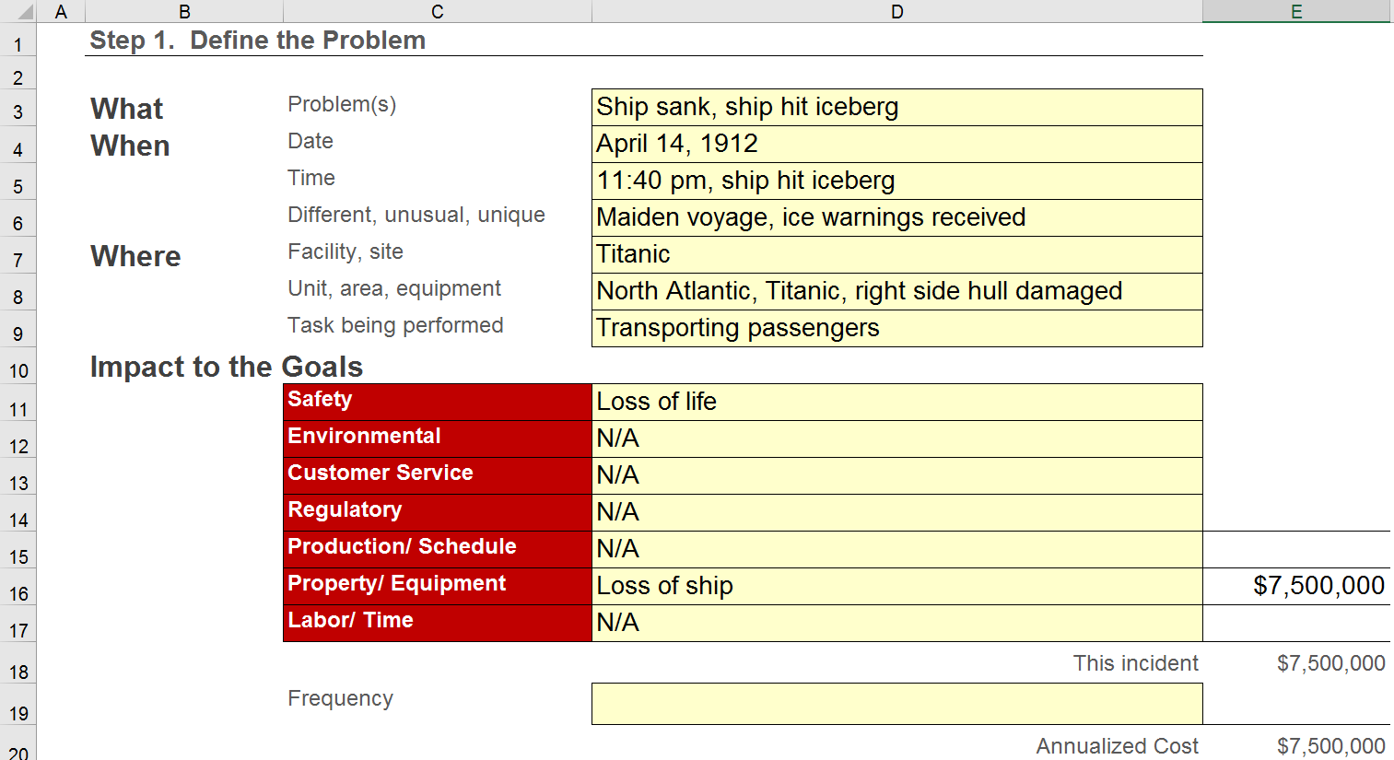
Image Credit: ThinkReliability® Cause Mapping Example.

Step 2 Example:
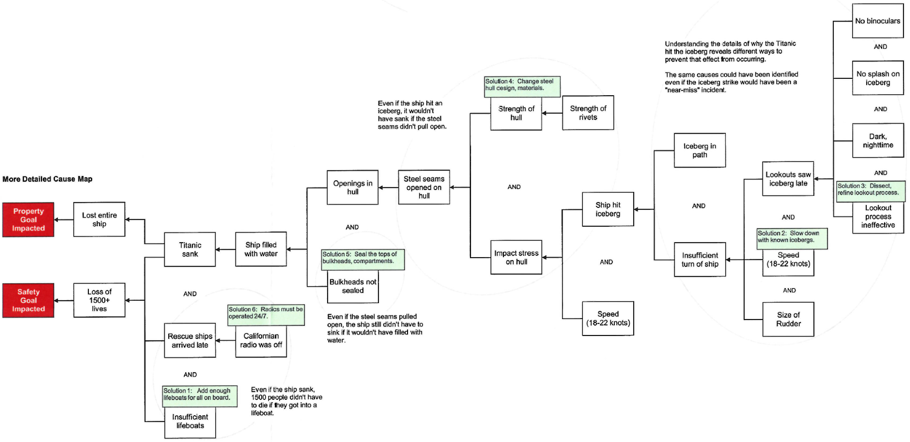
Image Credit: ThinkReliability® Cause Mapping Example.

Brainstorming
Brainstorming is a method for generating a large number of ideas about the potential causes or sources of the problem quickly. The team selected to conduct the brainstorming should be subject matter expects either directly or indirectly involved with the problem to be solved, as well as other subject matter experts who may be deemed to add value to the discussion. Typically, the problem description is recorded on a visual space such as whiteboard or flip chart so the entire group can see it. Using the flip chart, one person acts as the recorder and writes down ideas about the possible causes or sources of the problem as participants offer them. Participants are encouraged to generate as many possible causes or sources as possible with no evaluation or judgment made. Once the team has stopped generating potential causes or sources, they are clarified, and duplicates eliminated. This leaves a large list of possible causes or sources of the problem. These may be reduced through the use of quality tools such as Nominal Group Technique or Multi-voting.
During root cause analysis, this tool is useful for generating a list of potential problems to be resolved or for generating a list of potential causes for an identified problem.
Cause and Effect Diagram
A Cause and Effect Diagram is a diagram that shows the causes of an event. The cause and effect diagram (also called fishbone diagram or Ishikawa diagram) is used to identify potential factors causing an overall effect. Each cause or reason for imperfection is a source of variation. Note: this definition of cause and effect diagram is different than that used by the DOE in Root Cause Analysis Guidance Document, DOE-NE-STD-1004-92.

The effect or problem is stated on the right side of the chart and the major influences or causes are listed on the left. Causes are grouped into major categories to identify the sources of variation. The categories typically include:

- Personnel: people involved with the process
- Methods: How the process is performed and the specific requirements for doing it, such as policies, procedures, rules, regulations, and laws.
- Machines: Any equipment, computers, tools, etc. required to accomplish the job
- Materials: Raw materials, parts, pens, papers, etc. used to produce the final product
- Measurements: Data generated from the process that are used to evaluate its quality
- Environment: the conditions such as location, time, temperature and culture in which the process operates.
In the example below, it can be seen that the major causes of the problem are broken down further into primary, secondary, and tertiary causes which fill in the “bones” of the fish
During root cause analysis this tool is useful for determining, categorizing, and displaying root causes.

Collect Data

Check Sheet
A Check Sheet is a structured form that is used for collecting data in real time at the location where the data is generated. The check sheet is typically a blank form that is designed for the quick, easy, and efficient recording of the desired information, which can be either quantitative or qualitative.
A defining characteristic of a check sheet is that data is recorded by making tally marks ("checks") on it. A typical check sheet is divided into regions, and marks made in different regions have different significance. Data is read by observing the location and number of marks on the sheet. The check sheet is most useful when collecting data on the frequency or patterns of events, problems, defects, defect location, defect causes, etc.
In the example below reasons for product returns are recorded on the check sheet. For each reason, the number of returns is recorded per day. This allows the total returns for each day of the week and the total returns for each reason for the week to be easily calculated.
During root cause analysis this tool is useful for collecting and recording data.

Other quantitative tools include records of data collected during a multi-vari study or a statistically based sampling activity. Some qualitative data collection tools include interviews, observations, review of records and logs, and pictograms concentration diagrams) to illustrate spatial orientation (location) of symptoms of the problem. Sometimes specialized laboratory tests may provide useful types of data.

Analyze the Data
Histogram
A Histogram is a graphical display of a frequency distribution. It shows how often different values in a set of data occur within predetermined bins. It can be used to summarize data from a process that has been collected over time. It is important to understand the frequency distribution of any data set prior to performing any formal statistical analysis. To construct a histogram, individual observations are counted in bins located on the x-axis and the frequency in each bin is plotted on the y-axis. There are a number of rules of thumb and formulas available to determine the optimum number of bins for a given data set.

In the example below, the center of each bin is displayed as 30, 40, 50 and so on. The x-axis indicates a value, where 30 represents observations in the range (bin) 26 to 35, the value 40 represents observations between 36 and 45 and so on. The y-axis indicates a frequency of 4 observations in the first bin, 30 observations in the second bin, 88 observations in the third bin and so on.
During root cause analysis this tool is useful for displaying and analyzing the frequency distribution of data.
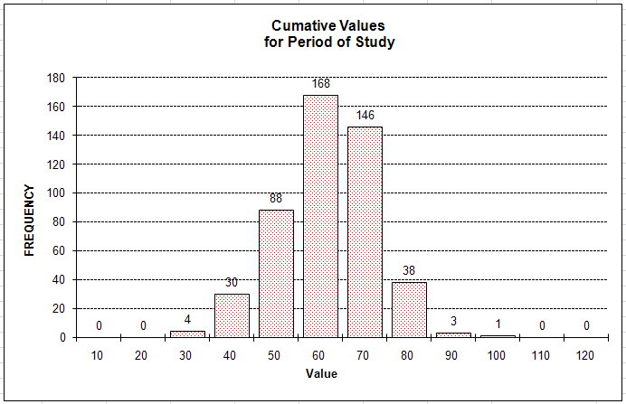
Scatter Diagram
A Scatter Diagram is a type of diagram that displays pairs of numerical data, with one variable on each axis, to look for a relationship between them. The data is displayed as a collection of points with each point having the value of one variable determining its position on the horizontal axis and the value of the other variable determining its position on the vertical axis. The points suggest various kinds of correlations between the variables such as positive (rising), negative (falling), or null (uncorrelated). A line of best fit (sometimes called a trend line) can be drawn to study the correlation between the variables.

In the example below weight and height of individuals are the 2 variables plotted on the graph. A trend line has been drawn which shows a positive (rising) correlation between weight and height – that is, as weight increases, height tends to increase as well.

During root cause analysis, this tool is useful for displaying and analyzing the relationship or correlation between 2 variables.

Control Chart
A Control Chart is a graph used to study how a process changes over time. A control chart is really a run chart that contains statistically determined upper and lower control limits drawn on either side of the process average center line. The control limits indicate the threshold at which the process is considered to be in or out of control. Control charts are often interpreted using additional rules such as the number of consecutive values above or below some value or an upward or downward trend inside the control chart lines.

Variations of the process points within the control limits are due to variation built into the process, also called common causes. Variation of the process points outside the control limits (and other rules violations) are due to causes outside the process, also called special causes. The purpose of control charts is to monitor, control, and improve process performance over time by detecting variation and its causes.

In the example below the process is considered to be in control, because all points lie between the upper and lower control limits. Variation in individual points is due to variation built into the process, also known as common cause.
During root cause analysis this tool is useful for displaying and analyzing process behavior over time. By investigating conditions leading to out of control situations it is possible to uncover clues as to the underlying causes.

Statistical Techniques
Statistical techniques are formal statistical models, methods and procedures used to analyze results of experiments or to monitor process outcomes as time series. Most of these techniques are beyond the scope of this document. A few types of statistical techniques are process capability analysis, Hypothesis Tests, Design of Experiments, and Regression Analysis.

