FESHM 7030: EXCAVATION

Revision History

Author | Description of Change | Revision Date
Raul Cantu | Added definitions, minor edited & formatting, added crane locates, Utility Marking “Refresh”, updated website links, added other gases that the yellow flag covers. Changed Utility Locate Administrator to JULIE Coordinator | May 2021
Jim Niehoff | Added applicability statement for Fermilab Leased Spaces. | December 2017
Jim Niehoff | - Added definition of Exclusion Zone  - Added EJULIE definition  - Added Utility Locate Administrator and Utility Subject-Matter Experts definitions  - Added Figure Nos 1 and 2  - Changed 7 to 10 days and changed 14 to 18 days, removed term business days.  - Added Electronic Excavation Permit  - Removed term Fermi-JULIE  - Changed 4.1 to Chief Safety Officer  - Added 75 year permit retention per DOE  - Removed Appendix A | March 2017
Jim Niehoff | - Changed high gas service from 100 psi to 2 psig.  - Damage to a gas line as a result of construction is considered reportable regardless of pressure.  - Added duration time for an excavation process. | December 2015
Jim Niehoff | Incorporated lessons learned related to extending an excavation permit, see Section 5.3.2, Item No. 8. | June 2012
Jim Niehoff | Implemented waiver process and developed a map depicting restricted waiver areas. | June 2011
Russ Alber | Removed Appendix Matrix and removed procedures. | March 2010
Tom Prosapio | Defined critical and non-critical work (emergency), updated permitting process. | July 2002
Ed Crumpley | Initial release Chapter 7030. | December 1999

TABLE OF CONTENTS

1.0 PURPOSE 2
2.0 SCOPE 2
3.0 DEFINITIONS 2
4.0 RESPONSIBLILITIES 5
4.1 Chief Safety Officer 5
4.2 Division/Section Head 5
4.3 Construction Coordinator/Task Manager (CC/TM) 5
4.4 Design Coordinator 5
4.5 Utility Owners 5
5.0 PROGRAM DESCRIPTION 5
5.1 Standardized Color for Utility Locators 6
5.2 Design Phase 6
5.3 Construction Phase 7
5.3.1. Excavation Permit Process 7
5.3.2. Excavation Activities 7
5.3.3. Utility Marking “Refresh” 9
5.4 Closeout Phase 9
5.5 Excavation Permit Record Retention 10
6.0 SPECIAL CONSIDERATIONS 10
6.1 Excavations – Emergency Situations 10
6.2 Permit Waiver 10
6.3 Waiver Prohibited (Restricted Areas) 10

PURPOSE

Safeguarding our workers and utilities is a continuous process that begins in the project planning, design, and execution phases and runs through documentation of as-built conditions. This chapter establishes a process to be followed by all divisions and sections when confronted with an excavation as a phase of work.

It is the intent of this chapter to provide guidance regarding actions needed to obtain an excavation permit prior to any activity that penetrates the soil and complementary procedures when operating under FESHM 7010 or when mobile crane underground utility locates are required per FESHM 10140. Standards to follow when opening an excavation can be found in the Code of Federal Regulations 29 CFR 1926 Subpart P.

This chapter only applies to the Fermilab site. Leased spaces will follow the rules and regulations set forth by the partnering institute and/or state or local codes and standards.

SCOPE

Existing utility locations will be considered during the design phase of all proposed work that involves excavation. Where appropriate, designs should be modified to minimize interferences with existing utilities.

Procurement documents will clearly spell out Fermilab’s expectations and requirements regarding excavation activities.

An “issued” permit is required before the start of any excavation activity and must be kept current and on the job site when an excavation is underway. The process, electronic version of the excavation permit, and the paper version of the permit is maintained by FESS. Lockout/Tagout (LOTO) procedures will be applied before excavating in the proximity of buried electrical cable and/or high-pressure gas lines. Special planning and precautions must be taken and the Hazard Analysis (HA) must be approved by the Chief Safety Officer or designee when deactivation of an existing electrical cable or high-pressure gas line in the area of an excavation is not possible.

As found and as-built utility information will be gathered and stored in a retrievable system. The preferred method for storing this information is Facilities Engineering Services Section Geographic Information System (GIS). The data/Information contained in this GIS is continuously being verified and updated and is for information purposes only. At a minimum, the GIS map depicting the restricted buffers around beam lines and solid waste areas must be reviewed by the Subcontractor’s Safety Subcommittee (S-3) and Radiation Safety Subcommittee (RSS) the first quarter of every calendar year.

DEFINITIONS

- Competent Person - One who is capable of identifying existing and predictable hazards in the surroundings, or working conditions which are unsanitary, hazardous, or dangerous to employees, and who has authorization to take prompt corrective measures to eliminate them.

- Construction Coordinator (CC) - A person specifically assigned to oversee the work of a construction subcontract for conformance to the subcontract agreements. Construction Coordinators serve as the primary construction point of contact between the Subcontractor and Fermilab.

- Design Coordinator – A person assigned the responsibility for assembly of complete design documents for the purpose of bidding and/or construction

- Electric Cable – Any buried medium or high-voltage electrical cable whether direct buried, in conduit or in a reinforced concrete duct bank.

- Excavation - Any man-made cut, cavity, trench, or depression in an earth surface, formed by earth removal. This includes directional drilling but does not include farm tillage operations.

- Electronic Excavation Permit (EJULIE) - An electronic on-line request form for generating an excavation permit. Facilities Engineering Services Section (FESS) maintains and administers this system.

- Exclusion Zone – A zone designated on the surface using standard color-coded markings, which contains the width of the utility plus 18 inches on each side of the utility. The only excavation technique allowed withing exclusion zones is vacuum excavation. see Figure No. 1 for example.
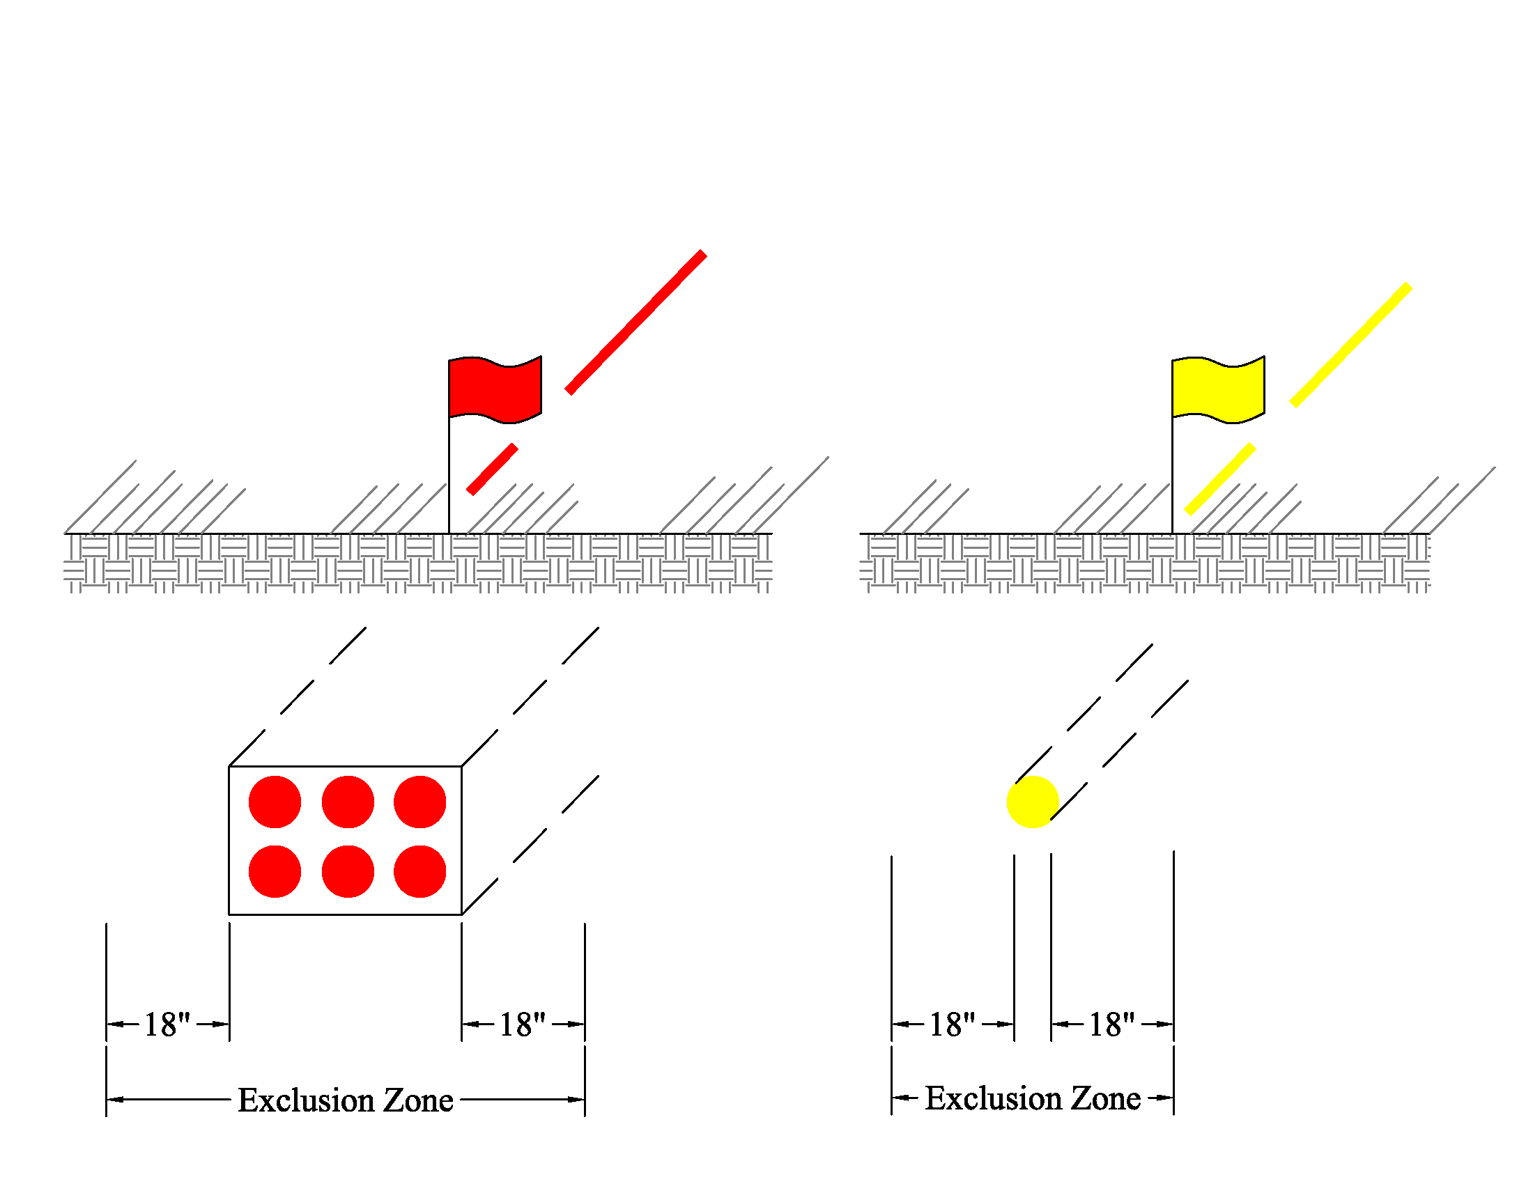
Figure No. 1

- Fiber Optic – A thin, flexible fibers with a glass core which transmit light signals/data. Fiber optic cables are used at Fermilab for safety interlocks, timing links for accelerator operation, communication and large amount of experimental data. Additionally, there are several privately owned fiber optic lines in established easements that transverse the Fermilab site.

- Geographic Information System (GIS) – A system that captures, stores, manages, and presents geographic data such as utilities, buildings, land use, and other special infrastructure. The GIS is considered the source documentation of utilities and is used in conjunction with the EJULIE system. The URL is: https://fessappprd.fnal.gov:8181/FessViewer/index.html

- High-Pressure Gas Service – For purposes of this chapter is defined as any gas service at or above 2 psig.

- Horizontal Directional Drilling (HDD) - is a minimal impact trenchless method of installing underground utilities such as pipe, conduit, or cables in a relatively shallow arc or radius along a prescribed underground path using a surface-launched drilling rig.

- JULIE – Joint Utility Locating Information for Excavators.

JULIE Coordinator - A Facilities Engineering Section designee responsible for the procedures, process and issuing the completed excavation permits.

- Potholing – Potholing is the practice of digging a test hole to expose underground utilities to determine the horizontal and vertical location of the utility. Potholing methods only includes:
  - Vacuum Excavation - Vacuum excavation consists of air or water pressure to break up the soil and a vacuum device to collect the spoil.

- Task Manager (TM) – A division/section-designated individual specifically assigned to oversee and direct a work activity. An approved TM list indicating individual experience and competency to direct specific work activities can be found at: https://esh-docdb.fnal.gov/cgi-bin/sso/ShowDocument?docid=75

- Utility Subject-Matter Experts – Individuals having knowledge and locating authority to identify buried utilities and signing off for the designated buried utility.

- Utility Marking “Refresh” – During the life of the excavation project, the JULIE Locate Administrator may be contacted by the TM/CC to “refresh” utility markings without the need for entering in a new Excavation Permit if and only if the area requested has not physically changed.

- Waiver – A written relinquishment of executing the excavation process and permit, typically prepared and signed by Construction Coordinator/Task Manager (CC/TM). In these instances, the CC/TM shall take full responsibility in the event of a utility strike. Typically, a waiver is only executed in an emergency when equipment or life safety is at risk.

RESPONSIBLILITIES

Chief Safety Officer

- The Chief Safety Officer or their designee must sign the Excavation Hazard Analysis when electrical, fiber optic cables and/or high-pressure gas service within exclusion zone or crossing an excavation cannot be de-energized or depressurized.

Division/Section Head

- Implementation of the requirements of this chapter for those construction activities managed by his/her staff.
- Assignment of a qualified CC/TM.

Construction Coordinator/Task Manager (CC/TM)

- Submit Excavation Permit
- Submit as-built existing and/or new utility locations to the GIS system.
- Assure a competent person signs the excavation permit.
- Obtain Chief Safety Officer’s approval of the HA if work near energized electrical cables or high-pressure gas lines is anticipated.
- Provide supervision during live work activities
- Preparing and submitting the electronic excavation permit (EJULIE)
- Physically signs off on a permit extension.
- Ensures utility locate marks remain present once marked in the event of work traffic and/or weathering.

Design Coordinator

- Verify proximity of excavation to accelerator enclosures and Solid Waste Management Units (SWMU’s) as well as any special delineated areas.
- Incorporate as-built existing and/or new utility locations into the design drawings into the Fermilab’s GIS system.

Utility Owners

• Once notified via the EJULIE program that there is a JULIE Permit Request, utility owners shall mark utilities in the field or confirm that the marks existing are accurate. In all cases where there are utilities in the excavation area, a field visit is typically required. Responses shall be entered within ten (10) business days for areas less than one (1) acre, and up to eighteen business (18) days for areas greater than one (1) acre.

PROGRAM DESCRIPTION

Standardized Color for Utility Locators

- Paint, flags, or other marking schemes will use color as specified in Figure No. 2.

- Yellow flags also signify compressed inert gases, such as helium, nitrogen and argon.

  - An ODH hazard may be the concern rather than an explosion hazard.
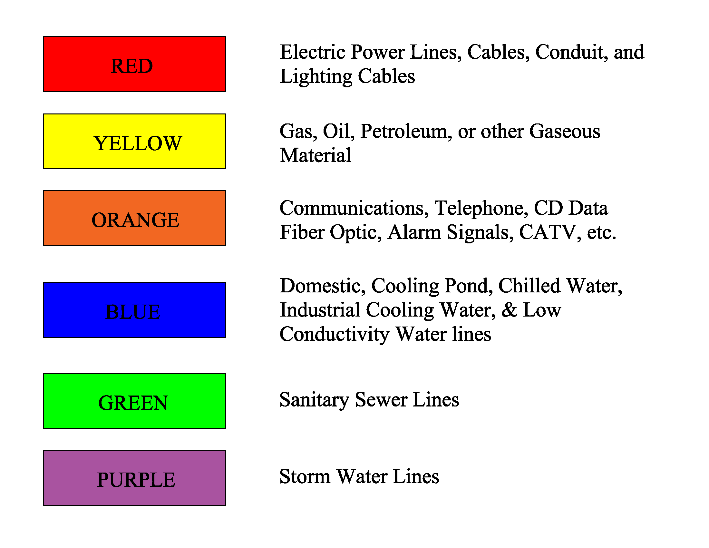
Figure No. 2

Design Phase

When it is recognized that completion of a task will include excavation, the design team will identify existing underground utilities and incorporate reasonable accommodations into the design to minimize the likelihood of damage. The TM is responsible for any and all required engineering/design activities for T&M activities. Design Coordinators are responsible for the engineering/design activities associated with fixed-price construction work. The design team will identify existing utilities using some or all the following:

- Existing utility maps
- Previous design and as-built documents, including; accelerator enclosure clearance zones, radiation shielding assessments, and delineated special areas such as Solid Waste Management Units (SWMU’s)
- JULIE Coordinator will arrange for the location of utilities
- Test holes
- On-site physical review
- Corporate knowledge

The design team will incorporate all known utility information into design and construction drawings.

Contracts for projects including excavation activities shall require:

- An Excavation Permit before beginning any excavation.
- Field marking of the proposed excavation zones and maintenance of the locator markings.
- Notification to Fermilab (utility owner) of any damage to existing utilities.
- Submission of as-built drawings with utility line coordinates and elevations for inclusion into Fermilab’s GIS System.

Construction Phase

Excavation Permit Process

- The requestor can prepare an excavation permit through the EJULIE application identifying the area and depth (volume) of the excavation; however, only trained and approved CC/TM can oversee the excavation activity. To request an Fermilab Excavation Permit, complete an Excavation Permit through the online EJULIE application. https://fess-app.fnal.gov/app/eJulie

- If practical, the CC/TM or subcontractor shall mark the perimeter of the proposed excavation in the field using stakes and tape, white flags, or white paint.

- Excavation permit process will normally take ten (10) business days for a single area less than one (1) acre (208-ft x 208-ft) and eighteen (18) business days for larger/multiple areas greater than one (1) acre or if the area has numerous utilities.

- An excavation permit will be issued when all Utility Subject-Matter Experts have signed off on their responsible utility.

- For further information, reference Facilities Engineering Services Excavation Procedure on requesting an EJULIE.

Excavation Activities

- The CC/TM shall review and sign the excavation permit with the subcontractor competent person.

- The excavation permit & sketch must be available for reference at the excavation site.

- During the excavation activity, when directed by the subcontract that the subcontractor shall provide coordinate documentation of new utilities, the CC/TM will verify that the existing and new utilities are documented by GPS in the Fermi Coordinate System. In addition, the CC/TM shall have all location flags removed after project completion.

- Pothole all utilities at regular intervals to ensure appropriate separation when installing utilities in parallel to existing utilities.

- During HDD activities, all utilities within 24” of marked utilities running in parallel shall be potholed at intervals, or to the utility extents, to ensure separation is kept.
- In addition, during HDD activities, all utilities to be crossed prior to the boring operation shall be potholed via vacuum excavation to ensure separation and prevent a utility strike.

- The CC/TM is to conduct a preparatory meeting prior to the beginning of any excavating activity. Suggested agenda items include:

- Review permits, HA, LOTO, disablements
- Review shop drawings, materials on hand
- Confirm utility location markings are legible
- Discuss routing of existing utilities and interferences
- Confirm extent of excavations
- Establish inspection stop points
- Coordinate location of actual utility positions
- Establish schedule for any further meetings

Suggested attendees include:

- CC/TM
- Subcontractor superintendent
- Excavating foreman
- Machine operators
- Subcontractor safety representative

- Electrical cables, fiber optic cables, and/or high-pressure gas service in the area of the excavation will be de-energized/depressurized and LOTO procedures implemented. The Chief Operating Officer or his/her designee must sign the Excavation Hazard Analysis when electrical cables and/or high-pressure gas service is within exclusion zone or crossing an excavation cannot be de-energized or depressurized.
Note: This requirement is waived when performing potholing excavation method.

- CC/TM presence is strongly recommended at the excavation site when:
  - Excavation activity first begins or enters a new phase.
  - Excavating within 5’ of markings of energized electrical cable and/or high-pressure gas lines.
  - Excavating under existing utilities.
  - Excavating across roadways
  - Potholing existing utilities.
  - All excavations shall have a means to barricade to alert individuals of a potential fall hazard by means of safety fence or equivalent means to prevent unintended access when workers are not present at the site.
  - In lieu of barricade, a cover may be provided to protect against the tripping/stepping into hazard or a guardrail could be used to prevent employee exposure to the tripping/stepping into hazard. In addition, pothole covers (e.g. plywood) shall have the word “HOLE” visibly written on them.

- Any incident involving damage to existing utilities shall be reported and investigated per the procedures in FESHM 3020, “Incident Investigation”.

- Excavation permit is only valid seven (7) calendar days after issuance; however, the CC/TM may extend the excavation permit. Prior to extending an excavation permit, the CC/TM shall verify with the GIS web map that additions or modifications have not been made to the utilities in the area of the excavation.
    - Excavation Permit extensions shall entail the following:
      - The CC/TM will confirm all utility markings still exist. Reference utility owner approvals and comments in the physical Excavation Permit for guidance.
      - The Excavation Permit Extension on the last page of the permit shall have the following information entered by the CC/TM:
        - Name
        - Email
        - Phone Contact
        - Date of Extension
        - Extended to Date (maximum 7 calendar days)
    - The Excavation Permit Extension does NOT have to be extended for every week up to the physical excavation work date, but all criteria shall be satisfied for the extension to be allowable.

Utility Marking “Refresh”

There are projects that through equipment traffic, foot traffic, or weather, inadvertently remove utility makings. The CC/TM may contact the Julie Locate Administrator to request a utility marking “refresh” of the excavation area if and only if there have been no physical changes to the utilities or landscape for that specific area. In these instances, no new EJULIE Permit Request is required, and the CC/TM still has custody of the excavation area.

If the excavation area has undergone any physical changes, the CC/TM shall submit a new Electronic Excavation Permit (EJULIE) to properly document and protect all parties. The CC/TM shall not execute any new excavation activities until the new EJULIE Permit for that area has been “issued”. All current open excavation work should continue in this area.

Closeout Phase

At the completion of each excavation activity, the CC/TM will submit as-found and as-built information to the JULIE Coordinator and GIS System with locations and depths of existing and installed utilities.

Excavation Permit Record Retention

After the completion of excavation work, the Excavation Permit must be stored for seventy-five (75) years, in accordance with DOE Records Retention requirements, ADM Section 37.

SPECIAL CONSIDERATIONS

Excavations – Emergency Situations

There may be instances where a system, utility or facility failure requires an immediate excavation to make repairs or where timeliness is of the utmost importance to preserve life or property. Applying the requirements of this chapter when an emergency arises may prove to be unfeasible when speed of repairs is essential. Under these circumstances, the CC/TM is authorized to waive the requirements of this chapter, and at a minimum shall contact the JULIE Coordinator before proceeding through any reasonably available means (phone, text, email, etc.). The CC/TM shall take special care to identify high-risk utilities before proceeding.

In case of emergencies and the EJULIE application is unavailable then a paper permit will be issued by JULIE Coordinator.

Permit Waiver

There may be times when it is known with certainty that the volume where an excavation is being considered is free of buried utilities. This certainty may have been reached by various means including corporate memory of construction of the facility, review of as built information or other means. The CC/TM shall provide a waiver in writing to the JULIE Coordinator for their files that such an area is devoid of buried utilities and/or corporate knowledge. This waiver must be based on corporate knowledge and shall be attached to the HA, in effect, will become the permit. Before any waiver is considered, the GIS web map shall be reviewed to verify that the proposed excavation does not conflict with these restricted areas and that no new utility has been installed in the proposed excavation area.

Waiver Prohibited (Restricted Areas)

This waiver cannot be executed if the area in question is within the special considerations, that is, if excavation on or within buffers of beamlines, archeology sites, solid waste areas shown on GIS link are restricted and therefore; waivers are prohibited.

