APENDIX 3 7010-2
Rev. 11/2010

TECHNICAL APPENDIX 3
ES&H Program for Construction

Mobile Crane – Safe To Operate Review Items

Third Party Inspection | This inspection can be verified by looking in the cab (drivers or operator's) for a metal plate that will show the name of the inspecting company, the serial number of the crane and the date it was inspected in accordance with ANSI B30 standard. If this plate cannot be found, have the operator show the paperwork from the third party that proves that the crane was inspected in the last 12 months from the date it is in operation at Fermilab.  Note: Pay particular attention to the paperwork to see it has not been altered with white out Some crane rental companies have been caught doing just that.
Operator's Qualifications  - City of Chicago Operator’s License, or  - Local 150 card | - Best gauge of the operator's skills. The City of Chicago makes operator's take a written exam and a practical test. If they have a license to operate in Chicago that is good enough for Fermilab work.  - If they are a Journeyman from local 150 of the Operating Engineers Union it means that they have undergone an apprenticeship and journeyman training that is suitable for Fermilab.  - If neither of the two conditions above is met the subcontractor must provide documentation of training and qualifications for evaluation by the CC and/or the ES&H Section. Call Safety for assistance (J. Cassidy Ext 8223 or Bob Arnold Ext 8001).
Condition of Equipment | Some of these checks are performed by climbing in the operator’s cab and looking around. They are identified by an asterisk (*)
Anti-two block device installed | This is a safety device that prevents the block from bringing the boom over the maximum vertical angle and breaking or damaging the load.
Hook and Latch | Look for visible deformation.
Wire rope in wedge socket (Becket) installed correctly | Nothing should be attached to the load side. The operator may loop the dead side around and attach it to itself with a Crosby clip or may take a piece of wire rope and attach it to the dead side with a Crosby clip. (As shown in the illustrations below).  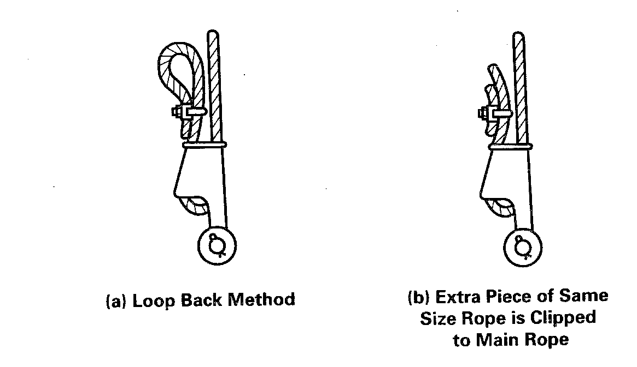
Wire rope for gross damage or distortion | Just look at the wire rope for broken strands. If it does not look right it probably is not. Consult with Safety personnel.
Windshield free of cracks and clean | You need to check only the cab where the operator controls the clean crane while lifting. The windshield must be free of cracks, clean and free of distortion.
Operators Manual onboard and in readable condition. | Look at the manual and make sure it is readable and that pages are in readable condition not torn off the book. If in bad condition reject the crane. The operator needs the book as a reference and it should be readable and in good condition.
Load charts onboard and in readable condition | These charts are normally placed on the operator's cab fixed to the walls. They are laminated or printed on metal. Again, they must be readable. If unreadable, reject the crane and DO NOT OPERATE.
Operating controls clearly marked regarding their function. | Each control must be clearly marked as to the type of action that will happen when moved. Each degree of movement must be clearly and understandably marked. You must make a subjective decision if the markings are not legible or scratched
* Equipment fire extinguisher on board and charged. | Look at the fire extinguisher in the cab and check the gauge. It MUST be in the green arc. If there is no fire extinguisher you have a decision to make.
Crane boom angle device operating and readable. | Look outside on the boom to see the boom angle indicator. When the crane arrives and the boom is horizontal it must read zero. When the boom is lifted it must show something other than zero. Some newer crane designs have a digital readout on the operator's panel. If the angle indicator is not working DO NOT OPERATE THE CRANE. DO NOT LIFT OUR PROPERTY.
Check rope reeving in drum. | As you walk behind the crane look up at the drum. The wire rope should be reeving smoothly and each lay of the wire rope should be spooling next to the previous one and in the grooves of the layers below. Any crossovers mean trouble. Reject the crane.
Hand signal placard on the outside of the crane cab | Self-explanatory. If the operator is not using the standard signals, the operator and signalman must get together and agree on the signals.
Visual indications of hydraulic leaks from hydraulic hoses, particularly those that flex in normal operation. | If you see a lot of hydraulic fluid chances are there is, a problem when the crane is loaded. Again, this is subjective on your part.

During Operation
Tire inflation | Make sure that all the tires look the same regarding inflation. Only take action if a tire is under-inflated and you are operating "on the rubber". If using outriggers do not be concerned about the tire inflation.
If on outriggers, check they are fully extended | Normally crane manufacturers mark the full extension of the outrigger. If the operator is on outriggers and you cannot see the indicator STOP the lift. The crane lifting capacity is predicated on outriggers fully extended. There are no tables made for operating at less than full extension.
If on outriggers, check that all tires are completely off the ground | If any tire is even barely touching the ground, the operator must use the "on the rubber" charts. Once the crane is lifted check that there is empty space between the tire and the ground.
Check that loads are not swung over personnel | Any operator who swings loads over people "IS NOT" a good operator. This is grounds for stopping the lift and getting someone else because this is an accident waiting to happen. A well trained and experienced operator WILL NEVER swing over people.

