FESHM 5032.2: LIQUID CRYOGENIC TARGETS

Revision History

Author | Description of Change | Revision Date
Mike Zuckerbrot | - Document storage procedures updated to include Teamcenter requirement.  - Master Target Safety Review Book and Target Safety Review Book requirements merged into single Target Safety Report.  - Clarified responsible review panel  - Minor edits. | June 2022
Jim Kilmer | - Milestone authorizations in TA Section IV. C changed to be in agreement with 5032.2 Section 4.3.  - Guideline Update Procedure in TA Section VII changed to show Liquid Hydrogen Safety Panel recommendation and Cryogenic Safety Subcommittee approval  - Added section 4.6 References | February 2016
Arkadiy Klebaner | Revision 1 – to incorporate comments from experts, proper links to the existing supporting documents and minor editorial changes.  - Changed reference from Research Division to Particle Physics Division  - Changed all references from Research Division Operating Manual chapter RD_ESH_010 to Technical Appendix to this Chapter (5032.2TA)  - Added 5032.2TA  - Changed Division/Section to Division/Section/Center  - Changed Laboratory Safety Committee to FESHCom | February 2011

TABLE OF CONTENTS

1.0 INTRODUCTION 2
2.0 DEFINITIONS 2
3.0 RESPONSIBILITIES 2
4.0 REQUIREMENTS 2
4.1 Design, Fabrication and Testing 2
4.2 Safety Analysis and Review 2
4.3 Authorizations and Permits 2
4.4 Operation 2
4.5 Target Safety Report 2
4.6 References 2
5.0 Technical Appendix for: 2
GUIDELINES FOR THE DESIGN, FABRICATION, TESTING, INSTALLATION AND OPERATION OF LH2 TARGETS 2

INTRODUCTION

Liquid cryogenic targets are frequently used in fixed target experiments and beamlines. Typically these targets are filled with hydrogen or deuterium. The hazards posed by these targets include the normal cryogenic hazards, pressure safety considerations, as well as the hazards associated with flammable gases. Targets are generally fragile vessels installed in the midst of experiment apparatus. Frequently, the experiment requirements are at odds with normal engineering practices, e.g. standard pressure vessel safety factors vs. the need for vessel walls as thin as possible. Therefore, special precautions are necessary to ensure safe operation. These precautions take the form of specialized methods for design, fabrication, testing, secondary containment, personnel access, and stringent requirements on material specification and quality control. These techniques have been developed over many years within the Particle Physics Division Mechanical Engineering Department. These techniques and technical requirements are specified in the technical appendix to this Chapter (5032.2TA). Though the technical appendix 5032TA is specific to liquid hydrogen targets, many of its considerations apply to targets for other liquids.

Procedures for controlling normal cryogenic hazards associated with cryogenic targets are given in Chapter 5032 of the Fermilab ES&H Manual. Chapter 5032, in concert with this chapter, serves to define all requirements for design, review, approval and operation of liquid cryogenic targets.

DEFINITIONS

Cryogenic - at a temperature below -150oC.

Cryogenic target – A vessel of any size holding a cryogenic liquid used in an experiment or beamline as a target.

Cryogenic personnel – Those engaged in or responsible for the production, use, transport or storage of cryogenic fluids and materials.

Review Panel – The Fire Safety Subcommittee, or panel designated by the Fire Safety Subcommittee

Safety Report – A written analysis demonstrating the target meets the requirements of 5032 and its technical appendix 5032.2TA.

RESPONSIBILITIES

The D/S/P responsible for the area of operation of the target is responsible for ensuring the requirements of this chapter are met. The D/S/P head shall arrange for the review of the target by the Fire Safety Subcommittee (or designated panel), hereafter referred to as the "Review Panel"). The head shall certify that the target complies with this chapter by a written memo authorizing the operation of the target.

The Review Panel is responsible for verifying that the target meets the engineering requirements specified in the technical appendix to this chapter (5032.2TA).

The department head responsible for the design of the target shall ensure that the safety report is maintained and filed for future reference.

The ES&H Section shall audit divisions/sections on their compliance with this chapter.

The Review Panel shall serve the division/section head and the ES&H Section in a consulting capacity in all matters related to cryogenic targets. These committees may recommend appropriate modifications to this chapter as necessary. Changes in this chapter may be recommended by the FESHCom after consultation with affected division/section heads.

REQUIREMENTS

Design, Fabrication and Testing

a. The requirements of FESHM chapter 5032.2TA shall be adhered to.

Safety Analysis and Review

a. A safety analysis and review in accordance with Chapter 5032 of the Fermilab ES&H Manual shall be performed on every cryogenic target system. Those responsible for the design, fabrication, testing, installation, and operation of the target system shall prepare the safety analysis in accordance with the technical appendix of Chapter 5032. The analysis shall be reviewed by the Review Panel, and conclusions reported to the appropriate division/section head.

b. The safety review of the cryogenic target shall be conducted using the procedure given in the technical appendix to Chapter 5032. The review will begin as early in the conceptual design stage as deemed appropriate by the designer of the target system and the Review Panel chair. The documentation specified in Chapter 5032TA, and detailed in Part 5 below, shall be provided to the Review Panel following a schedule which will permit a thoughtful and unhurried review. The target designers and the Review Panel should meet at a frequency which will facilitate the review process.

c. A Target Safety Report shall be maintained for each target system. This Report shall contain all required documents and any other documents considered appropriate by the Review Panel.

Authorizations and Permits

a. The safety review of the target system will result in several milestones at which the target designers will be given authorization to proceed. At least the following four milestones shall be present in the review process:

Milestone | Authorizing  Person | Authorizing Vehicle
Accept Design | Review Panel Chair | Teamcenter workflow review/approval of design drawing and/or documentation
Testing with cryogens in test facility | Department Head | Memo or email
Installation | Department Head | Memo or email
Operation | Division/Section Head | Memo or email or online ORC tool

Operation

a. Operating procedures shall be documented in the Target Safety Report. Operating procedures define all phases of cooldown, filling, warm-up and steady-state operations. Sub-atmospheric operation of a target must be specifically addressed in the procedures by a combination of administrative and engineered controls. All operating functions except transferring liquid from the target to the reservoir shall be done by qualified cryogenic personnel. The transfer of liquid to the target vessel or the reservoir may be performed by other suitably trained personnel (i.e. experimenters).

b. Emergency procedures for each target system will vary depending on the area in which the target is operated. Therefore, area specific procedures shall be written, reviewed and documented in the Target Safety Report. Operators of the target shall be provided with a call-in list of qualified personnel who are available at all times.

Target Safety Report

a. The Target Safety Report is the primary means of transmitting safety information about the target to the Review Panel. The Target Safety Report shall be provided to each member of the Review Panel. The target designer shall maintain the Target Safety Report which contains i) all required documentation and ii) all correspondence to/from the Review Panel, and iii) notes from meetings held when applicable. The Target Safety Report shall be uploaded, stored, and maintained within Teamcenter and shall be reviewed/approved and revision controlled using the Teamcenter workflow process.

b. The Target Safety Report shall contain all of the required documents of Chapter 5032TA, including the following:
1. Structural calculations on all parts of the target
2. Venting calculations for the target
3. Venting calculations for the vacuum space
4. Venting calculations for the secondary containment
5. Complete drawings of the target, vacuum system and secondary containment
6. Instrument and valve summary
7. Interlock list
8. Operating procedures
9. Emergency procedures
10. Operational call-in list
11. Material certification data on parts
12. FMEA, what-if analysis
13. Flow diagram
14. Testing results

References
- FESHM 6013 FIRUS. , section 4.10.1 as applicable for experiment gas detection.
- FESHM 6020.3: Storage and Use of Flammable Gases
- FESHM 4240: Oxygen Deficiency Hazards

Technical Appendix for:

GUIDELINES FOR THE DESIGN, FABRICATION, TESTING, INSTALLATION AND OPERATION OF LH2 TARGETS

Table of Contents

I. | Scope | 2
II. | Design, Fabrication and Testing | 2
 | A. Refrigeration System | 2
 | B. Reservoir Vessel | 2
 | C. Target Flask | 4
 | D. Vacuum System | 9
 | E. Thin Windows for Vacuum Vessels | 11
 | F. External Piping and Valves | 14
 | G. Secondary Hydrogen Containment System | 15
 | H. Target Support Stands | 17
III. | System Testing and Installation | 17
IV. | Safety Analysis and Review | 18
V. | Operation | 19
VI. | Documentation Requirements | 19
VII. | Guideline Update Procedure | 22
List of Appendices |  | 23

- SCOPE
These guidelines apply to the design, fabrication, testing, installation and operation of all liquid hydrogen and deuterium targets at Fermilab regardless of capacity, site of installation, duration of use, origin of manufacture, or previous use at Fermilab or other experimental facility. These guidelines are not intended to cover in detail all possible target configurations or installations, but rather to provide minimum requirements and recommendations which experience and analysis have shown helpful in ensuring the safety of hydrogen target systems. Portions of these guidelines may also be recommended as good practice for inert gas/liquid target systems.
To aid in understanding the terminology and equipment associated with these systems, a typical flow schematic is shown in Appendix I. Although most target systems are unique, the general components which are used are usually quite similar.

- DESIGN, FABRICATION AND TESTING II.A. Refrigeration System II.A.1. Refrigeration System Design

II.A.l.a. General Requirements
All liquid hydrogen targets must be refrigerated. The use of batch filling is prohibited due to the inherent danger of handling the large amounts of liquid hydrogen associated with this practice. Most target systems are refrigerated with a Gifford-McMahon refrigerator. However, some systems may require direct heat exchange with liquid helium, other cryogens, or a larger refrigerator to operate properly.

II.B. Reservoir Vessel

II.B.1. Reservoir Vessel Design

II.B.l.a. General Requirements
The refrigerator reservoir vessel shall have a capacity equal to the total volume of the target flask and piping plus an excess volume. The excess volume is required to prevent liquid from contacting the refrigerator condensing plate while operating in the target (flask) empty mode. Many previous target systems utilizing reservoirs have had reservoir vessels with a six-inch diameter. In this case, the excess volume is approximately one liter providing a two-inch clearance between the liquid and the plate. For other reservoir diameters, the excess volume must also provide a minimum two-inch clearance between the liquid and the plate. The piping volume shall include all vent and fill pipes from the base of the reservoir to the bottom of the target flask.

II.B.1.b. Materials

II.B.1.b.(i) Recommended Materials
The recommended materials from which the reservoir vessel shall be made are the 300 series (austenitic) stainless steels. The vessel may be manufactured from raw material or an existing container (e.g., laboratory beaker) may be modified to form the vessel.

II.B.l.b.(ii) Quality Control
The raw material used for vessel manufacture shall meet the quality control requirements for metals given in II.C.I.b.(ii). Existing containers shall be shown to be fabricated from 300 series stainless steel.

II.B.l.c. Stress Analysis

II.B.1.c. (i) General Requirements
A stress analysis of the reservoir vessel shall be performed which considers the stresses produced by pressure, dead weight, cool down, and any other system of thermal or mechanical loads to which the reservoir may be subjected. All calculations shall be included in the Target Safety Report. The maximum allowable working pressure for the design of the reservoir shall be greater than or equal to the working pressure of the target flask it is to be operated with.

II.B.1.c.(ii) Procedures
The procedures of the ASME Boiler and Pressure Vessel Code, Section VIII, Div. 1 (hereafter called the Code) shall be followed where possible in the stress analysis of the reservoir vessel. Where the Code does not provide sufficient guidance, good engineering judgment shall be used to establish a safe analytical approach for stress analysis.

II.B.1.c. (iii) Allowable Stresses
Allowable stresses shall be 80% of those specified in the Code for recommended materials at room temperature.

II.B.2. Reservoir Vessel Fabrication

II.B.2.a. General Requirements
Fabrication shall be according to the procedures and details specified in the Code, wherever practical. Alternate fabrication techniques, shown to produce a vessel which performs predictably under operating and emergency conditions, may also be used. These alternate techniques should include exercising the requirements of II.B.3.d.

II.B.3. Reservoir Vessel Testing

II.B.3.a. General Requirements
Testing shall be performed on the reservoir vessel to verify the integrity of the vessel under all anticipated operating and emergency load conditions and complete records of all testing shall be maintained in the target logbook.

ILB.3.b. Leak Testing
The reservoir shall be leak tested with a helium leak detector and no leaks shall be detected on a scale with a minimum sensitivity of 10⁻⁹ atm-cc/sec. Leak testing is done after all fittings and feedthroughs are welded and soldered in place.

II.B.3.c. Non-Destructive Pressure Testing
All reservoir vessels shall be pressure tested according to the procedures of UG-100 of the Code.

II.B.3.d. Strength Testing
Reservoir vessels which can be designed in close agreement with the procedures of 1I.B.l.c. need not have additional strength testing. Other vessels whose design, stress analysis or fabrication deviates from these procedures, including those vessels whose fabrication involves cold working which might significantly alter the properties, residual stresses, or load carrying characteristics of the reservoir vessel, shall be subjected to additional testing. Vessels having a diameter of six inches or less shall be hydrostatically tested according to UG-99 of the Code except that the test pressure shall be equal to at least five times the relief pressure of the reservoir vessel. Vessels with diameters exceeding six inches shall undergo a burst test according to the requirements of UG-101 of the Code.

II.C. Target Flask

II.C.1. General Requirements
Target flasks which will be filled with liquid deuterium rather than liquid hydrogen must take account of the extra weight in the design procedure. Because of concerns about mylar material degradation, all new experiments will begin runs with new target flasks. Experiments spanning multiple runs must have its Mylar flask material tested to assure its integrity. A square yard of Mylar from the roll from which the target was fabricated from will be saved in a secure area. Every six months during a long run, samples of this material will be tested as a measure of the possible degradation of the material in the target. If evidence of degradation of material is seen, then the evidence is brought to the attention of the Review Panel.

II.C.1.a.(i) Maximum Pressure Differential
The target flask shall be designed for a maximum allowable working pressure of at least 25 psid.

II.C.1.a.(ii) Liquid Hydrogen Capacity
The target flask shall not be limited in minimum or maximum liquid hydrogen capacity.

II.C.1.b. Materials

II.C.1.b.(i) Recommended Materials
The materials recommended for target flasks are polyester film (Mylar), polyimide film (Kapton), 300 series stainless steel, aluminum and copper. There is extensive experience in the application of these materials to hydrogen targets. Other materials may be used provided that adequate cryogenic behavior is documented, fabrication methods are in accordance with good engineering practice, and the completed flask satisfies the requirements of this section and II.C.3.

II.C.1.b.(ii) Quality Control
The material from which the flask is constructed shall be verified as follows:

Plastic Film: On receipt of every new roll and prior to each new run, a sample from the beginning of each bulk roll of material from the manufacturer shall be tested for yield strength according to the test methods given in Appendix II to assure that the minimum manufacturers specification is met. The rolls shall be labeled with the date of purchase and the yield strength. They shall be stored with orderly inventory control in a dark room to avoid deterioration by ultraviolet radiation.

Metals: A manufacturer's material certification sheet showing the composition, yield strength and ultimate strength of the material shall be obtained and a copy shall be included in the Target Safety Report.

Other Materials: For other materials a quality control procedure will be written and approved as is done for plastic film. The primary objective is to verify that the material possesses known properties, and that the target was actually manufactured from material for which documented properties exist.

II.C.1.b.(iii) Radiation Damage Limits
Mylar may be used in any target which will be exposed to less than 10⁸ rads of absorbed energy. Kapton may be used for any radiation exposure of a target less than 10⁹ rads. All targets that will be exposed to radiation greater than 10⁹ rads must be fabricated from a metal consistent with II.C.l.b.(i).

II.C.1.c. Stress Analysis

II.C.1.c.(i) General Requirements
A stress analysis of the flask shall be performed which considers the stresses produced by pressure, dead weight, cooldown, and any other system of thermal or mechanical loads to which the flask may be subjected. All such calculations shall be documented and included in the Target Safety Report.

II.C.1.c.(ii) Procedures
The design procedures of the Code shall be followed wherever possible in the stress analysis of the target flask. Where this Code does not provide sufficient guidance, good engineering judgment shall be used to establish a safe analytical approach for determination of the stress.

II.C.1.c.(iii) Allowable Stresses
The maximum allowable stress in tension in the target flask material at the MAWP of II.C.l. and in combination with other operational loads shall be less than the limits specified below:

Plastic Films: (2/3)Sy, where Sy is the yield strength at 5% permanent offset for plastic film at room temperature.

Metals: (2/3)Sy or (1/4)Su, whichever is smaller, where Sy is the minimum specified yield
strength of the material at room temperature, and Su is the minimum specified ultimate strength of the material at room temperature.

Other Materials: As for metals, except that if the material has known sensitivity to other failure modes such as brittle fracture at low temperatures, good engineering judgment shall be used to ensure that a minimum safety factor of at least 4 is maintained with respect to these modes.

II.C.2. Target Flask Fabrication

II.C.2.a. General Requirements
A logbook shall be maintained during flask construction noting the material used, and the drawings from which the flask is fabricated. The log shall also contain detailed accounts of the steps of fabrication, noting material dimensions, condition, and other characteristics of material and workmanship as might be relevant in assuring the integrity of the flask.

II.C.2.b. Plastic Flasks

II.C.2.b.(i) Joint Tolerance
All adhesive joints are to be designed as slip fits (approximately 0.001 inches) to minimize the thickness of the epoxy bond. Experience has shown that bonds thicker than 0.003 in. are prone to fracture at cryogenic temperatures.

II.C.2.b.(ii) Joint Design
All joints are to be designed such that the force on the mating members place the epoxy bond under pure shear when the flask is pressurized. The following table specifies the overlap of material required for the bonding of longitudinal seams in cylindrical shells and the attachment of dished heads to cylindrical shells to ensure that the adhesive bond can develop the full strength of the parent material:

Flask Diameter Overlap
(inches) (inches)
up to 1 0.250
1.0-2.0 0.375
2.0-3.0 0.500
3.0-4.0 0.625
4.0-8.0 0.750

These joint dimensions are the same for any Mylar film thickness.

II.C.2.b.(iii) Joint Preparation
All mating surfaces must be sandblasted using aluminum oxide powder. The SS White Industrial Co. sandblaster with No. 3, 50-micron aluminum oxide powder, is recommended. After sandblasting and just prior to bonding, the surfaces are to be cleaned with reagent grade acetone. Care must be taken to keep the surfaces as clean as possible prior to bonding.

II.C.2.b.(iv) Recommended Adhesives
The recommended resins are Shell Epon 828 or 815, and the recommended curing agents are Epon V40 or V25. The resin and curing agent are mixed in a 1/1 ratio by weight. By using different combinations of resin and curing agent it is possible to achieve the proper viscosity for the various joints made in flask fabrication. The epoxy and curing agent must be within the manufacturer’s dated shelf life. Care must be taken to thoroughly mix the epoxy before applying. After the joint is made and before curing, any excess epoxy is removed from the joint.

II.C.2.b.(v) Curing
All epoxy joints must be allowed to cure undisturbed for 16 hours at room temperature and then placed in an oven for 4 hours at 150 deg. F.

II.C.2.b.(vi) Artificial Seams
All flasks will distort upon cooldown, but for flasks greater than one foot in length the distortion may be excessive. It has been found that the bonding of a Mylar strip of a width equal to the actual seam and on the opposite side of the flask body from the actual seam will produce an artificial seam with a compensating contraction which removes thermal distortion on cooldown.

II.C.2.b.(vii) Dished Heads
It is recommended that the dished heads of the flask meet the requirements of UG-32 of the Code. The recommended fabrication procedure is detailed in Appendix III. Geometries other than those permitted by the Code may be used subject to verification by analysis and testing as provided by these guidelines.

II.C.2.b.(viii) Joint Inspection
All epoxy joints are to be inspected after fabrication. Joints having voids, excess thickness of epoxy, or insufficient overlap are to be discarded and redone.

II.C.2.c. Metal Flask

II.C.2.c.(i) Joint Design
It is usually not possible to make welded butt-type joints in metal flasks because the shells and heads must be very thin. Therefore, soldering of lap joints with a 60/40 solder and MA stainless steel flux from Lake Chemical Co., Chicago, IL; is the recommended method of fabrication. After soldering, all joints should be washed with 10% solution of ammonium
hydroxide in water.
The following table specifies the required material overlaps for soldered joints:
Flask Diameter Overlap
(inches) (inches)
up to 2.0 in. 0.25
2.0 in. and larger 0.50

Joint thickness must be less than .010 inch on the solder. Any excess solder is to be removed during the soldering operation.

The Joint Efficiency used in calculating the flask stresses may be assumed equal to one with appropriate testing to support this assumption. A minimum of five samples must be shown to consistently fail at a stress greater than the material strength (allowable strength times the appropriate safety factor, see paragraph II.C.l.c.(iii)) assumed in the flask stress calculations. Testing of the metal samples with soldered lap joints shall be performed in the same manner as outlined for plastic samples with epoxy joints in Appendix II.

II.C.2.c.(ii) Dished Heads
Dished heads for metal flasks shall be in accordance with II.C.2.b.(vii).

II.C.2.d. Thermal Standoff and Alignment
The target flask must be held stationary and in proper alignment to function adequately as an experimental target. The mounting device must provide for adjusting position of the flask as well as thermally isolating it from the vacuum container. A G-10 triangle and ring assembly, detailed in Appendix IV, has been used successfully on many targets and is recommended for this purpose.

II.C.2.e. Provision for Thermal Contraction
It is necessary to allow for the thermal contraction between the supply and return hydrogen piping and the stationary flask. It is recommended that a bellows of 300 series stainless steel with a pressure rating of at least 75 psig be placed between the flask pipes and the refrigerator piping to accommodate relative contraction.

II.C.2.f. Installation of Resistor Temperature Sensors
There are two ways to install resistors depending on the material used in the flask body support. When a Vespel flask support is used, holes 0.002 in. larger than the resistor wire are drilled in the Vespel. The resistor wire is then coated with epoxy (specified in II.C.2.(iv)) and slipped through the hole and cured. When a stainless-steel flask support is used, a suitable double pin Kovar and glass cryogenic single feedthrough must be used to place the resistor inside the flask. These connectors are soldered into the flask support using 60/40 solder and MA stainless steel flux.

II.C.2.g. Multi-Layer Insulation
All flask and piping is to be insulated with at least 10 layers of 0.00025 in. thick aluminized Mylar, applied one layer at a time. Care must be taken to cover all surfaces to minimize heat leak. It is recognized that some physics applications preclude the use of aluminized Mylar on the flask. In these cases, plain Mylar has been shown to be of some benefit in reducing the radiation heat load. However, the heat load on the system is considerably higher than when aluminized Mylar is used, and the refrigeration system must be sized accordingly.

II.C.2.h. Piping and Transitions
Care must be taken when making transitions between stainless steel piping and plastic piping, such as nylon, phenolic, or G-10 due to the difference in thermal contraction which can cause the fracture of bonded joints. It is recommended that a transition piece be made from Vespel which bonds to the outside of both components. This joint is sandblasted and bonded with the epoxy specified in II.C.2.b.(iv) and cured as specified in II.C.2.b.(v). Other pipe joining techniques may be used if their adequacy can be demonstrated through testing. An example is shown in Appendix VIII.

II.C.3. Testing
II.C.3.a. General Requirements II.C.3.b. Standalone Testing

II.C.3.b.(i) Cold Pressure Tests
Plastic Flasks: A duplicate of the target flask shall be burst at approximately 80 K to verify that the burst pressure is greater than 40 psid.
Metal Flasks: If the flask has been designed to a maximum allowable working pressure (MAWP) according to the rules of the Code, and if there is agreement among the designers and Target Safety Review Panel on the analysis details not directly covered by the Code, then the flask shall be tested at 1.5 times the MAWP at approximately 80 K. If there is disagreement or uncertainty concerning details of the design, then a duplicate of the flask shall be proof tested in accordance with UG- l01 of the Code.

II.C.3.b.(ii) Tests at Room Temperature
The target flask shall be pressure tested in accordance with UG-100 of the Code.

II.C.4. Pressure Relief Devices

II.C.4.a. General Requirements
Each liquid hydrogen target flask must be protected by a safety relief valve. Two valves, one on the fill tube and one on the vent tube are recommended. The primary relief device should be connected to the vent line. Each flask not connected by common piping must have a relief system. If possible, a venting device should be installed to prevent use of the primary relief device for standard venting purposes.

II.C.4.a.(i) Relief Pressure
Hydrogen targets with plastic flasks must be relieved at 10 psig (25 psid). Metal flasks shall be relieved in accordance with the relief requirements of UG-125 of the Code.

II.C.4.a.(ii) ASME Code Stamped Relief Valves
It is recommended that relief valves "UV" stamped to show compliance with Code requirements be used wherever possible. It is recognized that Code stamped valves are not available for relief pressures less than 15 psig.

II.C.4.a.(iii) Relief Valve Sizing
Relief valves shall be sized for the maximum heat flux produced by air condensation on the bare (i.e., non-multilayer insulated) target flask at atmospheric pressure. Calculations demonstrating the adequacy of the relief valve system shall take into account the pressure drop of the connecting tubing and entrance/exit losses. The calculations shall be clearly documented and included in the Target Safety Report. All relief valves used on the target flask must be bench tested before installation to determine the opening pressure. All valves for which there is no manufacturer's flow data shall also be flow tested to obtain a curve of pressure drop vs. flowrate. All valves shall be tested for back flow for the condition when the valve inlet is at a vacuum. All valve test results shall be recorded in the logbook for the target system and in the Target Safety Report.

II.C.4.a.(iv) Relief Valve Installation
Relief valves which vent into a secondary containment system shall exhaust above electrical equipment and instrumentation located in the secondary containment system. Any piping attached to the outlet of a relief device to meet this requirement must be considered when sizing the relief device.

II.D. Vacuum System

II.D.1. Vacuum System Design

II.D.1.a. General Requirements
The volume of the insulating vacuum space available for the release of hydrogen shall be at least 52 times the volume of the hydrogen liquid contained in the target flask. Hydrogen expands 52 times as liquid is vaporized to cold gas at atmospheric pressure. Sizing the vacuum space in this manner limits the maximum vapor evolution rate to be vented in a target flask failure. Where this is not possible, a detailed failure analysis of the "what if" type must be performed to demonstrate that liquid hydrogen released into the vacuum space will be vented in a safe and controlled way. In addition, the heat flux to the liquid hydrogen shall be in accordance with II.D.3.a for the purposes of calculating the vapor evolution rate. Nevertheless, failure of the vacuum system to contain the hydrogen must be assumed, and safety demonstrated by means of the emergency hydrogen containment system.
The vacuum container of the target flask should have a vacuum common with that of the hydrogen condensing pot for purposes of simplicity, heat leak, and vacuum volume/flask volume ratio.

II.D.1.b. Materials

II.D.1.b.(i) Recommended Materials
The materials recommended for vacuum containers are 300 series Stainless Steel or aluminum alloy 6061-T6 for those experiments which allow metals, and Rohacell foam for those which cannot. Experience has shown that these materials can safely accommodate the various geometries and installation details found in the vast majority of target systems.

II.D.1.b.(ii) Quality Control
The material from which the vacuum container is constructed shall be verified according to II.C.I.b.

II.D.1.c. Stress and Stability Analysis

II.D.I.c.(i) General Requirements
A stress analysis of the vacuum container shall be performed which considers the stresses produced by pressure, dead weight, and any other system of thermal or mechanical loads to which it may be subjected. All such calculations shall be clearly documented and included in the Target Safety Report. The MAWP of the vacuum vessel shall be at least 15 psig internal.

II.D.1.c.(ii) Procedures
It is recommended that the design procedures of the Code be followed wherever possible in the stress analysis of the vacuum container. For geometries where elastic collapse is a possible failure mode, and Code designs do not apply, non-Code designs may be used if it is experimentally demonstrated that the collapse pressure is at least 25 psid. In the case of foam vacuum shells, experimental verification of collapse is required due to the absence of Code guidelines for such materials.

II.D.1.c.(iii) Allowable Stresses
Rohacell: Due to the variation of strength with the direction of loading, and the tendency for foam plastics to exhibit little elongation prior to failure, the allowable stress shall be taken as 0.25 times the appropriate ultimate stress as given by the manufacturer. For example, if the critical calculated stress is a bending stress, then the allowable stress is 0.25 times the flexural strength of the Rohacell. If the critical stress is a compressive membrane stress, the allowable stress is 0.25 times the compressive strength of the Rohacell, etc.

Metals: The allowable stresses for metals shall be those given in II.C.1.c.(iii) for metal flasks.

II.D.2. Vacuum System Fabrication
Fabrication shall be according to the procedures and details specified in the Code, wherever possible. Alternate fabrication techniques, shown to produce a vessel which performs predictably under operating and emergency conditions, may also be used.
Foam vacuum vessels are fabricated from several pieces of Rohacell foam laminated with epoxy and machined to final shape. Complete construction details are given in Appendix V.

II.D.3. Pressure Relief Devices

II.D.3.a. General Requirements
Every vacuum vessel for a hydrogen target must be fitted with a pressure relief device capable of limiting the internal pressure in the vacuum vessel to less than 15 psig following a flask rupture and subsequent deposition of the flask contents into the vacuum space. Two relief devices are recommended for each vacuum system as good practice. One device shall be located on the vacuum space housing the target. The other one may be on the refrigerator vacuum can. For the purposes of calculation of vapor evolution rates, the heat flux to the liquid hydrogen shall be taken as 20W/cm². For other fluids the vapor evolution rate is calculated by using the film boiling heat flux for the fluid with a temperature difference from room temperature to the fluid normal boiling point temperature. Calculations shall take into account pressure losses from all connecting piping and entrance/exit losses. Calculations shall be clearly documented and included in the Target Safety Report.

II.D.3.b. Recommended Pressure Relief Devices
The recommended relieving device is a parallel plate relief assembly as detailed in Appendix VI. Commercial rupture disks or relief valves are also permitted, or any combination of the above.

II.D.4 Vacuum System Testing

II.D.4.a. Internal Pressure Testing
The vacuum vessel shall be pressure tested with nitrogen gas in accordance with UG-100 of the Code. All windows shall be in place, but relief devices may be blanked off.

II.D.4.b. External Pressure Testing
An external pressure test shall be performed on all foam plastic vacuum vessels. The vessel shall be placed in a sealed container, and a vacuum is drawn on the vessel. The pressure of the sealed container is then raised to 10 psig, resulting in an external pressure differential of 25 psid.

II.D.4.c. Leak Testing

II.D.4.c.(i) Pressurize and Decay
The vacuum vessel shall be pressurized to an internal pressure of 22.5 psig, allowed to equalize for several minutes, then isolated from the source of pressure. The pressure must remain constant over a 1/2 hr period as measured by a calibrated test gauge attached to the vessel. This ensures that there are no leaks under the positive pressures associated with fault conditions, and that the windows do not visibly creep under load. The test gauge used shall be a 1% accurate gauge capable of reading in 0.1 psi increments.

II.D.4.c.(ii) Mass Spectrometer Leak Testing
Following the above test, the vacuum container is leak tested in accordance with II.B.3.b. Care must be taken not to confuse permeation through the Mylar window (a normal phenomenon) with an actual leak.

II.D.5. Instrumentation for Vacuum Readout

II.D.5.a. General Requirements
Vacuum sensors must be provided on the target vacuum container. The sensor must not be an ignition source. Capacitance type sensors have been used in several target systems. Other sensor types may be used and include those subject to certain requirements mentioned below.

II.D.5.b. TC Gauges
TC gauges may be used on the roughing pump or the forepump if solenoid valves on the vacuum container isolate these gauges should the vacuum in the target vacuum space get above 50 microns Hg. Although a margin of safety can be demonstrated for TC gauges (report by C.T. Murphy, et al., June 16, 1987) they will not be attached to the vacuum container.

II.D.5.c. Discharge Gauges
A discharge gauge is needed for diagnostics purposes since a typical capacitance manometer does not read below 10⁻³ mm Hg with a pressure rating comparable to the vacuum system MAWP. A discharge gauge can be used on the target vacuum system provided all items below are satisfied:

- It is on the diffusion pump side of the vacuum gate valve and the valve is interlocked to close at 50 microns.

- The AC power to the discharge gauge is interlocked to trip off at a vacuum greater than 50 microns.

- The discharge gauge is operated only during the presence of a qualified hydrogen target operator.

II.E. Thin Windows for Vacuum Vessels II.E.1. Thin Window Design
II.E.1.a. Materials

II.E.1.a.(i) Recommended Materials
The material recommended for thin windows is polyester film (Mylar). Extensive experience exists in the use of this film, and experimental studies of burst properties have demonstrated good ductility and consistency of burst pressure for a given thickness and diameter of window. Stainless steel, titanium, and other materials may be used provided the requirements of II.E.1.b.(i) and II.E.3.a. are met.

II.E.1.a.(ii) Quality Control
The material from which the windows are constructed shall be verified according to II.C.I.b.(ii) of this standard.

II.E.l.b. Thickness

II.E.I.b.(i) Circular Windows
Mylar: The thickness of circular windows shall be no less than that calculated using:
t = thickness of window, in.
a = diameter of window measured at O-ring on flange, in.
S = yield strength of window material at 5% permanent deformation, psi.
E = Young's modulus of window material, psi.

This thickness will give a working stress in the center of the window of 0.667S psi. at 15 psid.

Metals: The thickness of thin metal circular windows, with fixed and held edge conditions, shall be no less than that calculated using:

t = thickness of window, in.
q = actual pressure applied to window = 15 psid
a = radius of window measured at flange edge radius, in.
υ = Poisson's ratio
E = Modulus of Elasticity, psi
y = deflection of window at center, in.

The above formula is to be used when the maximum deflection, y, exceeds one half the window thickness, t. Solve the formula for y and then obtain the stresses, σ, from the equation below. The edge and center window stresses are required to be less than or equal to the allowable strength of the material. The allowable strength is to be taken as the smaller of 0.667 (yield strength) or 0.40 (ultimate strength).
For windows which are determined to have edge conditions other than fixed and held, the appropriate constants from Roark and Young for flat, circular plates with diaphragm stresses are to be used in the above formulas when the maximum deflection, y, exceeds one half the window thickness, t. See Chapter 10, Article 10.11 of the sixth edition. The allowable strength is to be taken as the smaller of 0.667 (yield strength) or 0.40 (ultimate strength).

Exception to the determination of the allowable strength is to be taken in cases where the window material is highly brittle. In these cases the allowable strength is to be decreased to compensate for the brittleness. Note that the ductility of the material is to be considered at cryogenic temperatures as well as at room temperature. See also II.E.3.a. of this standard.

Other materials: The above formulas may be used to calculate an initial thickness for other materials, with the substitution of the yield strength into the formula. However, final design shall be based upon burst testing consistent with II.E.3.a.

II.E.I.b.(ii) Rectangular Windows
Mylar: The thickness of rectangular windows shall be no less than that calculated using:
t = thickness of window, in.
K = constant based on ratio a/b. See table below.
S = yield strength of window material at 5% permanent deformation, psi
E = Young's modulus of window material, psi.
a = short side of rectangular window, measured at o-ring.
b = long side of rectangular window, measured at o-ring.

This thickness will give a working stress in the center of the window of 0.667S psi at 15 psig.

Values of K for Rectangular Windows
b/a | K
1.0 | 0.143
1.1 | 0.162
1.2 | 0.169
1.3 | 0.178
1.4 | 0.183
1.5 | 0.189
1.6 | 0.191
1.7 | 0.195
1.8 | 0.196
1.9 | 0.198
2.0 | 0.198
3.0 | 0.203
>3.0 | 0.203
Adapted from Brookhaven National Laboratory Occupational Health and Safety Guide, Section 1.4.2, "Glass and Plastic Window Design for Pressure Vessels" .
Other materials: The formula may be used to calculate an initial thickness for other materials, with the substitution of the yield strength into the formula. However, final design shall be based upon burst testing consistent with II.E.3.

II.E.1.c. Multi-Layer Mylar Windows
Mylar windows with a thickness greater than 0.010 in. shall have that thickness built up from multiple layers of Mylar, with no single layer more than 0.010 in. thick. The overall thickness shall be no less than that calculated by the formulas of II.E.1.b.

II.E.2. Thin Window Fabrication

II.E.2.a. Mounting
The mounting flange shall be made of aluminum alloy 6061-T6 with a thickness of not less than 3/8 in. for windows <3.5 inches in diameter and 1/2 in. for windows >3.5 inches in diameter for both the fixed and loose portions of the flange. The radius on the flange with which the window comes in contact shall be 1/8 in. (Flange detail shown in Appendix VII.) Mounting bolts shall be 1/4-20 SS304 stainless steel spaced not more than 1.0 in. between centers.

II.E.2.b. Multi-Layer Mylar Windows
Multi-layer Mylar windows shall have the multiple layers bonded together along the edges only, with the bonded portion not extending beyond the radius portion of the window flange. Joints shall be fabricated as described in II.C.2.b.

II.E.2.c.
Joints for edge-bonded windows are critical and must be inspected for any voids, excessive thickness, or bonding beyond the edge area. Any of these will be cause for rejection of the window.

II.E.3. Thin Window Testing

II.E.3.a. General Requirements
Windows constructed of Mylar need to be tested as a part of the general vacuum system pressure testing of II.D.4. It is required that they sustain 22.5 psid without rupture or measurable creep. Also, five samples must be burst tested to demonstrate a burst pressure of at least 37.5 psid for all samples.
Windows constructed of metals with known properties must have at least five samples burst tested to demonstrate a burst pressure of at least 37.5 psid for all samples. Additional testing at cryogenic temperatures is encouraged for highly brittle materials. These windows are also tested as a part of the general vacuum system pressure testing and are required to sustain 22.5 psid.
Windows constructed of other materials must have at least five samples burst tested to demonstrate a burst pressure of at least 75 psid for all samples. These windows are also tested as a part of the general vacuum system pressure testing and are required to sustain 22.5 psid.
For all materials, the windows are discarded following their testing and new windows installed.

II.F. External Piping and Valves

II.F.1. Definition
External piping and valves are defined as all piping outside the target vacuum vessel, including vacuum lines, helium lines, hydrogen lines, and vent lines.

II.F.2. General Requirements

II.F.2.a. Hydrogen System
All hydrogen lines must be metal. The hydrogen supply cylinder shall be placed outdoors or, if indoors, in another suitable flammable gas storage area. A suitably sized excess flow valve must be installed in the hydrogen line before the line enters the building or leaves the flammable gas storage area. High pressure cylinders must have a regulator at the cylinder. The hydrogen supply line must have a relief valve sized to protect the target and purifier system at or below the maximum allowable working pressure of the purifier. The relief valve must be sized for the maximum flow rate the regulator is capable of delivering. The hydrogen piping system shall be pneumatically tested for leaks at approximately 0.9 times the relief pressure before operating the system. Any piping or system components with relief settings above 150 psig shall be tested at 1.25 times the relief pressure per Chapter 5034 of the Fermilab ES&H Manual. A leak test using suitable means shall also be performed prior to operating the system. Test results shall be documented in the Target Logbook.
Vent piping must be made from non-flammable materials. Sizing for the vent piping is determined by calculating the pressure drop in the vent from the maximum available flow from the target. Any instrument measuring flow in the vent piping must be explosion proof, or intrinsically safe as defined in Article 500 of the National Electric Code. Exterior vents must be protected from intrusion by rain, snow, animals, etc., by suitable means.

II.F.2.b. Helium System
Helium supply and return lines between the refrigerator and the compressor must be metal. The lines must have a maximum working pressure consistent with the discharge pressure of the compressor. For target refrigerators whose helium is supplied from a shared compressor, such as a beamline Mycom, the high-pressure supply line must have a remotely actuated shutoff valve controlled only by the target control system. The high- or low-pressure lines may have regulators or control valves as required for proper operation of the target refrigerators.
The high-pressure supply line must be relieved at the maximum allowable working pressure of the refrigerator in all cases where the compressor discharge pressure may run higher than this. The relief valve capacity must be large enough to protect the refrigerator from a failure which delivers the full compressor flow to the refrigerator. Any piping with relief settings above 150 psig shall be tested at 1.25 times the relief pressure per Chapter 5034 of the Fermilab ES&H Manual.
For systems where it is anticipated that maintenance work will be done on the refrigerator while the compressor discharge is still at high pressure the high-pressure line must include a system of double block and bleed valves to isolate the refrigerator during the maintenance. One block valve may be the remotely actuated valve and one must be a manual valve. A pump and purge valve must also be supplied to repurge the refrigerator after maintenance.

II.F.2.c. Vacuum System
Vacuum hoses from the pump cart to the target must be metal. The internal MAWP of vacuum hoses may be no less than 40 psig.

II.G. Secondary Hydrogen Containment System

II.G.1. Secondary Hydrogen Containment System Design

II.G.1.a. General Requirements
The secondary hydrogen containment system is any enclosure or enclosures which contains and controls the release of hydrogen gas from the hydrogen target system in the event of a rupture of the vacuum container windows or vacuum container rupture relief system.
As the "last line of defense" of a target installation, the secondary containment provides the protection for the Mylar vacuum windows as well as a final hydrogen venting path. During target operations, no one will be allowed into the secondary containment area with the only exception being that a qualified hydrogen target operator may be allowed to enter to carry out a specific task provided the task is documented by a written procedure and the procedure is approved in advance by the Target Review Panel.

II.G.1.b. Electrical Equipment
Electrical equipment inside the secondary containment enclosure must be one of the following:

1. Meet requirements of Class I, Div. 2, Group B of the National Electrical Code.
- Bagged and purged with inert gas.
- Intrinsically safe in a hydrogen atmosphere as defined in Article 500 of the National Electrical Code.

II.G.1.c. Flexible Tenting

II.G.1.c.(i) Recommended Materials
It is recommended that for those systems where flexible tenting is used as a part of the containment system that the tent be constructed of Staph-CHEK, a reinforced PVC cloth manufactured by the Herculite Company, or other flame-resistant material. Also, for search and secure requirements, clear 1/4 inch Lexan Standard 9034 Sheet manufactured by General Electric is recommended.

II.G.1.c.(ii) Quality Control
The tent material shall be visually inspected for flaws.

II.G.1.c.(iii) Seams
Simple overlap seams 1.5 in. wide, bonded with PVC pipe adhesive are acceptable when assembling a tent from Staph-CHEK material. Double overlapped seams which are stapled are also acceptable. Seams in tenting material shall in any case be as strong as the material itself; i.e., the seam shall fail by tearing of material adjacent to the seam, and not a separation of the seam itself. Under no circumstances may a seam be sealed with a flammable material such as duct tape.

II.G.1.d. Windows

II.G.1.d.(i) General Requirements
It is recommended that secondary containment systems made of flexible material be constructed without beam windows if possible. Such windows are subject to both the internal pressure produced by hydrogen release and the pressure fluctuations resulting from failure of a vacuum vessel window, and in both cases, it is very difficult to analytically predict the probability of window survival. In those cases where windows are necessary for reasons such as beam intensity or experimental needs, they shall be shown to survive the maximum possible tent pressure, as well as any effect associated with the rupture of vacuum windows.

II.G.1.d.(ii) Search and Secure Requirements
Search and secures of radiation areas are required in order to interlock them. Because hydrogen targets and their secondary systems are located within radiation areas, it is required that secondary containment systems which are sized for personnel access must be searched before interlocking the area is completed.

In order to accommodate this requirement, clear Lexan Panels shall be installed on these secondary containment systems. These panels are to be located and sized to provide adequate viewing of the secondary containment system interior for the search and secure teams. It is preferred that such panels are located on a side of the secondary containment system other than the upstream or downstream side, relative to the beam direction. It is recommended that the material used for this purpose be clear Polycarbonate Sheet (Lexan Standard 9034 Sheet, manufactured by General Electric) at a thickness of 1/4 inch, or a similar material which meets or exceeds the strength and fire resistance properties of the above described polycarbonate. All panel edges shall be mechanically secured to the tent frame. Additional cross members are to support the panels as required for expected pressure differentials across the walls of the tent constructed with Lexan. Scenarios to consider include when a target vents due to a flask failure and when the secondary containment venting unit operates.

II.G.2. Venting of the Containment Volume

II.G.2.a. General Requirements
The purpose of the vent is to contain hydrogen in the event of failure of the flask and vacuum vessel, so that it can be released in a safe area. Many different venting systems can be used depending on the area in which the target is installed and the secondary containment used. The vent must be of a fire retardant material and cannot contain ignition sources. In case of flask rupture venting of the hydrogen to a safe area outside the building is the preferred method; however, if it can be shown that the flask volume is small relative to the building size, then the hydrogen may be safely released into the building, subject to committee approval.

If a blower is used in the venting system, its motor shall be external to the vent ducting flow path. Verification of the blower flow has been successfully determined with the use of a pitot tube installed in the vent ducting in previous liquid hydrogen target systems.

II.G.2.b. H2 Detection System
In cases where standard venting of the target contents causes a release of hydrogen or deuterium into the secondary containment, a flammable gas detector should be installed. The detector should be placed above all hydrogen circuit relief and vent valves and should trigger the secondary containment venting unit to operate. A sounding device, outside of and in the immediate vicinity of the secondary containment, shall also be triggered in the case that hydrogen or deuterium is detected.

II.G.3. Vacuum Volume Tanks

II.G.3.a. General Requirements
Under certain circumstances, additional volume tanks may be added to the vacuum system in order to increase the total volume. The goal is to size these tanks so that in the case of a rupture of the target flask the entire contents of the hydrogen system warmed to room temperature could be contained in the vacuum space without bringing the pressure in the vacuum system above atmospheric pressure. The use of this method of secondary containment is generally limited by the size of the hydrogen flask. The use of an additional vacuum volume tank in lieu of a more conventional tent secondary containment must have the concurrence of the Target Safety Review Panel. All vacuum tanks and connecting piping shall be made from metal materials such as 300 series stainless steel or aluminum.

II.H. Target Support Stands

II.H.1. General Requirements
Target support stands shall be fabricated from nonflammable materials. The recommended materials are metals such as stainless steel and aluminum.

II.H.2. Stress Analysis
Calculations for the structural members shall be supplied in the target safety report. All loads seen by the target stand must be taken into account.

II.H.3. Testing
All target support stands will be load tested before installation of the target with a load equivalent to 125% of the weight of the target. The test will be documented in the target safety report.

III. SYSTEM TESTING AND INSTALLATION

III.A. Testing
Before the target system may be installed in the experimental area, the complete system with all equipment to be used (with the exception of the secondary hydrogen containment system to be installed in the Experimental Hall) should be assembled and operated in a designated hydrogen test area. If this step in the testing process is not possible and the initial test of the system must be done in place, additional precautions must be taken to assure safety of personnel and equipment. These precautions must have the agreement of the Target Safety Review Panel prior to testing. During the test, data should be recorded on the cooldown and fill times and the time necessary to empty the target flask to the reservoir. The target system should be run for several days to determine its stability. The final test is a power failure simulation in which the main power to the system is turned off, causing the shut down of the vacuum and refrigeration systems. The pressure in the target shall be recorded to determine the maximum target pressure resulting from power failure.

III.B. Installation
After testing, the target system can be installed into the experiment. Care must be taken during transportation and installation to prevent damage to any part of the system. A target installation log shall be kept with a record of each installation step.
Appropriate signs warning of the presence and danger of hydrogen shall be posted in all areas where the system equipment is located. In addition, a flashing blue light shall be installed in the target area. A second flashing blue light shall be installed in the area of the system equipment if the two areas are not adjacent.

IV. SAFETY ANALYSIS AND REVIEW

IV.A. General Requirements
A safety analysis and review in accordance with Chapter 5032 of the Fermilab ES&H Manual will be performed on every target system operated at Fermilab. Those responsible for the design, fabrication, testing, installation and operation of the target system will prepare the safety analysis in accordance with the technical appendix of ES&H Manual Chapter 5032. The analysis will be reviewed by a safety Review Panel appointed in accordance with ES&H Manual 5032. The panel will report the conclusions of their review to the appropriate division or section head.

IV.B. Safety Review Procedures
The safety review of the target system will be conducted following the procedure given in the technical appendix of ES&H Manual 5032. The review will begin as early in the conceptual design phase as deemed appropriate by the designer of the target system and the Review Panel chairman. The documentation specified in ES&H Manual 5032TA will be provided to the panel following a schedule which will permit a thoughtful and unhurried review. The target designers and the Review Panel will meet at a frequency which will facilitate the review process.
A Target Safety Report shall be maintained for each target system. This Report shall contain the documents required in these guidelines and any other documents appropriate to the safety review.

IV.C. Authorizations and Permits
The safety review of the target system will result in several milestones which the target designers will be given authorization to proceed. At least the following four milestones will be present in each target system:
Milestone | Authorizing Person | Authorizing Vehicle
To accept design | Panel Chairman | Memo or signed assembly drawing
To begin test of system with H₂ in test facility | Division Head | Memo or endorsement
To install | Division Head | Memo or endorsement
To operate in experimental area | Division Head | Memo or endorsement

- OPERATION
V.A. General Requirements

V.B. Operating Procedures
Operating procedures shall be documented in the Target Safety Report. Operating procedures define all phases of cooldown, filling, warmup, and steady-state operations. Subatmospheric operation of a target must be specifically addressed by the procedures by a combination of administrative and hardware controls. All operating data shall be monitored by operations personnel as long as hydrogen is in the system. All operating functions except transferring liquid from the target to the reservoir shall be done by qualified personnel. The transferring of the liquid from the flask to the reservoir or vice versa may be performed by suitably trained experimenters.

V.C. Emergency Procedures
Emergency procedures for each individual target will vary depending on the area in which it is operated. Therefore area-specific procedures will be written, reviewed, and documented in the Target Safety Report. Operators of the target will be provided with a call list of qualified personnel available at all times in case of emergency.

- Documentation Requirements
- VI.A. Target Safety Report

VI.A.1. General Requirements
The Target Safety Report is the primary means of transmitting safety information about a target to the Review Panel. A Report shall be provided to every member of the Review Panel. The engineer of a target shall maintain the Target Safety Report which contains in addition to the list below, a section with all correspondence to/from the safety panel, and notes on any safety meetings held on the target when applicable.

VI.A.2. Documentation Required
The documentation provided in the Target Safety Report should include, but is not limited to the following.
- Structural calculations on all parts of the target
- Venting calculations for the target
- Venting calculations for the vacuum space
- Venting calculations for the secondary containment
- Complete drawing set of target, vacuum system, and secondary containment
- Instrument and valve summary
- Controls logic listing
- Operating procedures
- Emergency procedures
- Operational call-in list
- Material certification data on parts
- FMEA, what-if analysis
- Flow diagram

VI.B. Target Log Book
VI.B.1. General Requirements
A target logbook for each system should be maintained which provides additional back-up information on the design, fabrication, testing and operation of the target. All entries must be legible, signed and dated.

VII. Guideline Update Procedure
These procedures may be modified by recommendations from the Liquid Hydrogen Safety Panel and submitted to the full Cryogenic Safety Subcommittee for approval.
List of Appendices
Appendix I: General Target System Components
Appendix II: Test Method for Thin Film Tensile Strength
Appendix III: Dished Heads
Appendix IV: Thermal Standoff for Target Flasks
Appendix V: Rohacell Vacuum Jacket Construction
Appendix VI: Vacuum System Parallel Plate Relief Assembly
Appendix VII: Vacuum Window Mounting Flange
Appendix VIII: Typical Stainless Steel to Plastic Transition

APPENDIX I
General Target System Components
Appendix II
Test Method for Thin Film Tensile Strength

This appendix is based on ASTM Standard number D882-83. The purpose of this test is to determine the tensile strength of thin films used in targets at room temperature. No facility exists at Fermilab, at present, to test film strength cold. Should such equipment become available, this appendix will be revised to include such tests.

PREPARE THIN FILM STRIPS
- Sample strips should be cut from the roll longitudinally (with the roll). This is the preferred direction. Samples may be taken and tested from the other direction for comparison, but sample orientation must be reported as one of the results.
- Hold film between cutting bars and cut shape with a smooth slice to prevent nicks. Use double sided tape to hold the film. The shape is that shown in drawing 2727-MB-58066.
- Inspect edges of the sample for nicks or flaws. Discard any with flaws.
- Mask off the middle 4 1/8 inch of the film sample and sandblast the ends at 20 psig air pressure.

PREPARE ALUMINUM BLOCKS
- Cut blocks 2 1/2 inches long from 1/8 inches long 1 inch stock.
- Break the edge that will face the film with 400 grit sandpaper.
- Sandblast the bond surface at 80 psig air pressure.

LAY-UP SAMPLES
- Use fixture to insure 4 inch sample length and consistent clamping.
- Lay a single bead of Zap CA (Pacer Tech) down the center of the bond area.
- Bond the film sandwiched between two pieces of aluminum at each end.
- Clamp sample in the fixture for 15 minutes.
- Allow at least one hour for full cure before testing.
- Number each sample.

TEST
- Set up Instron with tensile grips and 500kg load cell and calibrate.
- Use 50kg full scale setting for 3, 5, and 7 mil film; use 100kg full scale setting for 10 mil film.
- Set chart speed for 30 cm/min. Set chart speed B for .5 cm/min.
- Set crosshead speed for 1 cm/min.
- Lock sample in the grips.
- Use chart speed A (30 cm/min) and start crosshead travel
- Switch to chart speed B (.5 cm/min.) when yield point is reached -strain continues to increase with no increase in stress. Yield for films is usually defined as 5% elongation of the sample.
- Continue test until sample breaks in the narrow section.
- If the sample breaks at the block or pulls out of the block, the results of that test are invalid.
- Stop machine when sample breaks.
- Measure the final length of the sample extension.

RESULTS OF THE TEST
- Place the overlay for the specific sample thickness on the chart recording. The curve should fall close to the lesser tangent line.
- Figure the yield point in pounds.
- Figure the break point in pounds.
REPORT
- Use a worksheet like that shown at the end of this appendix.
- Tabulate modulus results from overlay inspection as HI, LO, or OK.
- Tabulate yield and break point loads in pounds.
- Tabulate extension as measured.
- Figure and tabulate yield strength in psi.
- Figure and tabulate ultimate tensile strength in psi.
- Figure elongation as a percentage of 2.5 inches.
- Figure average for yield, tensile, and elongation percentage.
- Summarize results on "Film Certification Testing Sheet" kept in the Mylar cabinet.

DEFINITIONS
EXTENSION is total length (at breakage) minus 4 inches.
YIELD STRENGTH is Yield point load divided by the cross-sectional area of the sample.
ULTIMATE TENSILE STRENGTH is the break point load divided by the cross-sectional area.
ELONGATION is the extension measure divided by 2.5 inches multiplied by 100%.
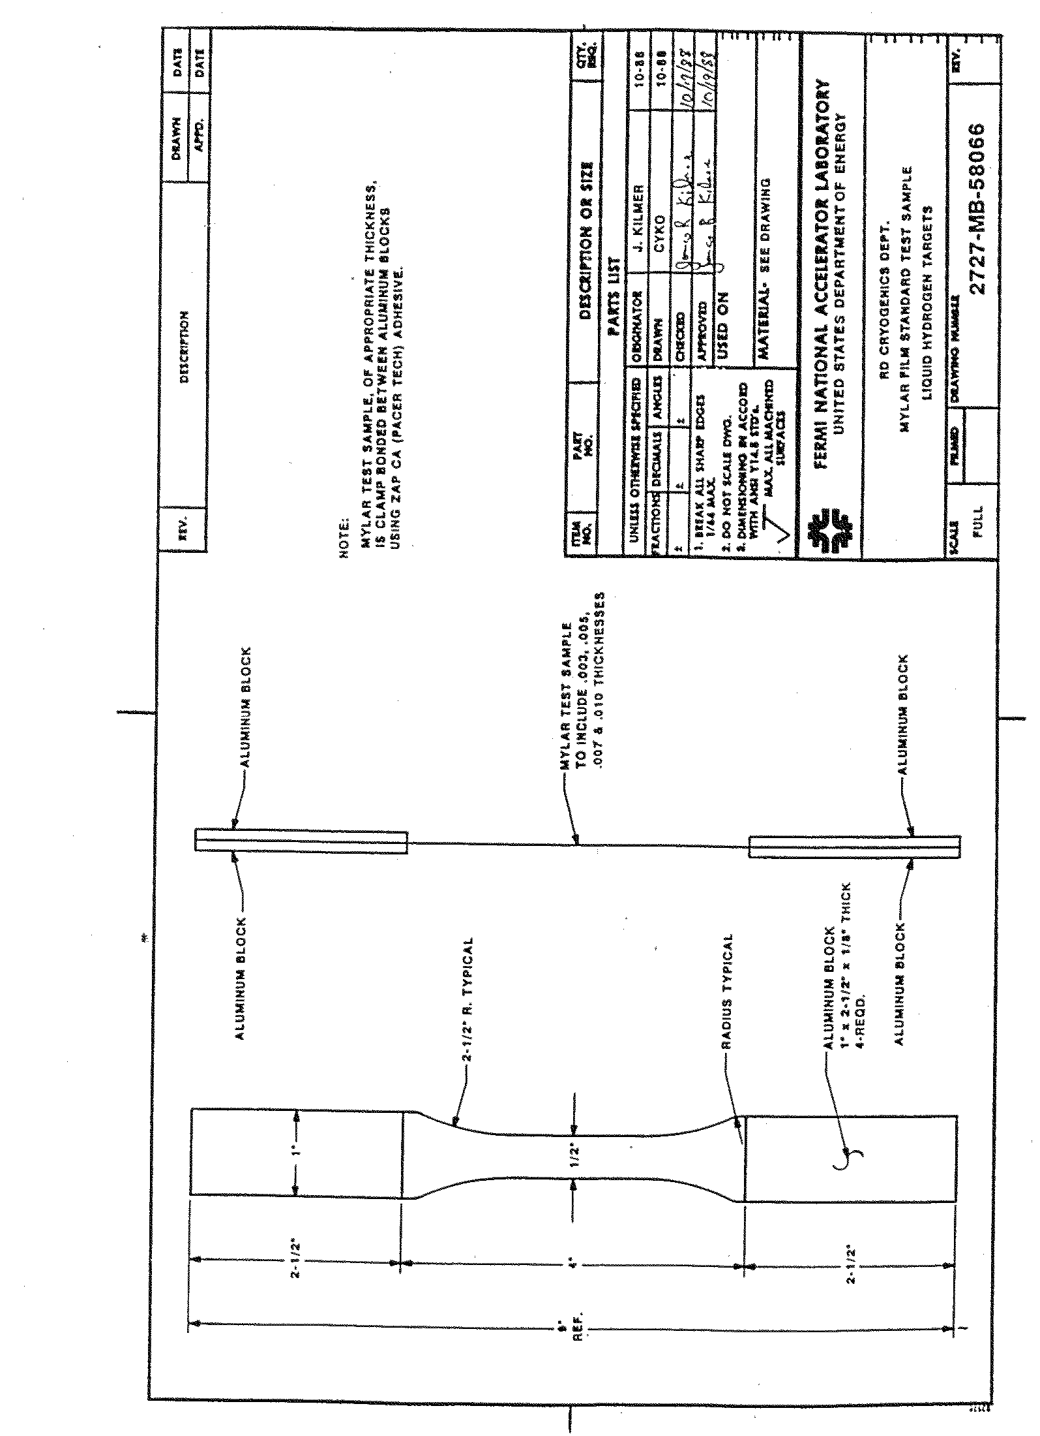
Appendix III
Forming Dished Heads for Target Flash and Vacuum Containers

Dished head of Mylar, kapton, stainless steel and other materials can be formed by drawing them between 2 layers of copper foil. These dishes will have a minimum of thinning in the center and can be held to a very tight tolerance on the diameter. The mold for this forming is simple and easy to machine because no inside finish machining is necessary.

This same mold can be used to make dishes of several different configurations by using punches of different design. The attached drawing shows a typical dish head forming mold and assembly.

The mold consists of three parts machined out of mild steel. The punch is designed to give you the final shape of the dish. The face plate is used as a guide to align the punch to the base plate. The base plate controls the diameter of the dish.

The copper sheets used in the mold are of OFHC copper which is dead soft. The lubricant used in the forming process is MS 122 Teflon mold release from Miller and Stephenson Co. References to the attached drawing will show how the mold is assembled and which areas are to be lubricated and the tolerance of the various pieces.

The bolt torque is very critical in the forming process. In most cases the bolts are torqued to their maximum. If the copper breaks before the dish is fully formed, the torque can be backed off slightly and another attempt made. The rate of speed the punch is driven into the mold can be varied to correct problems in the forming process.

During assembly, care must be taken to keep all dirt and dust out of the area between the copper and the material being formed because it will cause flaws in the formed dish. After assembly, the punch is pushed into the mold at about 1 inch per minute using a hydraulic process, universal testing machine, or similar device. The machine must be capable of exerting a force of 20,000 lbs. in order to form most large dishes. The punch should be pushed to a depth deep enough to give you the proper flat section on the side of the dish. This operation should be done in a continuous motion otherwise the copper will work harden and break. Once the punch has been pushed to the proper depth, it should be removed using a metal bridge and the jacking screw in the center of the punch. After the punch is removed, the copper cavity is filled with molten 60/40 or 50/50 solder at 255° which is allowed to solidify.

This part of the process heat sets the plastic film but is not necessary when forming metal dishes.

After the solder has cooled, the mold is disassembled and the copper shims pulled apart. At this point, the dish is inspected for flaws if no flaws are present; the outside material of the dish is trimmed away to within 1/8" of the outside radius. The dish is now ready to be used in the flask assembly.
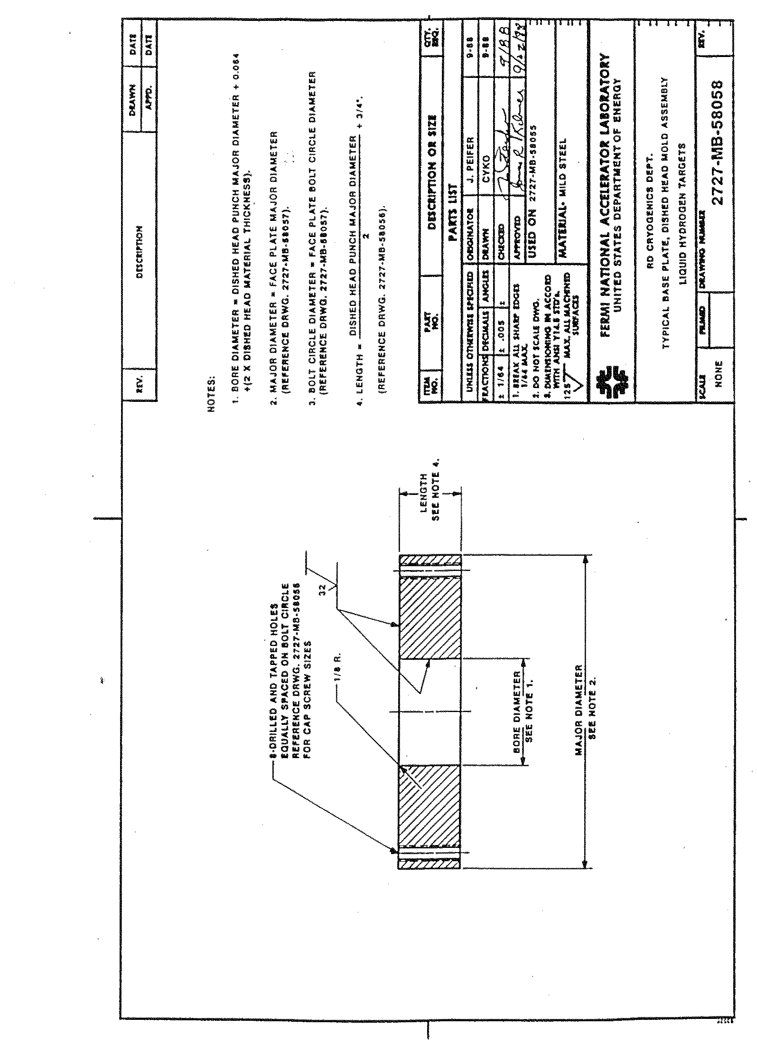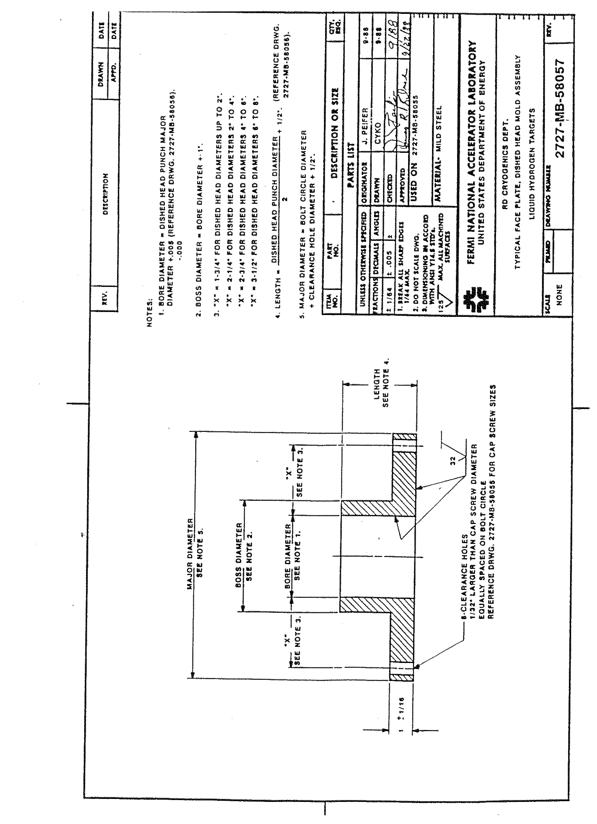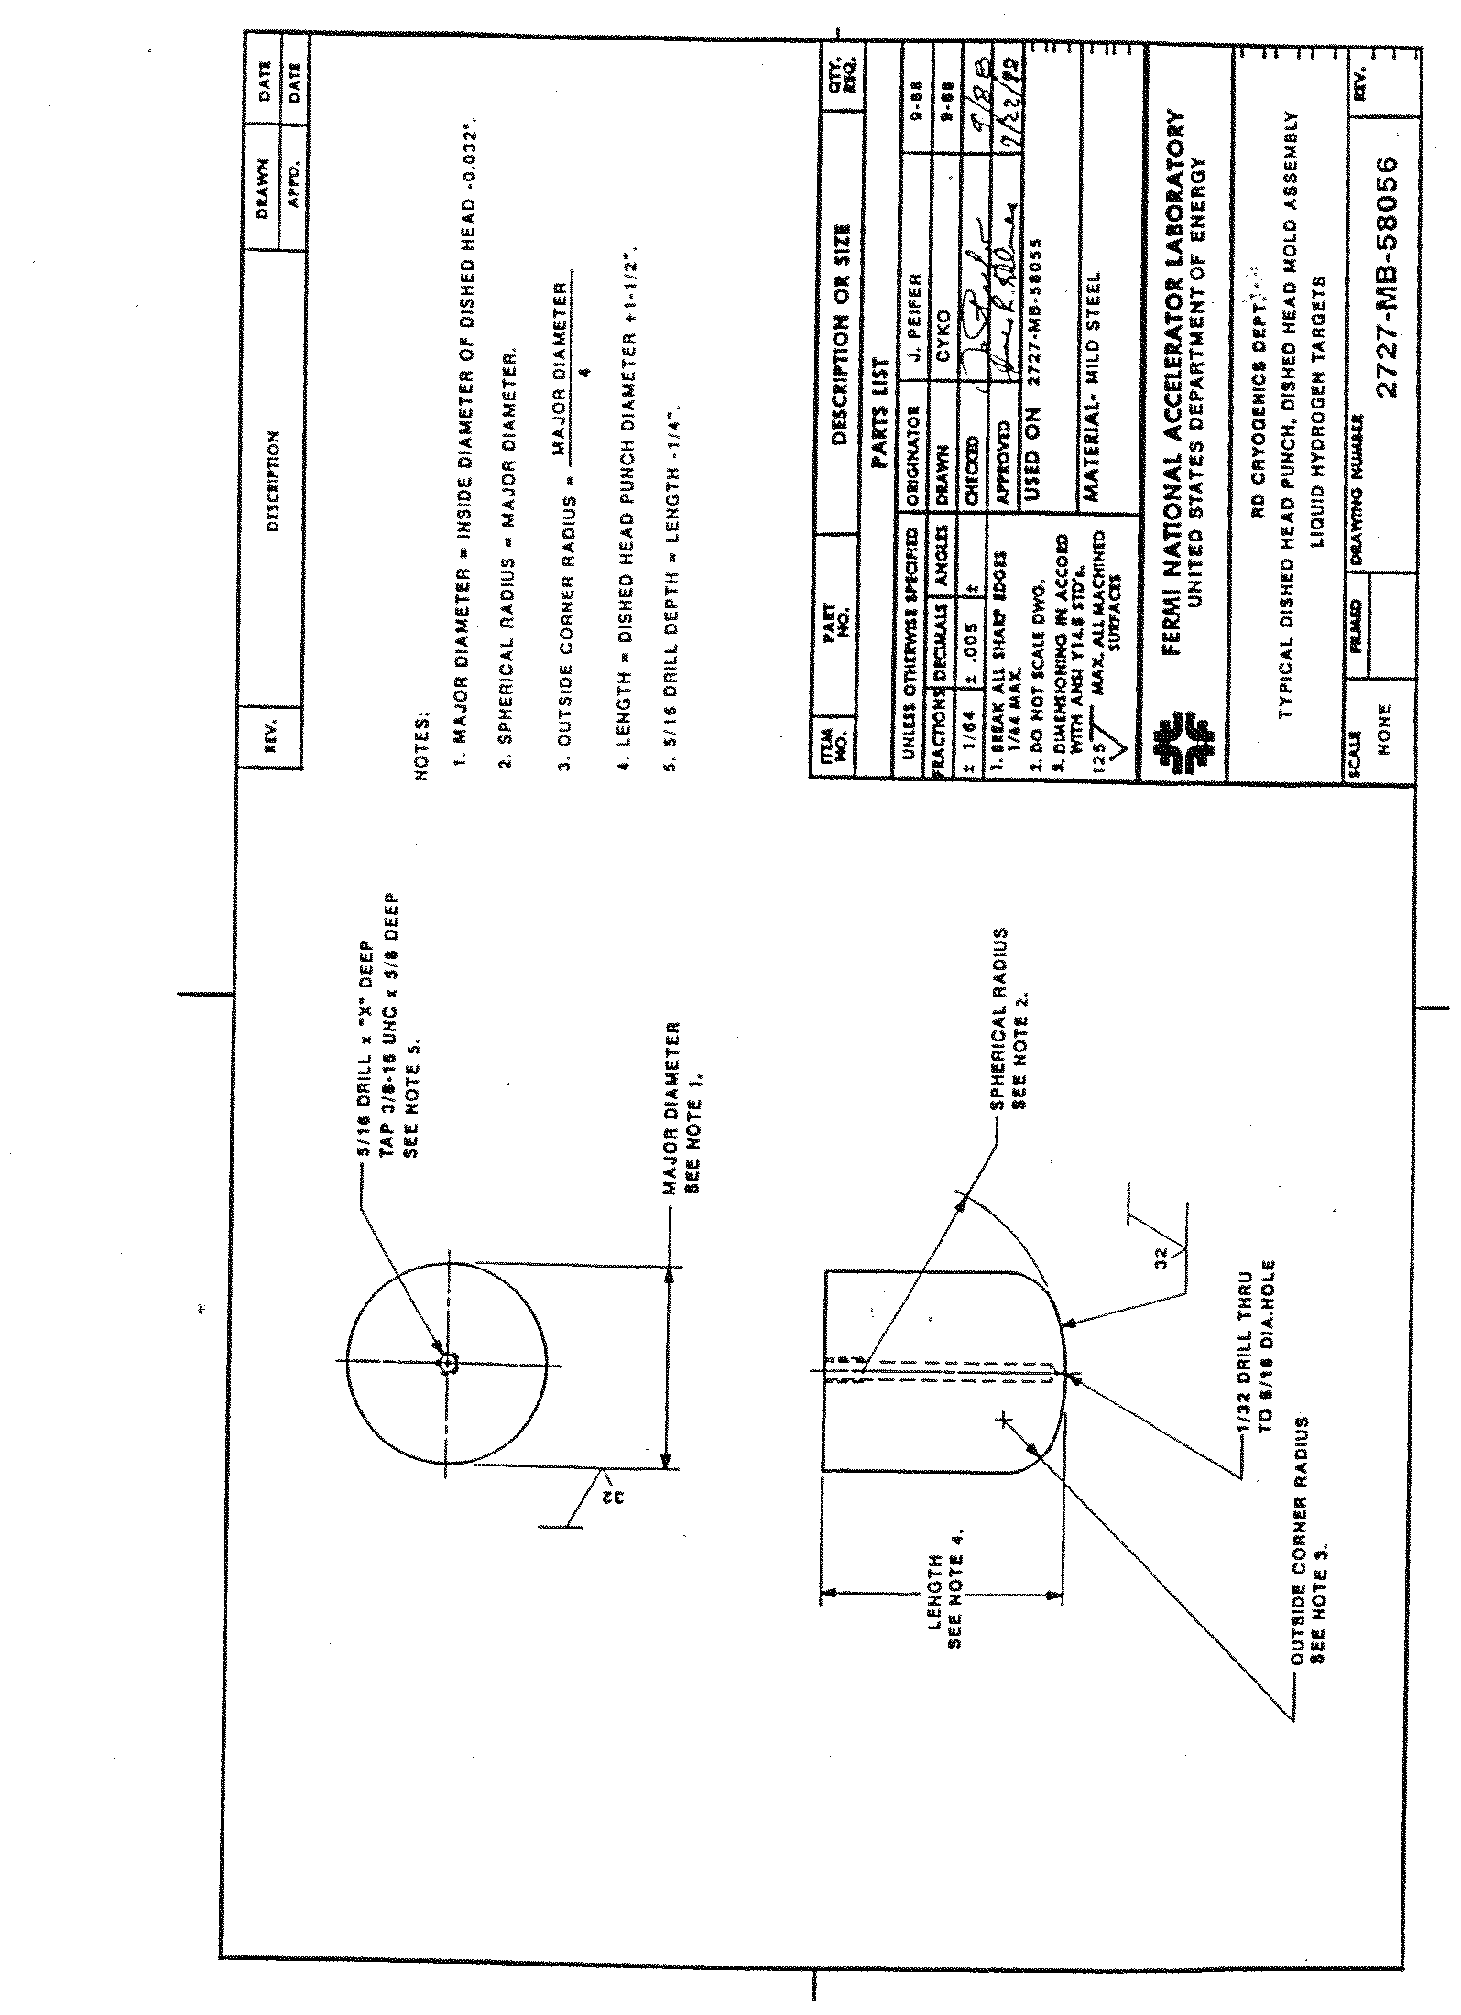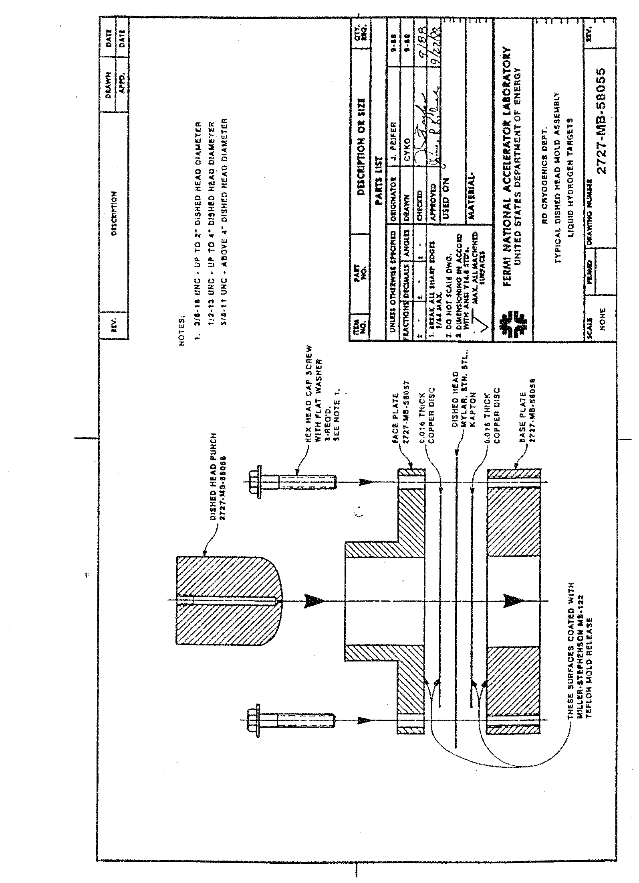
APPENDIX IV
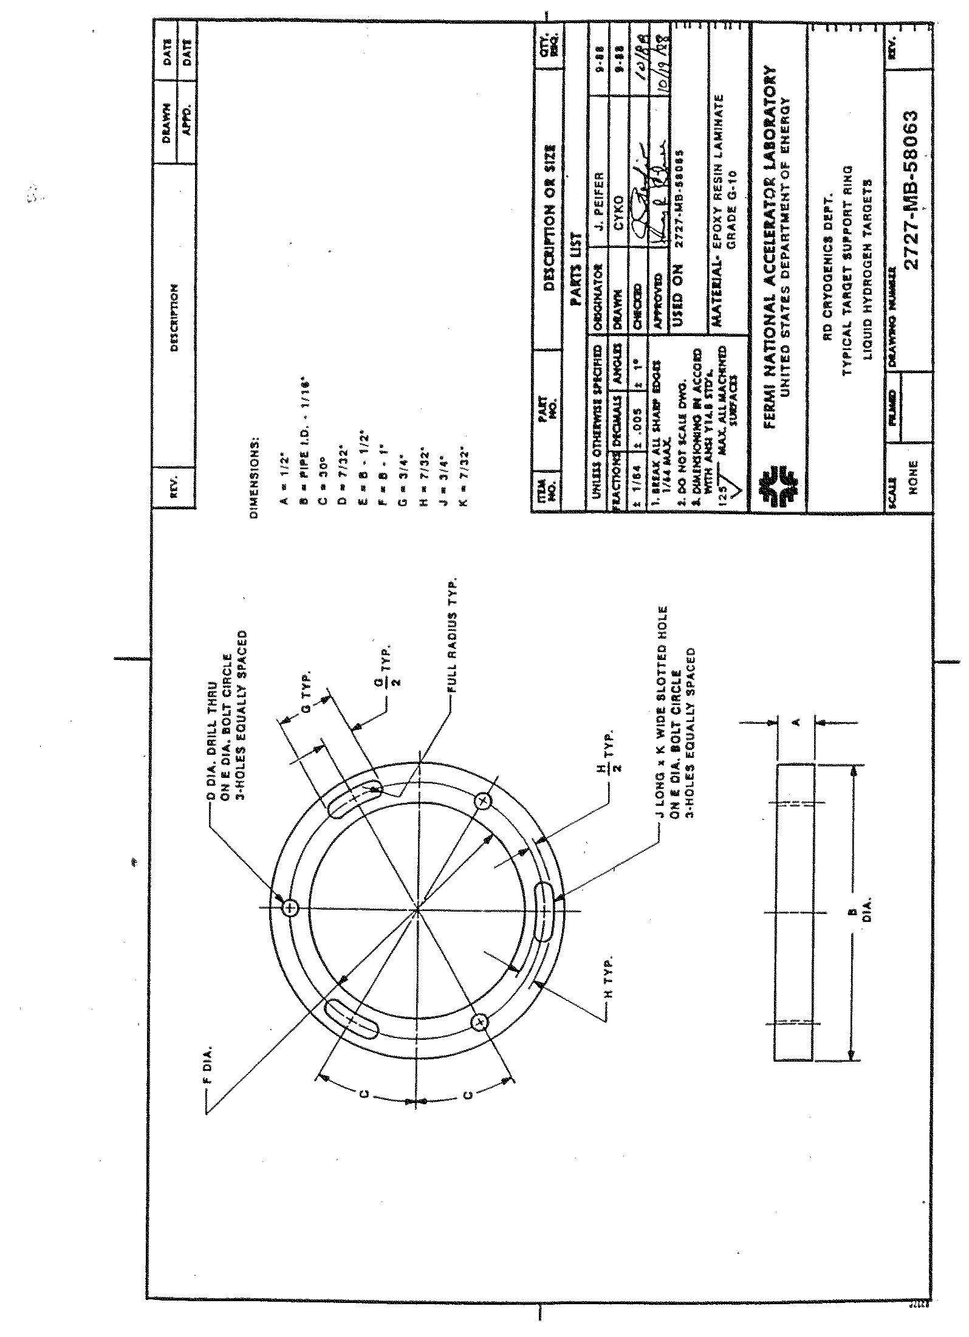
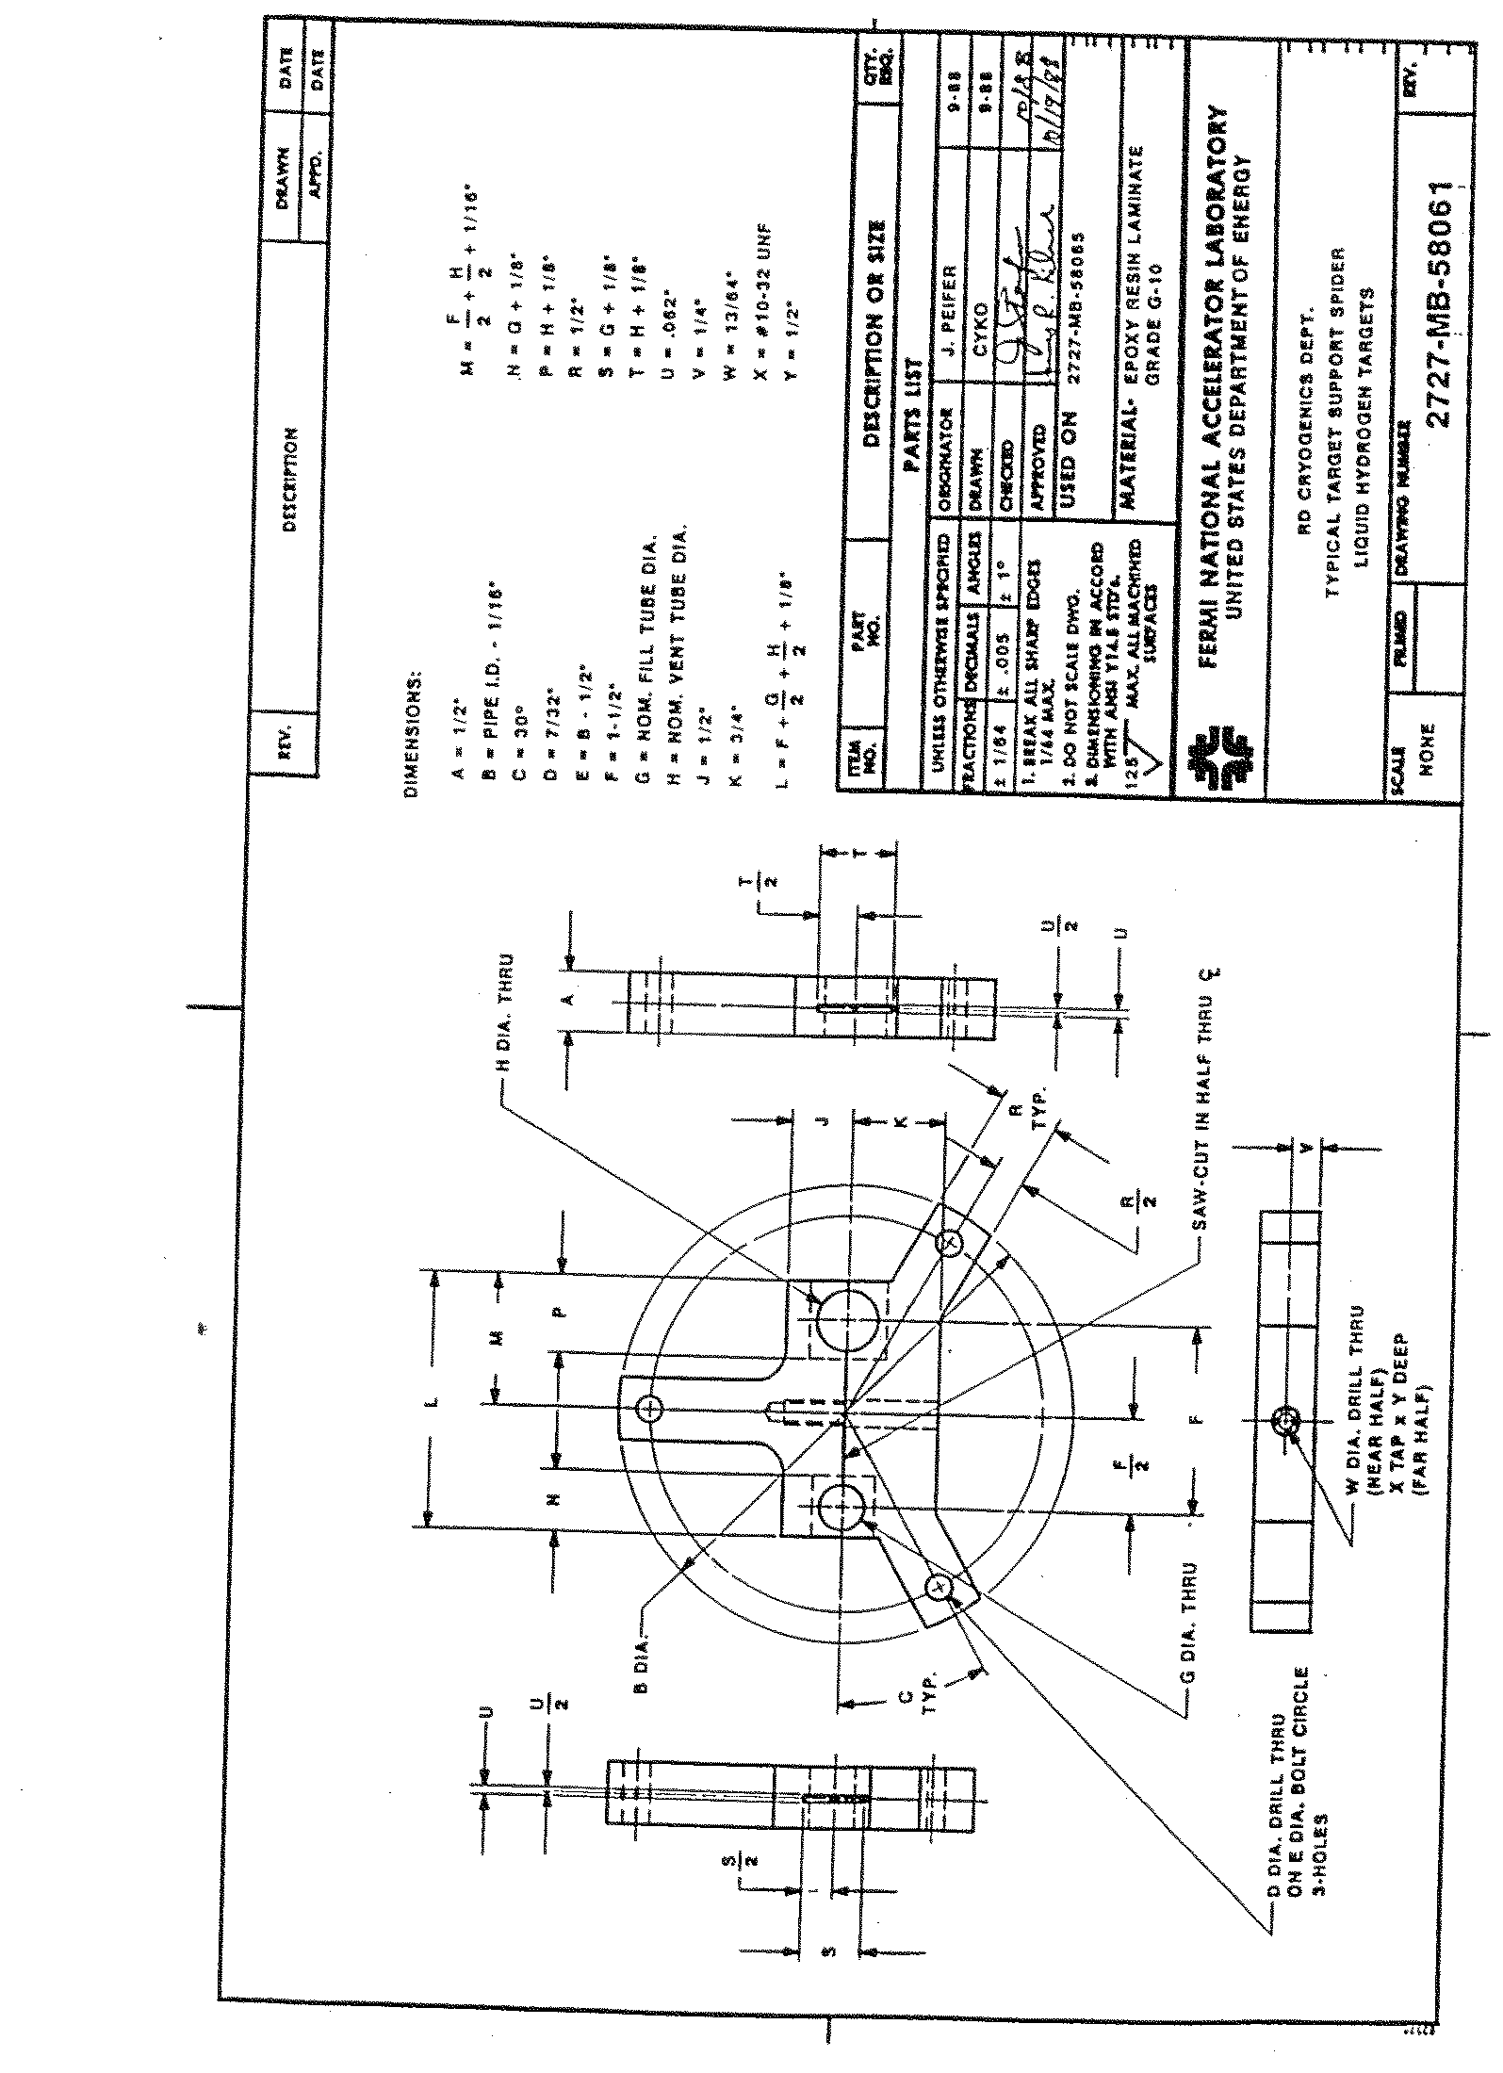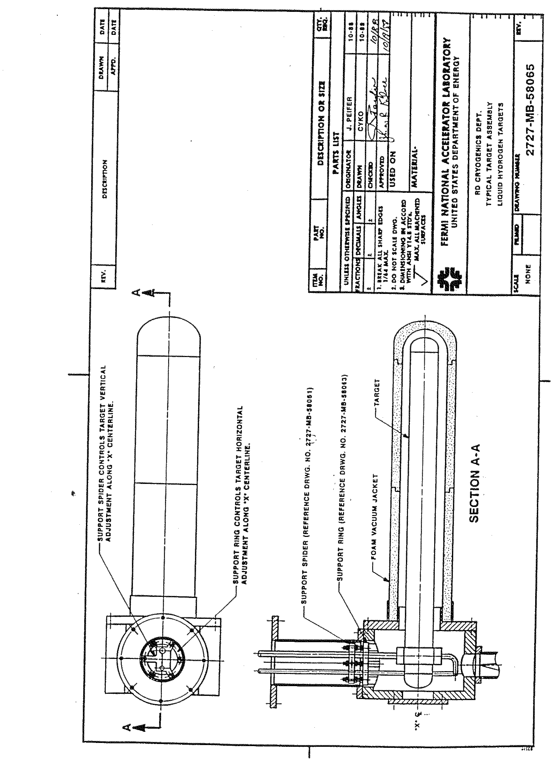

APPENDIX V

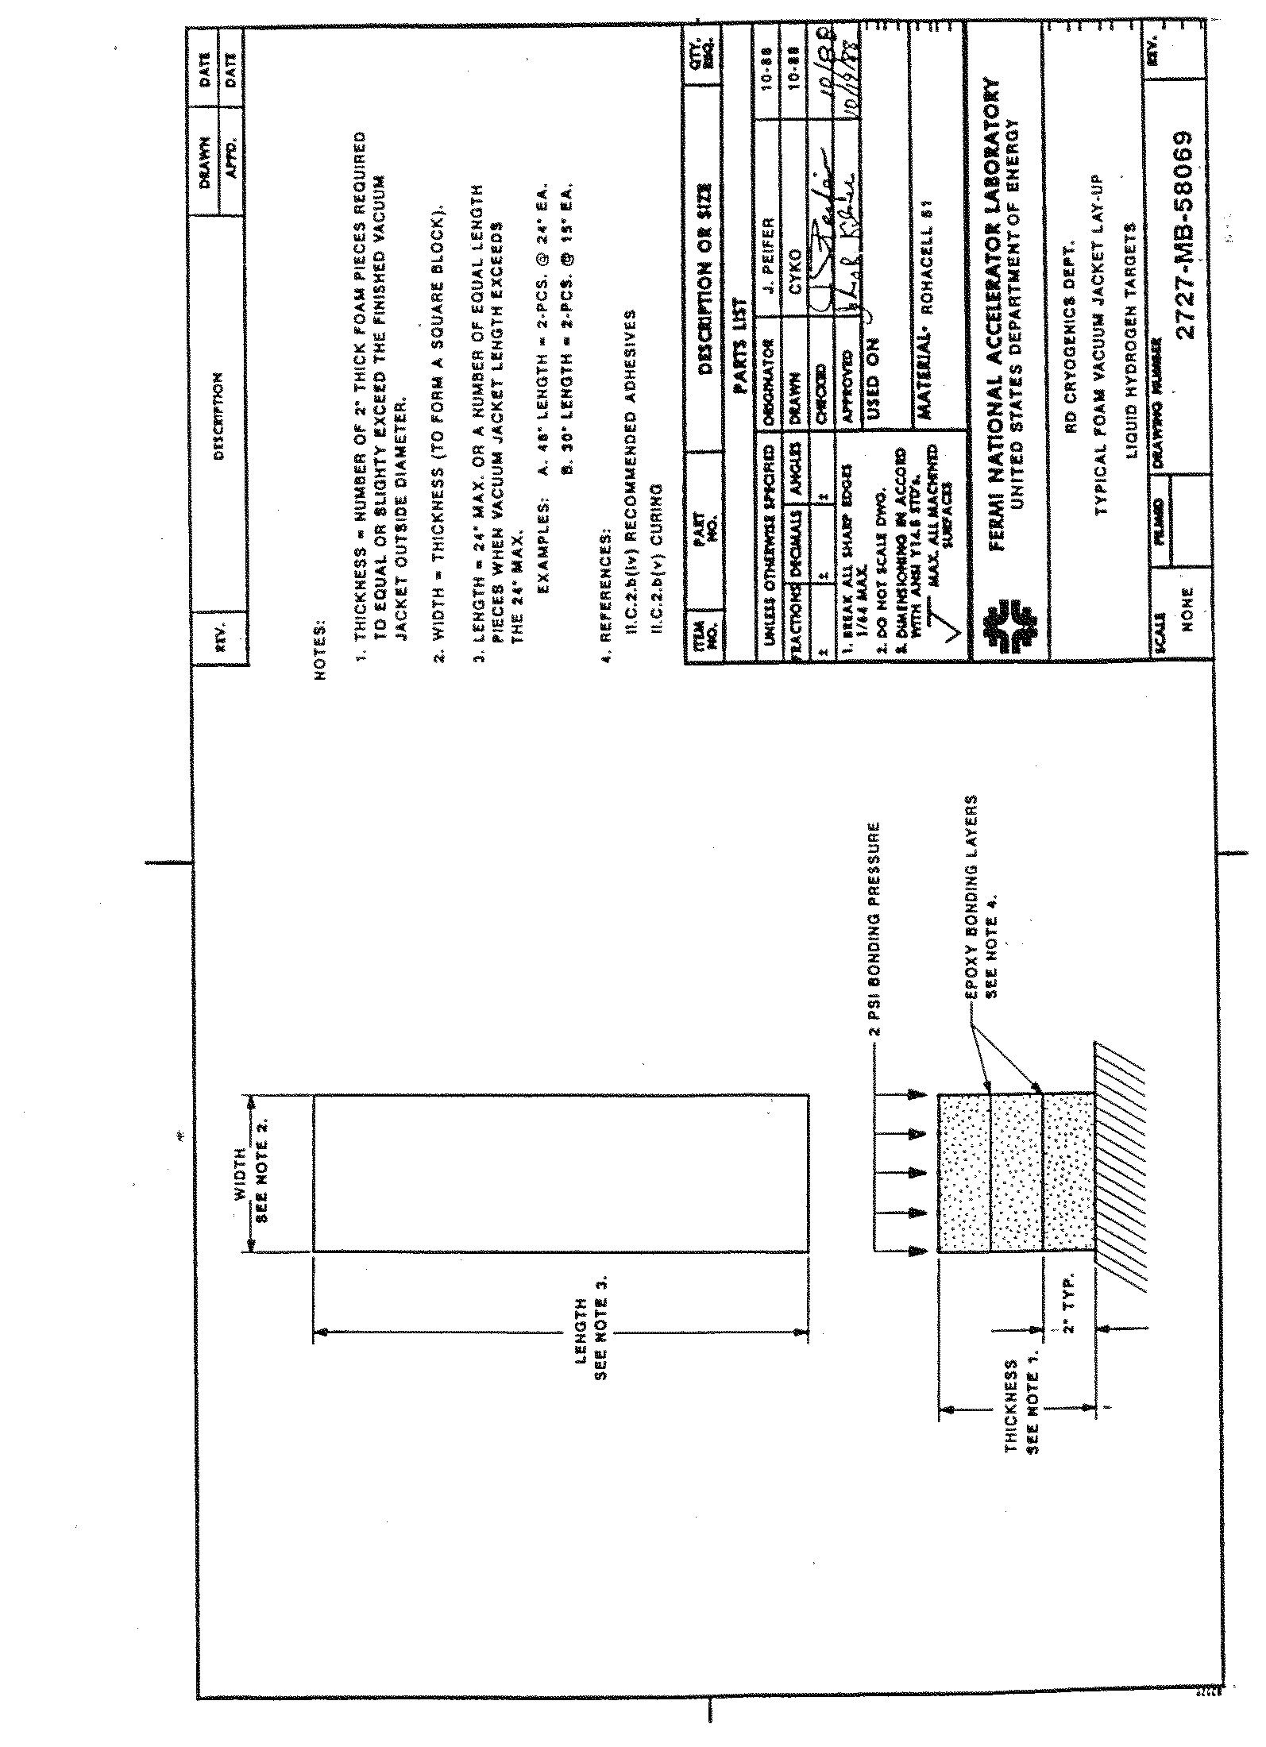

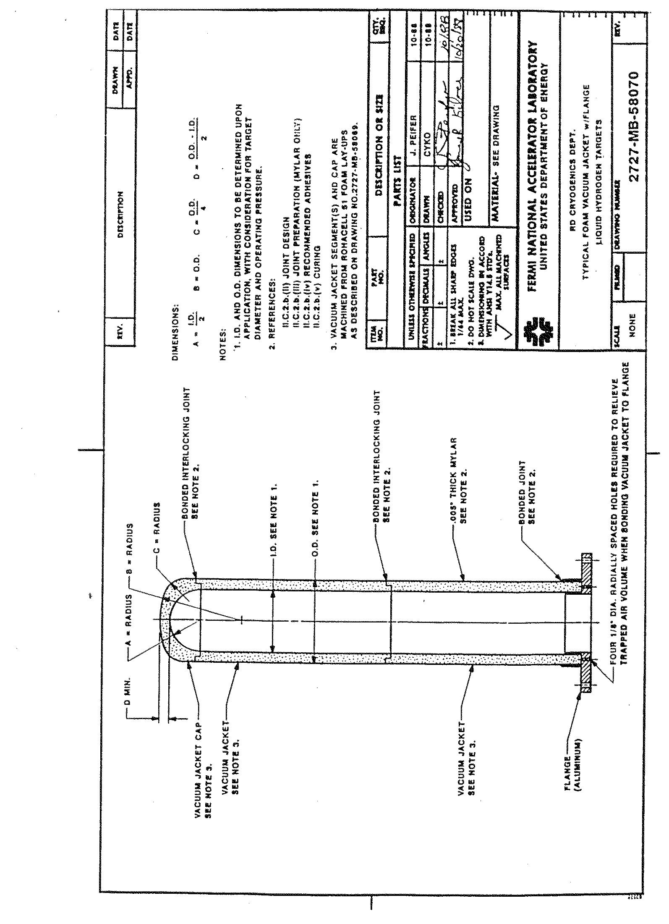
APPENDIX VI

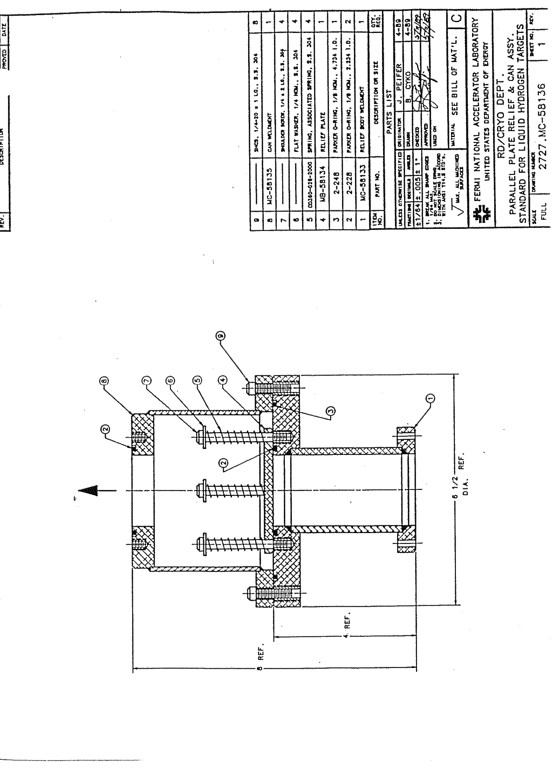

APPENDIX VII
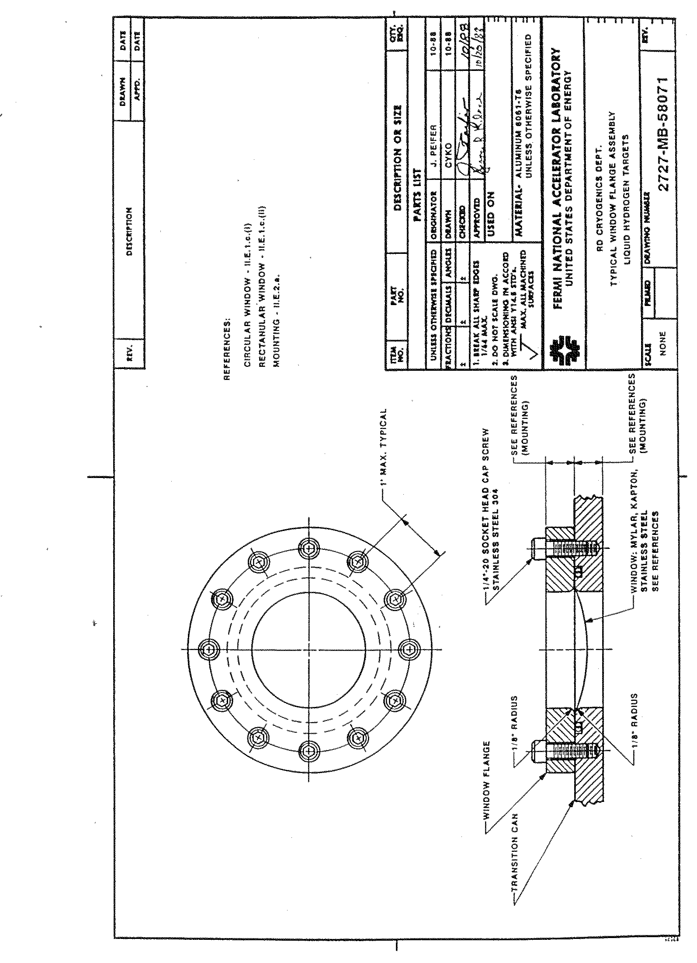

APPENDIX VIII

