FESHM 5100: STRUCTURAL SAFETY

Revision History

Author | Description of Change | Revision Date
Roza Doubnik | Updated link to the Prime Contract No. DE-AC02-07CH11359 with the conformed, contract through Modification No. 302 from June 10, 2022. | July 2022
Brian Rubik  Angela Aparicio | Addition of Technical Appendix related to cribbing usage as structural support | September 2021
Brian Rubik | Initial release Chapter 5100 | March 2018

TABLE OF CONTENTS

1.0 INTRODUCTION AND SCOPE 2
2.0 DEFINITIONS 2
3.0 RESPONSIBILITIES 3
3.1 The Designated Structural Safety Authority Having Jurisdiction (AHJ) 3
3.2 The Division/Section/Project Head 3
3.3 The ES&H Section 3
3.4 The Mechanical Safety Subcommittee (MSS) Structural Panel 3
4.0 PROGRAM DESCRIPTION 3
5.0 PROCEDURES 4
5.1 Design 4
5.2 Re-use or Modification of Existing Structures 5
5.3 Review 6
5.4 Construction 6
5.5 Documentation 6
6.0 REFERENCES 6
7.0 TECHNICAL APPENDICES 7
7.1 Use of Plastic Timber as a Structural Support 7

INTRODUCTION AND SCOPE

There are a wide variety of structures at Fermilab and Fermilab leased spaces, and therefore a variety of potential hazards to people and property if these structures are improperly designed, constructed, modified, or re-used. The best way to mitigate the hazards is through sound engineering design, use of appropriate safety factors, and compliance with applicable codes and standards listed in the Prime Contract No. DE-AC02-07CH11359 with the conformed contract through Modification No. 302 from June 10, 2022. Attachment J.9 Appendix I DOE Directives. The International Building Code (IBC) and its referenced standards are intended to be a set of requirements that provides an acceptable level of safety including for structural design. The purpose of this chapter is to define the requirements with which the design and construction of structures at Fermilab and Fermilab leased spaces must comply.

DEFINITIONS

The Code – International Building Code (IBC), the latest edition at the time of the start of detailed design. Note that equivalency between the US structural design codes (IBC and referenced standards) and the European structural design codes (the Eurocodes) was developed. The white paper demonstrating this equivalency is shown in the references in this chapter.

Structure – That which is built or constructed, and which is most appropriately governed by the IBC and its referenced standards rather than other codes and standards. In the context of this chapter, this includes any structure or part thereof, the failure of which could reasonably pose a threat of injury to an individual or a non-trivial amount of damage to property, the design of which does not fall under the jurisdiction of another more applicable code or standard.

Qualified Person – A person who, by possession of a recognized degree or certificate of professional standing, or who, by extensive knowledge, training, and experience, has successfully demonstrated the ability to solve or resolve problems relating to the subject matter and work.

Authority Having Jurisdiction (AHJ) and Building Official – The Code and other standards refer to the role and responsibility of the AHJ and/or the Building Official. For structures at Fermilab and Fermilab-operated spaces, the AHJ shall be as described in the Fermilab Worker Safety and Health Program.

Engineer of Record (EOR) – The code and other standards refer to the role and responsibility of the EOR. For structures at Fermilab and Fermilab leased spaces, the EOR shall be the qualified person or licensed engineer performing or supervising the design of the structure as required by Section 5.1 of this chapter.

Engineering Note – A document (e.g. analyses, calculations, drawings, specifications) demonstrating that a given building, structure, and/or part thereof satisfies the requirements of the Code.

RESPONSIBILITIES

A responsibilities section is included only if there are any responsibilities which are unusual, i.e., different than those indicated in FESHM 1010.

The Designated Structural Safety Authority Having Jurisdiction (AHJ)
The primary responsibilities of the AHJ are:

- Selecting and applying appropriate Codes and Standards to new, modified and existing facilities or processes.
- Writing equivalency, variance or exemption requests for DOE Fermilab Site Office (FSO) approval.

The AHJ will be supported by FESS and the MSS Structural Panel depending on the nature of the structure. Work such as inspections, drawing/specification review, etc. may be performed by:
- For conventional structures (i.e. buildings and appurtenances): FESS
- For programmatic structures: MSS Structural Panel

Any questions or disputes over jurisdiction shall be resolved by the AHJ.

The Division/Section/Project Head
The Division/Section/Project (D/S/P) Head that controls the area of operation of the structure is responsible for carrying out the requirements of this chapter. The D/S/P head or his/her designee shall:
            - Ensure that a qualified person is designing or overseeing design of a structure.
            - Arrange for the review of the Engineering Note by a qualified person or committee.
            - File the original Engineering Note as required by the Fermilab Engineering Manual (FEM).

The ES&H Section
The ES&H Section shall:
            - Audit the divisions, sections, and projects on their compliance with this chapter.

The Mechanical Safety Subcommittee (MSS) Structural Panel
The MSS Structural Panel shall serve the D/S/P Heads and ES&H Section in a consulting capacity on structural matters. This includes providing recommendations regarding the applicability of a standard, in addition to the Code, to a given structure.

PROGRAM DESCRIPTION

The IBC defines a structure as “that which is built or constructed”. This definition could conceivably apply to nearly any object at Fermilab. However, some additional guidance is given in Section 101.3 Intent: “The purpose of this code is to establish the minimum requirements to provide a reasonable level of safety, public health, and general welfare through structural strength… and safety to life and property from fire and other hazards attributed to the built environment…”.

The scope of this chapter is therefore any structure the failure of which could reasonably pose a threat of injury to an individual or a non-trivial amount of damage to property, which does not fall under the jurisdiction of another more applicable code or standard. Some degree of engineering judgment must be exercised in determining whether a structure need comply with the IBC; any questions on this matter should be forwarded to the structural Authority Having Jurisdiction (AHJ) for resolution.

Some structures may be partially governed by multiple codes. An example of this is a membrane cryostat, where the fluid containment portion of the structure is governed by one set of codes and the pressure restraint and supporting structure is governed by structural codes. In such a case where a portion of a structure is not governed by other, more applicable codes, the Codes defined in this chapter shall govern design and construction of that structure. Care must be taken to clearly define the applicability of each code set to all portions of the assembly. Questions on the applicability of structural codes should be forwarded to the structural AHJ for resolution. See FESHM 5031.7 for more information on membrane cryostats.

PROCEDURES

Design

Design of structures and components thereof shall be performed by a qualified person.

The complexity of some structures may require the design to be performed or supervised by a person licensed to practice structural engineering in the state in which the structure will reside (an S.E. license in Illinois, for example). The complexity of the structure shall be determined and documented in the engineering note or other written analysis document. Structures determined to be “non-complex” are permitted to be designed by a qualified person. Structures determined to be “complex” shall be designed by a person licensed to practice structural engineering in the state in which the structure will reside. Examples of attributes of structures that are non-complex are:
- Common materials and joining methods
- Clear load paths
- Structures with a relatively low consequence of failure
- Structures designed to the US set of codes
The requirement for a licensed engineer to design complex structures may be waived by the AHJ and shall be documented as part of the engineering note. Questions regarding whether the design of a structure requires a licensed engineer should be forwarded to the MSS Structural Panel for resolution.

Design of structures shall comply with the latest edition of the Code at the time of the start of detailed design. This edition shall be the “Code of Record” and shall be indicated on the engineering note or other written analysis document. Design must also comply with any material-specific and other design standards referenced by the Code. Note that the latest edition of these other standards may not be the edition referenced. See Chapter 35 of IBC entitled “Referenced Standards” for a list of referenced design standards in the US. Some notable standards for structural design are:
- ASCE 7 – Minimum Design Loads for Buildings and Other Structures
- AISC 360 – Specification for Structural Steel Buildings
- ACI 318 – Building Code Requirements for Structural Concrete
- ADM1 – Aluminum Design Manual
- AWS D1.1 – Structural Welding Code - Steel

An engineering note or other written analysis document shall be created for all structures based on the graded approach defined in the FEM. The engineering note shall include, at a minimum:
- Name or identifier of the structure
- Name of the engineer in charge of the design
- Edition of the Code that is used for design
- Location and intended use of the structure
- Design criteria including loading on the structure
- Codes, standards, design guides, or other reference documents used
- Any calculations, analyses, finite element models with output, etc.
- Any construction or fabrication drawings or specifications

Testing, inspection, and contractor submittal (if applicable) requirements shall be identified in the structure drawings, specifications, and/or engineering note. These requirements shall meet or exceed what is required by the Code.

Re-use or Modification of Existing Structures

If an existing structure is to be used for anything other than its original design intent or modified in any way, then the structure must be analyzed and documented in an engineering note or other written analysis document. This new analysis shall comply with the latest edition of the Code at the time of the start of detailed design and Section 5.1 of this chapter.

Where possible, the new engineering note shall reference any original analysis documentation. If no original documentation for a structure exists, all material properties, geometry, and other design parameters must be verified through testing, measurements, or other reproducible means.

Review

All engineering notes and other design documentation shall be reviewed based on the graded approach described in the FEM.

Construction

Construction oversight of a structure shall be the responsibility of the D/S/P Head that controls the area of operation of the structure or their designee, unless otherwise required (i.e. Fermilab policy states that conventional construction shall be overseen by FESS).

The person responsible for oversight of construction shall ensure that construction proceeds in conformance with the drawings, specifications, and/or other design documents. This may include testing, inspection, or other means according to a graded approach as described in the FEM. Structures determined to be complex per 5.1.2 shall also be inspected by the AHJ or their designee for general conformance to the drawings, specifications and the Code.

Documentation

All documentation for the structure shall be filed as described in the FEM. Documentation shall include, if applicable:
- Engineering note
- Results of any reviews
- Construction or fabrication drawings and/or specifications
- Test and inspection reports
- Any other pertinent information related to the design or use of the structure

REFERENCES

Fermilab Engineering Manual

Acceptance of Steel and Aluminum Structures Designed per the Eurocodes at Fermilab. July 18, 2017.

FESHM 5031.7: Membrane Cryostats

TECHNICAL APPENDICES

Use of Plastic Timber as a Structural Support

Fermilab has experienced issues in the past due to the use of plastic landscape timbers which were not structurally rated as cribbing or other structural support. (e.g. https://www-esh.fnal.gov/pls/cert//hpi_rpt.html?hid=235; also see lesson learned describing this incident in Section 7.1.1) The use of non-rated plastic landscape timbers as cribbing is not permitted unless the plastic landscape timbers will be utilized in a single-layer application (no stacking of items/material; the cribbing is fully supported by the structure underneath). All other uses of cribbing/structural support will require the use of structurally rated cribbing/material (structurally rated plastics or acceptable wood species). No cribbing material may be used in a configuration where it could bend.

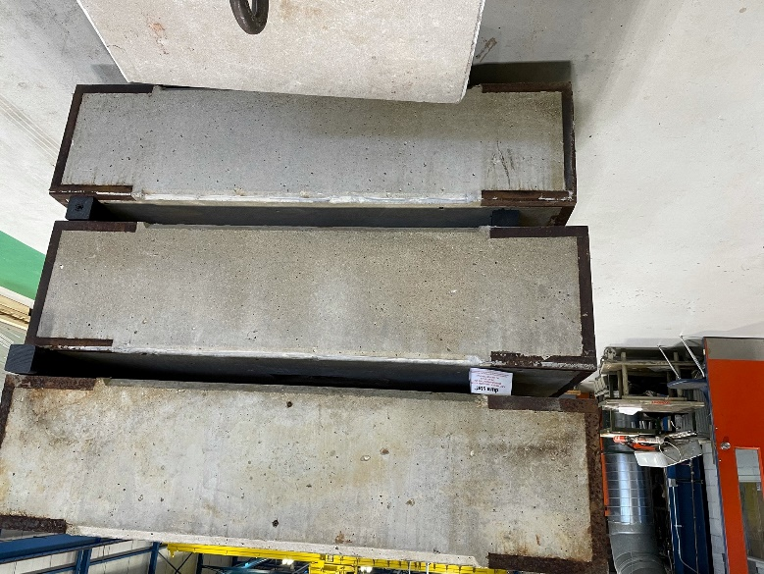 | 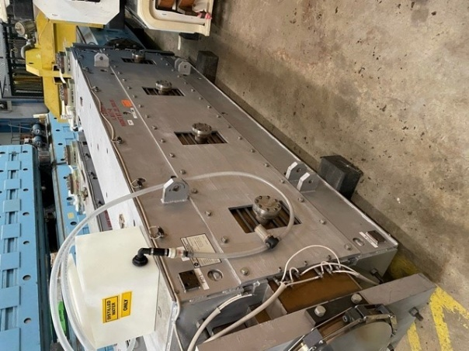
Shield blocks stacked in multiple layers using non-rated plastic lumber – not acceptable | Magnet stored on non-rated plastic lumber in single layer - acceptable
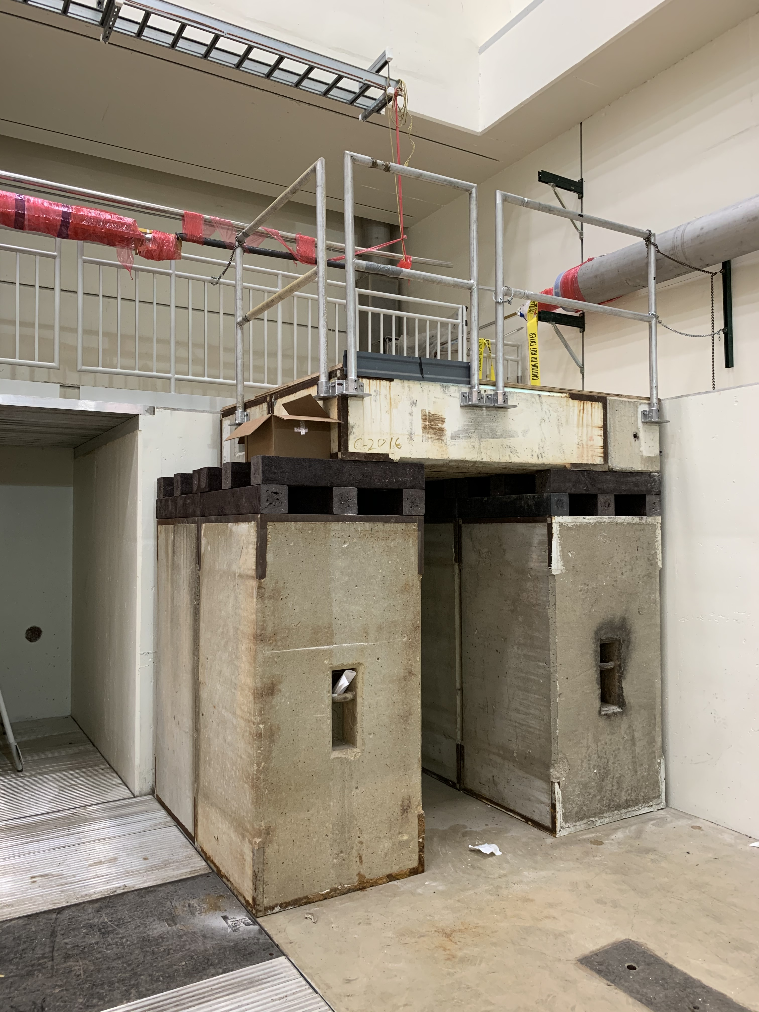
Non-rated plastic lumber utilized for a work platform support –
not acceptable

Structurally rated cribbing must be marked to indicate the rated capacity. See example in photo.
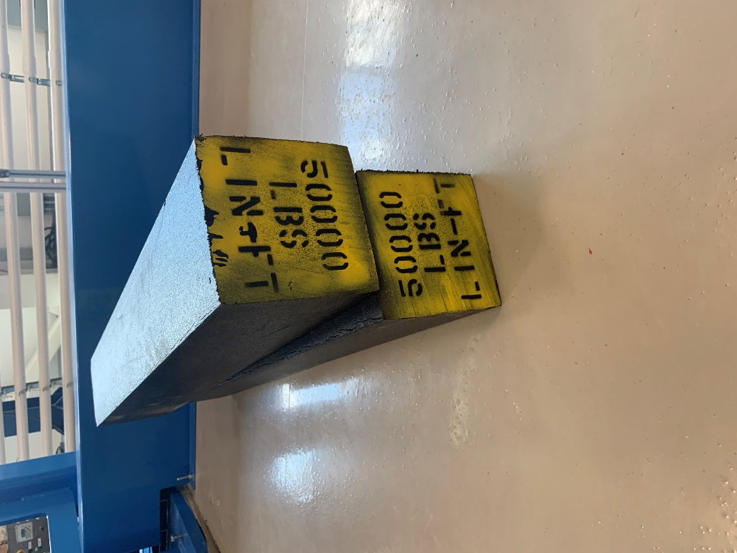

The strength of wood cribbing can be determined utilizing the Urban Search & Rescue Shoring Operations Guide. The Timber Cribbing Guide provides information on cribbing construction and load-bearing capacities of different types of wood: https://esh-docdb.fnal.gov/cgi-bin/sso/ShowDocument?docid=6447.

Examples of companies that produce plastic cribbing with ratings are shown below. Other products and companies may be acceptable. Contact the Mechanical Safety Subcommittee or a Division Safety Officer (DSO) with questions concerning suitability of a material.
https://www.turtleplastics.com/dura-crib-cribbing-blocking/
https://dicausa.com/prostack-plastic-cribbing-blocks/
https://www.blackrhinoproducts.com/our-products/rhino-cribbing/
https://ameintl.net/product_category/superstacker-cribbing/

Lesson Learned

Summary:
In 2019, a 15-ton magnet was placed on steel carts in IB2 and supported by plastic lumber used as cribbing. During off-hours, the cribbing partially failed and the magnet partially dropped. Fortunately, no one was injured and the magnet was not damaged. Although the HPI investigation is currently underway, it seems that the cause of the near miss was the use of non-structural plastic lumber in a structural application. The recommendation is for all staff involved in moving and supporting loads to clearly understand the load rating of the materials and products being used. If there is any doubt about the load rating or applicability, contact a DSO or Mechanical Safety Subcommittee for guidance.

What Happened:
A 15-ton magnet was placed on two custom-built steel carts in IB2. Plastic lumber was used as cribbing to support both ends of the magnet, although one side had an additional steel plate to help spread the load. On the weekend of February 22-24, the plastic cribbing partially failed and the magnet partially dropped (see images below).

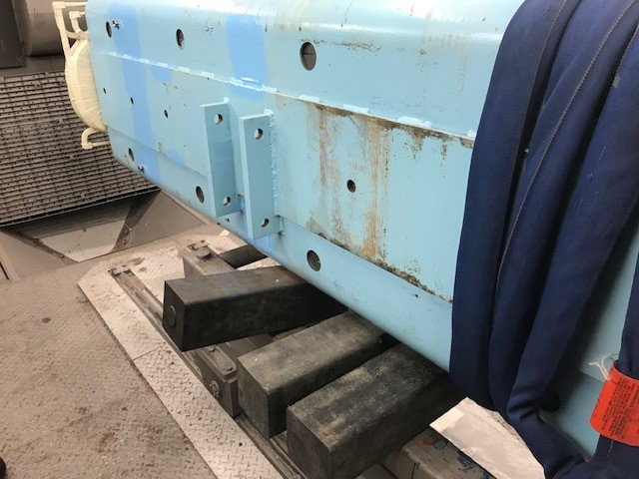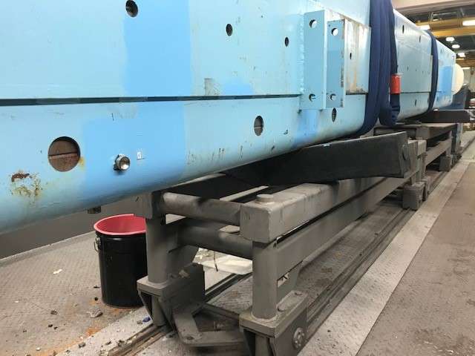

Fortunately, nobody was injured and the magnet was not damaged. When workers noticed the cribbing failure, they secured the load and contacted their DSO.

Preliminary Assessment:
It seems that the cause of the incident was the use of non-structural plastic lumber in a structural cribbing application. See information below on the cribbing material that was used to support the magnet. Note that some plastic lumber products are rated for structural use. See the HPI report for this event here: https://www-esh.fnal.gov/pls/cert//hpi_rpt.html?hid=235.

Recommendations:

All staff involved in moving and supporting loads should understand the load rating of the materials and products being used. Only products rated for structural use should be used in structural application such as cribbing. Care should be taken to avoid confusion between structural and non-structural materials, especially since those materials may be similar in appearance and be stored / used in the same location.

Additionally, anyone that uses plastic lumber should verify its rating and intended applications. The non-structural lumber was available in the Fermilab stock room for many years. Although it will be removed from the stock room in favor of more suitable material, pieces of the non-structural lumber will have to be identified and removed on a case-by-case basis.

If there is any uncertainty regarding the load rating of a material or product for use in a structural application, please contact your DSO or the Mechanical Safety Subcommittee for guidance.

