 | FERMI NATIONAL ACCELERATOR LABORATORY

Guidelines for the Design, Fabrication, Testing and installation of SRF Nb Cavities
TABLE OF CONTENTS

1. INTRODUCTION 3
2. MATERIALS 3
3. DESIGN AND ANALYSIS 7
4. WELDING AND BRAZING 15
5. INSPECTION EXAMINATION AND TESTING 20
6. REFERENCES 21
APPENDIX A – OVERVIEW OF THE CODE 22
APPENDIX B – APPLYING DIV. 1 RULES TO SRF CAVITY DESIGN 25

INTRODUCTION
Superconducting Radio-Frequency (SRF) cavities containing cryogens pose a potential pressure hazard. Pressure vessels such as SRF cavities fall within the scope of the ASME Boiler and Pressure Vessel Code (henceforth the Code) or the ASME Code for Pressure Piping.

However, the use of niobium (a non-Code material), as well as other cavity design and fabrication features, make it impossible to strictly satisfy all requirements of the Code.

The procedures contained in this document have been developed by Fermilab engineers and represent their current understanding of best practice in the design, fabrication, examination, testing, and operation of the Dressed SRF cavities. These guidelines comply with Code requirements wherever possible, and for non-Code features, procedures were established to produce a level of safety consistent with that of a Code design.

These procedures do not cover all possible aspects of SRF cavities. It is reasonable, and possible at times necessary, to diverge from the methods presented here. Such divergence need not imply an unsafe device. For these cases, alternative procedures and measures shall be developed and shown to assure a level of safety equivalent to that afforded by the ASME codes. These alternative procedures are subject to written approval by a reviewer and/or SRF Pressure Safety Review panel prior to onset of an SRF cavity fabrication.

MATERIALS

General

The materials of construction of SRF cavities and their associated helium vessels are high purity niobium, a 45 niobium/55 titanium alloy, and Grade 2 titanium. Niobium and niobium/titanium alloys are not accepted by the Code as being suitable for construction of pressure vessels. As a result, the mechanical properties of these materials are not available in Section II, Part D of the Code. Properties for Grade 2 titanium are available, but it is not accepted for use at cryogenic temperatures.

In this chapter, the requirements and testing to be used in the determination of the material properties for non-Code recognized materials is described. Subsequently, the material properties determined will be utilized to calculate the maximum allowable stress values using the Code methodology.

Properties – the properties to be determined for each material are:

Yield strength and ultimate strength

Young's modulus

Charpy impact energy

Chemical composition

Table 2.2.1 - Established Properties for Materials Used in SRF Dressed Cavities

Material | Property
Material | Elastic Modulus | Yield Strength |  | Ultimate Strength |  | Integrated Thermal Contraction 293K to 1.88K (in/in)
Material | (psi) | (psi) |  | (psi) |  | Integrated Thermal Contraction 293K to 1.88K (in/in)
Material |  | 293K | 1.88 K | 293K | 1.88 K | Integrated Thermal Contraction 293K to 1.88K (in/in)
Niobium | 15.2E+06 | 5,500 | 46,000 | 16,600 | 87,000 | 0.0014
55Ti-45Nb | 9.0E+06 | 69,000 | 79,000 | N/A | N/A | 0.0019
Titanium, Gr. 2 | 15.5E+06 | 40,000 | 121,000 | 50,000 | 162,000 | 0.0015

In lieu of conducting the materials testing specified in this chapter, the values for the materials listed in Table 2.2.1 shall be utilized by the engineer or designer. These values represent the accepted minimum properties determined by testing and published in available SRF cavity literature [1].

The Charpy impact strength and chemical composition do not need to be provided if the values in Table 2.2.1 are utilized.

Materials Required to be Tested

If the values in Table 2.2.1 are not utilized, testing shall be performed on each of the following in accordance with the requirements outlined below. Material properties measured at 4.5 K are acceptable for use at lower temperatures due to the practical difficulty of testing at below 4.5 K.

As-received material (unless appropriate data is provided by the material supplier, see below).

Samples of heat treated, welded or brazed material, if those processes apply.

Testing Requirements

Tensile Testing

Test Specimens - bulk material

Three samples must be taken from the material and tested in the longitudinal and transverse directions (6 total).

Test Specimens – welded and brazed material

Three samples must be prepared such that the weld or braze is perpendicular to the load direction and centered within the test specimen.

Procedure

Tensile testing shall be performed in accordance with ASTM-E8. Young’s modulus shall be determined in accordance with ASTM-E111-04. Stress-strain curves shall be provided for each sample.

Charpy Impact Testing

Test Specimens

A collection of samples identical to those used for tensile testing shall be used to determine room temperature Charpy impact strength of the material.

Procedure

Charpy impact testing shall be performed in accordance with ASTM-A370.

Cryogenic Testing

For cryogenic vessel materials, all room temperature tests shall be repeated at 77 K and 4.5 K.

Chemical Composition

An analysis shall be performed to determine the chemical composition of the material.

Testing Exceptions: supplier data

Material supplier data may be used as a substitute for material testing provided that data represents the material in its as-used condition.

Test grid

The following grid is a testing guide. The shaded areas are for use with materials for cryogenic service only.

Allowable Stresses
Material
Batch ID
 | Room temperature |  |  |  |  |  |  | 77 K |  |  |  |  |  |  | 4.5 K
Sample ID |  | Yield |  |  | Ultimate |  | Charpy |  | Yield |  |  | Ultimate |  | Charpy |  | Yield |  | Ultimate |  | Charpy
Trans-1
Trans-2
Trans-3
Trans avg
Long-1
Long-2
Long-3
Long avg
Elastic modulus
Chemical content

Allowable stresses for all non-Code materials used for construction of dressed SRF cavities shall be determined in accordance with the Code, Section II, Part D, Mandatory Appendix 1. All values of the allowable stress shall be de-rated by a factor of 0.8 (reduced by 20%).

DESIGN AND ANALYSIS

General

The following guidelines apply to the design and analysis of dressed cavities under all loadings (dead weight, pressure, thermal contractions, and tuner motion) common to those devices. They are intended to provide an equivalent approach to ASME Code, Section VIII design, consistent with Division 1 rules whenever possible; it is acknowledged that a true Code design is not currently possible, primarily due to the use of niobium, a non-Code material, and the absence of Code-required NDE of welded joints.

It is strongly recommended that a stress analyst knowledgeable in the Code be committed to the cavity development effort as early as possible in the design cycle, and that every modification be assessed prior to its implementation in the production device. This will provide a continuity of experience and documentation which will greatly aid the final review process.

Materials Selection

Discussion

Neither Div. 1 nor Div. 2 of Section VIII permits the use of materials not approved by their respective Divisions. This approval is indicated by inclusion of the material properties in the relevant tables and text of the Code, Section II, Part D.

At this time, Div. 1 approves 71 types of titanium and its alloys; Div. 2 approves 40 types. Neither Division approves any TiNb alloy or niobium in any form. From the standpoint of SRF cavities, the use of Nb and TiNb alloys is viewed as an unavoidable violation of Section VIII rules, to be mitigated by subjecting these unapproved materials to rigorous testing and control (of both continuous and welded sections) to demonstrate compliance with Chapter 2 (Materials) of these guidelines

Div. 1 (but not Div. 2) also explicitly proscribes welding titanium and its alloys to other materials (see UNF-19(b)). This is interpreted as permitting welding between members of the approved family of Ti alloys, but prohibiting welding of these materials to any non-titanium material. Under this provision, for example, even if niobium and 55Ti45Nb alloy were approved materials, welding the two would likely be prohibited. This circumstance should be regarded as corollary to the general issue of material approval, again to be addressed by extensive testing to demonstrate the integrity of such welds.

For those components where the designer can exercise judgment, materials should be chosen from those permitted by the ASME Code, Section VIII, Div. 1. These materials are those listed in Section II, Part D, Subpart 1, Tables 1A and 1B.

For a detailed discussion of material properties, and how they are determined for non-Code materials, see Chapter 2.

Guidelines

Whenever possible, use Code materials and the properties listed in the Code Tables. If a non-code material is used, the allowable stresses may be established according to Chapter 1 of these Guidelines.

Welding and Brazing

Discussion

Div. 1 provides joint details for all common joint configurations. There are also several details which it explicitly prohibits. Historically, non-Code welds have been a major impediment to Code qualification of dressed cavities.

Therefore, it should be emphasized that qualification of the dressed cavity under Div 1 rules requires that special attention be given to following all requirements of Part UW (welding) and UB (brazing) with regard to joint configuration and weld type.

Detailed discussion of welding and brazing procedures in Chapter XXX of these guidelines

Guidelines

Use only joint configurations and details given in Div. 1.

Satisfying U-2(g)

Discussion

It can be shown that the bulk of the dressed cavity qualification by Div. 1 rules must be under the provisions of paragraph U-2(g), which states that, in cases where the Division does not give complete details of design and construction, the designer is responsible for providing details of design and construction which are as safe as those provided by the Division. (see Appendices A and B)

For a Div. 1 vessel design, a method must be chosen for satisfying the U-2(g) requirements. There are two broad categories of approach: Closed-form solutions, and numerical solutions.

The dressed cavity assembly is statically indeterminate and applying closed-form solutions is likely to be tedious and exceedingly approximate. It is recommended, therefore, that finite element analysis be chosen as the analysis method. It is adaptable to essentially any geometry and provides high quality estimates of stresses and deflections.

Section VIII, Div. 2, Part 5 gives rules for the stress analysis of vessels which can be used to satisfy the U-2(g) requirements of Div. 1. For SRF dressed cavity analysis, two basic approaches are recommended for use with the finite element method: Elastic analysis, in which the material is assumed to remain below the proportional limit under load; and elastic-plastic analysis, a load and resistance factor design (LRFD) procedure which employs a true stress-strain curve and takes account of actual plastic behavior.

It is recommended that, whenever possible, the elastic analysis approach be used. This is due to its relative simplicity and smaller computing requirements. Linearized stresses across critical sections are categorized according to location and source, with higher allowables for so-called “secondary” stresses. This is particularly useful to the dressed cavity analysis, because the thermal contraction and imposed (cavity tuner) displacements both produce only secondary stresses under this approach.

When elastic analysis is used, buckling must be analyzed separately. For cylindrical or spherical shells, this is typically done with the procedures of Div.1, UG-28 or Div.2, Part 4.4. For geometries not covered by these rules, a finite element analysis, either linear (Euler) or non-linear (elastic-plastic) may be performed under the rules of Div. 2, Part 5.

Although in many circumstances the elastic analysis and elastic-plastic analysis give broadly similar estimates of MAWP, the elastic-plastic approach may be preferred. Because it purports to model the actual elastic-plastic response, it can be used to include forming strains such as those incurred during the “dry tuning” process for elliptical cavities. It is also more tolerant of high secondary stresses and allows the explicit consideration of ratcheting by actually exercising the vessel through several load cycles and tracking any tendency for the subsequent deformations to systematically increase. When used with models which include initial geometric imperfections, elastic-plastic analysis will also inherently consider buckling failure modes.

The elastic-plastic analysis requires a true stress-strain curve, which can be constructed by a Ramberg-Osgood correlation for any Code approved material by the procedures of Div.2, Part 3. These procedures, which use the engineering yield and ultimate stresses and tabulated material parameters, are general enough to allow construction of a true stress-strain curve for non-Code materials such as niobium. The tabulated material parameters for the correlation do not include those for Nb; the parameters for titanium /zirconium (which are in the same family of transition metals) can be used instead. When available, the actual measured stress-strain curve may also be used.

The application of Part 5 rules does not imply a Div. 2 design; the techniques are sound approaches to the analysis of any pressure vessel. To bring the analysis firmly into the Div. 1 regime, the allowable stresses used to assess the FE results in an elastic analysis should be taken from the relevant tables (or developed from user-measured properties by the relevant formulas) for Div. 1 materials. For an elastic analysis, joints with low joint efficiencies (and the goal is to forgo NDE wherever possible, thus producing many low efficiency joints) should have their allowable stresses in the weld regions reduced further by the applicable joint efficiency factor.

If the elastic analysis approach is used, the allowable stresses given by Chapter 2 of these guidelines will already include the Fermilab derating factor of 0.8. No further adjustment is necessary for an elastic analysis, or any analysis which uses allowable stress design. However, the elastic-plastic approach uses a stress-strain curve based on the full yield and tensile strengths of the material. Therefore, to reflect the 0.8 derating, the MAWP arrived at with the elastic plastic analysis must be multiplied by 0.8 to produce the actual MAWP.

As mentioned earlier, while elastic-plastic analysis takes into account the failure modes related to buckling, an elastic analysis does not consider these instabilities, and additional calculations are necessary under the rules of Div. 1 UG-28 or Div. 2, Part 4.4 or 5.4. These calculations can be done with full material properties, and the resulting pressures de-rated by 0.8 to determine the actual MAWP.

Guidelines

Closed-form or numerical solutions, employing either elastic or elastic-plastic material models, may be used to demonstrate satisfaction of the U-2(g) requirements.

If an elastic-plastic analysis is used, the MAWP calculated by the analysis must be de-rated by a factor of 0.8. This factor is in addition to any other derating factors (e.g., joint efficiencies) which are applied.

When buckling calculations are done separately, per Div. 1 Ug-28 or Div. 2, sections 4.4 or 5.4, the resulting pressure must be de-rated by a factor of 0.8.

Weld Joint Efficiency

Discussion

For an elastic analysis, the joint efficiency appears in the establishment of the allowable stress, i.e, after linearization and categorization of stresses in a section through the material, those stresses are compared to allowable stresses which are those of the unwelded material multiplied by the joint efficiency.

For an elastic-plastic analysis, the preferred joint efficiency is one. This minimizes the effort necessary to create the model and produces the highest MAWP. If the necessary NDE has not been performed to achieve this efficiency, then an equivalent (but more difficult) alternative is to explicitly model the weld regions, reduced in volume to account for the reduced efficiency.

An alternative approach allows the full volume of weld but multiplies the calculated MAWP by a derating factor to account for the low efficiency joints. Given the various degrees to which the low efficiency joints might participate in the failure of a specific design, no general advice can be given for establishing a derating factor. This factor should be determined on a case-by-case basis for each dressed cavity assembly.

Guidelines

For an elastic analysis, joint efficiencies from part UW of Div. 1 shall be used to de-rate the allowable stress in the region of a weld.

For elastic-plastic analysis, joint efficiency may be considered by modeling a reduced volume of weld, after which no additional derating is necessary; or by modeling welds at their full thickness, then subsequently derating the MAWP appropriately.

Braze Joints

Discussion

The joining of dissimilar materials may be achieved by brazing. The strength of a given braze joint is determined by testing, from which average yield and ultimate stresses, under shear or normal loadings, can be calculated.

Guidelines

For elastic analysis, braze joint allowable stress shall be taken as the smaller of the yield stress multiplied by 2/3, and the ultimate stress divided by 3.5. This is consistent with the Code procedures for establishing allowable stresses given in Section II, Part D, Mandatory Appendix 1.

For elastic-plastic analysis, it need only be shown that the nominal shear or normal stresses in the braze joint are below the failure stresses for all of the factored load cases.

Fatigue

Discussion

Div. 1 of the Code does not directly address fatigue analysis except for requiring that cyclic loading be considered in the design of the vessel (UG-22). Div. 2 is more explicit, providing in Part 5 a fatigue screening procedure to determine if a fatigue analysis is warranted, and, if so, extensive guidance on how it should be conducted.

Guidelines

The fatigue screening procedure given in Section VIII, Div. 2, Part 5, 5.5.2 shall be used to determine whether a fatigue analysis is necessary for a dressed cavity assembly. If an analysis is must be done, Div. 2, Part 5 rules are recommended (but not required) for use in performing the analysis.

Div. 1 Calculations

Discussion

Div. 1 does not provide rules for the design of all cavity components under all loadings; however, important formulas are available. For example, the required thickness of a cylindrical shell under internal pressure can be calculated, as can the required thickness of a flat annular head. Both components are likely to be found in dressed cavity assemblies. These calculations provide useful checks of numerical simulations and set minimum thicknesses for important components.

Guidelines

Any applicable Div. 1 calculations for component thickness shall be performed, even if they are valid for only one load condition (e.g., internal pressure, warm). No component shall have a thickness less than that given by the Div. 1 calculation.

Verification

Discussion

Simple hand calculations can provide useful checks of a numerical (e.g., finite element) analysis. For example, the hoop and axial stresses far from discontinuities in a cylindrical shell under internal pressure are easily calculated and can be compared to the finite element results. Agreement in such cases is typically within a few percent. Likewise, the expected dead weight of a dressed cavity can be compared to the vertical reaction force summation for a finite element model which includes gravity loading. In some cases, it may be necessary to run the finite element model for loadings which match the conditions of the hand calculation, even if such conditions are not precisely those of a dressed cavity loading.

For finite element simulations, discretization error (the effects of mesh density) can be examined by comparing the results of at least two models (or regions of models) with different numbers of nodes and elements. As a practical matter, it is usually easier to create a coarser mesh than that used in the final finite element analysis and demonstrate adequate agreement with the final mesh.

Guidelines

The analysis results shall be verified by comparison to closed-form solutions and expected reaction force summations whenever possible. In the case of a finite element analysis, the results for two models (or regions of models) of different mesh densities shall be compared. Selection of the appropriate loading, relevant regions, and details of demonstrating adequate agreement, are left to the analyst's discretion.

Summary

The goal is to design and build SRF dressed cavities to the rules of the ASME Code, Section VIII, Div. 1 in all regards except those related to Code-approval of materials. The majority of loadings will require a stress analysis beyond that provided explicitly by the rules of Div. 1, triggering the application of paragraph U-2(g). In these cases, the rules of Div. 2 provide detailed guidance for either an elastic, or elastic-plastic, analysis, and are recommended for satisfying the U-2(g) requirements.

Appendix A gives an overview of the Code in the context of the SRF cavities; Appendix B looks specifically at applying Div. 1 rules to two different cavity types.

WELDING AND BRAZING

General

The objective of this section is to outline procedures for the development of electron-beam (EB) welding, gas tungsten arc welding( GTAW) and brazing parameters that will guarantee to a reasonable level of certainty that the SRF accelerating structure to be fabricated will be in compliance with 10 CFR 851.

In each case, if the welded or brazed joint is not a standard ASME Code joint, the development must also include sufficient analysis and mock-up testing to support the conclusion of equivalent safety.

These procedures provide equivalence to the ultrasonic examination required by ASME Section VIII, UW-11(e). It also provides equivalence to the requirement in UNF-57 for 100% radiography of Category B joints whenever the weld efficiencies of table UW-12 are followed.

Procedure for EB Welded Joints

Given a final design for a specific SRF accelerating structure and working with the selected contractor, the following procedure will be applied for each weld joint within the pressure boundary.

Generate cut, etched and polished EB weld samples for each joint using the contractor’s EB welding machine. Examine the weld samples with a microscope, metallograph or SEM. Adjust the weld parameters and repeat the above two steps until examination of the samples verifies that a base set of acceptable weld parameters has been established for each joint.

By adjusting the base weld parameters (e.g., focus, beam current and material feed rate) for each joint; develop a range of viable weld parameters that yield full penetration (single pass weld) or full overlap (dual pass weld). Welds obtained using parameters at the extreme limits of the range would produce either: 1) A minimally acceptable weld joint, or 2) A weld that, although acceptable, borders on overpowering the joint, or adversely affecting the function of the SRF component (e.g., deforming cell shape). There would be little, if any, margin for error using parameters at either extreme.

Weld samples for each joint must be as representative as possible: i.e., mass, geometry and material thickness of the components to be welded together must be equivalent or identical to the actual joint to be welded on the RF structure.

Generate a weld matrix (see Table 1 for a sample weld matrix) listing the range of acceptable weld parameters developed above for each joint. Write A WPS for each weld in the matrix specifying the range of weld parameters verified above as acceptable.

Generate weld samples for each representative weld in the weld matrix using selected parameters spanning the full range listed in the WPS. A sufficient number of samples per weld should be produced to allow at least two each of tensile tests and bend tests (face and root) at 300 K, 77 K and 4 K. Samples must also be radiographed or ultrasonically examined. Complete a PQR for each sample detailing the exact weld parameters employed. Submit the samples to a testing agency. If all the samples pass, the specified accelerating structure(s) can be fabricated using mid-range weld parameters in accordance with the WPS.

The procedure above will establish compliance with 10 CFR 851 by means of a comprehensive weld sample matrix with the samples certified according to code. Once the parameters are established, EB welding is a very repeatable process. Modern EB welding machines feature digital electronic controls and continuous feedback. Parameters are generally not subject to drift. Therefore, the recertification of repetitious welds is not normally required, as long as the contractor provides evidence that the EB welding machine in use is calibrated biannually.

Procedure for GTAW Welded Joints

Given a final design for a specific SRF accelerating structure, work with the SRF designer to develop weld geometries for each GTAW weld joint within the pressure boundary. The ASME Code Section VIII calls out Section IX for welding and brazing. Welding is covered in Part QW, Welding.

Generate weld samples for each joint. Examine the weld samples with a microscope, metallograph or SEM. Adjust the weld parameters and repeat the above two steps until examination of the samples verifies that a base set of acceptable weld parameters has been established for each joint.

Develop a Welding Procedure Specification (WPS) for each joint based on the established weld parameters (e.g., gas shielding, filler metal, thickness, etc.). The WPS lists the variables, both essential and non-essential, and the acceptable ranges of these variables when using the procedure.

Produce weld test specimens based on each WPS. Typically, six specimens will be required: two of tensile testing, two for face bend testing, and two for root bend testing.

Document the testing of the specimens with a Procedure Qualification Record (PQR) for each WPS. The PQR is a record of variables recorded during the welding of the test specimens. It also contains the test results of the tested specimens.

Document the qualification of each welding operator with a WPQ (Welder Performance Qualification). The WPQ documents the workman’s ability to make a sound joint in accordance with the WPS. The welder or welding operator who prepares the qualification test specimens is also qualified within the limits of the PQR. Additional welders can be qualified to the WPS by producing specimens that only need to be examined by x-ray.

Procedure for Brazed Joints

Given a final design for a specific SRF accelerating structure, work with the SRF designer to develop geometries and procedures for each brazed joint within the pressure boundary. The ASME Code Section VIII calls out Section IX for welding and brazing. Brazing is covered in Part QB, Brazing.

Generate braze samples for each joint. Examine the braze samples with a microscope, metallograph or SEM. Adjust the braze parameters and repeat the above two steps until examination of the samples verifies that a base set of acceptable braze parameters has been established for each joint.

Develop a Brazing Procedure Specification (BPS) for each joint based on the established braze parameters (e.g., gas shielding, braze metal, braze
Table 1 Checklist of Essential Welding Variables
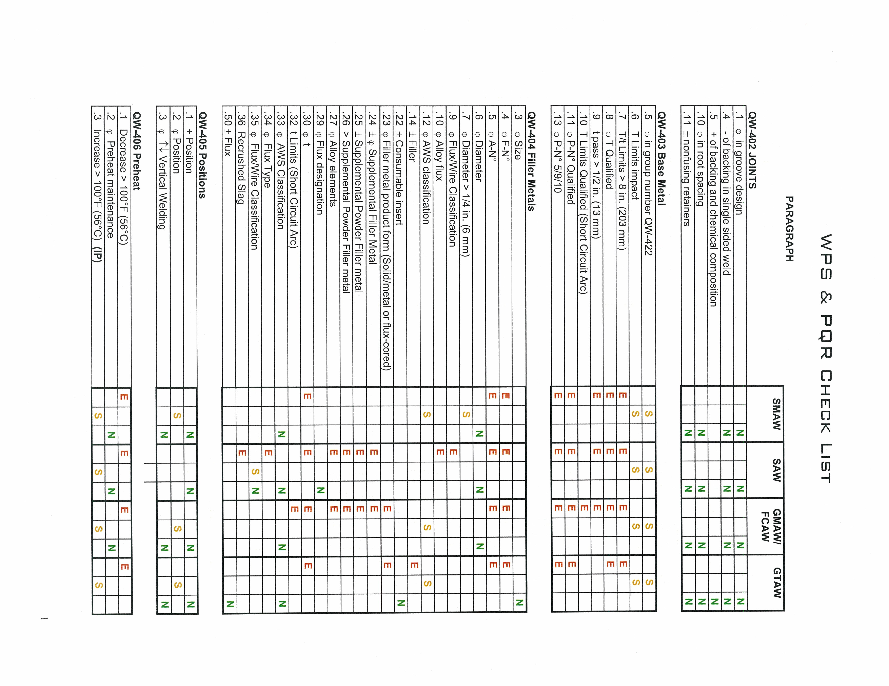
Table 1 Checklist of Essential Welding Variables (cont.)
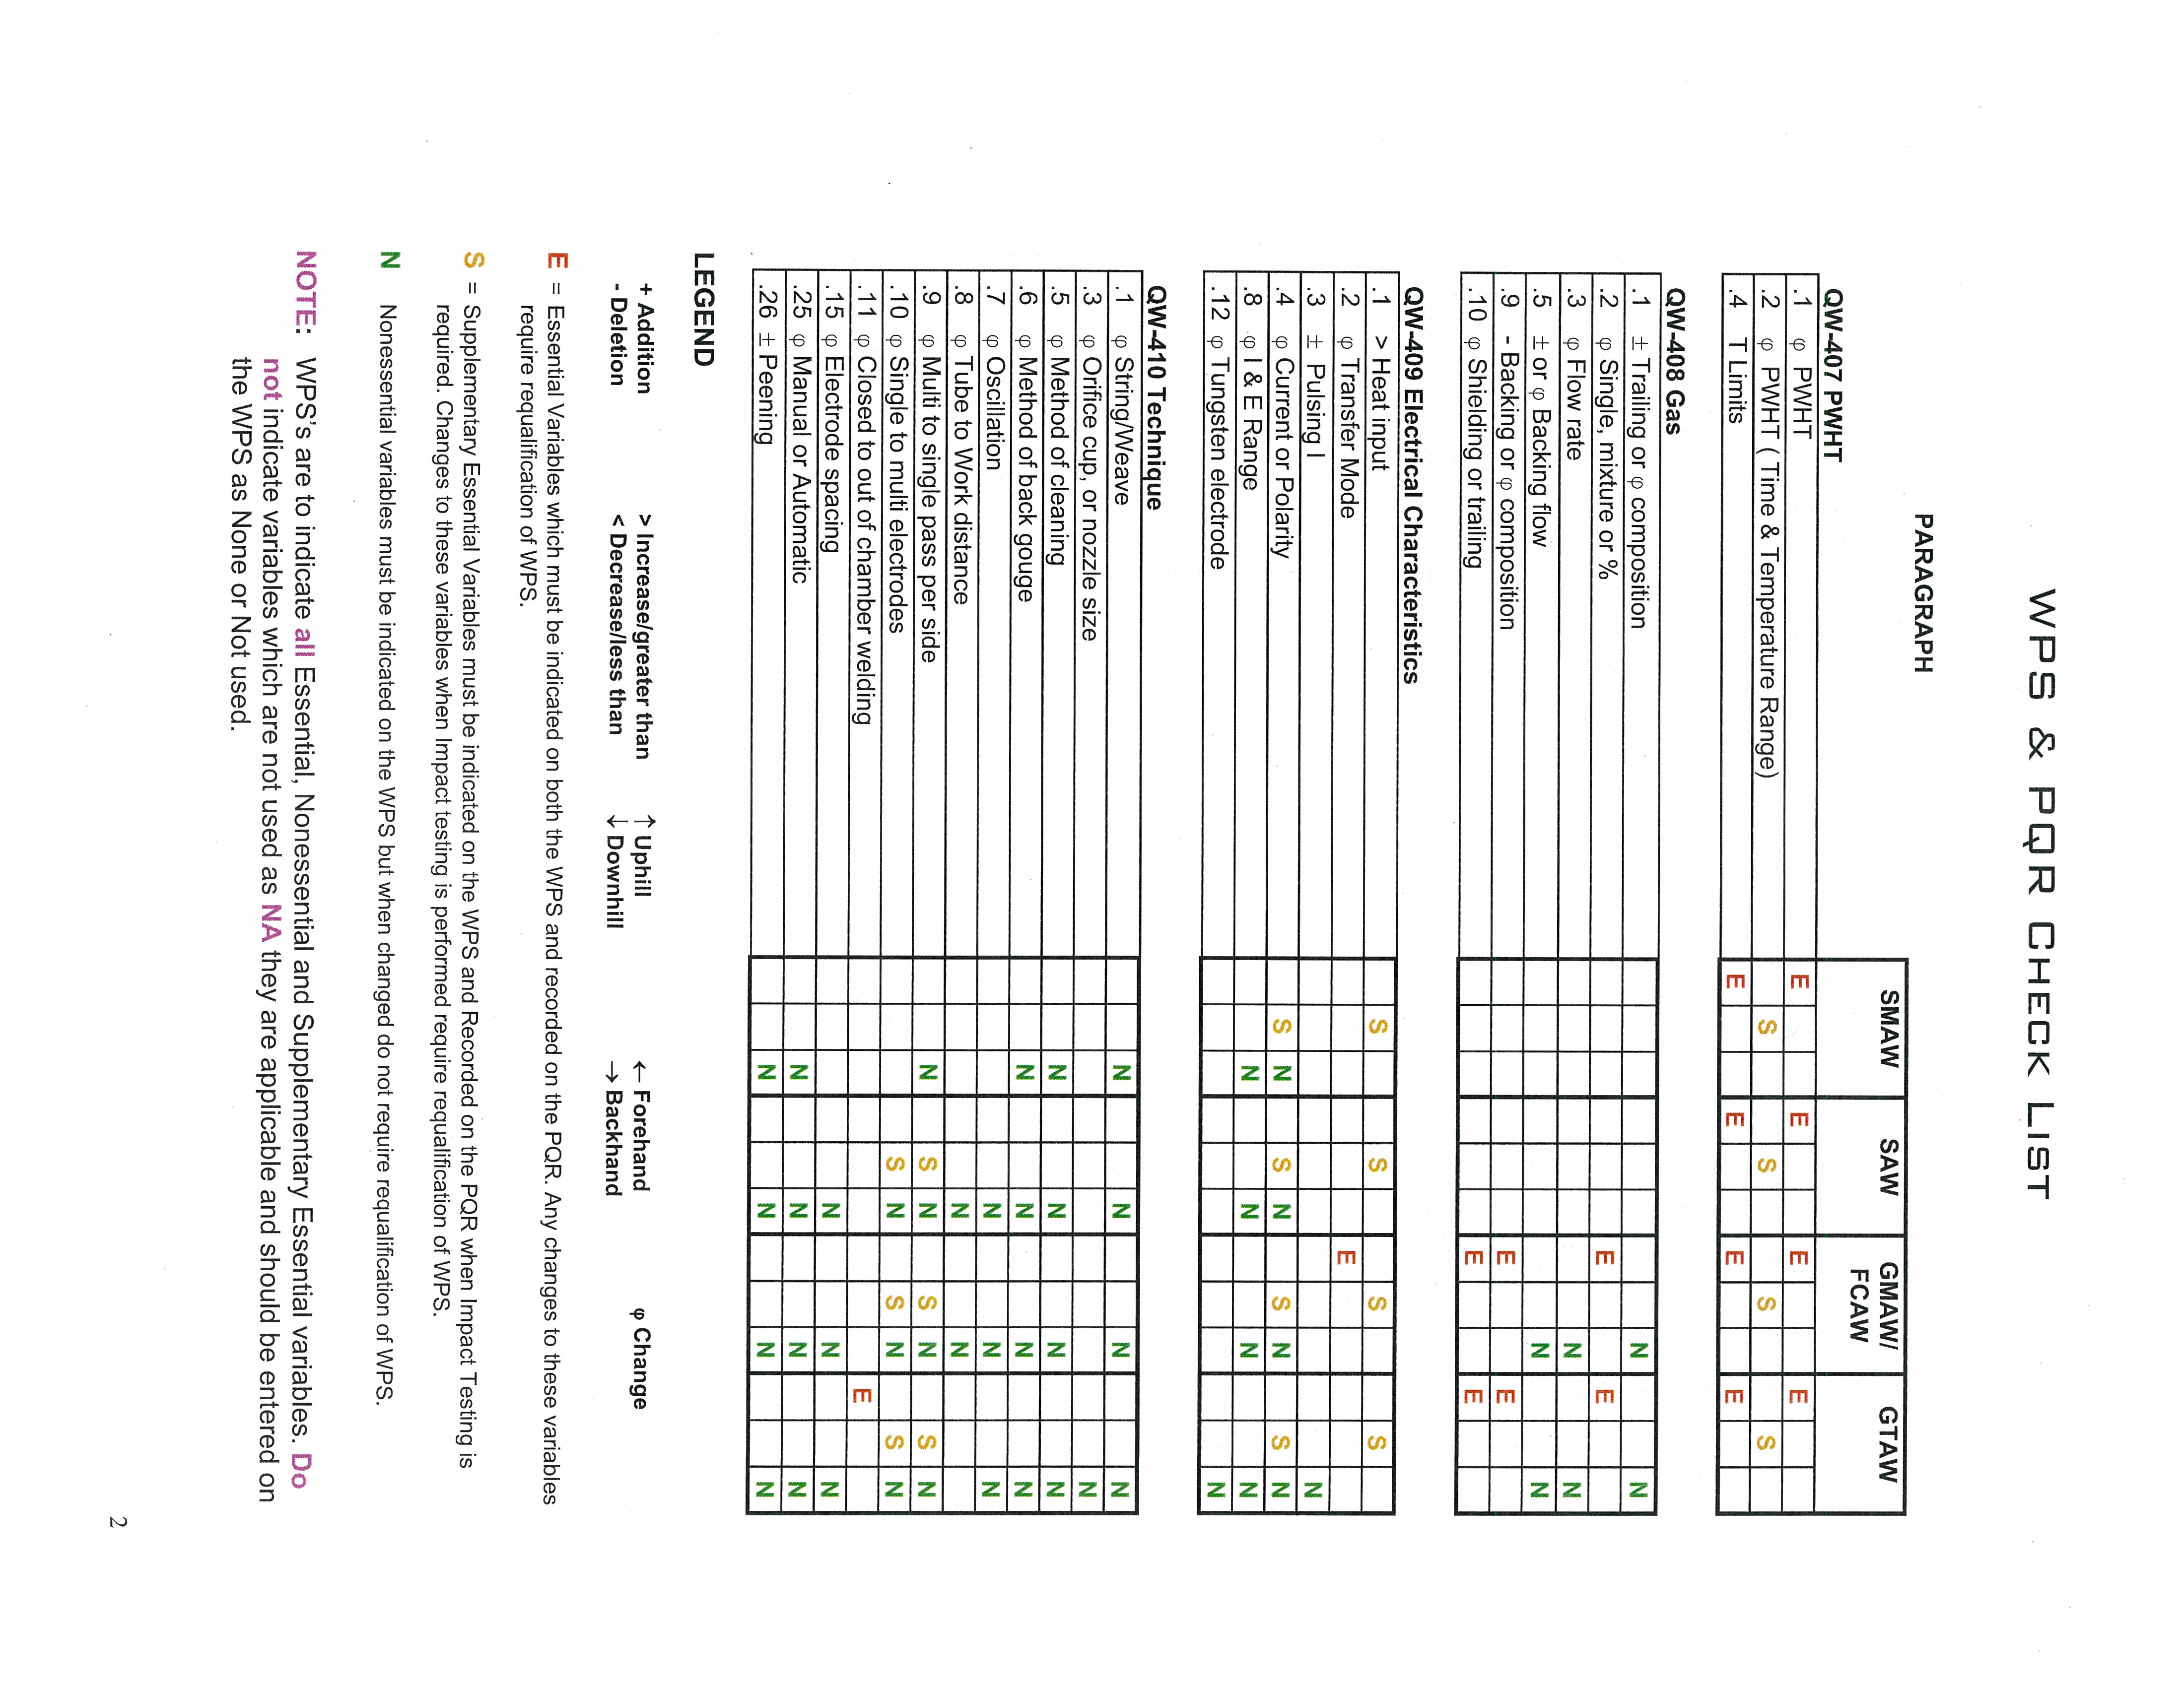

temperature, etc.). The BPS lists the variables, both essential and non-essential, and the acceptable ranges of these variables when using the procedure.

Produce braze test specimens based on each BPS. Typically, four to six specimens, depending upon the type of joint, will be required: two for tensile testing and two/four for peel/bending testing.

Document the testing of the specimens with a Procedure Qualification Record (PQR) for each BPS. The PQR is a record of variables recorded during the brazing of the test specimens. It also contains the test results of the tested coupons.

Document the qualification of each brazing operator with a BPQ (Brazer Performance Qualification). The BPQ documents the workman’s ability to make a sound joint in accordance with the BPS. The brazer or brazing operator who prepares the qualification test specimens is also qualified within the limits of the PQR. Additional brazers or brazing operators can be qualified to the BPS by producing specimens for peel and workmanship testing as defined in Part QB.

INSPECTION EXAMINATION AND TESTING

Introduction

A dressed SRF cavity consists of two major elements, the helium vessel and the SRF cavity. This section outlines the requirements for each of these major elements.

The examination and inspection of the helium vessel shall meet the requirements of the ASME Boiler and Pressure Vessel Code.

The SRF cavity is constructed of non-Code materials and examination per the ASME BPV is not practical. The AMSE Process Piping Code, B31.3, does allow for construction with non-Code materials and is deemed more applicable to the SRF cavity. Therefore, the examination and inspection of the cavity shall follow the requirements of the ASME B31.3 Code.

Inspection

Inspection requirements are set forth in ASME B31.3, Chapter VI, Section 340.

The FNAL engineer responsible for the SRF cavity is considered to be the “Inspector”. He/she may delegate inspection functions to another person but it is the Inspector’s responsibility to determine that this delegate is qualified to perform that function. In no case shall the Inspector represent nor be an employee of the cavity manufacturer, fabricator, or erector unless these functions are performed at FNAL.

Examination

The examination requirements of the ASME B31.3 Process Piping Code, Chapter VI for Normal Fluid Service shall be followed for the SRF cavity. Below is a summary of the minimum requirements.

Visual Examination: 341.4.1(a)

Other Examination: 341.4.1(b)

Certifications and Records: 341.4.1(c)

Testing

Pressure tests for both the helium vessel and the SRF cavity shall follow Chapter 5034 of the Fermilab ES&H Manual.

The dressed cavity shall be pressure tested after all welding and processing is complete. Any subsequent processing which removes material or changes the material's structural properties (heat treatment) shall invalidate the original test results, and the cavity shall be re-tested prior to putting the cavity in service.

REFERENCES
Peterson, T.J. et al, “Pure Niobium as a Pressure Vessel Material”, presented at CEC/ICMC 2009, Tucson, AZ, July, 2009.

APPENDIX A – OVERVIEW OF THE CODE IN THE CONTEXT OF SRF CAVITY DESIGN

Overview of Section VIII – Division 1

General

Div. 1 is directed at the economical design of basic pressure vessels, intending to provide functionality and safety with a minimum of analysis and inspection. Rules are presented which, if applicable, must be used. Common component geometries can be designed for pressure entirely by these rules. Adherence to specified details of attachment eliminates the need for detailed analysis of these features for pressure loading. NDE of welds can typically be avoided by taking a penalty in overall thickness of a component.

Design

The efficiency of welded joints is determined strictly by the amount of radiography. These efficiencies range from 0.45 to 1.00 (see Table UW-12). Code Case 2235-9 provides for the substitution of ultrasonic examination for radiography in some cases where the thickness of the material exceeds 0.5 inches. This thickness is unlikely to be encountered in SRF cavity design.

Neglecting for the moment issues related to materials, joining, and NDE, difficulties emerge with Div. 1 designs in two primary areas: 1) Loadings other than pressure, 2) geometries not covered by rules.

Considering loads, Div. 1 provides very little guidance for thermal contraction loads and the imposition of controlled displacements, both relevant to the design of SRF cavities.

Considering geometries, the functional heart of a cavity assembly – the formed Nb shell - cannot be designed by Div. 1 rules.

The typical approach to achieving a Div. 1 vessel under these circumstances is to invoke the provision of paragraph U-2(g), which states:

“This Division of Section VIII does not contain rules to cover all details of design and construction. Where complete details are not given, it is intended that the Manufacturer, subject to the acceptance of the Inspector, shall provide details of design and construction which will be as safe as those provided by the rules of this Division.”

In the case of the SRF cavities, it will be shown that the great majority of the design must be justified by U-2(g).

Four Div. 1 requirements in particular will impact an SRF cavity design:

All Category B joints (i.e., circumferential joint between pressure parts) in titanium vessels must be either Type 1 or Type 2 butt joints and must be fully radiographed. (see UNF-19(a), UNF-57(b)). This may be difficult to achieve in practice.

All electron beam welds, regardless of material, must be examined over their entire length ultrasonically. (see UW-11(e)). Although this examination is required, there appears to be no way that it can be used to increase the efficiency of a joint.

The minimum thickness of any pressure part (with some exceptions, none of which are relevant to SRF cavities) is limited to 1.5 mm (see UG-16(b)). This is in the range of thicknesses typical of Nb cavities.

If a component is designed for external pressure only (the Nb cavity), no radiographic examination of welds is required (see UW-11(c)). However, ultrasonic examination is still required for EB welds in such a component.

Overview of Section VIII – Division 2

General

Div. 2 is directed at engineered pressure vessels, which can be thought of as vessels whose performance specifications justify the more extensive analysis and stricter material and fabrication controls and NDE required by this Division. Thus, while a Div. 2 vessel is likely to be more efficient than a Div. 1 vessel in terms of total material used, this efficiency is accompanied by increased design and fabrication cost.

Design

Design is governed by two loosely-coupled provisions: Part 4 (Design by Rule), and Part 5 (Design by Analysis). A device may be designed by either Part; but regardless of the Part used, the provisions of Part 3, 6, and 7 (materials, fabrication, and inspection) must be met.

The rules of Part 4 are very complete, duplicating many of the rules of Div. 1, while expanding them to cover a wider range of geometries.

The rules of Part 5 provide for a strictly analytical approach to the vessel design. A numerical analysis technique is assumed, and either elastic or elastic-plastic analysis is permitted. With regard to finite element analysis specifically, extensive guidance is provided for simulation and interpretation. (see Annex 5.A)

For the most part, a Part 5 design can ignore any applicable rule of Part 4 even if it results in a thinner pressure part than Part 4 would allow. One important exception to this rule is that no pressure part may have a thickness of less than 1.6 mm (see 4.1.1.5).

The mandatory NDE for welded joints in this Division is extensive. Typically, both volumetric (radiographic or ultrasonic, which are interchangeable in this Division) and areal (dye penetrant or magnetic particle) examination are required. Joint efficiencies range from 0.65 to 1.00. (see Table 7.2)

The Div. 2 requirements most likely to impact an SRF cavity design are those for non-destructive examination of welds.

APPENDIX B – APPLYING DIV. 1 RULES TO SRF CAVITY DESIGN

Cavity Types

At this time, two types of cavities will be encountered: Elliptical cavities and spoke cavities. They are similar only in the broadest sense of being jacketed vessels; they differ greatly in detail.

Both cavities are assembled at room temperature and operated at LHe temperature. Both cavities have a provision for being deliberately strained while cold to maintain proper RF tuning.

Elliptical Cavity

The elliptical cavity assembly consists of the Nb cavity (a convoluted shell structurally similar to a bellows or expansion joint), surrounded by a metallic jacket used to contain liquid helium in the annular space between the cavity and jacket. The jacket has mounting rings for a tuning device, which expands or contracts the assembly (exercising the bellows on the jacket, and changing the length of the Nb cavity), tuning the RF output.

The jacket is connected to the Nb cavity through conical transitions, which also serve (for the example shown) to transition between the metal used in the jacket (for the example, titanium) and the Nb of the cavity.

The particular Code compliance issues with this design are (neglecting non-Code materials):

Nb cavity geometry - not addressed by the Div 1 expansion joint design rules of Appendix 26.

Dissimilar materials and thermal contraction

Conical head half-apex angle greater than 30 degrees

For examples with titanium jackets, weld type and full radiography requirements of Category B joints.

Spoke Cavity

There are currently single spoke and three spoke cavity designs under consideration. This description applies to the simpler single-spoke design.

The spoke cavity assembly consists of an Nb cavity (a cylindrical shell with communicating chamber and formed heads) surrounded by a metallic jacket (a cylindrical shell with flat heads.) Transitions between the jacket and cavity occur at the inner radius of the cavity, and at diametrically opposed locations on the cavity perimeter, which also serve as vacuum and input coupler ports.

The particular Code compliance issues with this design are (neglecting non-Code materials):

Nb formed heads - a geometry not addressed by Div. 1 rules.

Dissimilar materials and thermal contraction

Design Loads

Typically, the cavity assembly is subjected to the following loads:

Pressure – this occurs in the annular space which holds the liquid helium, resulting in an internal pressure on the jacket and head components, and an external pressure on the Nb cavity itself. This pressure may occur both warm and cold. In either case, the Nb cavity is susceptible to buckling failure.

Thermal contractions – the cool down from room temperature to operating temperature will produce thermal strains due to the dissimilar materials used in the assembly. Commercially pure titanium (Grades 1 – 4) and pure Niobium have integrated thermal contraction coefficients of 0.00151 mm/mm and 0.00143 mm/mm, respectively, when cooled from RT to 4.2 K. However, the typical tuning device (placed between the two support rings on the jacket) is made of 3xx stainless steel, which has an integrated thermal contraction coefficient of 0.00304 mm/mm over that temperature range. This produces a substantial mismatch between the jacket and cavity contractions, increasing the thermal strains. In designs with jackets made entirely of SS304, the situation becomes more acute.

Imposed displacements – for the elliptical cavities, after cooldown, the tuning device will be exercised to change the length of the cavity for tuning. This is an imposed displacement, similar in concept to a thermal strain.

Dead weight – the cavity assembly is supported through the tuning device (elliptical cavities) or support post (spoke cavities). Elliptical cavities may be supported in a vertical (testing) or horizontal (operation) position.

Applicable Division 1 Rules for Elliptical Cavities

Table B-1 shows the loads and lists the paragraphs of Div. 1 which are relevant to the design of the various components. Where no rules exist for either the geometry or the loading, paragraph U-2(g) is invoked.
Table B-1. Applicable Div. 1 Rules for Elliptical Cavity Assembly
Load | Component
Load | Nb Cavity | Jacket | Conical Head | Bellows
Pressure (internal) | - | UG-27 | UG-32, UG-36, 1-5(g) | Appendix 26
Pressure (external) | U-2(g) | - | - | -
Thermal Contraction | U-2(g) | U-2(g) | U-2(g) | U-2(g)
Imposed Displacement | U-2(g) | U-2(g) | U-2(g) | U-2(g)
Dead Weight | U-2(g) | Appendix G, U-2(g) | U-2(g) | U-2(g)

As the tables indicate, the majority of the spoke cavity must be qualified under the provisions of U-2(g).
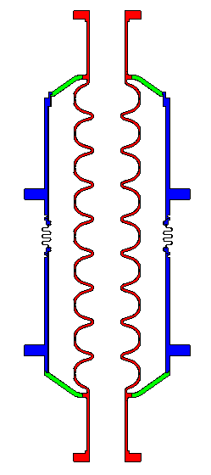
Ti – Gr 2 (cylindrical shell or jacket)
Nb
(convoluted shell, expansion bellows)
45Nb/55Ti alloy (conical reducer or head)
45Nb/55Ti alloy (conical reducer or head)
Ti – Gr 2
(expansion bellows)
Ti – Gr 2
(stiffening ring or support)
Nb
(integral flange)
Figure B-1. An Elliptical Cavity Assembly

Applicable Division 1 Rules for Spoke Cavities

Table B-2 shows the loads and lists the paragraphs of Div. 1 which are relevant to the design of the various components. Where no rules exist for either the geometry or the loading, paragraph U-2(g) is invoked.

Table B-2. Applicable Div. 1 Rules for Spoke Cavity Assembly
Load |  | Nb Cavity Component
 |  | Cylindrical Shell |  | Formed Head |  | Penetrations in shell and head |  | Transitions to jacket and beam pipe
Pressure (internal) |  | - |  | - |  | - |  | -
Pressure (external) |  | U-2(g) |  | U-2(g) |  | UG-37,U-2(g) |  | U-2(g)
Thermal Contraction |  | U-2(g) |  | U-2(g) |  | U-2(g) |  | U-2(g)
Support |  | U-2(g) |  | U-2(g) |  | U-2(g) |  | U-2(g)
Load | SS304 Jacket Component
Load | Cylindrical Shell |  | Formed Head |  | Penetrations in shell and head |  | Transitions to jacket and beam pipe |  | Bellows
Pressure (internal) | UG-27 |  | U-2(g) |  | UG-37, U-2(g) |  | U-2(g) |  | Appendix 26
Pressure (external) | U-2(g) |  | U-2(g) |  | UG-37,U-2(g) |  | U-2(g) |  | Appendix 26
Thermal Contraction | U-2(g) |  | U-2(g) |  | U-2(g) |  | U-2(g) |  | U-2(g)
Support | Appendix G, U-2(g) |  | U-2(g) |  | U-2(g) |  | U-2(g) |  | U-2(g)

As the tables indicate, the majority of the spoke cavity must be qualified under the provisions of U-2(g).

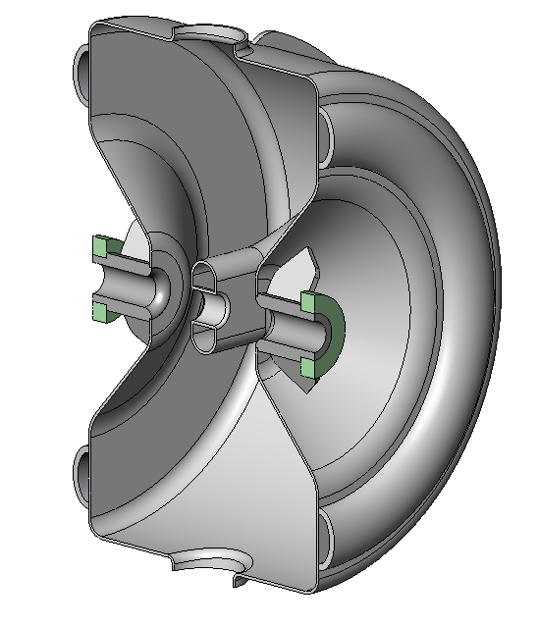
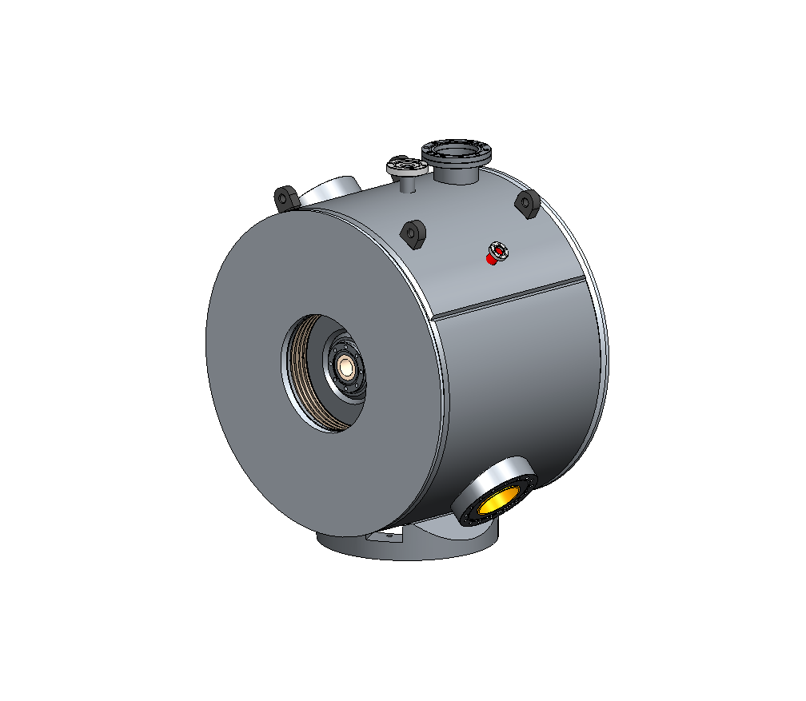
Figure B-2. A Spoke Cavity Assembly
Nb
(formed head with stiffeners)
Nb
(cylindrical shell with penetrations and stiffeners)
Nb
(intruding nozzle)
SS304
(cylindrical shell or jacket, with penetrations)
SS304
(flat head)
SS304 (support)
cavity-to-He vessel transition (vacuum port)
cavity-to-He vessel transition (input coupler port)
cavity-to-beam pipe transition
cavity-to-beam pipe transition
cavity-to-He vessel transition
Helium Vessel
Cavity
SS304 bellows

