FESHM 4160: EMERGENCY EYEWASH AND SHOWER STATIONS

Revision History

Author | Description of Change | Revision Date
Steven Carlson | - Revised definitions, procedure requirements, references, and technical appendices.  - Added supplemental equipment limitations and Appendices to sustain performance.  - Removed the requirement to display vendor-purchased tags and replaced it with a requirement to display in-house verifications presented in this chapter’s appendices. | April 2022
Richard Rebstock | - Replaced “Tepid” with moderately warm; lukewarm with moderately warm; lukewarm between 60-100 degrees F.  - Replaced Division/Section/Center with Division/Section | January 2017

TABLE OF CONTENTS

1.0 INTRODUCTION AND SCOPE 3
2.0 DEFINITIONS 3
3.0 RESPONSIBILITIES 4
3.1 Environmental Safety and Health (ES&H) Section 4
3.2 Division/Section Heads 4
3.3 Supervisors 4
4.0 PROCEDURES 4
4.1 Emergency Eyewash or Combination Unit Procedure 4
4.2 Emergency Shower Procedure 5
4.3 Supplemental Equipment Procedural Limitations 5
4.3.1. Personal Flushing Bottles 5
4.3.2. Hand-held Drench Hoses 5
5.0 REFERENCES 5
6.0 TECHNICAL APPENDICES 7
6.1 Appendix A: Initial Verification 7
6.2 Appendix B: Weekly Verification 8
6.3 Appendix C: Approved Self-Contained and Supplemental Equipment List 9

INTRODUCTION AND SCOPE

This chapter covers guidelines and requirements for the use, inspection and maintenance of emergency eyewash and shower equipment designed for the immediate treatment of exposure to corrosive chemicals. This chapter applies to Fermi Research Alliance (FRA) and its leased spaces.

DEFINITIONS

Approved water source: adequately supplied source of tepid potable water or saline solution.

Combination unit: an interconnected assembly of equipment supplied by one approved water source; often an emergency shower with eyewash.

Corrosive material: chemical substance that produces the destruction of skin tissue.

Hand-held drench hose: supplemental device, connected to an approved water source, used to irrigate the face or other body areas.

Personal flushing bottles: supplemental, pre-filled bottles used to irrigate and flush the eyes, face, or other body areas.

Plumbed emergency eyewash: a fixed device used to irrigate and flush the eyes by delivering fluid from an approved water source, at a rate of 0.4 gallons per minute, for a minimum of 15 minutes.

Self-contained emergency eyewash: a moveable, stand-alone device used to irrigate and flush the eyes by delivering fluid from an approved water source, at a rate of 0.4 gallons per minute, for a minimum of 15 minutes.

Plumbed emergency shower: a fixed device used to cascade fluid over the entire body, delivered at a flow rate of 20 gallons per minute, for a minimum of 15 minutes.

Plumbed: equipment connected to a continual source of potable water.

Potable water: water of drinking quality.

Saline solution: preserved, buffered flushing fluid or other medically acceptable solution.

Tepid: potable water or saline solution temperature of 60-100°F (16-38°C)

RESPONSIBILITIES

Environmental Safety and Health (ES&H) Section
The ES&H Section’s Industrial Hygiene Group shall:
- Review this chapter and ensure technical appendices are maintained.
- Provide Appendix A or B (forms) upon request, or as needed.

Division/Section Heads
Each Division/Section Head shall:
- Ensure emergency eyewash and/or shower unit verifications are completed and documented to demonstrate compliance with this chapter. Area Facility Managers (AFM) will support Division/Section Heads by ensuring that plumbed eyewash and/or shower stations are adequately supplied with an approved water source (i.e., potable water) that may be used for emergency units. Building, section, or project tenants must ensure units are inspected and maintained according to this chapter’s appendices.

Supervisors
Supervisors shall:
- Assume the responsibility or designate a worker to complete procedures in this chapter.
- Ensure affected employees are instructed in the proper use and location of emergency showers, eyewashes, combination units, hand-held drenching hoses, and personal flushing bottles in their working area.
- Ensure eyewash instruction discusses holding the eyelids open and rolling the eyeballs so flushing fluid flows on all surfaces of the eye and under the eyelid. Additional instruction must reiterate that, should an exposure occur, affected areas must be flushed for 15 minutes and affected clothing must be removed.
- Conduct hazard assessments with Division Safety Officers and/or the Industrial Hygiene Group for emergency planning, especially when new emergency eyewash or shower equipment is furnished.

PROCEDURES

Emergency Eyewash or Combination Unit Procedure
Plumbed or self-contained emergency eyewash or combination units shall be:
- Installed where corrosive material may contact the eyes through splashing, spraying, misting, or other aerosolizing job task processes.
- Connected to an approved water source.
- Located on the same level as relevant hazards
- Accessible by any job task the eyewash or combination unit is meant to service; reachable in 10 seconds or less (≤ 55 ft.)
- Free of obstructions that block a potential user’s path of travel.
- Well-lit and identifiable by a highly visible sign that is viewable within the serviced area.
- Initially verified, when installed, to ensure acceptable performance using Appendix A.
- Verified weekly to ensure maintained performance using Appendix B.

Emergency Shower Procedure
Plumbed or self-contained emergency showers shall be:
- Installed where corrosive material may contact the body through splashing, spraying, misting, or other aerosolizing job task processes.
- Connected to an approved water source.
- Located on the same level as relevant hazards.
- Accessible by any job task the shower is meant to service; reachable in 10 seconds or less (≤ 55 ft.)
- Free of obstructions that block a potential user’s path of travel
- Well-lit and identified by a highly visible sign that is viewable within the serviced area.
- Initially verified, when installed, to ensure acceptable performance using Appendix A.
- Verified weekly to ensure maintained acceptable performance using Appendix B.

Supplemental Equipment Procedural Limitations

Personal Flushing Bottles

Personal flushing bottles, also referred to as personal eyewash bottles, are meant to support the flushing of potentially injurious eye exposures in a quick, manual manner. However, personal eyewash bottles do not satisfy all relevant compliance criteria tied to emergency eyewashes, showers, or combination units. Therefore, when corrosive material is involved, personal flushing bottles must not be used as stand-alone items; they must be used along with appropriately installed emergency eyewashes, showers, or combination units.

If relative work does not involve corrosive material that may contact the eyes, face, or body through splashing, spraying, misting or any other aerosolizing process, personal flushing bottles may be selected and utilized as stand-alone devices (as desired).

Hand-held Drench Hoses

Handheld drench hoses are meant to supply flushing fluid after potentially injurious eye or face exposures. They are considered supplemental equipment and cannot supersede emergency shower, eyewash, or combination unit requirements. Handheld drench hoses may be installed with fixed, plumbed eyewash units. However, in these cases, fixed drench hoses must not alter eyewash station performance. Additionally, drench hoses must deliver an approved water source, at a rate of 3.0 gallons per minute, for 15 minutes or more. Like plumbed eyewash and shower verification checks, drench hose performance must be verified initially and weekly.

REFERENCES

American National Standards Institute, Inc. (2015). American National Standard for Emergency Eyewash and Shower Equipment. Arlington: International Safety Equipment Association, 2015. Z358.1-2014

Occupational Safety and Health Administration. (1998). Occupational safety and health standards: Medical and First Aid (Standard No. 1910.151). Retrieved from https://www.osha.gov/laws-regs/regulations/standardnumber/1910/1910.151

Richard E Fairfax. Occupational Safety and Health Administration Directorate of Enforcement Programs (Standard No. 1910.151; 1910.151(c)). [Online] June 1, 2009. Retrieved from https://www.osha.gov/laws-regs/standardinterpretations/2009-06-01

TECHNICAL APPENDICES

Appendix A: Initial Verification

Appendix A: Initial Verification

Building FIMS #: _________________________________________

Location Description ______________________________________

Equipment ID # (provided by ES&H): _________________________

Completed By (first & last name): ____________________________ Fermi ID: ____________ Date: ___________

This verification certifies an initial check has been completed and performance meets the compliance details below. If applicable, commissioning instructions provided by the manufacturer must also be completed before certifying this verification. This verification shall be fixed in a plastic holder at/near the applicable emergency shower or eyewash unit. When completed, responsible building, section, or project tenants must send a copy of this form to stevenc@fnal.gov or mail slot 355.

Step | Facility Plumbed Emergency Shower | Facility Plumbed Emergency Eyewash | Self-contained Emergency Eyewash
1 | Connect flowmeter to the unit to be tested or provide other means of measuring flushing fluid flow. | Connect flowmeter to the unit to be tested or provide other means of measuring flushing fluid flow. | Set up the unit per the manufacturer’s instructions
2 | Connect unit per manufacturer specifications to a flow pressure of 30 psi +0.5 psi - 0 psi. | Connect unit per manufacturer specifications to a flow pressure of 30 psi +0.5 psi - 0 psi. | Fill the unit with flushing fluid or pre-packaged fluid provided by the manufacturer.
3 | Open the valve on the unit and verify that it fully opens in one second or less and that it stays open. | Open the valve on the eyewash and verify that it fully opens in one second or less and that it stays open.
4 | Determine that flushing fluid is substantially dispersed throughout the pattern. The flushing fluid column pattern shall be 82 to 96 inches from the surface which the user stand; the diameter shall be a minimum of 20 inches. The drenching area available for users to stand in should offer 34 inches of space (measured as a diameter). | Ensure that the flushing fluid area is dispersed less than 8 inches above the eyewash nozzle(s).
5 | Throughout this 15-minute test, verify that the flow rate is a minimum of 20 gallons per minute. | Throughout this 15-minute test, verify that the flow rate is a minimum of 0.4 gallons per minute.
Other | Customized instruction or unique manufacturer instructions may need to be referenced. Such instructions must be included with this form to certify appropriate steps have been followed prior to commissioning emergency flushing equipment for use. Such steps must be approved by ES&H. DSO’s or this program’s administrator can assist in these requests. (ex: drenching hoses must be designed with a flow rate of 3 gallons per minute and verified)

Appendix B: Weekly Verification

Appendix B: Weekly Verification

Building FIMS #: _________________________________________

Location Description ______________________________________

Equipment ID # (provided by ES&H): _________________________

This form certifies a weekly verification has been completed and performance meets compliance details below. If applicable, additional manufacturer-provided weekly inspection instructions must be completed before certifying this form. This verification shall be fixed in a plastic holder at/near the respective unit. At the end of each calendar year, responsible building, section, or project tenants must send a copy of this form to stevenc@fnal.gov or mail slot 355.

Facility-plumbed emergency shower performance must be verified using the following steps, weekly:
- Ensure the unit is properly connected to a potable water or flushing-fluid / saline solution source. There should be a connection made by a supply valve or valves. Shut this valve and ensure there are no leaks and then reopen.
- Ensure the unit is unobstructed. Ensure the drenching area available for a user to stand offers 34 inches of space or more (measures as diameter).
- Ensure the height of the shower head continues to measure between 82-96 inches from where the user would stand.
- Shut associated plumbed supply valves and verify piping connections do not have leaks.
- Fully open valves. Ensure the action can be completed in 1 second or less. Verify the valve remains open without manual assistance.
- Activate the performance control valve to begin the full flow of potable water or saline solution. Once activated, the shower should operate without the need for an operator’s hand(s) until intentionally closed.
- At minimum, water must remain activated to clear sedimentation in stagnant water supply lines. Contact AFM to determine this unit’s appropriate run time. This unit’s minimum run time is ________ (minutes) but it must be run longer - if needed - to ensure water runs clear.

Self-contained emergency showers and eyewashes must be visually verified using the following steps, weekly. However, the self-contained units approved in Appendix C may be visually verified monthly:
- Visually checked to ensure: no damage or issues have occurred; The area around and beneath remains unobstructed.
- Determine if flushing fluid (saline solution) needs to be changed within the week and perform the changeout.
- Ensure manufacturer provided operation, inspection, and maintenance instructions available at the unit and followed.

Year: | Week 1 (initial/date) | Week 2 (initial/date) | Week 3 (initial/date) | Week 4 (initial/date) | Week 5 (initial/date)
January
February
March
April
May
June
July
August
September
October
November
December

Appendix C: Approved Self-Contained and Supplemental Equipment List

Appendix C: Self-Contained and Supplemental Equipment List

Product | Manufacturer Information & Model Number | Stockroom Number | Example
Self-contained Emergency Eyewash Station | Honeywell Fendall Pure Flow 1000  32-001000-0000 | N/A | 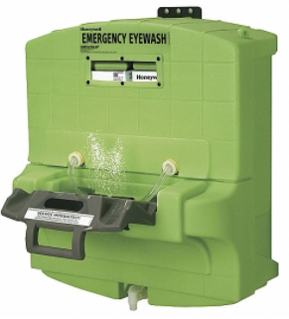
Replacement Eye Wash Cartridges for Self-contained Emergency Eyewash Station | Honeywell Fendall Pure Flow 1000 Eye Saline Cartridges  32-001050-0000-H5 | N/A | 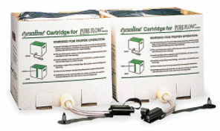  (2-year shelf life)
Self-contained Emergency Eyewash Station | Honeywell Fendall Pure Flow 2000  32-002000-0000 | N/A | 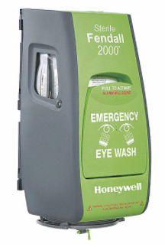
Replacement Eye Wash Cartridges for Self-contained Emergency Eyewash Station | Honeywell Fendall Pure Flow 2000 Eye Saline Cartridges  32-ST2050-0000 | N/A | 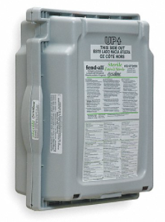  (2-year shelf life)
Eyewash Station Stand or Cart | Honeywell Eyewash Stand  32-001065-0000  Honeywell Eyewash Cart  32-001060-0000 | N/A | 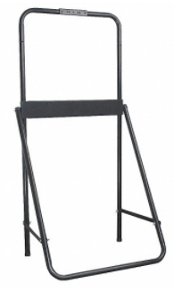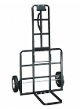
Personal Eye Wash Station | Honeywell Eye Saline Station  32-000462-0000-H5 | N/A | 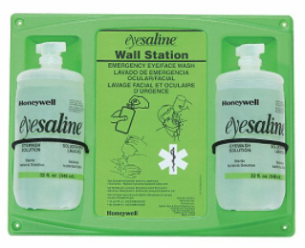  (3-year shelf life)
Replacement 32 Ounce Personal Eye Wash Replacement Bottle | Honeywell Eye Saline Bottle  32-000455-0000-H5 | 2650-010000 | 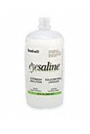  (3-year shelf life)

